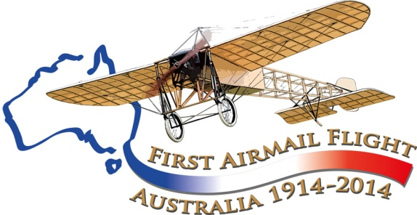

Maurice Guillaux…

An Introduction

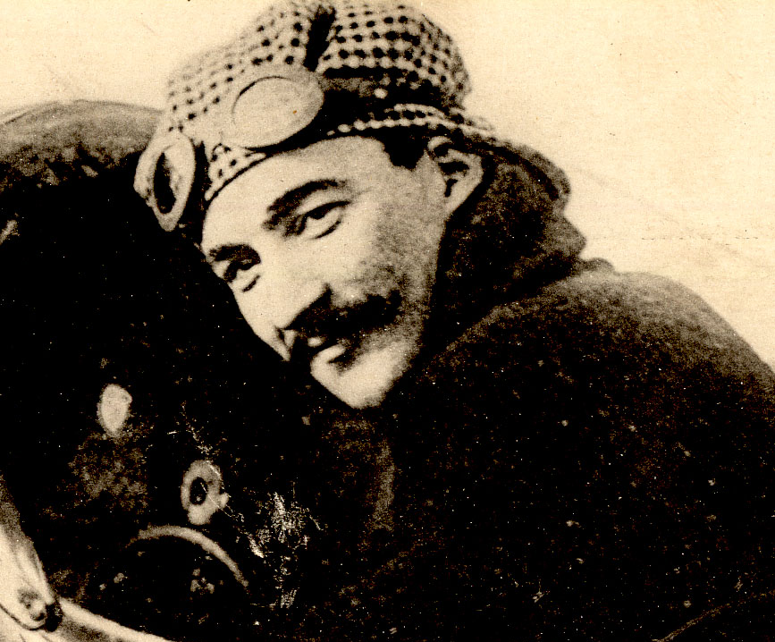See the back page for a special offer to readers!

Tom Lockley
Co-ordinator
Aviation Historical Society of Australia (NSW) inc
Air Mail Centenary Commemoration Group
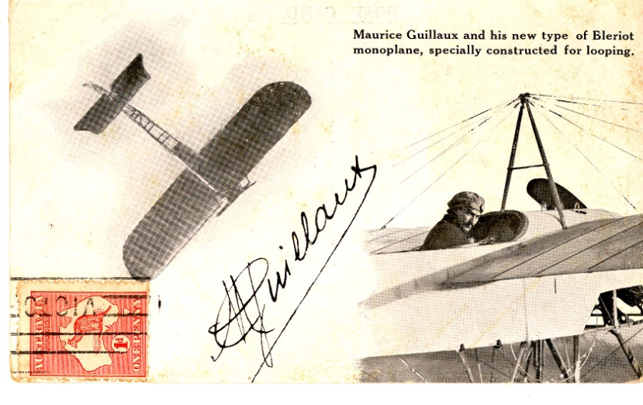
The dashing, elegant aviator Maurice Guillaux was born in Montoire in Central France in 1883. We know little of his early career, but by 1912 he was famous as the chief pilot of the Caudron factory, giving many aerial displays. He was successful in the Pommery Cup competition for long-distance flying, but by 1913 the aircraft were doing up to 1000 km a day, and measurement was difficult. The competition became less popular with the public.
He then acquired a new Bleriot monoplane, specially designed for ‘looping the loop’, a new and exciting feat. After a few demonstration flights in France he and four associates left on a world trip, aiming to make lots of money by giving flying displays.
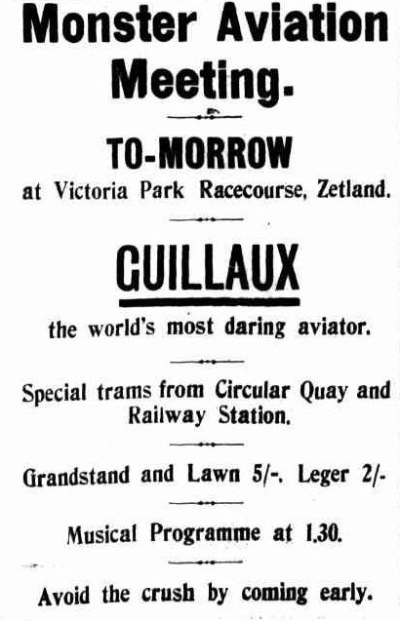
After a brief stop in Egypt, the team came to Australia, landing in Sydney on April 4, 1914. He gave displays in Sydney and Newcastle. In May and June he also performed in Melbourne, and regional centres such as Wagga Wagga, Albury, Bendigo and Ballarat. These displays were hugely successful: hundreds of thousands of people paid to see him fly. Other pilots, including the American Arthur B “Wizard’ Stone and the Australian Harry Hawker were clearly outclassed by Guillaux.
On May 13 ‘Wizard’ Stone announced plans to fly mail from Melbourne to Sydney, with a flight date proposed ‘on or about’ 23 May. This was delayed until June 6, but on June 1 Stone crashed in Rockhampton, Queensland, while racing against an automobile. He was injured and his aircraft was badly damaged.
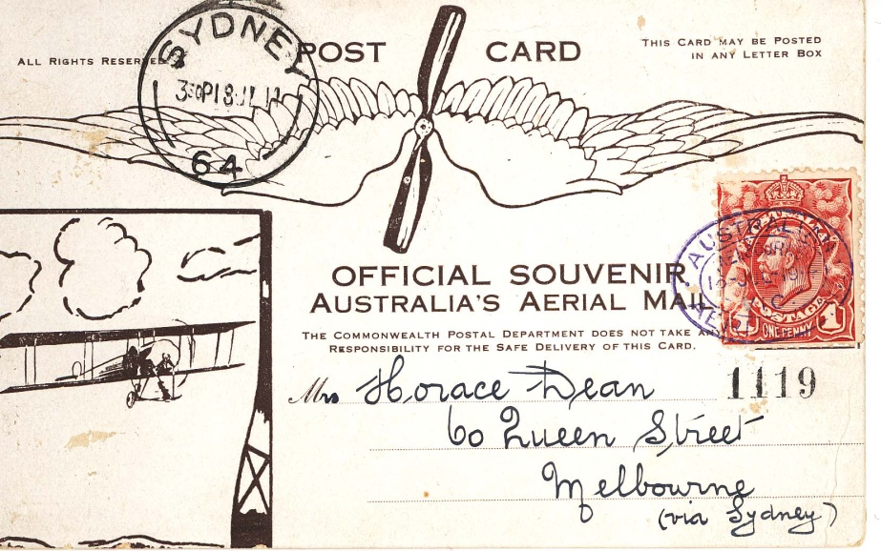
Guillaux took over the air mail project. He took off on his journey from Flemington showgrounds, Melbourne at 9 12 am on 16 July, 1914, and landed in fields at Seymour and Wangaratta before entering New South Wales, reaching Albury racecourse at 12 50 pm. Here he had lunch with compatriot Alderman Frere before flying on to Wagga Wagga and then to Harden at 4 06 pm. Trying to fly on, he was forced back by bad weather. In one day he had flown about 1000 kilometres, giving aerobatic displays over each town to entertain the huge crowds that greeted him at every stop.
On 17 July he was again forced to return to Harden because of weather, but on 18 July he was able to move on to Goulburn. This was a freezing winter morning, for which Goulburn is infamous, and when he landed he rushed to the beacon fire to thaw out. He flew on, missing a planned landing at Moss Vale, but landing just behind the main street of Liverpool. After lunch with the locals, he took off in time to arrive at Moore Park, in central Sydney, by 2 50 pm.
Here he was received by a huge crowd, including the Governor-General. A band played the Marseillaise and he handed over his cargo. About 2500 cards were printed, individually numbered, but the evidence is that only 1785 were carried, with special messages such as those from the Governor and the French Consul in Victoria to their counterparts in New South Wales. A packet of Liptons Tea and some OT lemon cordial were also carried; this was Australia’s first air freight.
This was, at the time, the longest air mail flight anywhere in the world and certainly this epic of endurance, courage and skill ensured that he was the pre-eminent aviator of the time in Australia.
Guillaux was not only active as a showman, but took an important part in other aviation matters. Lebbeus Hordern, a member of the wealthy Hordern family had purchased a Farman seaplane, and Guillaux made many record-breaking flights in it, sometimes with rather attractive lady passengers. He was involved in the development of the Ham Common airfield, which is now Richmond RAAF base and gave advice to the fledgling Australian Flying Corps. His 197 days in Australia had an enormous effect on Australian aviation history.
By August, the news was dominated by the outbreak of war. On 2 August, Guillaux had a major crash, damaging his aircraft and injuring himself. The aircraft was repaired, and Guillaux recovered in a few weeks, but the time for flying displays was over. Guillaux returned to France on 22 October, as an aviator attached to the First Australian Division. He eventually returned to France and was killed in an aircraft crash, while test-flying a new aircraft, on 21 May 1917.

A re-enactment flight will take place in 2014, between Melbourne and Sydney, using a Jabiru, a modern Australian lightweight sports aircraft of similar weight and engine capacity to Guillaux’ Bleriot. The Jabiru will be accompanied by a number of other historical aircraft and will follow the route pioneered by Guillaux, with major celebrations at each stop. The flight’s conclusion will be the centrepiece of Sydney’s Bastille Day Celebrations.
To find out more, go to www.australiasfirstairmail.com .
Send your email address to guiillauxcentenary@gmail.com to receive the latest news on this event – and you can also buy the replica postcards that will be the most desirable philatelic material of recent times.
If you have any suggestions, or you would like to help in any way, please email guillauxcentenary@gmail.com

