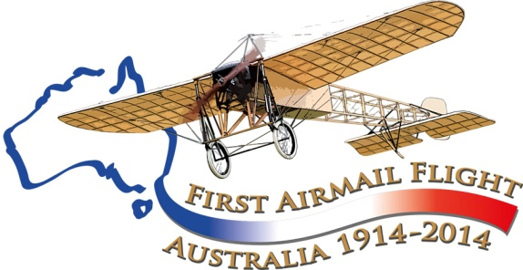

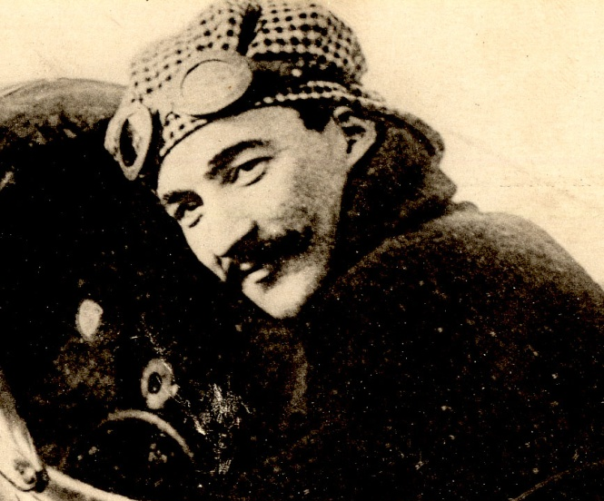
Maurice Guillaux’ displays in Sydney, 1914
This is a brief treatment of the aeronautical activities in Sydney (and Bathurst) of Maurice Guillaux, French aviator who was in Australia from April to October 1914. His main feat was the carriage of Australia’s first official air mail from Melbourne to Sydney, 16-18 July 1914. His contributions to Australian aviation history are great, but because World War 1 broke out days after his main flight, much of the story has been lost.
In this centenary year, a re-enactment of the air mail flight is occurring, and we are also taking advantage of the interest being shown to collect as much information as we can. If you can add to the story, please email guillauxcentenary@gmail.com.
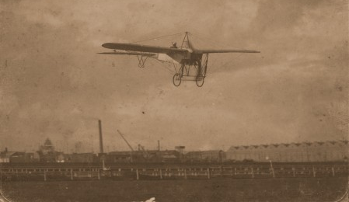
Picture: from the collection of the PowerHouse Museum, Sydney: Guillaux flying over Victoria Park, his main Sydney venue. The museum also holds the original aircraft used by Guillaux, one of the world’s great aeronautical treasures.

Tom Lockley
Co-ordinator
Aviation Historical Society of Australia (NSW) inc
Air Mail Centenary Commemoration Group
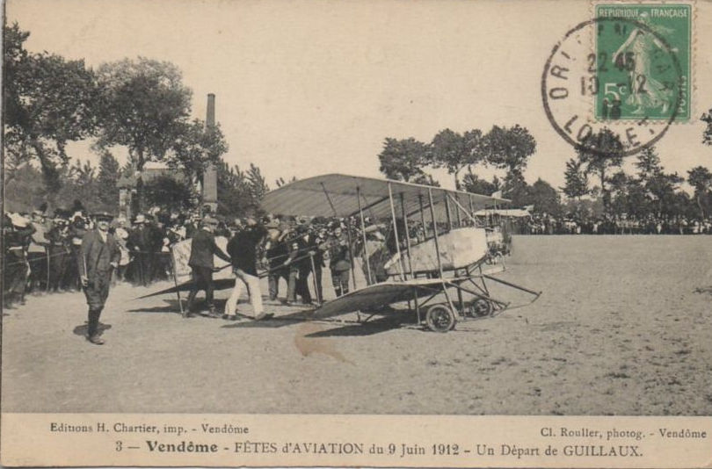
Certainly Guillaux was a fine pilot. He had appeared on the French aeronautical scene when awarded licence no 749 in France on 19 February 1912, at the age of 29. By June 1912 he was a noted pilot for the Caudron factory, as seen in the postcard. He moved on to become chief pilot of Clement-Bayard, winning the Pommery Cup for long-distance flying and becoming one of the top French pilots. This elite band was idolised by the public. However late in 1913 he was suspended from the long-distance flying completion because of a discrepancy of his records. He purchased a new Bleriot XI, specially modified for aerobatics, and set off on a world tour with the aim of making money.
He and his associates, Messrs Rupeausseu, Maistre, Cominos, and du Coque, arrived in Sydney on the Orontes on 8 April 1914.
We know relatively little about his associates. Lucien Maistre was the son of a former French vice-consul in Australia, and this may explain Guillaux’ team’s choice of Australia as the first major stop on the proposed world tour. He is listed in early newspaper reports as a representative of the Gnome engine company. Rupeausseu is sometimes listed as ‘manager’. Even less is known of the other two.
An Australian entrepreneur seems always to have arranged events for visiting celebrity airmen. One such was Arthur Rickard, a land developer responsible for subdivisions from Woy Woy to Penshurst. He organised events for the American Arthur Burr ‘Wizard’ Stone. Albert Sculthorpe, a councillor of St Kilda, Melbourne, was ‘manager’ of Guillaux’ performances in many places, the first record of this being The Sydney Morning Herald of April 22.
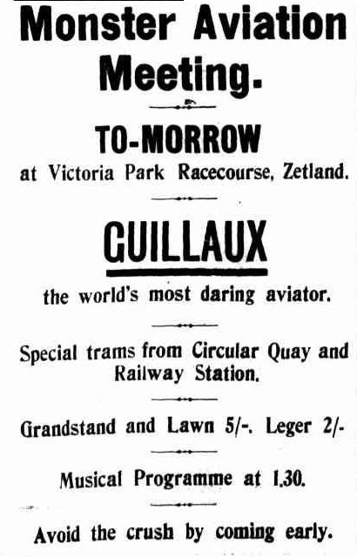
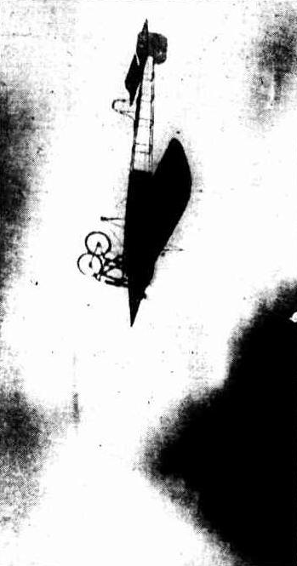
The assembly of the aircraft was a complex operation. We know that Guillaux was very knowledgeable about the aircraft and had a ‘hands-on’ mechanic role. Obviously the task was finished by Monday 21 April, when he gave an exhibition at Victoria Park racecourse, which seems to have been his main base in Sydney at the time. This was given to a small crowd, and was probably mainly a test flight. However, ‘he looped the loop three times in succession, with the utmost ease, and as coolly as though he were lighting a cigarette’, as described by the Herald reporter. In his next flight he went for a tour of Sydney Harbour, flying through the heads. Among those who congratulated him after the flights was W S Hart, a pioneer Australia aviator,
The following Saturday, 25 April, he gave a performance at Newcastle, then returned to Sydney. He flew over Sydney on Friday 1 May, attracting huge interest, and held a well-advertised public performance on Saturday 2 May.
The Sydney Sunday Times described the event:
‘Guillaux was fully 800feet above the earth, and dipping the nose of the monoplane, he MADE A SENSATIONAL DESCENT straight at the Vice-President of the Executive Council (Mr Flowers), the Lord Mayor (Alderman Richards), and a group of pressmen. Mr Flowers looked up, and seeing the monoplane coming towards him at a terrific rate, caught hold of a little boy who accompanied him, and together with the Lord Mayor beat a hasty retreat. Guillaux, however, swerved upward when within 30 or40 feet of the ground, and relieved Mr Flowers' feelings. Climbing steadily, Guillaux circled the course several times. Once, when he was at the southern end, he tilted the machine and rushed downward in a bee-line for the hundreds of people who had congregated on the sandhill there. Most of them thought the airman welcoming to grief there and then, also a number of themselves, for THEY FLED PRECIPITATELY. Guillaux, however, righted the machine within what appeared to be a few feet of the side of the sandhill, and flew away. Setting the nose of the machine upward again, the Frenchman rose until there were fully 1500feet between him and mother earth. He dipped the nose of the machine downward, and descended at a terrific rate of speed, giving one the impression that he was falling. He was too— for several hundred feet — but righted himself again gracefully, and soared aloft.
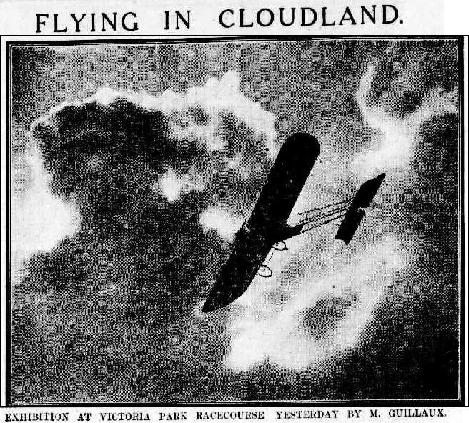
The Frenchman's next feat was what the crowd had been anxiously waiting for — the loop-the-loop, and he executed the dangerous manoeuvre at a height of about 2000 feet, where he was in full view of the spectators. Heading in the direction of the grandstand the little yellow machine suddenly turned a complete somersault. The roar of applause that broke from the crowd was deafening. A second or two later it broke out again as Guillaux looped the loop for the second time.. There were spiral descents, volplanes, banking and fish-like movements until he reached the straight, along which he flew at a RATE OF 71 MILES AN HOUR receiving the plaudits of the spectators. He was smiling when he started on the first aerial journey, and he was smiling when he landed, 25minutes later.
‘........ The second exhibition occupied 30 minutes.......... even more daring than the first, for, besides looping the loop so often that one lost count of the number of times he executed this movement, the Frenchman turned his machine over and flew for a considerable distance upside down — a feat that requires the greatest courage and technical skill.
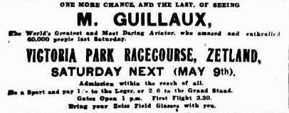
‘At the conclusion of the last flight Guillaux flew along the straight. The machine was below the level of the fence, and as it sped along prior to coming to a halt there was a mighty and unanimous shout of 'Hooray, Guillaux,' which completely drowned 'See the Conquering Hero Comes,' which the band was discoursing. Between his flights Guillaux was presented to the Governor, Sir Gerald Strickland. A leading French lady of Sydney also presented him withal magnificent floral tribute’.
Guillaux and his team were occupied the following week in assembling and flying Lebbeus Hordern’s Farman seaplane, but he returned to Victora Park for another display on May 9. This was advertised as ‘one more chance, and the last of seeing M Guillaux, the world’s most famous and daring aviator, who entertained 60 000 people last week’. The crowd figure might be exaggerated, but an independent estimate of the 9 May attendance was 30 000, and the aerobatics were as spectacular as previously. There was a rather frightening incident: ‘for a time he flow close to the earth. This was the most dangerous, though less spectacular, of all his movements, and was nearly the cause of an abrupt termination to the exhibition. He passed outside the grounds flying so low that the chauffeurs in the waiting motor cars ducked their heads. A sharp turn to the left, and he passed between the grand stand and the leger. ... almost instantly he crashed into the telephone wires drawn tight between the buildings. One wire snapped at the point of impact and fell clear of the machine, but the other broke some distance away and coiled over the right wing as the machine headed for the flat. The wing did not free itself from the wire until the second fence was reached’.
The following week he moved south, giving displays at Wagga Wagga, Albury, Melbourne, Bendigo, Ballarat, Adelaide and Geelong before preparing for the Melbourne-Sydney mail flight early in July.
Moore Park was chosen as the Sydney landing-place for this flight, and the timing – 3pm on Saturday 19 July – was made to suit the convenience of the football crowd and the Governor and other dignitaries, who welcomed him. This was a huge event: an enormous advertising campaign was launched for Liptons Tea and OT juice, whose products were carried on the first flight as Australia’s first air freight.
Another performance was given on 25 July at Newcastle. On his return to Sydney it was advertised that he was going to drop money over the city on behalf of Black and White Whisky, but the authorities banned this activity.
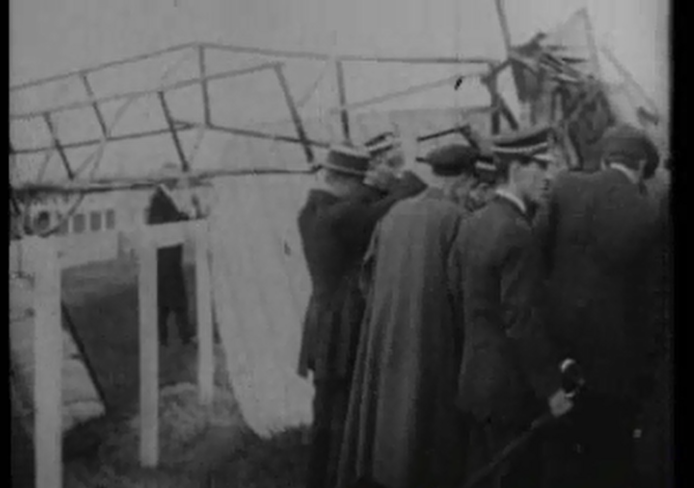
The next performance was held at Ascot racecourse on Saturday 2 August. While flying at an altitude of about 200 feet, the aircraft dropped on one side and crashed to the ground. Guillaux was able to walk away from the badly damaged aircraft, but had bad cuts to the face and head.
Scene from (very rare) film footage of the crash at Ascot.
Thus the Evening News: ‘It was when he was immediately over the grandstand that the accident happened. The centre of all eyes, the Frenchman was noticed to bend forward and touch a lever, and on the Instant the large machine, which was going at a fast rate, turned almost in its own length. ..... and as the aeroplane canted over on its side many shouted out a warning to the intrepid aviator. Evidently he realised the gravity of the occasion, and he bent forward with his hand on one of the levers. It was too late, however, and still travelling fast the machine dipped more and more on its side. The Frenchman was noticed making frantic efforts to right his craft, but turning completely over It swooped like an arrow to the ground.
' There were cries of horror from the crowd, but as the machine neared the earth there was an ominous silence. Women turned away their heads and refused to look, while a large number of the men seemed as if transfixed. Then' It happened. With a crash and a hard thud, the machine struck the ground. That broke the spell. Men rushed to the spot, and thronged round the fallen aeroplane. Guillaux was lying In the midst of the wreckage, still strapped to his seat, but he was bleeding profusely from a deep wound in the head, and blood was streaming down his head and his clothing.......... He was evidently unconscious to what was going on around him, and moaned and chattered in French. Then the work of rescue was begun, but it was not as easy as would appear. The unfortunate man lay entangled in a mass of broken wires and splintered woodwork, but they were gradually cut away. At last, the rescuers were able to reach him and he was carried tenderly out. By this time the whole crowd had thronged round the spot, and as the Frenchman was lifted out they cheered madly. The noise seemed to bring him back to his senses and he struggled weakly on to his feet. This was the signal for the crowd, and cheer after cheering out. Guillaux smiled, but be was scarcely able to stand. He exhibited great self-possession, however, and conversed in a low tone with those around him’.
Fortunately there were doctors present, and Sir Alexander McCormack and Dr O'Gorman Hughes forced their way through. They immediately bandaged the Frenchman as best they could with the means at their disposal. He was severely cut about the heat and lower part or the body, and appeared to be in great pain. He was placed in a waiting motor car and hurried away to St. Vincent's Hospital, the crowd cheering wildly as the machine moved down the ground.
Many theories were advanced as to the cause of the crash, but nothing definite emerged.
Ascot racecourse has long since been absorbed into Kingsford-Smith airport.
By September 12 Guillaux and his machine were fit enough repaired to give a performance at Bathurst. A new Australian managers had appeared, Messrs. MacCallum Bros, and Treacy, represented in Bathurst by Mr R H Treacy.
Guillaux spoke of his earnest desire to return to France, and of the importance that aircraft would have in the war. The description of the display indicated that both Guillaux and his repaired aircraft were on top form, but there was no doubting that the enthusiasm for flying displays was waning, as the war took all people’s attention. Lucien Maistre had already left for France.
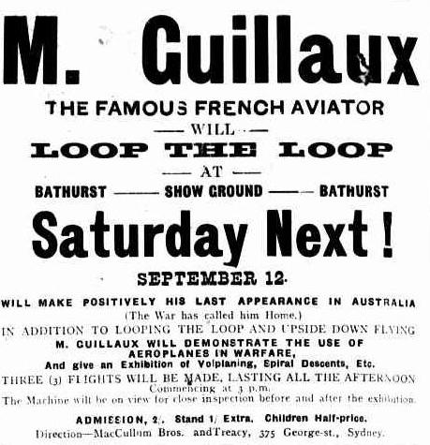
The Bathurst Times reported on a civic reception given by the Bathurst Council. Guillaux was widely praised and through a Mr A McLauglan, described as his business manager, replied to the speeches, saying that Guillaux would shortly leave for France. However, he wanted to return to Australia soon, obviously expecting a short and victorious war.
The time for display flying was over. Guillaux sailed for Europe on 22 October as an aviator attached to 1 Australian Division. He was killed in 1917 while test-flying a new aircraft. He is recorded as a French-Australian casualty of the war on the honour board in the French Consulate in Sydney.
A re-enactment flight will take place in 2014, between Melbourne and Sydney, using a Jabiru, a modern Australian lightweight sports aircraft of similar weight and engine capacity to Guillaux’ Bleriot. The Jabiru will be accompanied by a number of other aircraft and will follow the route pioneered by Guillaux, with major celebrations at each stop. The flight’s conclusion will be the centrepiece of Sydney’s Bastille Day Celebrations.
To find out more,and to buy your unique 2014 postcards go to www.australiasfirstairmail.com .
Send your email address to guiillauxcentenary@gmail.com to receive the latest news on this event. If you have any suggestions, or you would like to help in any way, please email guillauxcentenary@gmail.com

