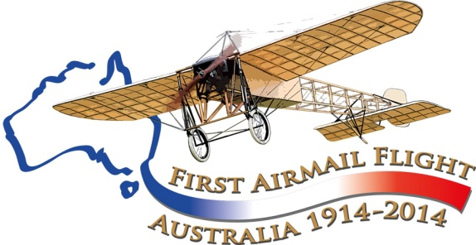

Centenary of the first seaplane flight in Australia…

Rose Bay, 11 May 2014,
seaplane flypast, landing at Rose Bay, 10 am

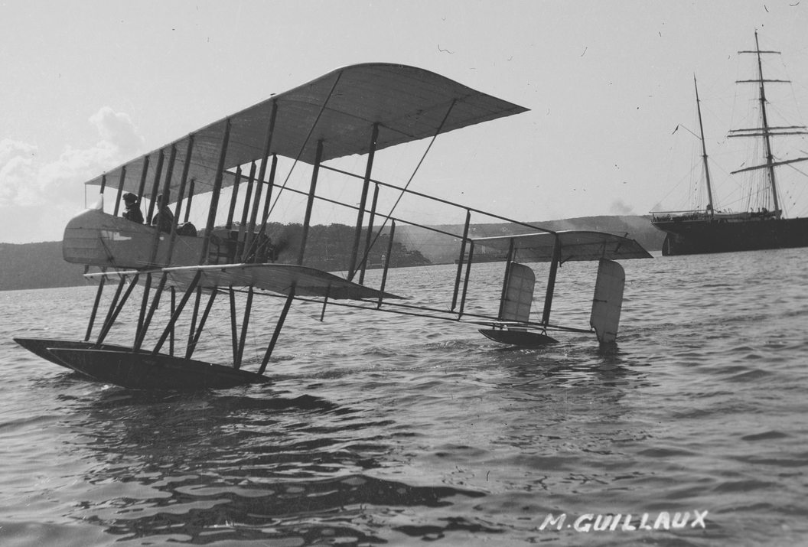8 May 2014 will mark the centenary of the first seaplane flight in Australia.
Picture Sam Hood. State Library of NSW –a128591

Tom Lockley, Co-ordinator
Aviation Historical Society of Australia (NSW) inc
Air Mail Centenary Commemoration Group
To learn more about the Air Mail Centenary commemorations visit www.Australiasfirstairmail.com and send your email address to guillauxcentenary@gmail.com

The event:
The Seaplane Pilots Association of Australia is organising a commemoration of the centenary of the first flight by a seaplane in Australia. On Sunday 11 May there will be a flypast of seaplanes over the harbour and many of the seaplanes will land at Rose Bay about 10 am and stay there for an hour or so. Onshore there will be displays of seaplane memorabilia provided by the SPAA, the Australian Aviation museum at Bankstown, and the Airmail Centenary Commemoration Group. Bring your aviation-minded mum for a fascinating glimpse into the past of this wonderful method of travel!

The history....
Lebbeus Hordern, a member of the wealthy family which owned the Sydney department store Anthony Horderns, imported a Farman seaplane in 1914. It was the first seaplane in Australia. Its 70 horse-power Renault engine enabled a maximum speed of 60 miles-per-hour. Wingspan was about 57 feet, 17.3 metres, it was about 35 feet, 10.6 metres long, and weighed about 1680 pounds, 760 Kilograms. It could carry ‘two seventeen-stone passengers’ or three passengers of lesser weight!
Lebbeus Hordern enlisted the services of the visiting French aviator Maurice Guillaux and his team. They had arrived in Sydney on 4 April 1914, with their Bleriot XI which had been specially prepared for stunt flying, and gave flying exhibitions in Sydney, Melbourne and provincial centres.
Maurice Guillaux flew the Farman for the first time on May 8 1914, as described by the Sydney Morning Herald reporter:
Mechanics moved about in an orderly sort of disorder. Wire stays were tightened, ash props were tested, nuts were screwed up or slackened as required, levels were taken, the great polished propeller was tried. It was a general tuning up of the white-winged flying machine. And over all, Guillaux kept a hawk-like supervision. No detail was too small for his personal attention. At last all was ready.
‘Right to a millimetre’ was Guillaux's comment after he had subjected all to a minute scrutiny……. nothing could be left to chance. Up into the pilot's seat he mounted, the hydro-aeroplane having been wheeled down to the water's edge by many willing hands. Petrol was poured into the tank, and a mechanic, who looked as if he came well up to the 17 stone standard, climbed into the passenger's seat behind Guillaux, a dapper figure in a tweed suit, who made no sartorial preparation for the flight beyond casting aside his Homburg hat.
The mechanic set the propeller whirring at top speed. So strong was the air-current which its revolutions set up, that a shower of sand and hats was blown into the shed behind, small children wore thrown to the ground, and the crowd holding the ‘tail’ were almost forced to let go their hold.'
Guillaux sat himself firmly in his seat, gave the order for release, and immediately afterwards the 'plane was skimming along the waters of Double Bay at breathless speed. For a few hundred yards it rushed along, spurning the water, in a direct line for Clarke Island.
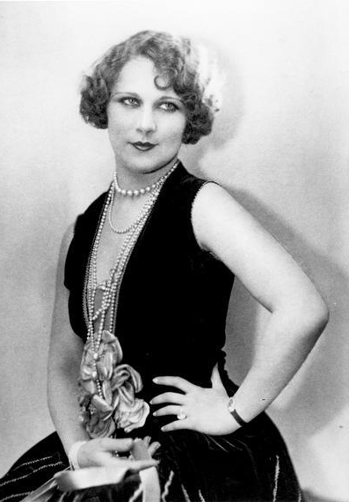
‘There she goes!’ shouted the spectators, as they saw the far-spreading wings lifted slowly into the air. By degrees it rose, like a great bird stretching its pinions for height, and up it soared, its white wings showing clearly against the dark green foliage which clothes the slopes of the opposite shore. Away over towards Mosman it glided, as easily as if it were a bird, and then, with a wide sweep towards the right, it sailed in the direction of Manly. It seemed to soar right over one of the Manly boats, which sounded its siren in salutation. For a few minutes it was lost to view, and then it re- appeared over Point Piper. Right over the heads of the watchers at Double Bay it flew citywards, and after a circular movement, came back to the starting point. Landing on the water some distance out, it made its way to the point of departure, covering the intervening distance at the speed of an express train.
Guillaux then took Lebbeus Hordern for a flight. He came back enraptured. ‘Flying is the sport for me after this’ he said. The next passenger was the French Consul, M. Chayet.
The following Monday Guillaux made twelve flights, On one of these the passenger was Miss Louise Carbasse, then a 19 year-old Australian actress. After the war, she became a well-known Hollywood actress under the name of Louise Lovely. Three days later, in a flight above the harbour, he travelled at over 100 miles an hour, thanks to strong tailwinds.
On 22 May Guillaux and Lebbeus Hordern announced their intention to fly the seaplane from Sydney to Melbourne, but this flight was never attempted. Guillaux also announced his intention to remain permanently in Australia, making his home in Sydney. He had purchased some more aircraft that would arrive in about three months.
During June Guillaux was largely occupied with giving his performances, and then on July 16-18 he made an epic flight in his Bleriot from Melbourne to Sydney, carrying Australia’s first air mail and air freight. This was claimed to be the longest such flight that had been made in the world at the time. Liptons tea and O.T. juice, sponsors of the flight, mounted huge advertising campaigns and the entire population was aware of this great achievement.
Only a fortnight after the epic mail flight, war broke out. This completely dominated the media, and largely for this reason Guillaux’ feat is not widely known. On 5 August the Herald reported Guillaux’ eagerness to return to France. These plans were delayed by a bad crash in his Bleriot, which caused serious injury, and eventually he did sail for Europe on HMAT Orvieto on October 22. He accompanied the Headquarters staff of the First Australian Division, listed as ‘Aviator’, and travelled with an unnamed attendant. He was killed in France on 21 May 1917, while testing a new aircraft.
At the outbreak of war Hordern presented his seaplane to the Australian Government and the aircraft was taken on strength at Point Cook as CFS7, in other words the seventh aircraft, and the first seaplane, of what eventually became the RAAF. Almost immediately it was sent, with a BE2 landplane, to New Guinea on HMAS Una to take part in the capture of German possessions in New Guinea Though it was not used in these operations, this was the first overseas military deployment of an Australian combat aircraft. The aircraft was returned to Point Cook in 1915, but was reconstructed as a landplane. It was still in use in 1917, but its subsequent fate is unknown.
After the war, Lebbeus Hordern continued his interest in marine-type aircraft. In 1920-22 he imported a Felixstowe F3 twin-engined flying-boat, two Curtiss Seagull flying-boats, and a Short Shrimp seaplane, which Captain Frank Hurley used for his New Guinea film Pearls and Savages. The decision to build the Australian seaplane carrier HMAS Albatross, announced in 1925, may well have been influenced by the publicity gained by Hordern’s seaplanes.

