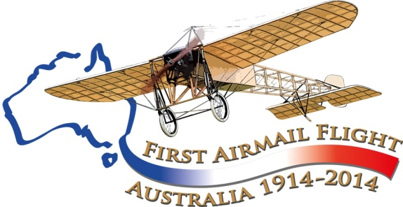

Maurice Guillaux in Newcastle

April 25 1914 was not Anzac Day!
It was the day the first aeroplane gave an aerobatic display over Newcastle
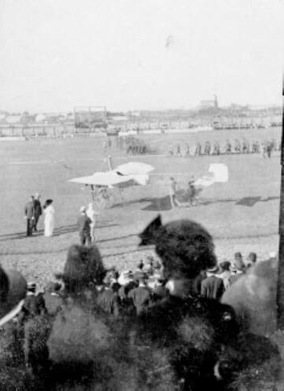
This picture is reproduced by courtesy of the Newcastle Region Library, and depicts the scene at Newcastle Showground on 25 April, 1914.
The French aviator, Maurice Guillaux had arrived in Sydney on 8 April. He and four associates had come to Australia to make money by giving aerial displays with their Bleriot XI aeroplane, and Newcastle was the venue for his second public display in Australia.
Groups of army cadets can be seen in the background, and the group near the aircraft probably includes the Mayor, Mr John Reid, and his wife. The fashionably dressed people in the foreground have probably paid two shillings to sit in the grandstand for the display.
The Australian Aviation Historical Society (NSW) is commemorating the centenary of his visit in 2014 and seeks any further information on his activities. Can you help?
Aviation Historical Society of Australia(NSW)inc
Air Mail Centenary Commemoration Group
In mid-July 1914, French aviator Maurice Guillaux flew from Melbourne to Sydney seated on his Bleriot XI aircraft. The journey took 2 days, 5 hours and 43 minutes, and he carried Australia’s first air mail and air freight). However two weeks later, World War I broke out, and Guillaux’ epic feat was largely lost to historic memory.
The Aviation Historical Society of Australia, NSW (inc) is co-ordinating a re-enactment flight which will occur on 12-14 July next year, and is seeking to gather together the history of his time in Australia.
Guillaux stayed in Australia for only 200 days, and gave flying displays in Newcastle twice, the first visit being April 25. The Sydney Morning Herald of Monday 27 April gave a full report.
The display was scheduled to begin at 3 pm on Saturday 25 April, and from two o’clock onwards there was a long queue of cars, sulkies and buggies entering the gates of the showground. The total crowd was estimated at 6000 to 7000. Weather was ideal: clear skies and a light wind.
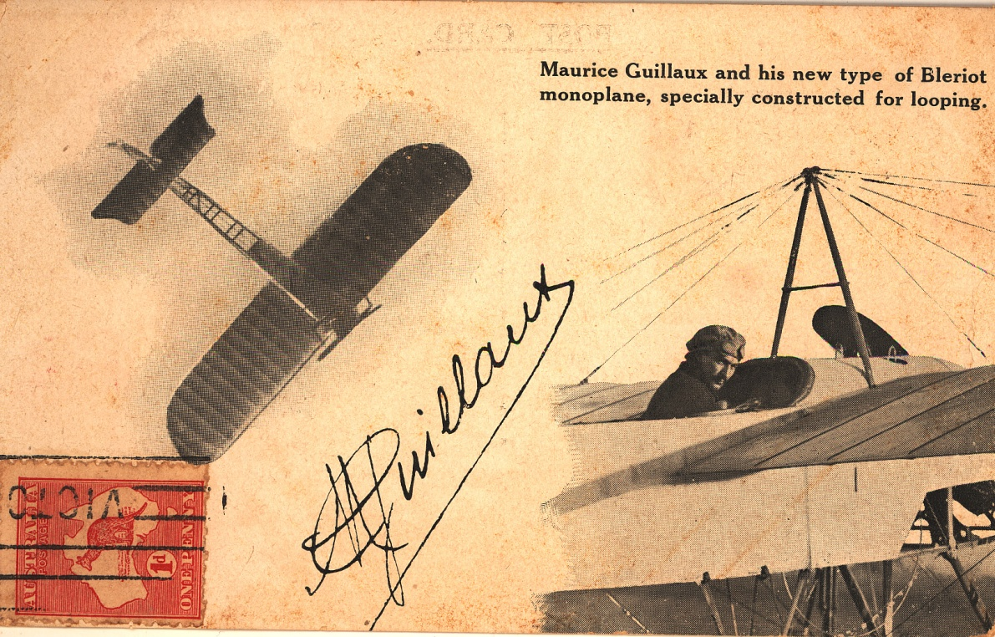
Promptly at 3 pm, Guillaux appeared and as he moved to his aircraft the band played the Marseillaise. He took off and circled the showground, gaining height. He switched his engine off and glided down. According to the report, ‘many people thought that they would be struck by the machine, and they ran in all directions’, but the engine was re-started and waved to the crowd and soared upwards again.
The show consisted of many ‘somersaults’ – which must mean ‘loop-the-loops’, including three consecutive ‘backward somersaults’, outside loops. Perpendicular dives, pulling out at the last possible moment, were regarded as being even more exciting than loops. The crowd cheered enthusiastically.
The first flight lasted 33 minutes.
Guillaux was congratulated by the Mayor, Mr John Reid. Mrs Reid presented him with a red, white and blue scarf and with a horseshoe-shaped bouquet of flowers. Guillaux thanked her, and presented her with a diamond brooch and a rosette. Some minutes after, he took off again.
Groups of cadets were on the ground, present at Guillaux’ invitation. He flew low over their heads, but ‘no disorder prevailed’ even though he was about three feet above their heads. Even more spectacular aerobatics were interspersed with these low runs across the crowd, and the vertical dives and ‘somersaults’ were repeated. A near-collision with a sparrow created merriment.
He then set out towards Stockton, to the north. He flew over the harbour; all the steamers tooted and the men working on the vessels cheered loudly. The French frigate La Bruyere dipped its flag in salute.
The people on the ground watched the aircraft till it was out of sight. It returned at a height of 7000 feet. After another spectacular display of aerobatics, Guillaux landed to the cheers of the crowd and with the band again playing the Marseillaise.
He was interviewed after the flight, probably using the services of his friend Lucien Maistre as interpreter, as he did not speak English. He spoke of the magnificent view of Port Stephens that he had seen. Despite the warm day, at 7000 feet he was very cold. He spoke highly of the warmth of his reception in Newcastle and the number of people attending.
This was actually his first public performance in Australia. He had flown in Sydney on the previous Monday, from Victoria Park racecourse in Zetland, Sydney, where a new housing development is now being built. However entry to this was ‘by invitation only’.
There are a many gaps in our information about Guillaux at Newcastle. The newspaper archives list no advertisements for his show, and usually he charged a shilling or more for entry to the ground from which he flew.
There is a record of A W Jones flying at West Maitland on July 12, 1913. However, when he took off to fly to Newcastle on July 15 he crashed; we do not know if either he or other aircraft flew at Newcastle before Guillaux’ flight.
The photo on the front cover of this brochure is only photo we have found of the event. It will be great if we find out more about his time at Newcastle as a result of interest in the centenary of his visit.
Guillaux moved on to conduct similar displays in Sydney, Wagga Wagga, Albury, Melbourne, Bendigo, Ballarat, Adelaide and Geelong. In Sydney he also became the first person to fly a seaplane, when on 8 May 1914 he flew a Farman ‘hydro-aeroplane’ that had been imported by Mr Lebbeus Hordern of the famous retailing family.
His major feat in Australia was the flight from Melbourne to Sydney on July 16-18 1914, carrying 1785 postcards (Australia’s first airmail) and some Liptons Tea and some O.T. lemon cordial (Australia’s first air freight). This was believed to be the longest such flight that had been undertaken anywhere in the world.
After this, Guillaux made another visit to Newcastle, giving another display on July 25. This did not get as much publicity as the previous visit had generated, but a newspaper report recorded an attendance of about 10 000. At this time the news was being dominated by events in Europe that would shortly lead to the outbreak of World War I.
Guillaux had a bad crash at Victoria Park on August 1, seriously damaging himself and his aircraft. The aircraft was repaired and he gave other displays at Bathurst and Sydney, but on 22 October he sailed back to Europe on a troopship. His wartime career is not well documented, but he was killed in the crash of a new fighter aircraft on 21 May 1917.
Almost uniquely for aircraft of this era, the actual aircraft used by Guillaux was preserved and may be seen hanging from the ceiling at the PowerHouse Museum, Sydney
The Royal Newcastle Aero Club website reports an interesting legacy of his visit. When they began their club in 1928, ‘there was much controversy before the site [for its operations] was selected. Some years ago a visiting French pilot gave a public exhibition of flying, including a death-defying loop the loop from Newcastle Showground. Possibly because of this and the apparent fragility of the vintage aircraft he was flying, public reaction was immediate and hostile with many regarding aircraft as out of this world, strongly opposing the siting of an aerodrome in the city area’.
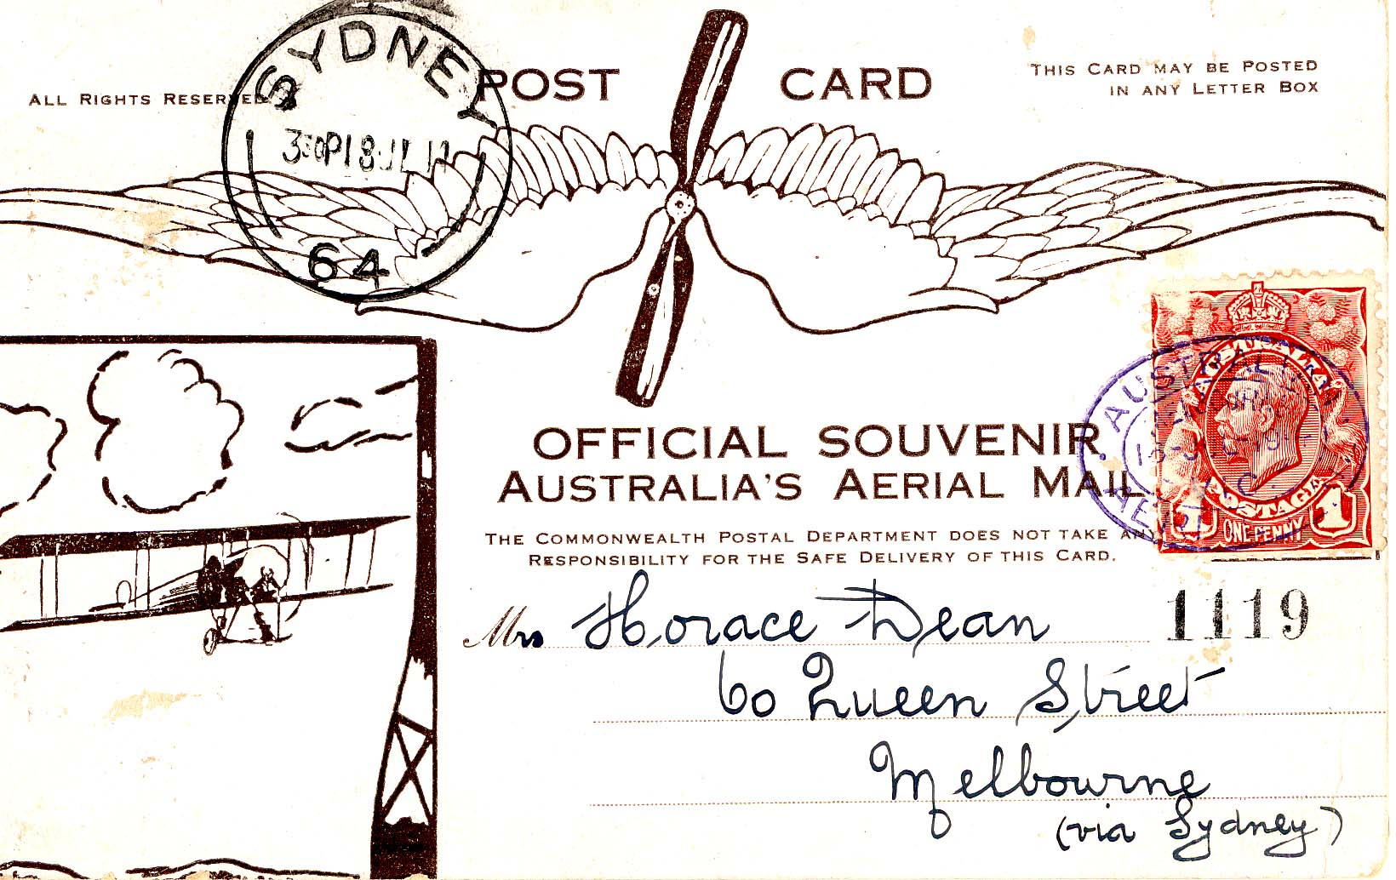
A re-enactment of Guillaux’ mail flight will take place on July 12-14 2014, between Melbourne and Sydney, using a Jabiru, a modern Australian lightweight sports aircraft of similar weight and engine capacity to Guillaux’ Bleriot. It will carry exactly 1785 postcards, the same number as was carried on the original flight and based on the originals. These unique philatelic items can be purchased from the website.
The Jabiru will be accompanied by other aircraft and will follow the route pioneered by Guillaux, with major celebrations at each stop. The flight’s conclusion will be the centrepiece of Sydney’s Bastille Day Celebrations.
To find out more, go to www.australiasfirstairmail.com .
If you have any historical information about Guillaux’ activities in Australia, if you would like to take part in the commemorations, or you would like to help in any way, please email guillauxcentenary@gmail.com .
Tom Lockley, PO Box 301, Pyrmont NSW 2009, co-ordinator 30 March 2012

