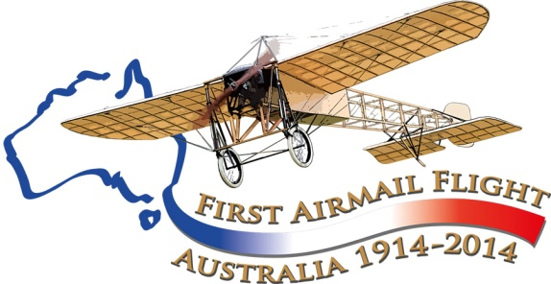

Maurice Guillaux in Albury (and Wagga)

May 16 to 24 and July 16-17 1914
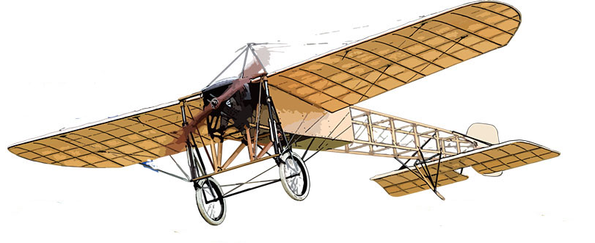
Maurice Guillaux, a famous French aviator, visited both Wagga Wagga and Albury twice – the first time to give aerobatic displays and the second time while carrying Australia’s first air mail and air freight from Melbourne to Sydney – at the time, an epic flight that was of world-wide interest. However two weeks later, World War I broke out, and Guillaux’ epic feat was largely lost to historic memory.

Albury: re-enactment flight Saturday 12 July, Albury Airport from 12 noon:

Watch for further news about this exciting event! There will be many activities at Albury airport: the air mail re-enactment flight is due to arrive at 2:20!
The lead mail-carrying aircraft will be an Australian-designed, Australian made Jabiru aircraft. flown by one of Australia’s best known light aircraft pilots, Albury’s own Father John Fowles.
If your organisation would like to take part, contact Vanessa Williamson, vanessa.w1@bigpond.com .
Albury has a unique tradition of looking after visiting aviators, so please join in!
Aviation Historical Society of Australia(NSW)inc
Air Mail Centenary Commemoration Group
guillauxcentenary@gmail com; mail to PO Box 301, Pyrmont 2009; phone Tom Lockley on 0403 615 134.
Maurice Guillaux left France on a world tour early in 1914 to make money from aerial aerobatic displays. He and his team reached Australia early April 1914.
After assembling his Bleriot XI aircraft, specially designed for aerobatics, he gave performances in Sydney and Newcastle. Guillaux became the first person in Australia to fly a seaplane when he flew a Farman ‘hydro-aeroplane’ on 8 May. For more information visit our website or contact us for more printed material.
We do not have a good photograph of Guillaux, members of his team, or his aircraft, either in Albury or Wagga Wagga. This picture comes from Goulburn. Are there pictures from Wagga and Albury, and can we find them?
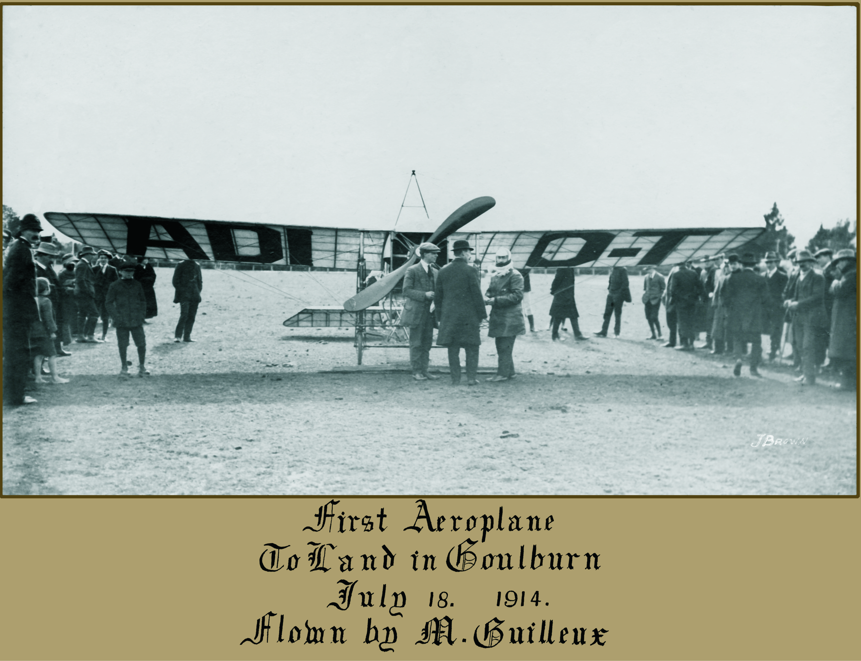

Wagga Wagga: en route to Melbourne,
May 16 to 18 1914
The Urana Independent and Clear Hills Standard gave a full report of Guillaux’ display at Wagga on May 16. Special trains had been run from Junee and Culcairn, and they were both packed with passengers. The paper estimated that 8000 people paid for entry to the racecourse and another two to three thousand people gathered outside. They were thrilled by the daring aerobatics, one of the most spectacular being a vertical dive that pulled out only just above the watching crowd.
Guillaux was assisted by various people. Alderman Albert Sculthorpe of St Kilda was listed as ‘director’ of the organisation. His daughter, Miss Milly Sculthorpe accompanied him.
A Mr Kyrle was listed as ‘manager’ and took ‘living pictures’ for a firm called ‘Panama Expositions’. M Lucien Maistre (translator and ‘manager’) and M Rupeausseu were French, and had come to Australia with Guillaux.
According to the Border Mail of 19 May, on the Saturday evening a ‘picture concert’ was seen in the Masonic Hall. 8000 feet of ‘living Sydney pictures’ were shown by Mr Kyrle.
The Mayoress of Wagga, Mrs McDonough, presented gifts (provided by Huthwaites store) to Guillaux and other members of the group.
Mr Kyrle had taken ‘living pictures’ of Wagga, including some of the aerobatic performance. The film went to Sydney for processing and returned by express train to be shown on the following Monday night. Unfortunately, the National Film and Sound Archive does not have a copy of any such film, and have little knowledge of Mr Kyrle. So far we have found only a few minutes of movie film depicting Guillaux’ activities in Australia.

The Albury event: Saturday 23 May
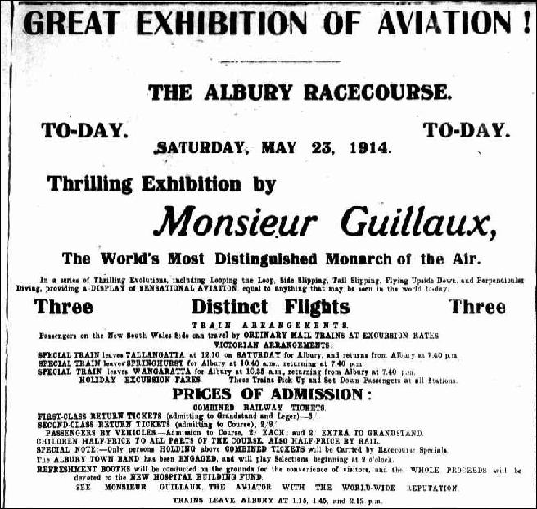
The Border Mail and Riverina Times from 19 May onwards described the preparations and the event. Mr Sculthorpe and Mr Kyrle arrived at the station on the morning express on 18 May, where they were met by Mr Lionel C Griffiths, who, with Alderman Frere was credited with arranging the visit. Alderman Frere was of French origin. For the event the golf club competition was postponed, but shops stayed open with reduced staff. Guillaux’ management offered the refreshment rights to the secretary of the New Hospital Fund; two liquor booth licences were taken out, with ‘arrangements for afternoon tea, etc’. Special trains both from Victoria and New South Wales were organised.
Mr Sculthorpe talked of Guillaux’ achievements including record-breaking long-distance flying in France and flying from Paris to London in a record-breaking 4½ hours, carrying four passengers. His claim to have flown over Mount Blanc at a height of 32 000 feet is not particularly believable! But certainly Guillaux had been very popular – over 120 000 people had seen his Sydney performances and at Wagga 8000 people had paid to see him.
Australian aviator Harry Hawker had visited Wagga the previous March. This had been a sensation: special trains had been run to his performances, but Guillaux’ display was more spectacular. ‘No words can describe what he does and can do. All other aviators pale before him; looping the loop at an altitude of 14 000 feet is mere child’s play to him. He knows no fear and seems bereft of nerves. He back-somersaults in the air, does perpendicular dives, spiral descents, flies upside down (which is more than the winged bird does)’.
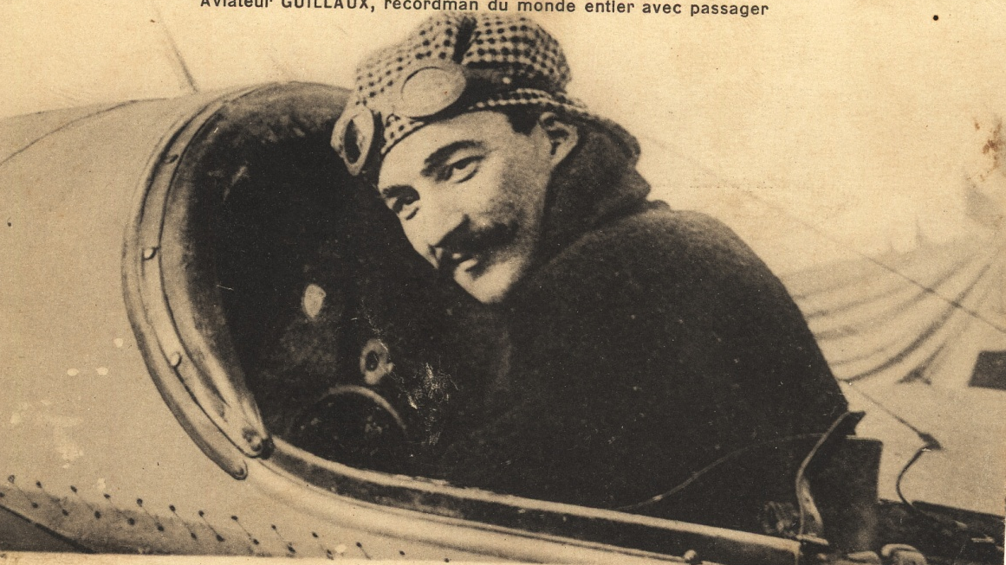
‘Guillaux is master of the air, a conqueror greater than Alexander’. It looked forward to the near future when ‘the Border Mail will reach its big circle of Upper Murray subscribers on the morning of issue and every morning, instead of being blocked by trains which run at infrequent intervals.’
Guillaux was rather short, but apart from that had ‘matinee idol’ looks.....

In Victoria and South Australia....
Guillaux visited Government house, by aircraft, on 28 May, where he was received by the Governor-General, the state Governor, and their wives. He gave a performance in Melbourne on Saturday May 30, then performed at Bendigo, Ballarat, Adelaide and Geelong before returning to Melbourne early in July.

The mail flight
At this time he was contracted to fly the first air mail from Melbourne to Sydney; the promoter Arthur Rickard and engaged the American aviator Wizard Stone to do this, but on June 1 he crashed, and after some negotiation, Guillaux agreed to make the flight.
On July 16 he left Melbourne Showgrounds on his journey. He landed in Sisely’s paddock, Trawool Road, Seymour, then at Jordan’s paddock, Wangaratta.

Albury, 16 July 1914
Guillaux’ aircraft had enough range to fly further than Albury, only about 15 minutes’ flight from Wangaratta. However he wanted to land there again to see his friend Alderman Frere. He landed alongside the judges’ box at the racecourse, which adjoins the present airport, at 12 50 pm. Senior Sergeant Blackburn and his mounted police formed a guard of honour.
Among the notable people who were there to welcome him were the chairman of the racing club Mr E J Belbridge, the secretary of the racing club Mr J Norman Hayn, Mr and Mrs F C Blacklock, Mr and Mrs H M Hassett, Mrs Kennedy and the Misses Kennedy, Mr and Mrs Gibson from Bulgandra station, Miss Thompson, Miss Cox, Miss Kenneally, Mr C J Williamson, Mr and Mrs G S Read, Mr and Mrs Phil Howard, Mr T H Butcher representing the Shell Oil Company of Australia, Mr F Read representing the Dunlop Rubber Company, Mr McLennan, Mr G A Gray JP, Mr J J Mangan, Miss Howe, Miss McLaurin and Ensign Setterfield. The Mayor, Alderman Waugh, welcomed him and called for three hearty cheers, then Alderman Frere took him to lunch.
The Melbourne Truth, a newspaper that was completely devoted to sex and scandal, reported that Guillaux was having an affair with one Bessie Harrigan, who originally came from Albury. Guillaux, so the story goes, met her when she was working at the Paris Cafe, a ‘swell Phillip Street Cafe’ in Sydney. Though the 18 July edition of Truth says that she accompanied the group, she is not mentioned in the local newspaper report!
This was the only stop at which there was no mechanic from Guillaux’ team. Mr Blacklock provided some oil and assisted with the starting of the engine. Guillaux took off at 1 35pm, heading for Wagga. The weather looked unfavourable, and he was anxious to be on the move.
He did fly over the town of Culcairn, 32 miles out from Albury. A hoaxer had phoned the shire office and pretended to be one of Guillaux’ mechanics. He asked if Guillaux could land there, and frantic preparations were made for him to land on the Railway Parade. As he flew over, the local newspaper proprietor waved a piece of red cloth impaled on a pitchfork to attract his attention, but he flew on, much to the town’s disappointment. A similar thing happened at Henty, the next town on the route. A large crowd had gathered at Spencers Hotel, a special mail package had been prepared, and petrol was on hand.

Wagga, 16 July 1914, and afterwards
Guillaux reached Wagga at 2 45 pm, covering the 79 miles, 125 kilometres, in 70 minutes. He was to land at the MTC racecourse. As he approached, he saw a crowded racecourse, and landed in the main straight. However, it was the wrong racecourse, and he had landed, just near the judges’ box, shortly after a race had finished. He quickly flew off to the correct course, where the Mayor, Alderman McDonough and other councillors were waiting to greet him, One of Guillaux’ support team refuelled and serviced the aircraft. The Wagga Express recorded that ‘Sitting in his airship, wearing a comfortable fur-lined leather coat, hooded with a red, white and blue scarf, Monsieur Guillaux wore an expression of excited pleasure and intense satisfaction of his so far successful flight’.
After being delayed a full day at Harden, due to bad weather, he flew on and finally landed in Moore Park, Sydney, at 2 55pm on 18 July. He was greeted by a huge crowd – mainly from the nearby football game – and by the Governor and other dignitaries. The airmail flight was sensational news. Liptons Tea and O.T. juice all mounted huge advertising campaigns.
Guillaux flew at Ascot racecourse, now part of Kingsford-Smith airport, on August 1, but had a serious crash. He was badly injured and the aircraft was considerably damaged. Both were repaired and he conducted a display at Bathurst on 5 September and a final display in Sydney on 12 September. He then returned to Europe and was killed in France in 1917 while testing a new aircraft.
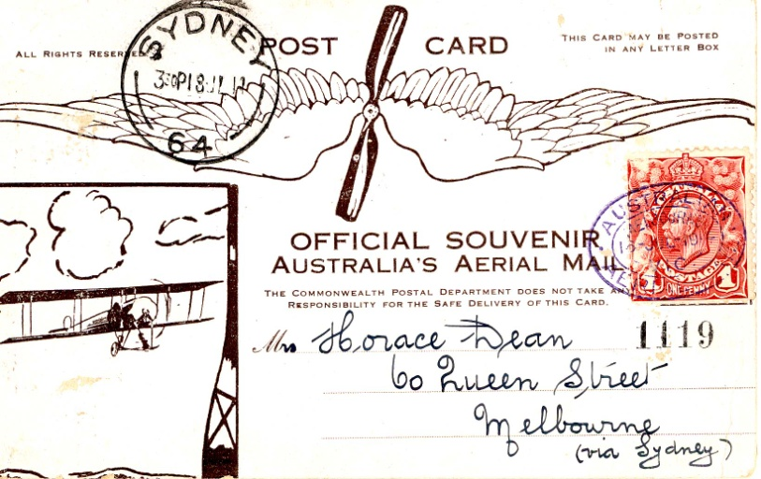
A re-enactment of Guillaux’ mail flight will take place on July 12-14 2014, between Melbourne and Sydney, using a Jabiru, a modern Australian lightweight sports aircraft of similar weight and engine capacity to Guillaux’ Bleriot. It will carry exactly 1785 postcards, the same number as was carried on the original flight and based on the originals. These unique philatelic items can be purchased from the website.
For more information: www.australiasfirstairmail.com
Email guillauxcentenary@gmail.com to go on the mailing list!

