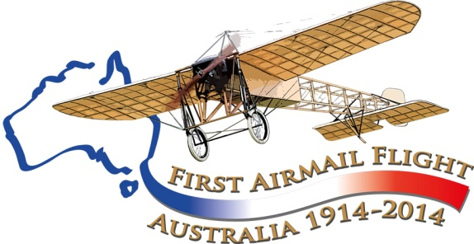

Maurice Guillaux in Bendigo and Ballarat

June 7 to June 13, 1914
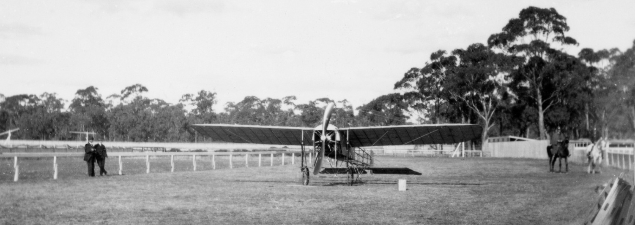
This wonderful picture, from the collection of Kevin O’Reilly, shows the Bleriot on the ground at Bendigo racecourse. It was taken on June 8, 1914, by local doctor Ken Skues.

Never heard of Maurice Guillaux?
The French aviator Maurice Guillaux spent less than 200 days in Australia, April-October 1914, but had a great influence on Australian aviation. His Bleriot XI aircraft was specially modified for aerobatics, and he gave spectacular aerobatic performances in Sydney, Newcastle, Wagga Wagga, Albury, Melbourne, Bendigo, (Monday 8 June, King’s Birthday holiday) Ballarat (the following Saturday), Adelaide, Geelong and Bathurst.
On Tuesday 9 June he flew his aircraft from Bendigo to Ballarat. This was the first time he had flown his aircraft from one engagement to the next, and was a sensational flight for the time. He actually carried some private mail, which many people regard as Australia’s very first air mail, but all has been lost except one postcard, described below.
His major feat occurred on 16 to 18 July when he flew from Melbourne to Sydney. The journey took 2 days, 5 hours and 43 minutes, and he carried Australia’s first air mail and air freight. However two weeks later, World War I broke out, and Guillaux’ epic journey was largely lost to historic memory.

The Aviation Historical Society of Australia, NSW (inc) is co-ordinating a re-enactment flight which will occur on 12-14 July 2014. Now read on....

Guillaux in Bendigo
Mr Alan Sculthorpe, an Australian from Melbourne, was involved in the negotiations for the performances in Bendigo and Ballarat. He was a former tailor who had become an entrepreneur and also became Mayor of St Kilda, Melbourne. He arrived in Bendigo on 4 June.
Bendigo was not going to stop everything for Guillaux’ performance. A time had to be negotiated so as not to clash with the football: two metropolitan teams were scheduled to play on the Kings Birthday holiday, and Mr Sculthorpe negotiated with the secretary of the jockey club, Mr R N Putnam, and the president and secretary of the football club, Dr Walsh and Mr Bennet respectively. Guillaux could perform at the nearby racecourse, but before the football game. There was considerable criticism of this in the local papers: people could see football every week, but had only one chance to see the flight.
Guillaux was in Sydney on Friday 5 June, flying Lebbeus’ Hordern’s ‘hydro-aeroplane’, but left that night for Bendigo.
His performance in Bendigo was on Monday 8 June, the King’s Birthday holiday. He stayed at the Shamrock Hotel, which is still standing: his team consisted of Francois Rupeausseu (sometimes listed as manager) Lucien Maistre (assistant manager who acted as translator for Guillaux) and an M Pivot, listed as mechanic. Special trams ran from Bendigo to the Epsom racecourse and the Hopetoun band played. Two shillings was charged for entry to the ground, and an extra two shillings for entry to the grandstand. From the Ballarat Courier:
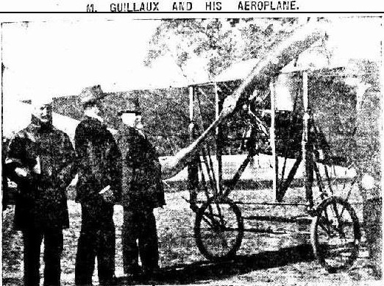
‘He started easily...... for a few seconds after power .had been applied to the engine his two French mechanics held desperately on to stays at the rear or tail of the machine. The machine had only run about 70 yards along the ground on its small pneumatic-tyred wheels, when it rose and soared away to the north-east like a beautiful bird. Rising to a height of about 1000 ft, the aviator made some graceful figures, every now and then coming close to his paying patrons. When the machine was between the eyes of the spectators and .the sun, the effect was spectacular, the machine being like a transparent butterfly. In playful spirit, M Guillaux would descend within almost a few feet of the heads of the crowd to their momentary consternation, but would relieve their apprehension by starting another climb. The monoplane would then appear to be making laboriously up a steep incline, yet it was rushing onwards and upwards at the rate of a mile a minute. When at a safe altitude, the headlong falling and tumbling would start, and the thrilling feats of looping the loop were all in motion. Of a sudden the engine would cease throbbing, and the machine would fall to one side and the other and then head downwards, as a bird shot in the air. No cage descended a mine shaft at the speed with which the monoplane was dropping, and it would not have been many seconds before reaching earth and disaster had not M. Guillaux righted it by applying power to the engine. By this time the crowd would have recovered from their suspense and the aviator would be gliding away or making beautiful curves amid the plaudits of his admirers. In looping the loop, for an instant the aviator flies upside down, but with his head toward the inside of the curve. It was in the second flight that the most daring perpendicular diving and spiral falls were seen, and with the stays of the machine glistening in the sunlight the sight was most impressive. Before alighting he raced along the straight in the course, but faster than the speed with which any Sandhurst Cup had been won.
Guillaux with (L to R) Mr S Lazarus, president of the Bendigo Jockey Club, Councillor R H S Abbott and Mr R Putnam secretary of the Jockey Club.
In the evening he attended Mr George Coates’ movie performances at the New Princess Theatre.

Bendigo to Ballarat
On Tuesday 9 June 1914, Guillaux flew from Bendigo to Ballarat. This in itself was a very rare event: the aircraft was typically moved from town to town by train. The newspapers publicised the route that would be followed and reported on it in detail. He climbed to a high level at the beginningof the flight. He claimed to have reached 12 000 feet above Bendgo, and to have descended to 10 000 feet over Castlemaine, enduring temperatures of 16 degrees below zero. The Elphinstone News column in the Kyneton Guradian reported that the birds were terrified of the aircraft, ‘magpies bythe score could be seen and heard flying away as fast as their wings could carry them’. They could clearly hear the aircraft as it passed over Castlemaine.
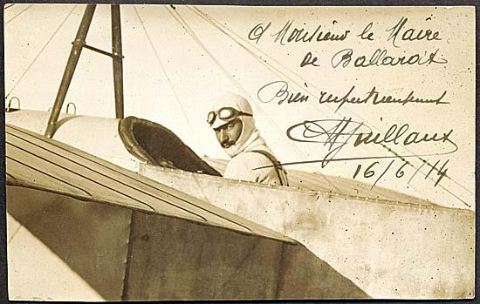
On arrival at Ballarat, he handed to the Mayor, Councillor Brokenshire, a letter from Councillor Andrew, the Mayor of Bendigo. Guillaux was also greeted by the City Clerk, Colonel R E Williams, Mr H Turnover, and Mr Gordon Chirmside, and he had a letter for Miss Bell, the daughter of Coucillor Bell.
Guillaux gave out a number of signed postcards, but only one of these is known to exist. It was re-sold in 2008 for $35 000.

The Ballarat Performance
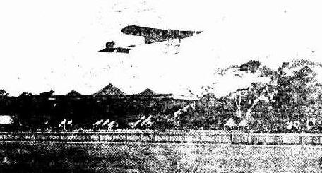
A band was in place to entertain those who came before the flying display began at 3pm, and indeed people began arriving early in the afternoon. The Ballarat Courier reporter said that thousands of people stood on the mullock heaps adjoining the racecourse, and during the performance Guillaux ‘caused excitement by diving towards one mullock heap [which was] crowded with people, and as M Guillaux approached, the crowd stampeded in all directions, fearing that the aviator was going to sweep them off. When about 20 or 30 feet away, Guillaux deftly righted the machine and continued his flight’. The Dalesford Advocate reporter said that ‘one portly individual who attempted to run down the heap fell down and rolled to the bottom. In the rush to get away from their seemingly safe position, two women and several children fainted, but they soon recovered. The mullock heap crowd will not quickly forget Guillaux’ visit to Ballarat’. Guillaux made three flights, the second being cut short by failure of a spark plug. But in the third flight, ‘there was more sensation, head-diving, turning on the side, and upside-down flying and upside-down flying, and this time a much higher altitude had been reached. Up and up the machine climbed, and suddenly it grew greyer and less distinct, and the onlookers realised that it had entered the clouds. Seven thousand five hundred feet, or so Guillaux estimated the height. It was getting late by the time the exhibition closed, but all waited to see the end of it, and went away more impressed than ever with the possibilities of aviation’. In Ballarat the football game occurred at the same time as the flight demonstration; crowds were small at the football, with many people distracted by the presence of the aircraft nearby.
After the show he stayed with Mr Gordon Chirnside at Carranballac.
While loading the aircraft on the train at Ballarat Guillaux and Repusseau lost £206 which was taken from a coat left temporarily on a fence. This included a cheque written by Mr A Sculthorpe for £146, in favour of Mr Turnover, of Pathe’s Pictures.
The next performance was given in Adelaide, on 20 June.
For more information visit
www.australiasfirstairmail.com
and send your email address to
guillauxcentenary@gmail.com

