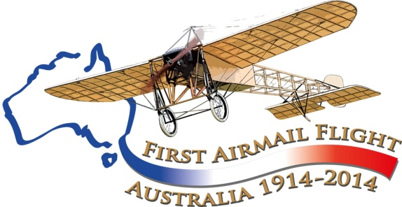

Maurice Guillaux and Adelaide

June 1914
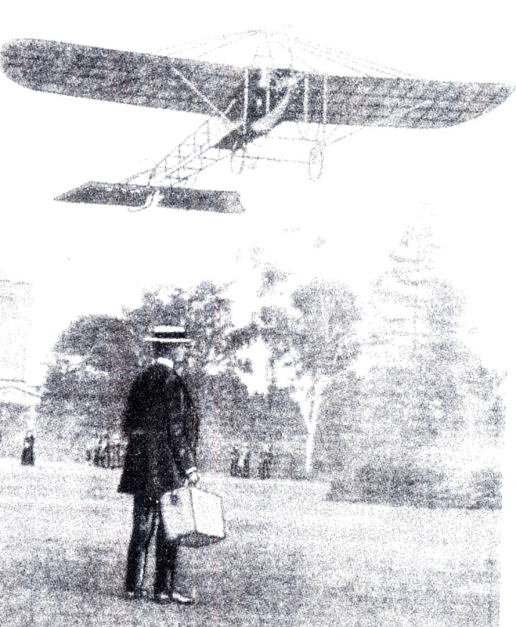
Frame from a 1914 newsreel movie: Maurice Guillaux taking off from the grounds of Government House, Melbourne, 28 May 1914

Never heard of Maurice Guillaux?
The French aviator Maurice Guillaux spent less than 200 days in Australia, April-October 1914, but had a great influence on Australian aviation.
His Bleriot XI aircraft was specially modified for aerobatics, and he gave spectacular aerobatic performances in Sydney, Newcastle, Wagga Wagga, Albury, Melbourne, Bendigo, Ballarat, Adelaide, Geelong and Bathurst. He was the first person in Australia to fly a seaplane in Australia when he flew Lebbeus Hordern’s Farman ‘hydro-aeroplane’ at Double Bay, Sydney, 8 May, 1914.
He made several record-breaking flights, but his major feat occurred on 16 to 18 July when he flew from Melbourne to Sydney. The journey took 2 days, 5 hours and 43 minutes, and he carried Australia’s first air mail and air freight). However two weeks later, World War I broke out, and Guillaux’ epic feat was largely lost to historic memory.
The Aviation Historical Society of Australia, NSW (inc) is co-ordinating a re-enactment flight which will occur on 12-14 July this year. Now read on....
Aviation Historical Society of Australia (NSW) inc
Air Mail Centenary Commemoration Group
On 8 June 1914 the Adelaide Advertiser reported the imminent visit of Guillaux, but not very enthusiastically. They had already seen A W Jones fly in that city, though Guillaux had some interesting new tricks.
Guillaux was interviewed on 16 June at the Grand Central Hotel, Adelaide – which, incidentally has since been demolished to make way for a car park. He told of his exploits in France, and of his long and safe career, including 100 flights in Australia.
On Friday 19 June he flew over Adelaide, creating the usual high degree of interest, with a few aerobatics to whet the people’s appetite for the next day’s event at Cheltenham racecourse. On Saturday 20 June, according to the Advertiser, ‘The large number of people who patronised the ground and Derby stands, the big crowd who paid for admittance to the flat, and the still larger concourse of spectators who did not pay, but watched the aviator in the air from points of vantage outside the course, bore testimony to the curiosity which the Frenchman’s visit had aroused’. One of the freeloaders was so impressed by the show that he later sent in a shilling to be given to the aviator. The Herald estimated the crowd at 15 000.
The Railways Brass Band provided musical selections. 'The Governor, Sir Henry Galway and Lady Galway arrived at the course by motor car shortly before 3 pm. M Guillaux was introduced to them by Mr J W Canaway, the French Consul. Lady Galway, who could speak French fluently, enjoyed a few minutes' conversation with the aviator’.
Guillaux personally inspected his aircraft carefully, and donned his leather coat and hat. The engine was started, as two attendants held down the tail. ‘The biplane (sic) was guided upward as if ascending a spiral staircase. When a good height had been attained, M. Guillaux stopped the engine and caused his machine to dip in such a startling way as to suggest to the uninitiated that he was about to crash to the ground. He speedily rose again from the drop and circled round side-slipping and dipping as before. Each time he reached higher altitudes by a series of graceful circling movements suggesting to the mind the flight of gulls above the crest of storm-tossed water...... Rising to about 3,000 or 4,000 ft he looped the loop-a thrilling feat, which must be seen to be fully appreciated, and he did it with an ease that astonished the spectators.. Having remained in the air about 20 minutes he descended to the ground by a graceful volplane. As his machine alighted virtually in the same spot from which it had arisen, the big crowd surged round him and cheered lustily’.
At about 4 pm he made a second -flight. This time he flew over the city and the southern suburbs. and returned to a great reception from the crowd.
The spectators at the West Adelaide and Norwood at the Jubilee Oval were delighted when Guillaux flew over the ground at half-time. The umpire, Mr Abernethy, was not popular when, ‘with insistent whistle, he, commanded players to resume while the airship was still in sight. The game was continued but for a space the crowd were quite unconscious of what was going on, on terra, firma. They had a-loftier ideal than football just then, and not being able to watch at once both players and airman, they forgot their allegiance to the national pastime and ignored the football’ (Advertiser). According to the Adelaide Register the flight had been pre-arranged with one Mr T Pope of Glen Ormond, who had persuaded Guillaux to fly over his home ‘Sunnyside’ where he was holding a party with 300 guests. He also flew over a parade of the 74th Regiment of army cadets at Unley, and the boys greeted him with a huge cheer.
He returned to Cheltenham, gave another aerobatic display, and landed to the cheers of the crowd. His aircraft, which attracted a lot of attention, was guarded by mounted troopers until it was dismantled for the trip back to Melbourne.
The following Monday evening Guillaux’ party, and their aircraft, left for Geelong where the next performance was due.
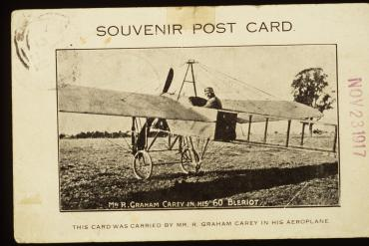
There was an interesting postscript to this visit. The Bleriot aircraft in which Guillaux flew was purchased in January 1916 by Graham Carey, a remarkable Australian businessman, Aged 41 at the time, Carey had made a career in the transport business, and by 1912 was a prominent motor-car dealer in Ballarat. When he was rejected for active service, he acquired the Bleriot, which had been left behind by Guillaux. He learnt to fly the aircraft, and flew at various displays during the last months of the year 1916. One such display was in Adelaide on 27 October 1916, dropping Enlistment and War Loan leaflets over the city ad performing for the Army Nurses day.
He flew South Australia’s first airmail from Adelaide to Gawler on 23 November 1917, again in the Bleriot. After the war he bought a number of other aircraft. His story is told in A Message from the Clouds, by Des Martin and Bertha Carey.
The Bleriot was seldom used after 1917, probably because of a shortage of spare parts. Carey eventually sold the Bleriot to K J Chaffey of Deniliquin. It was seldom, if ever, used and in December 1925 it was sold, for £25. Later it was acquired by the Sydney Technological Museum. It was restored mainly by students of the aircraft Engineering School, Sydney, and put on display at Mascot airport for the 1964 airmail flight re-enactment. It remains on display at the PowerHouse Museum, Sydney,
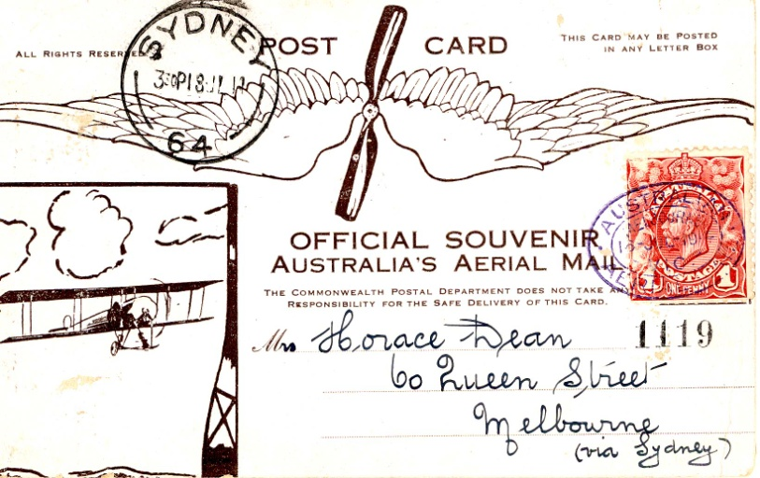
A re-enactment of Guillaux’ mail flight will take place on July 12-14 2014, between Melbourne and Sydney, using a Jabiru, a modern Australian lightweight sports aircraft of similar weight and engine capacity to Guillaux’ Bleriot. It will carry exactly 1785 postcards, the same number as was carried on the original flight and based on the originals. These unique philatelic items can be purchased from the website.
The Jabiru will be accompanied by other aircraft and will follow the route pioneered by Guillaux, with major celebrations at each stop. The flight’s conclusion will be the centrepiece of Sydney’s Bastille Day Celebrations.
To find out more, go to www.australiasfirstairmail.com .
Do you have any historical information about Guillaux’ activities in Australia? We would like to take advantage of the Centenary to collect all this material. We have not been able to locate any photographs from his Adelaide display.
Are you a light aircraft owner who would like to join the flight?
If you would like to take part in the commemorations, or you would like to help in any way, please email guillauxcentenary@gmail.com .
Tom Lockley, PO Box 301, Pyrmont NSW 2009, co-ordinator, 0403 615134,

