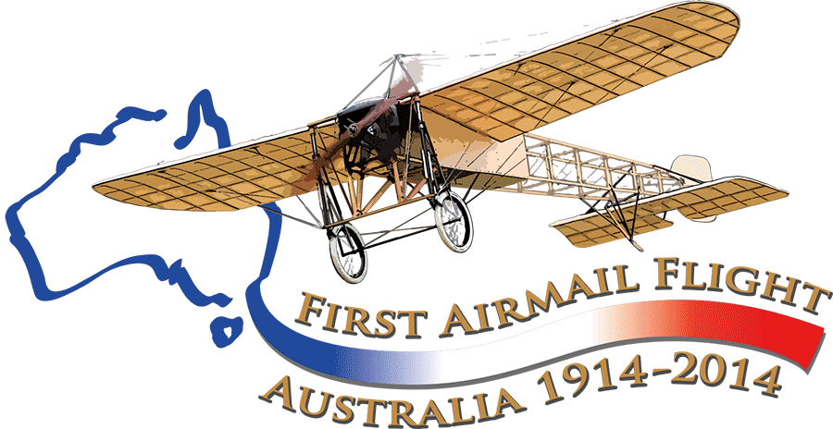
Stamp collectors, aviation history addicts....

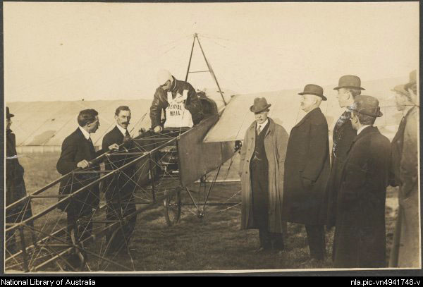An opportunity not to be missed!
July 1914: the French aviator Maurice Guillaux carried 1785 specially prepared and numbered postcards from Melbourne to Sydney, taking 2 days 5 hours and 43 minutes. This year, we are co-ordinating a major re-enactment flight: 1785 numbered postcards, based on the originals, will be carried. Read on to find out how to secure these valuable items!

Aviation Historical Society of Australia (NSW) inc
Air Mail Centenary Commemoration Group

The original flight, 16-18 July 2014
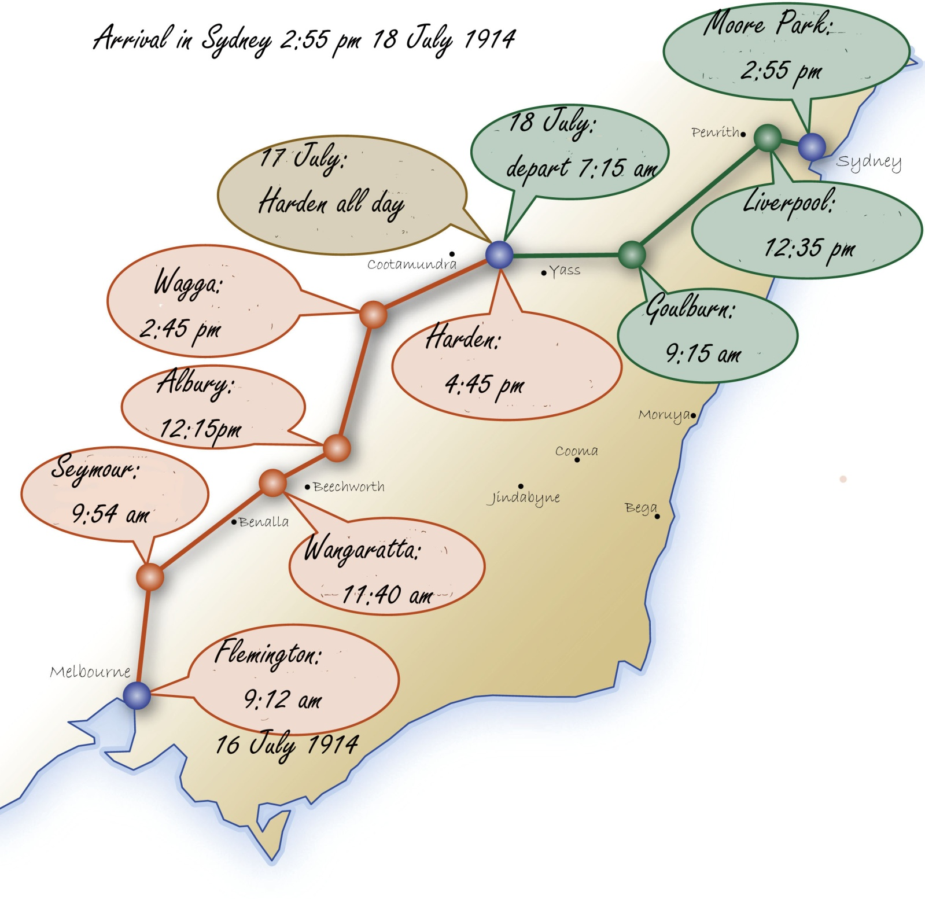
Maurice Guillaux spent fewer than 200 days in Australia in 1914. He gave air displays of amazing aerobatics in Sydney, Newcastle, Wagga Wagga, Albury, Melbourne, Bendigo, Ballarat, Adelaide and Bathurst. He was the first person in Australia to fly a seaplane.
But he is mainly remembered for his mail flight, as above. It was an epic feat: it was claimed as the longest such flight in the world at that time.
His flight occurred just before the start of World War I and so his epic feat was largely lost to historic memory.

How to buy your postcards

Buy online at www.australiasfirstairmail.com - pay by credit card or PayPal, (bank deposit or cheque payment is available – email guillauxcentenaryphilately@gmail.com for details).
Commemorative stamps are being issued by Australia Post on 1 July so we have to sell the cards in advance. You can choose from the ‘standard’ card ($30) with the 70c denomination stamp or the $35 ‘premium’ card with the 70c stamp and the $2.60. Website purchasers can select the number they prefer.
There will be no extra charge if stamp prices rise before the commemorative stamps are issued. You will be able to print off your purchase details and will also receive by post a Certificate of Purchase. On 18 July, the exact anniversary of the conclusion of Guillaux’ flight your card will be sent by registered mail to the address you provided.

Buy now: get your choice of low numbers and assist the re-enactment!

Any questions? Visit our website www.australiasfirstairmail.com or email guillauxcentenaryphilately@gmail.com .

Christine Ewoldt, manager, philately
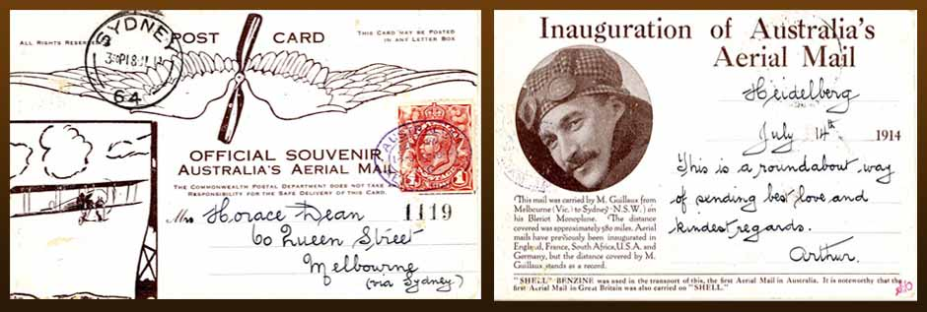
Original card carried on the 1914 flight. Ours is very similar: we alter the small print to reflect the present flight and instead of Inauguration of Australia’s Aerial Mail we have Re-enactment of Australia’s Aerial Mail, with the date 2014.

The 2014 re-enactment 12-14 July 2014
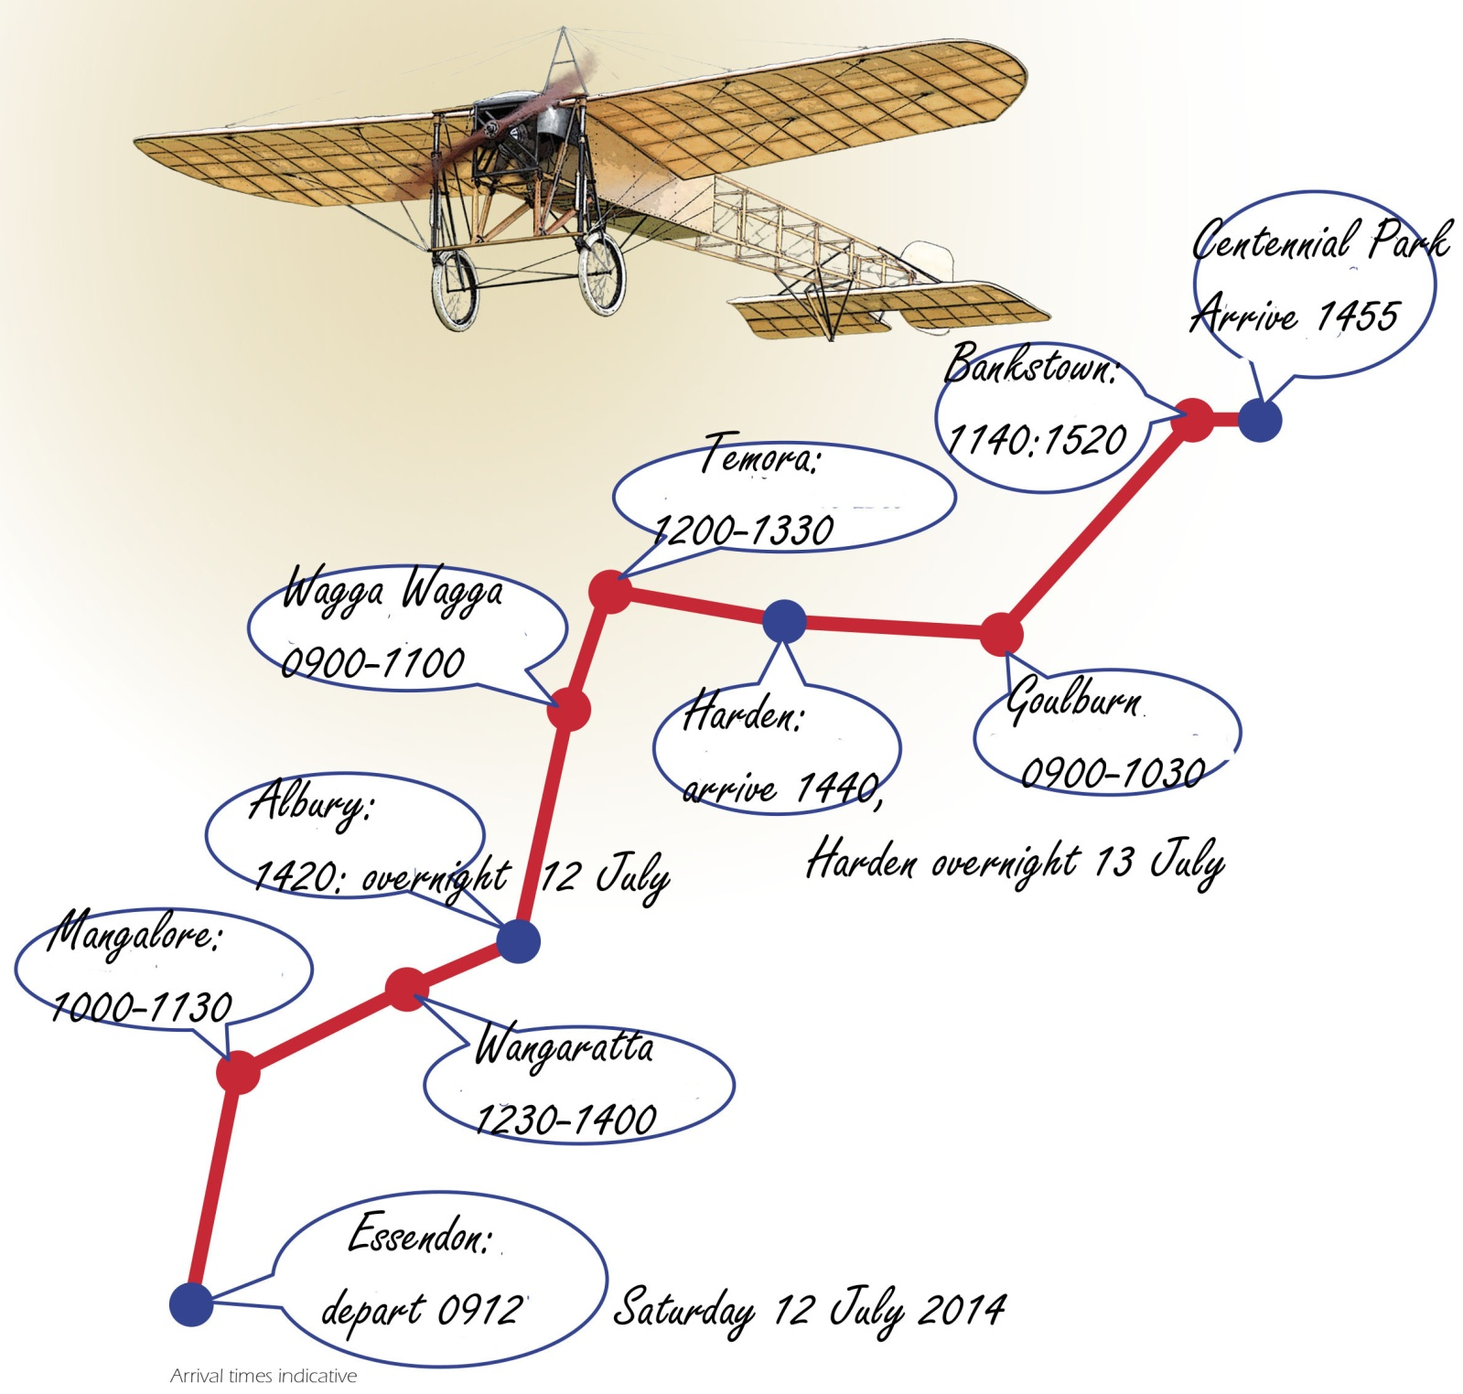
We are using a Jabiru aircraft (Australian-designed, Australian built) as our lead aircraft. It is a lightweight sports aircraft, of similar weight and engine capacity to the Bleriot. It will be flown by John Fowles, from Albury, who is one of the most experienced Jabiru pilots in Australia. It will be escorted by an all-weather aircraft that can take over the carriage of the mail for a few stops if necessary because of bad weather.
The arrival of the mail will be a central feature of the Bastille Day celebrations, conducted by the French community in Australia, to be held at the Parade Grounds, Centennial Park, on Bastille Day, Monday July 14. On July 18, the centenary of the arrival of the original flight in Sydney, your postcards will be backstamped and mailed to you by registered post.

