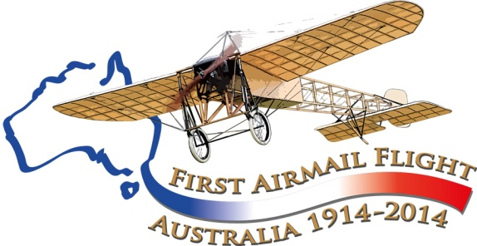

Maurice Guillaux and the miltiary
In the years before World War I there was considerable early support for military aviation in France: the country was still resentful of its loss to Germany in the Franco-Prussian War of 1870 and there was enthusiasm for new military devices such as the aeroplane so that they could turn the tables on Germany in the war that most people expected. The Aéronautique Militaire was created, as a branch of the Army, on 22 October 1910, and in mid-1911 the first military aviation brevets were awarded to army pilots. On 29 March 1912 the Aéronautique Militaire formally became part of the armed forces.
Guillaux took up flying in about 1911. There is a report that he had his own aircraft, in which he gave flying displays, charging one sou – five centimes, for entry to the display area. But there is no offical record of his flying activities until he was awarded pilot’s licence no 749 on 19 February 1912.
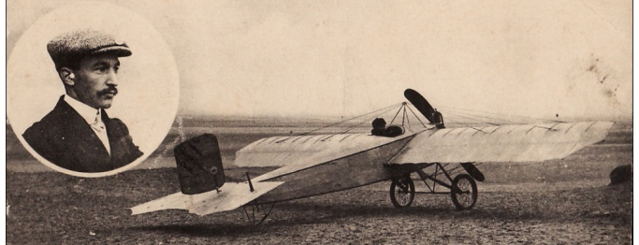
At the time it was thought that the main military use for an aeroplane would be for reconnaisance, and the miltiary authorities wanted proof that a pilot could navigate to a point. He gained his second class military licence on 9 October 1912 by flying from the Paris suburb of Issy to his home town Montoire, about 30 km west, returning the next day. He gained the highest possible military licence in December 1912 with a longer flight, Issy /Chartres / Orleans / Issy, in a total time of 4 hours 28 minutes including landings. The distance was about 200 kilometres. This was the only mention of military flying in his career until he reached Australia. He and his aircraft (an ‘all metal’ Caudron monoplane) were famous; the picture comes from a contemporary postcard.
Early in 1914 he left France and by April was in Australia. He gave his first interview to the Australian press when his ship docked at Fremantle on 3 April and stated that the French were well ahead of the Germans in developing the miltiary use of aircraft, and this was indeed true.
Aviation Historical Society of Australia(NSW)inc
Air Mail Centenary Commemoration Group
Website: www.australiasfirstairmail.com
In his display at Newcastle, on 25 April 1914, he gave two exhibition flights. The first was an aerobatic display close to the showground, and in the second he flew off into the distance about 5 to 7 miles from the showground. This was explained as a demonstration of the ability of the aircraft to carry out reconnaisance ‘for naval and military purposes’. On his return he gave another aerobatic display close to the showground.
The Newcastle Herald regarded this display as ‘a lesson to Australia’. ‘It took little exercise of the inagination to realise what such a man and such a machine could do in time of war. The military use of aeroplanes was demonstrated durlng the Balkan war, andthey are certain to become part of the permanent equipment of every force in the field’. The article went on to be very critical of the delay in properly establishing the training facilty at Point Cook.
This was fairly typical of the sort of incidental comment in the media that was made as a result of his spectacular and hugely popular aerobatic exhibitions.
On 8 May the Sydney Herald published a long interview in which Guillaux made several points. France had about 400 military aircraft. Monoplane scouts could direct artillery fire by radio-telegraph, biplanes could be armed with bombs and quick-firing weapons for ground attacks on soldiers and on such things as bridges. Airships were vulnerable, but could be used at night. France dominated the supply of aircraft and engines everywhere except in Germany, where a big build-up was in progress. Seaplanes (‘hydro-aeroplanes’) were slower than landplanes, but were especially useful in Australia where there were few landing fields. Aircraft were hard to shoot down when at high altitude.
This article was widely printed in other newspapers.
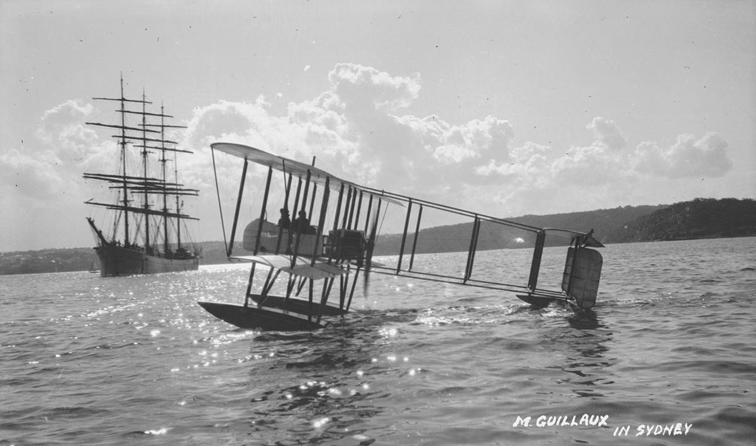
On this day he flew Lebbeus Hordern’s seaplane (left) for the first time. He took up a Herald correspondent who noted the vulnerabilty to air attack of the ships below. Another early passenger was Commander Robins, the governor’s aide-de-camp, who also reported on the possible military uses of aircraft.
On 13 May Guillaux was a guest at a meeting of the Aerial League, whose main aim was to secure the establishment of a strong military air force. He was praised in welcome addresses, but if the League expected strong support from him they were to be disappointed: he had little English, and all he said in reply was ‘Thank you’.

There was a general increase in discussion of the future of aircraft at this time. In Le Courrier Australien, the Sydney newspaper for the French community, on 20 May 1914, printed one of its longest articles ever in reporting a speech by Lieutenant-Colonel Paul Reynard, in which he forecast the military and civil use of large aircraft, along the lines of Sikorsky’s ‘Giant’. This was an enlarged and unsuccessful version of Sikorsky’s Ilya Muromets, a Russian aircraft which was by far the most advanced large aircraft of the time.
On 28 May, he landed in the grounds of the residence of the Governor-General, in Melbourne; Canberra was still a long way in the future. The Governor-General, Sir Ronald Munro Ferguson, Lady Helen Munro Ferguson, the Governor of Victoria, Sir Arthur Stanley, and his wife were also present. Lady Stanley conversed with Guillaux in French. The machine was carefully inspected – Lady Stanley calling for a chair upon which she stood to get a better view of the controls.
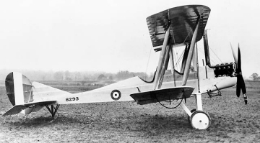
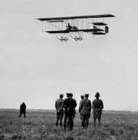
Guillaux performed an aerobatic show, and then returned to his base, the Flemington showground, where he was congratulated by Lieutenant Harrison, of the Aviation Corps. The following day, obviously at Harrison’s invitation, Guillaux visited Point Cook, where the first military flying school in Australia had commenced operations on 1 March 1914. The Argus reports that Guillaux had no problems in flying to Point Cook, but his mechanic, travelling by car, became lost and bogged en route. Guillaux gave a flying display and also rode in one of the Point Cook aircraft over the Point Cook area. Point Cook had two Deperdussin single seater monoplanes (later used only for training in taxying), one Bristol Boxkite two-seater with a maximum speed of 40 mph, 62 km/hr (left) and two BE2a two-seater aircraft (right) which could reach about 70 mph, 110 km/hr. His Bleriot was far more agile than these. He congratulated the government on its establishment of the base and gave his opinion that Point Cook was an excellent site for the purpose. His praise was very tactful: the aviation community was at the time very resentful of the government’s decision not to purchase Harry Hawker’s speedy Sopwith Tabloid aircraft; the official policy was that only slow training machines were needed in Australia.
After touring Bendigo, Ballarat and Adelaide, he returned to Melbourne and shortly after (July 16-18) made his major flight in Australia by carrying Australia’s first airmail and air freight from Melbourne to Sydney. After this he planned to return to his usual routine of giving public air displays each Saturday. However on August 3 he had a bad crash at Ascot racecourse, now part of Kingsford-Smith airport. He and his machine were both considerably damaged!
Guillaux recovered from his head injuries, and, contrary to some reports, the Bleriot was rebuilt and performed at Bathurst on 16 September. There was a new addition to the show – a demonstration of aerial bombing.
The time for display flying was over. Guillaux sailed for Europe on 22 October as an aviator attached to 1 Australian Division.
His subsequent career is not well documented. Within a few months he was flying reconnaissance sorties in France.
In his book Flying Matilda (1957) the Australian author Norman Ellison gives a detailed account of Guillaux in the company of Australian airmen in 1917, when he is alleged to have taken five (named) Australians into the air on a Farman aircraft. The story is undated, has discrepancies and is not supported by any official source. There are, however, official details of his work as test pilot during 1916 and 1917.
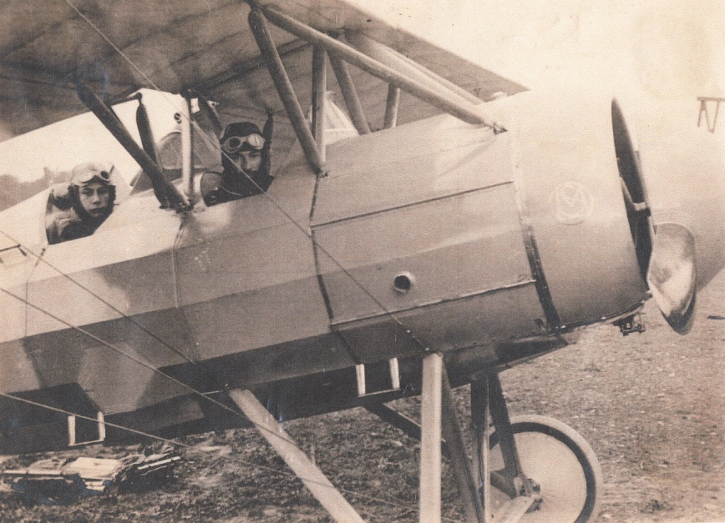
The aircraft on the left is a Morane Parasol P two-seater scout monoplane. Maurice is in the front of the aircraft and his son Bernard in the back. It is undated but must have been taken in late 1916 or early 1917.
Maurice was killed in 1917 while test-flying a new aircraft. His funeral was attended by a who’s who in French aviation at the time, including the Farman brothers, Georges Guynemer, M Caudron of the Caudron factory, and many French and British military officers.
He is recorded as a French-Australian casualty of the war on the honour board in the French Consulate in Sydney.
On 12-14 July, 2014, an Australian-made, Australian-designed Jabiru light aircraft, piloted by Owen Zupp will fly from Melbourne to Sydney as part of the commemorations of his airmail flight. He will carry 1785 postcards, modelled on the originals carried by Guillaux; these may be purchased from the website www.australiasfirstairmail.com . Email guillauxcentenary@gmail.com to get your name on our email list or to make general contact.

