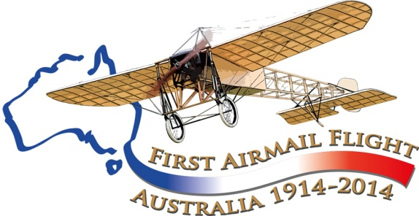

French aviation and Australia, pre-1914
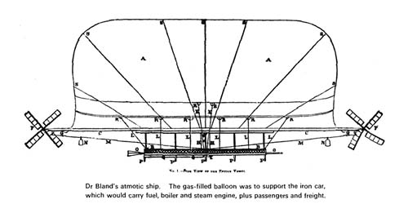
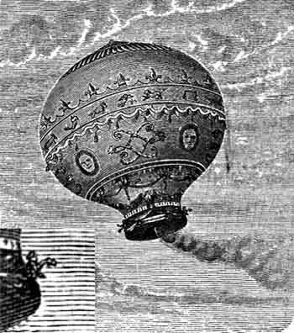
The first flight of a hot air balloon in France (The Montgolfier brothers, 1783) came almost at the time that the European settlement of Australia was being considered. French explorers were also in the region of Australia during that time, culminating in the extraordinary coincidence when Jean-Francois De La Perouse, with his ships, La Boussole and L'Astrolabe, met the First Fleet in Botany Bay on 26 January, 1788.
Ex-convict William Bland, a doctor who had been transported for killing a shipmate, drew up plans for an Atmotic Ship, essentially a dirigible balloon, 1851. This can be regarded as the earliest artifact of Australian aviation history of the period of Euopean settlement. A model of the airship was shown at the Crystal Palace in London in 1952, and this may have ended up in French hands. Certainly, after this, there was wide interest in the concept which can be seen in the work of Frenchmen like Henri Giffard, the Tissandier Brothers, Paris resident Alberto Santos-Dumont and finally Count Ferdinand von Zeppelin of Germany.

John Scott
Aviation Historical Society of Australia(NSW)inc
Air Mail Centenary Commemoration Group
Website: www.australiasfirstairmail.com
An unnamed Frenchman advertised a balloon ascent from Little Bourke Street, Melbourne at 7 pm on December 19, 1853, but there is no record of a successful ascent. On 15 December 1856 M Pierre Maigre attempted to fly his balloon from the Sydney Domain at 2 pm. He had tactfully named his balloon Sydney, and had vice-regal patronage for the event. However, everything that could go wrong did go wrong, and the crowd of around 12,000 people rioted, resulting in the destruction of the balloon and the death of an 11 year old Thomas Downes – the first aviation-related death in Australia: his tombstone in Sydney's Camperdown cemetery is decorated with a hot air balloon. Maigre , pursued by an angry mob, fled into Government House.
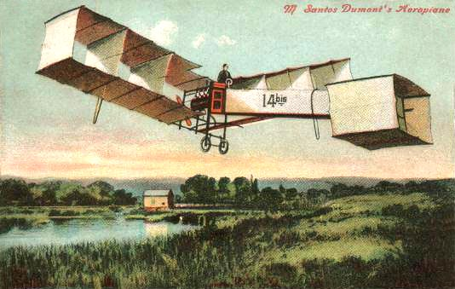
During 1903 Ernest Archdeacon of the Aero Club of France formed a committee aimed at ensuring that France would dominate the development of aviation. The main problems of the time were the lack of a lightweight power source and problems with airframe structure. Australian designer Lawrence Hargrave had planned a lightweight rotary engine and researched the box kite, which was the basis of gliders made by Gabriel Voisin and Louis Bleriot in 1905. In 1906 Alberto Santos-Dumont’ 14-bis aircraft, the first aircraft to fly in France, flew 60metres at a height of about 5m on October 23, 1906, at Bagatelle, near Paris. 14-bis (left) was essentially a collection of box-kites. Certainly, Hargrave had corresponded with Santos-Dumont with advice about rudder control for the 14-bis, but he was given little public credit for his assistance.
Many early aviators came from the ranks of early automobile drivers – eg Colin Defries, Fred Custance, and Maurice Guillaux himself. Oswald Watt was an Australian, from a wealthy grazing family. He drove his single-cylinder De Dion Bouton from Sydney to Melbourne in 2 days, 17 hours, 26 minutes in Spetember 1907, establishing a speed record. Following a much-publicised divorce, he moved to Cairo, where he purchased a Bleriot XI. In 1914 he established himself at the Bleriot aerodrome at Buc, near Paris. When war broke out he offered his aircraft to the French. He flew with the French Service dʼAviation Militaire with 30 Squadron, flying Bleriots. He later flew with 44 Squadron at Toul, flying Maurice Farman F.11 Shorthorns. In mid-1916 he transferred to the Australian Flying Corps, serving in the Middle East with No 1 Sqn AFC, then from September 1916 in France in command of No 2 Sqn AFC, and in February, 1918, was in England, commanding the AFC's 1st Training Wing. He received the Legion dʼHonneur and the Croix de Guerre, and in 1919 an OBE. The Oswald Watt Medal is still awarded by the Federation of Australian Aero Clubs for outstanding aviation feats.
Another link with France was forged by Charles Kellow,a Melbourne car dealer, who demolished Watt’s Sydney to Melbourne motoring record time on January 16, 1908, driving a 25 hp Talbot. Kellow went to England shortly thereafter: possibly for business reasons, possibly to escape a charge of having negligently driven a motor car in Brighton Road, Elsternwick, on March 25, 1908, causing the death of a horse and injury to its owner. A newspaper article reported that as he had made a balloon ascent on May 21 from Battersea, (London), in the Hon. C. S. Rolls' balloon. More significantly it was reported that he had ‘also made an ascent at Paris in Mr Henry Farman's aeroplane.’ If this is the case, he may have been the first passenger to fly in Europe. (The first aircraft passenger is recognized as Charles Furnas, flying with Wilbur Wright in a modified 1905 Flyer at at Kill Devil Hill, Kitty Hawk, N. C. on May 14, 1908; and the first passenger in Europe is generally recognised as being Ernest Archdeacon on May 29, 1908 with Henry Farman flying his Voisin-Farman 1-bis). Even if he was not the first European passenger, Kellow was an Australian at the centre of action in France.
Colin Defries was another car driver who had ru n foul of the law: after many infringements, in 1908 he was disqualified from driving for a year. He travelled to Australia, probably seeking a new start, arriving in Melbourne on October 5. In partnership with Lawrence Adamson, the headmaster of Wesley College, he imported a Wright Model A, which arrived in Sydney from France on November 15, 1909. He flew it in December, with just enough success for this feat to be acclaimed as Australia’s first powered aircraft flight.
After Louis Bleriot flew across English Channel on July 25, 1909, his aircraft became popular world-wide. In February 1910 a Bleriot XI was displayed in Melbourne by Lawrence Adamson, and one in Adelaide by Fred Jones. A Bleriot sales team arrived in Melbourne on September 5, 1910, with its demonstration pilot Gaston Cugnet, followed in October by mechanic Charles Ercole and Cugnet’s Bleriot XI.
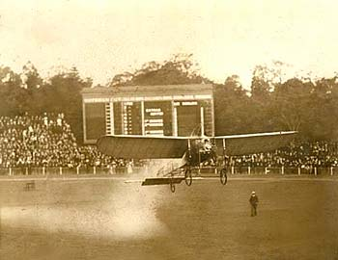
Cugnet takes off from the Melbourne Cricket Ground at about 7 pm. December 3, 1910; on this flight he crashed into the tennis courts at the western side of the ground. (NLA image 22221)
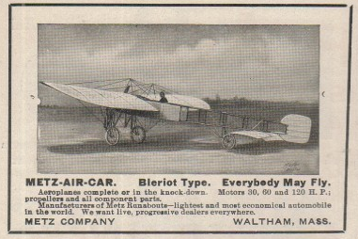
Cugnet was the first internationally accredited pilot to fly an aeroplane in Australia: he successfully flew the Bleriot XI at Altona on November 15, 1910. Harry Houdini had already flown at Diggers Rest on March 18, in a French Voisin biplane, maintained by Houdini's French mechanic Antonio Brassac. A. B. 'Wizard' Stone imported a ‘Metz-Air-Car, Bleriot type’, from the USA , in which he made the first flight west of the Blue Mountains at Bathurst on April 19, 1912. From 1909, the Bleriot XI was widely copied in Australia by local constructors.
Into this situation came Maurice Guillaux, and three more Bleriots were imported from France. One, which was owned by Tom Reynolds and located at the Kellow-Falkiner motor works in Melbourne, was acquired by the Defence Department when war broke out. By the end of 1914, the Central Flying School possessed seven aeroplanes, four of which were from French companies. These were CFS 4 and 5, Deperdussins, (built in London by the British Deperdussin Company); CFS 6, Bleriot XI, (the gift of Tom Reynolds); and CFS 7, Maurice Farman Hydroplane, (the gift of Lebbeus Hordern).
Three French Caudron G.III aircraft were also flown in Australia in 1913/14 – by Arthur Jones, Andrew Delfosse Badgery and John Claude Marduel. The Caudrom G III operated by Marduel was eventually acquired by the Central Flying School and given the serial number CFS 9.

