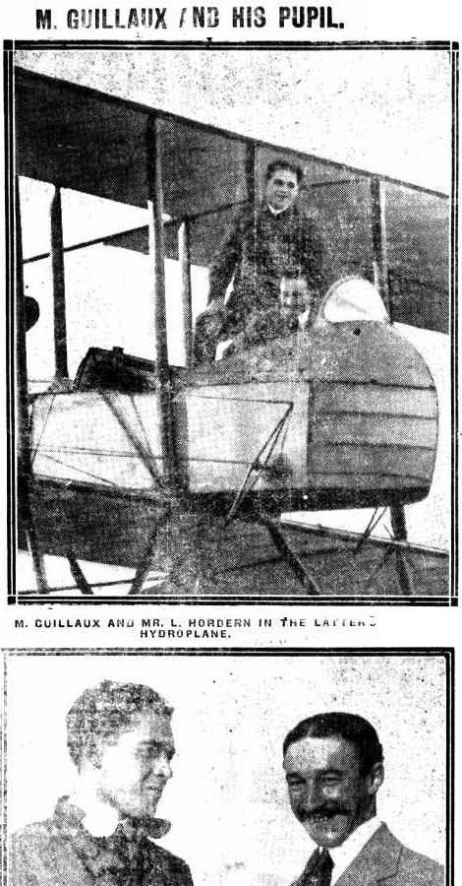
The Bathurst Times (NSW : 1909 - 1925), Saturday 12 September 1914, page 4

