Volume 27 March 2009
Capital Philately
This latest issue of Capital Philately has a reprint ofan article that was recently published in The Cover Collector. As most will be aware this journal has an editorial policy whereby we do not reprint articles from other journals, with rare exceptions. This article is one of those rare exceptions. It is in fact part two of an article of which the first part is not relevant to the story, as far as it concerns the Australian Capital Territory. The author, Michael Moore, who is a member of the Philatelic Society of Canberra, agreed to rewrite the article so that it made sense as a stand alone article, The author felt, and I agreed, that this article would be ofwide interest to local collectors and deserved a far wider audience of people within the ACT than it would gain in The Cover Collector. He was also keen to see it in full colour as he felt the illustrations had particular merit. I feel sure you will enjoy this article and I know one local collector who was fascinated to find an air cover from Australia that had actually landed on fresh water, as opposed to sea water.
The following article is reproduced in its originalformatfrom its previous publication in The Cover Collector:

Arthur Bergen and The Pacific

Islands Commemorative

Figure
I

Introduction
This article is also published in The Cover Collector, journal of the Australian Cover Society, No. 19, March 2009. Dingle Smith saw an early draft and suggested it would be of interest to members of the Philatelic Society of Canberra.
It is not usual for The Cover Collector or Capital Philately to reprint articles. This is, rather, a combined printing in two journals, of March 2009. It is an article of interest to both Societies, and of both of which the author is a member.
This is, in fact, Part 2 of an article. The two parts concern quite different commemorative flights and each can be read alone. Part 1, however, has additional background information about Jack Koch, Nelson Eustis and Arthur Bergen. It explains why I have often used the given name of Arthur Bergen and occasionally that of Nelson Eustis. PSC members can read Part 1 in the PSC library.
The unexpected highlight of the 2001 flight was a landing on Lake Burley Griffin. The Canberra Times published three excellent photographs of the occasion and gave permission for their use in this article. The publication of this account in Capital Philately may help preserve, among local philatelic and general readers, the memory and significance of the event.
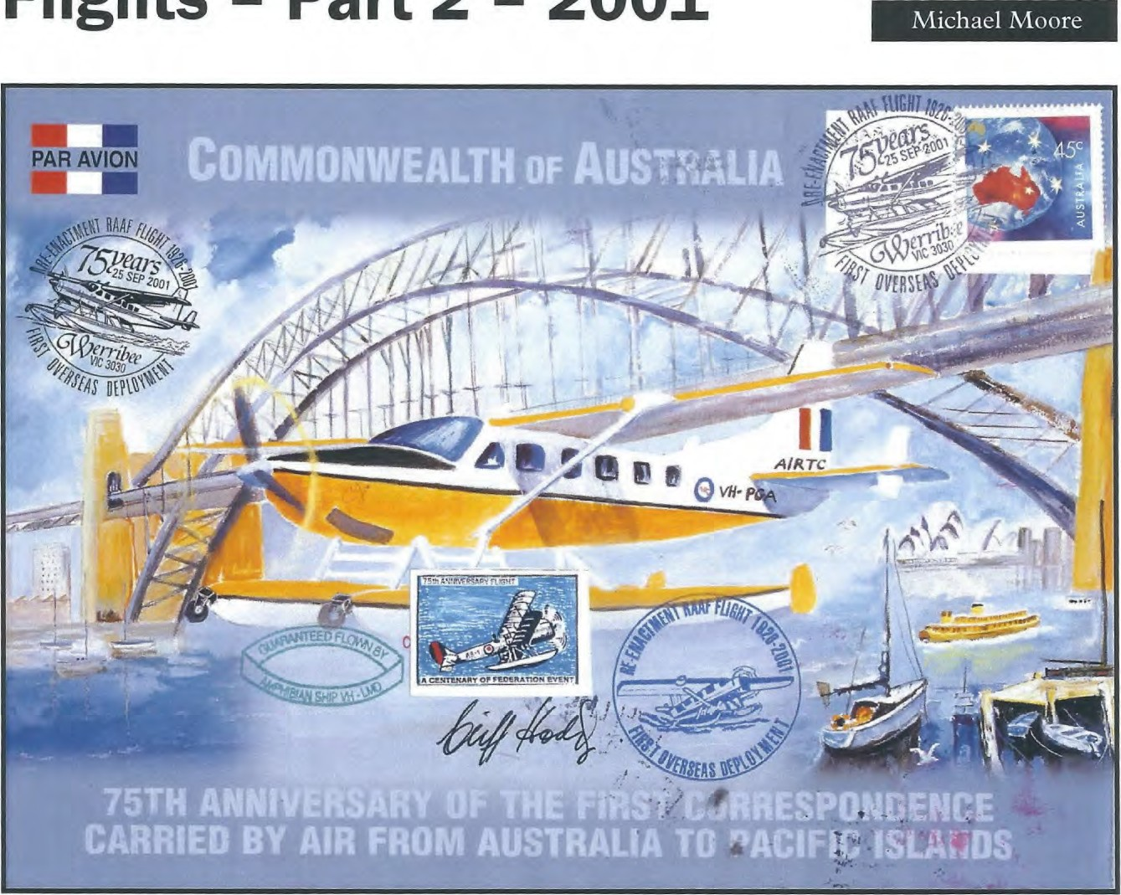

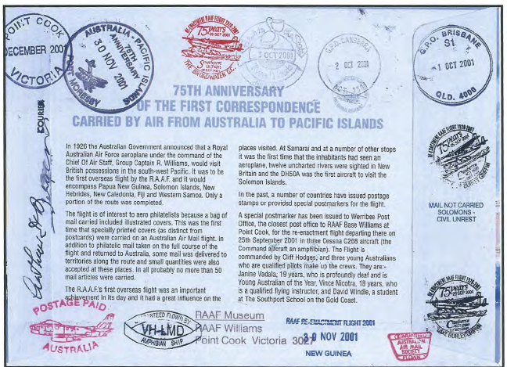
Pacific Flights — 1 926, 1976, 2001
Part 1 of this article gave brief details of the 1926 Pacific Flight flown by Group Captain Richard Williams. It then detailed the 1976, 50th anniversary, commemorative flight, the covers associated with it, and the involvement of the Australian Cover Society Patron, Arthur Bergen.
In 2001 , RAAF Warrant Officer Cliff Hodges, Air Force Cadets Training Officer and "Detachment Commander, 2001 /2002 Flights", arranged a 75th Anniversary flight. He hoped the flight would travel from Point Cook, via PNG, to the Solomon Islands.
He chose a crew of two young co-pilots who might hopefully carry on the tradition and fly a Centenary event in 2026. These were 18 year old, qualified flying instructor, Vincent Nicotra and 19 year old Janine Vadala, a qualified pilot. Ms Vadala, who is hearing impaired, had been named as Young Australian of the Year for 2001. David Windle, a student at Southport, was present on some of the stages.
Warrant Offcer Hodges largely funded the flight.
As with the 1976 commemorative flight, he hoped to recoup much of the expense through the sale of souvenir covers. However, the stamp market had "moved on" from 1976, and this hope was largely unrealised.
2001 Flight Cover
W. O. Hodges published the cover shown, front and back, as Figures 1 and 2. This is a very large cover, 228 X 166 mm. This cover type was advertised by Cliff Hodges at $100 each.
Hodges also published an unofficial (i.e. not published by a coin or stamp issuing authority) PNC (Philatelic Numismatic Cover) with a RAAF aluminium/bronze medallion. These were advertised for sale at $110. Australian Pictormarks@ records that 3,000 of the covers and 1,000 of the PNCs were produced.
The cover at Figures 1 and 2 has Cliff Hodges' signature on the front and that of Arthur Bergen on the back. This example was serviced by Arthur and has backstamps additional to those on the "official" version marketed by Hodges. These are discussed below.
Arthur Bergen
Arthur (at age 87 !) became involved, so was the only person to have flown on both commemorations. He wrote to me, from Southport on 3 December 2001:
I have not departed from this life ...I became tangled up in the RAAF re-enactment flight and things didn 't work out as I had expected.
Iheaded down to Werribee and met up with three others and an amphibian a/c — we left Point Cook and in a series of land and water landings (2 or 3 each day) arrived in Brisbane. Then made a special flight to Canberra to land on lake Burley Griffen (sic) — the first a/c to land there.
Back to Brisbane the same day and this is where funds ran out! I returned home — then received a a request to retum to Surfers Paradise to continue with the trip as far as Port Moresby. I was going to turn it in but then thought that I may as well continue as I may later regret not having done so.
So we went to Port Moresby via Caims — met up with thephilatelic boys there — had mailprocessed OK —I came back to Surfer's yesterday — now am booking my fare home — broke!!
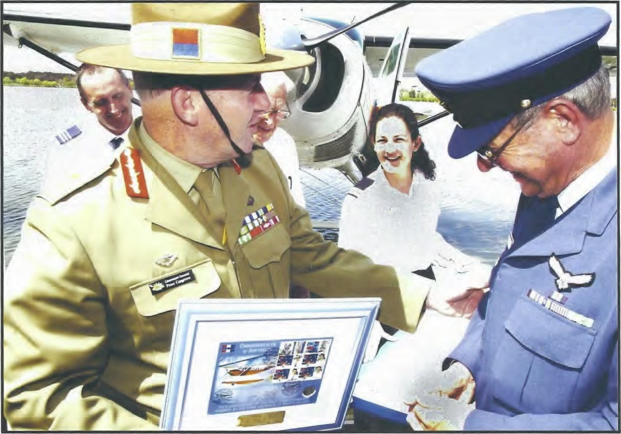
They say you can't take it with you (so I am not going) but... I guess the best thing to do is to do what you want to do (within reason).
At my age I should have more sense than to gad about.
The Flight
Cliff Hodges chartered a Cessna ^{S}'Caravan" aircraft similar to that shown in Figure 1. The charter included an experienced commercial pilot. This company pilot was (and remains) deliberately anonymous. Some accounts (see below) indicate that Hodges was the pilot. This was not generally so. Many landings were made on rivers and inlets which required considerable experience With seaplanes.
As it transpired, the flight went only as far as Brisbane. However, mail of various types was ultimately carried as far as PNG and the Solomons. One of the purposes of this article is to explain the covers associated with this event and how and where they were flown.
The flight left Point Cook on 24 September 2001 and flew via Sale (Victoria), Jervis Bay, Rose Bay (Sydney), Newcastle, Taree, Port Macquarie, Ballina, and other intermediate stops on the NSW coast. It reached Southport, Queensland on 28 September.
Sel Pfeffer, a long-time Stamp News columnist, joined the flight on 1 October and flew from
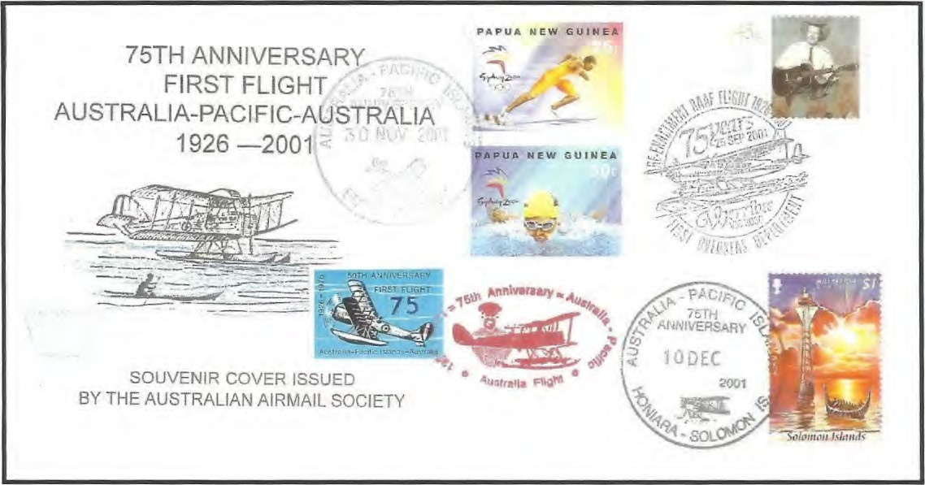
Figure 3 - front
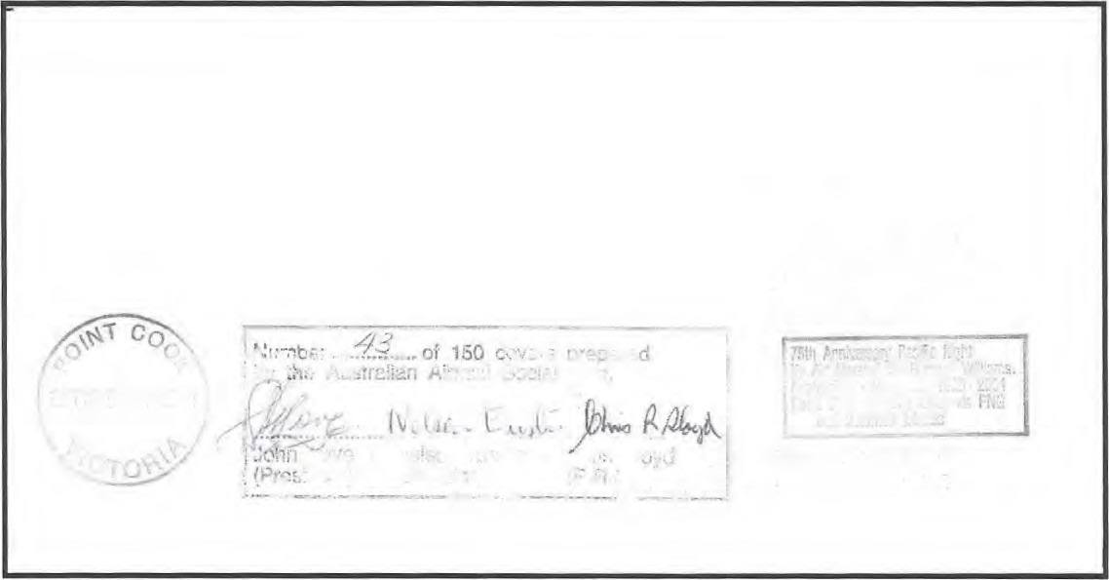
Figure 3 - back
Coolangatta, Queensland, the short distance to Brisbane where "Arthur Bergen and I caught a taxi to the GPO for postmarking the covers", and return. Sel wrote a short account in his "Focus on Framas article in Stamp News, December 2001/January 2002, p. 30. The article included three coloured photographs. One photograph shows the crew on that day, all identified except the anonymous company "co-pilot", standing in front of the aircraft.
Sel reports that the flight was met at Brisbane by the Gold Coast MLA, Lex Bell and "all the TV channels". Apart from Sel's own brief account, however, the event went largely unnoticed by philatelic collectors. Special Postmarker
Australia Post provided a special pictorial postmarker for this flight, APM 34080.This was issued at Werribee,Victoria somewhat dubiously said to be the closest Post Office to Point Cook. The cover at Figure 1 has postal markings with this same illustration, though smaller, dated Southport, Queensland, on 28 September 2001 and Canberra on 2 October 2001. Rather clearer images of these two "postmarks" are on others of the covers illustrated.
These are not official postmarks. The standard reference work on Australian pictorial and commemorative postmarks is Eury and Woolley, Australian Pictormarks@. The citerion used for listing a postmark in Australian Pictormarks@ is that it be advised in the Australia Post Stamp Bulletin. Such official advice allows collectors
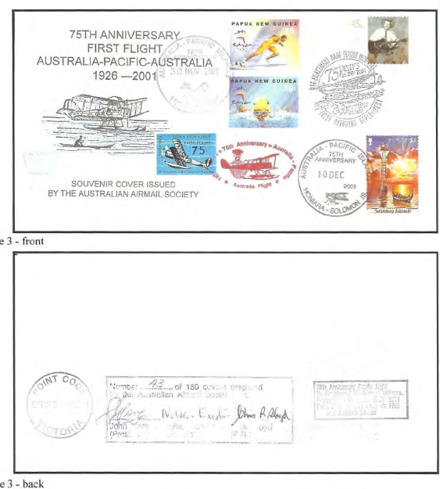
Figure 4 - back
to obtain impressions. Neither of these two "postinarks" was officially advised, and hence, neither is catalogued.

Accounts of the 2001 Flight
(The back of Cliff Hodges' cover shown as Figure 2 includes some details of the flight. This text however, was necessarily prepared prior to the flight and even the little it does record, is not wholly accurate.)
The Australian Air Mail Catalogue (AAMC), 2002 edition, has two accounts of the covers associated with this venture. Nelson Eustis was the AAMC Editor and Arthur Bergen was an Associate Editor. In spite of this (or perhaps partly because of this) the AAMC accounts beg as many questions as they answer. The AAMC records: "2001 (24 September) — Numbered and signed souvenir covers arranged by the Australian Air Mail Society for the 75th anniversary of the RAAF Pacific flight by Sir RichardWilliams were postmarked with pictorial commemorative cancels at Werribee (V), Port Moresby and Honiara (Solomon Is). The covers were franked with the stamps of the three countries and impressed with a number of cachets.
2262. Australia-PNG-Solomon Islands
(unofficial), (150) - $20
2262a. Vignette, blue and black, mint - $5
2001 (24 September) — Souvenir covers were
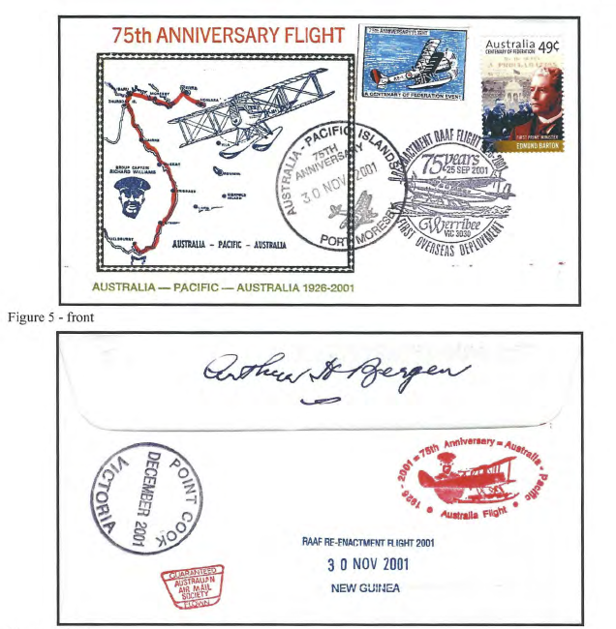
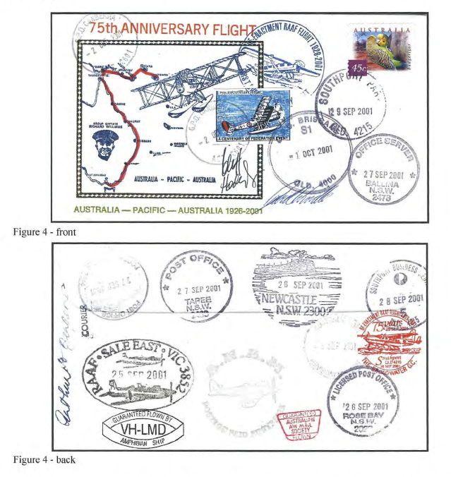
carried in a Cessna Caravan Amphibious, VHLMD, from Point Cook via various towns including
Canberra in a flight intended to commemorate the 75th anniversary of the 1926 RAAF Pacific flight by Sir Richard Williams. Pilot was Cliff Hodges. The flight terminated at Southport (Q). Covers were later taken to Port Moresby and stamped with a cachet indicating the covers would go no further.
2263. Australia-PNG (unofficial) - $10"

AAMS Covers
When Nelson Eustis learnt of this intended flight he contacted Arthur, suggesting that Arthur should go, to maintain the link with the Australian Air Mail Society. Nelson prepared 150 covers, modifying the cachet which had been printed for the 1976 flight. Many of these covers were pre-ordered.
An example of these AAMS covers (or at least of those eventually released — see below) is shown, front and back, as Figure 3. Frank Pauer kindly made avalable this example of what is a scarce cover. Nelson arranged that Arthur would carry, as courier, and arrange postmarking, of these Air Mail Society covers.
The fate of these original AAMS covers is detailed below.
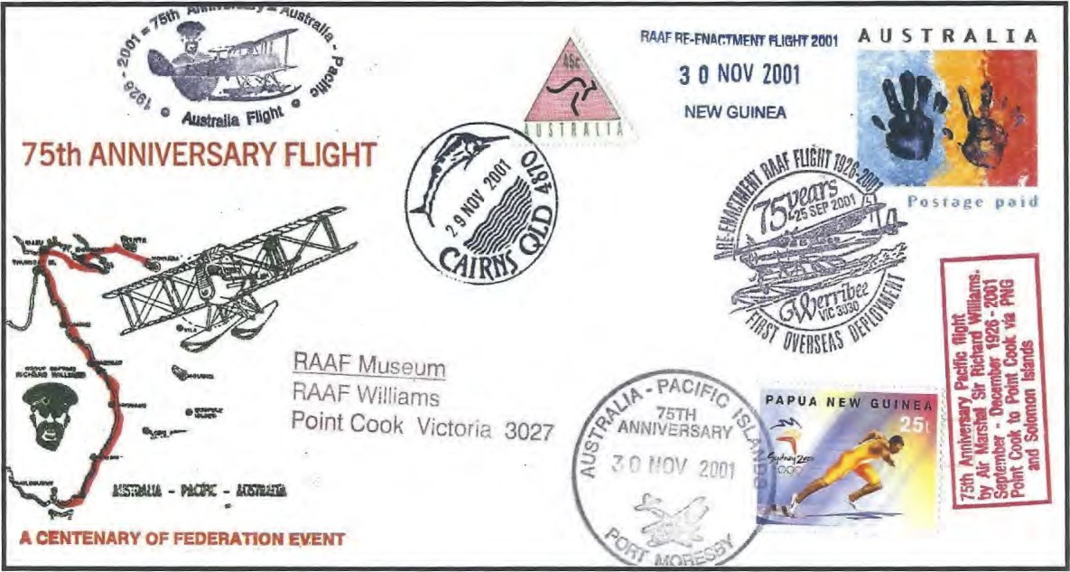
Figure 6 - front
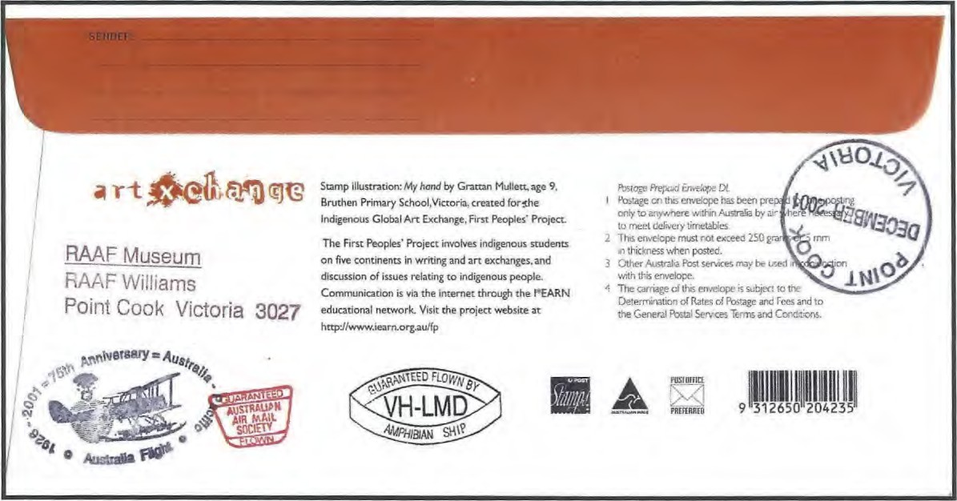
Figure 6 - back

Bergen Covers
Arthur produced and/or serviced several types of covers for this flight. Those he serviced are discussed in the next section.
Arthur personally printed a range of cover types with the cachet shown at Figures 4, 5 and 6. This basic cachet was illustrated and discussed as Figure 9 in Part 1 of this article. It was made for Jack Koch who gave it to Arthur in 1976. Originally it showed the route and the 1976 island stops which can still be seen on the 2001 version. Arthur modified the block to show the intended route of the 2001 flight through Thursday Island and Daru, thence to Kieta and Honiara.
The covers at Figures 4 and 5 are printed on envelope stock also designed by, and printed
for, Jack Koch. These have an embossed, gold, rectangular, border, prepared for the later addition of a cachet. When Jack Koch died he left tens of thousands of these mint envelopes, many of which Arthur acquired and has since used for many types of covers.
Both the fronts and backs of the Figure 4 and Figure 5 envelopes are shown. The various destinations and postal markings are discussed below.
Figure 6 shows another printing of this cachet. It is overprinted onto the Indigenous Global Art Exchange, Postage Prepaid Envelope. Arthur printed this cachet in various colours. The intended 2001 route is in red.
The flight was an official Centenary of Federation
Event. Some of Arthur's covers, e.g. Figure 6,

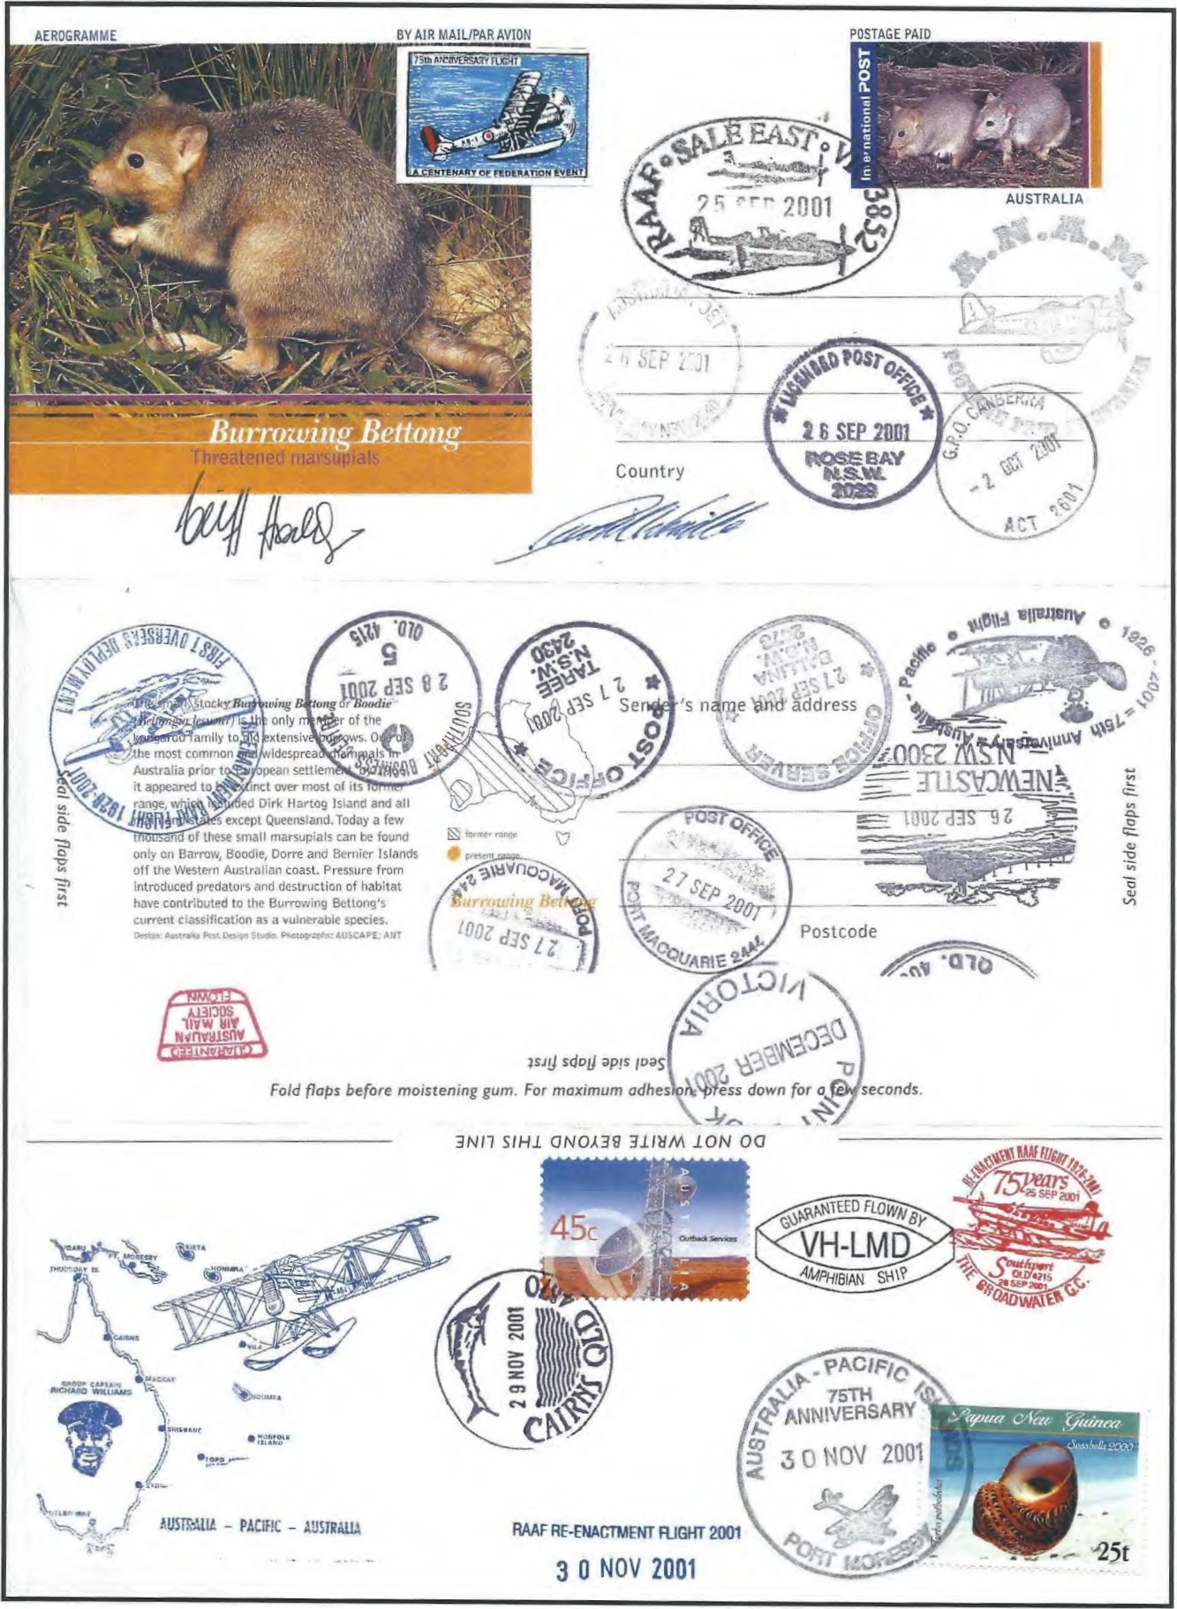
Figure
7
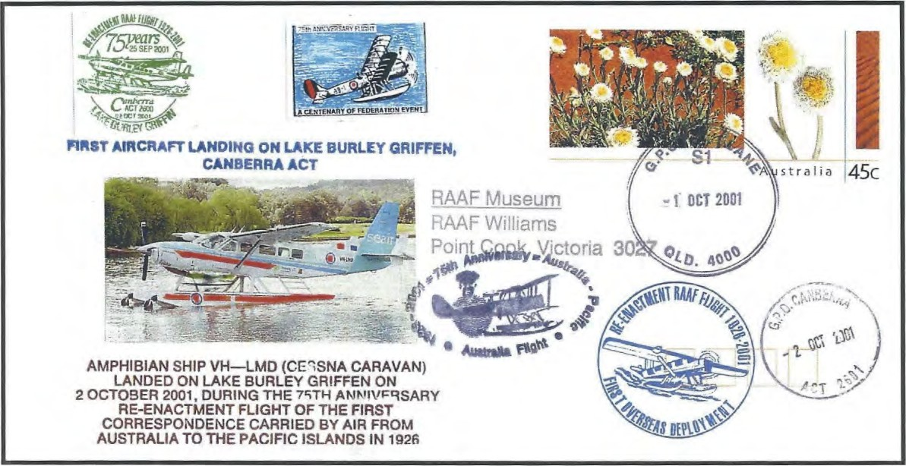
Figure 8 – front
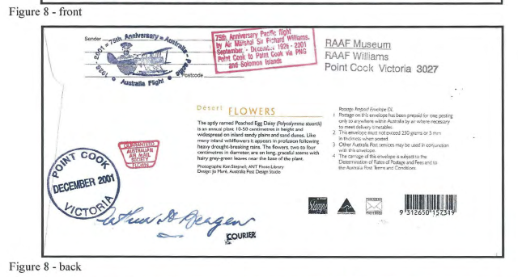
Figure 8 – back

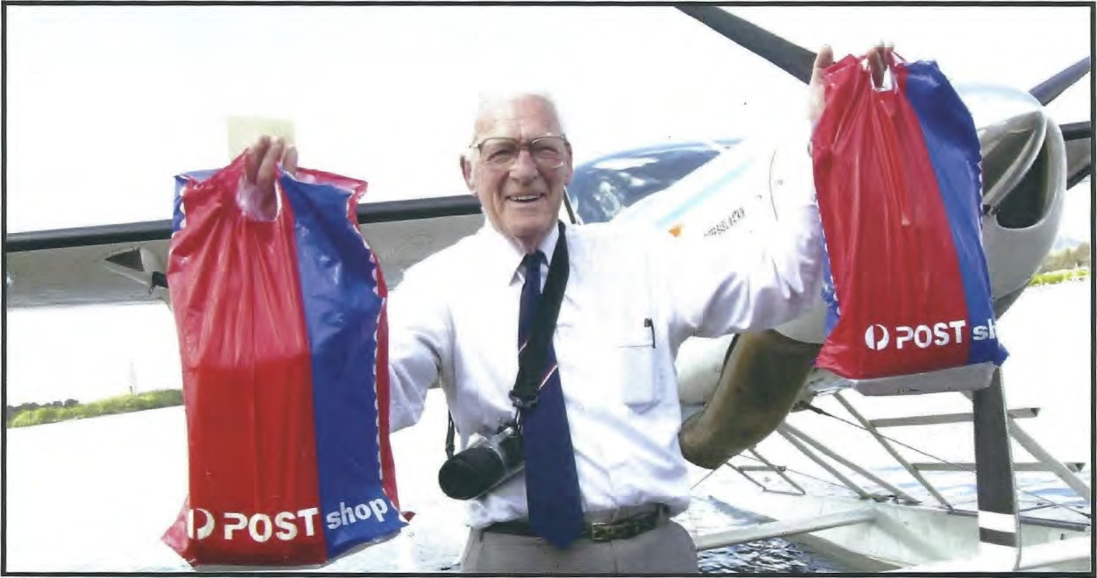

have this text; others do not.

Serviced Covers
As well as the covers he printed, Arthur serviced for his own use ( i.e. mainly for "the boys down at the Air Mail Society") many examples of the "flight cover" such as that shown as Figures 1 and 2.
This "flight cover" produced by Cliff Hodges would seem to be the "unofficial" cover catalogued by the AAMC as Number 2263. Ten dollars was a very low value to put on an item which was for sale only a year earlier at $100.
Figure 7 shows an "opened" aerogramme with a spectacular array of postal markings. Similar examples exist made on each of this series of "Threatened Marsupials" aerogrammes.

Signatures
For the last several years, Arthur has adopted the practice of signing the backs of each cover he prints. Hence he has signed the covers at Figures 4 and 5. He has not signed the Prepaid Envelope or the Aerogramme as they are not his publications. It is unusual that he has signed the Cliff Hodges "flight cover".
On the fronts of the covers at Figures 4 and 7
are the signatures of Cliff Hodges and David Windle.
The signatures of the Executive Officers of the Air Mail Society, on the AAMS covers, were applied after their journeys.

Souvenir Labels
The covers shown as Figures l, 43 5 and 7 have a souvenir label (or "vignette" or "cinderella") showing the 1927 aircraft. These were adapted from the label printed by Ted Roberts for the 1976 flight, Arthur redesigned and reprinted these labels. He reversed the direction of the 1976 aircraft image and added red and blue colours. The original text was taken out and replaced by "75th Anniversary Flight / A Centenary of Federation Event".
So that it would be obvious that this was an adapted printing, and by whom, Arthur added a "registration number" for the aircraft . This was "AB 1".
The Australian Air Mail Society covers do not have Arthur's label.

Brisbane to Canberra
After arriving in Southport, Cliff Hodges made a late decision to fly to Canberra. He had apparently heard that Lieutenant General Peter Cosgrove, then Head of Army, was interested in the flight. General Cosgrove was keen to meet the flight as he had been inducted as Australian of the Year in the same ceremony as Janine Vadala had been made Young Australian of the Year.
On 2 October 2001 the aircraft flew from Brisbane to Canberra and made the first aircraft landing on Lake Burley Griffn. General Cosgrove welcomed the flight and received a framed copy of the "flight cover".
This historic event was written up at some length in The Canberra Times of 3 October 2001 with three photographs, taken by the Times photographer, Martin Jones.
The photographs are reproduced by permission of The Canberra Times. One shows the aircraft landing on the lake. The second shows General Cosgrove meeting Cliff Hodges, with Janine Vadala framed in the shot. Behind him are the company pilot and, just visible, Arthur Bergen. The third photo showed Arthur, engaged in his special task and passion — proudly holding aloft "the Mail" en route to the GPO for cancellation. This photograph has been reproduced on the front cover of this issue.
This should have been a major publicity coup for the venture. General Cosgrove was, at the time, one of the highest profile Australians. However, it went virtually unreported outside Canberra and, again, virtually unnoticed by _philatelists. I then lived in Lara, Victoria, and was first told about the events some weeks later, by ACT member, David Daw.
The aircraft returned to Brisbane on the same day.
Arthur had examples of the then current "Desert Flowers" PSE cancelled at Bribane GPO on 1 October and Canberra GPO on 2 October. He later added the ilustration, a detailed text and other cachets to make a very attractive souvenir cover, an example of which is shown, front and back, as Figure 8.

Future of the Flight
Cliff Hodges told The Canberra Times reporter, "It's cost me so far $74,000," but he hoped, "people will start getting behind me and I'll get all the way around to the Solomon Islands". On return to Brisbane, however, some sort of crisis point, no doubt mainly financial, was reached and the commemorative flight was effectively terminated.
Arthur returned home to Adelaide in early October. Many of his covers for the flight do not show postmarkings beyond Brisbane as, at that time, it appeared that this would be the end of his journey.

AAMS Covers
Arthur reported to Nelson Eustis that he had been unable to carry the Australian Air Mail Society covers past Brisbane. When they had been given to Arthur, these AAMS envelopes had blank backs, so Arthur had duly secured transit postmarks similar to those shown on the back of the cover at Figure 4.
Nelson thought these unsuitable. He had intended to put on the backs, the cachets shown in Figure 3. Further, those who had pre-ordered covers would expect stamps and postmarks of PNG and the Solomon Islands. Nelson had these original AAMS covers destroyed.
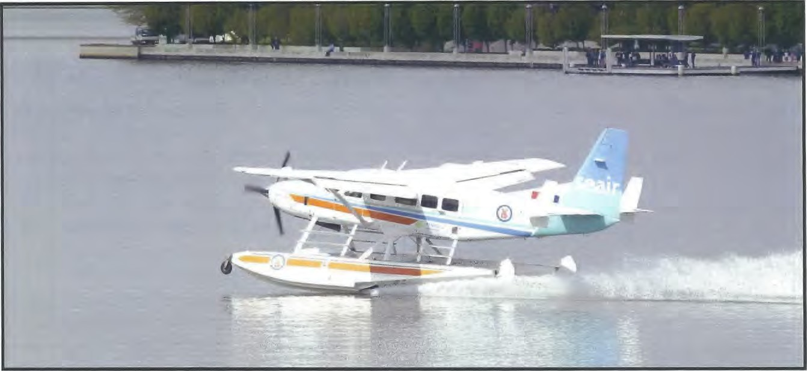
Another batch of AAMS covers was printed. These were taken to Port Moresby by regular Qantas service on 30 November and to Honiara by Air Nuigini on 10 December. There they had stamps affixed and were postmarked as shown on Figure 3.

Commemorative "Flight" - to PNG
Cliff Hodges soon realised that his "flight cover" would have to go at least as far as Port Moresby to be sold as commemorating a "Pacific Islands" flight. As Arthur was well known to "the philatelic boys" at Port Moresby, Cliff appealed to Arthur, in late November, to come with him to Papua New Guinea. Arthur agreed and they travelled to PNG by a regular Qantas flight on 29 November 2001.
En route Arthur had many of his own covers marked with a transit postmarker at Cairns. However, Australia Post had been none too pleased to learn that so many post offices had earlier applied postmarkers to the backs of covers (e.g. Figure 4) and to aerogrammes (e.g. Figure 7) and not over stamps. It insisted that Arthur affix new letter rate stamps for postmarking at Cairns.
At Port Moresby, PNG stamps were affixed to some ofArthur's covers and some of Cliff Hodges' flight covers. A PNG pictorial postmark was applied to the PNG stamps, as shown on Figures 6 and 7. The postal officials also agreed to apply this postmarker directly onto other envelopes, not over stamps, as at Figures 2 and 5.
The AAMC account quoted above indicates that the flight covers were "stamped with a cachet indicating the covers would go no further". I assume this is the small rubber stamp on the centre right of the back of the cover at Figure 2: ^{g}Niail not carried Solomons — Civil Unrest'S .

Extra "Postmarks"
Many of the apparent postal markings on covers associated with this event have already been discussed. Many additional markings are on the covers.
Most of these are not "postmarks" but are cachets made for either Nelson Eustis or Cliff Hodges. These include the oval shaped cachet stamped in either black or red on the fronts or backs of most of the mail items. This was adapted from the 1976 official Australia Post pictorial postmarker. One of these cachets deserves special mention. This is the large apparent "circular date stamp" of "Point Cook / Victoria / December 2001 It is not a cds as it does not have a specific date. Nor is it from Point Cook! It is a cachet which was designed by and made for Nelson Eustis.
Others of the cachets are rubber stamped texts in general use by the AAMS (such as the "Guaranteed Flown" cachets) or made specifically for these flights.
Arthur was always a little disappointed that no
Point Cook (airport) cancel was available for the 2001 covers.
In February 2003 Arthur came to Lara for the "Australian International Airshow 2003", held at Avalon, only 6 km away. We also visited the RAAF Museum at Point Cook. They allowed us (at least they did not expressly forbid us!) to use their "RAAF Museum/ RAAF Williams/ Point Cook Victoria 3027" rubber stamp and even their "Postage Paid" marking showing a Sabre jet. Arthur was delighted, and applied these to about 100 of his 2001 covers (which he "just happened to have" with him). These markings are on the flight cover (as serviced by Arthur) at Figure 1 and on several of the other covers illustrated.
These were the final "postal" markings applied to covers for this rather unusual series of events and misadventures which, between them, were the "2001 Pacific Commemorative Flight"

Thanks
I have already thanked many of those who helped with this article, at the end of Part 1. Of course, I must again, and specifically, thank Arthur for much of the information on the 2001 flight.

