AVIATION HISTORICAL SOCIETY OF AUSTRALIA (NSW) Inc
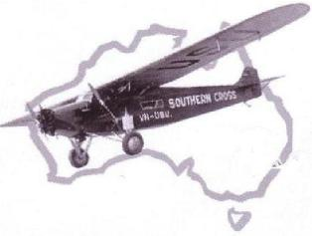
ABN: 83 295 759 224
HON SECRETARY, PAUL EWOLDT : E paul.ewoldt@hotmail.com
13/40A ROSLYN GARDENS RUSHCUTTERS BAY NSW 2011
A H S A Southern Skies
THE NEWSLETTER OF AHSA (NSW) Inc
NOVEMBER 2019 ~ No 544
Honorary Life Members AHSA (NSW) Inc: Ian Debenham OAM : Senja Raymond Robey BEM : Dr Ronald Houghton DFC, LdH

THE NOVEMBER AHSA (NSW) Inc MEETING
WILL BE HELD ON WEDNESDAY 6th COMMENCING at 8:00 pm.
PLEASE NOTE THE VENUE IN THE GRAND PITTWATER ROOM AT
THE NORTH RYDE RSL COMMUNITY CLUB
The club is located at the corner of Pittwater and
Magdala Roads, North Ryde. There is ample free
parking and visitors are most welcome. The facilities
of the club are available to members and visitors for
pre and post meeting refreshment and conversation.
MEMBERS MEET FOR DINNER IN THE RIVERVIEWS
RESTAURANT ON THE TOP FLOOR AT 6.30 pm.
JOHN VINCENT WILL BE OUR GUEST SPEAKER for this year’s Arthur Butler lecture at North Ryde RSL.
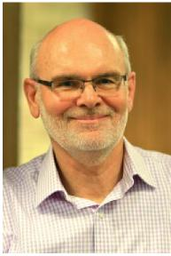
He will present a talk about the retrieval and transporting of a “Connie” from the Philippines to the Qantas Founders Museum at Longreach QLD, and its ongoing restoration.
John will be selling some Qantas merchandise on the night - CASH ONLY as per his list/prices (see over).
Our guest speaker at the October meeting held at North Ryde RSL was AHSA member, Warwick Bigsworth, who presented a slide show about his trips to Europe to see the commemorations of the D-Day landings and also the Berlin Airlift.
Following a brief historical overview, Warwick told members about the rather unfortunate “Bad planning” of both events which overshadowed what should have been a major event in both France and Germany. Basically a lack of proper coordination between various authorities resulted in visitors being very disappointed at the promised events not being delivered.
However, Warwick was able to take some photographs of various Dakota and DC3 types both in the air and on the ground, some of which had flown some distance to be there.
You are invited to attend
The 37th Annual
Arthur Butler Memorial Lecture
Guest Speaker
John Vincent
BE Aero (Hons UNSW), CEng, FRAeS, GAICD
John has extensive airline engineering and maintenance experience over a professional career spanning more than 40 years, including more than 25 years in executive, general and accountable airworthiness management roles in large airline Engineering and Maintenance organisations.
He is an Aeronautical Engineer, having worked in airline technical services (structures and systems), aircraft performance, fleet assessment and aircraft acceptance/delivery roles. He has filled senior engineering, maintenance, fleet development, safety, quality and risk management roles including holding various National Aviation Authority (CASA) approvals and has led the Engineering and Maintenance businesses of Air Pacific in Fiji and Ansett Australia and Qantas Airways Ltd in Australia.
His main career focal areas have been business strategy, business process improvement, change management, governance, regulatory compliance, operational and occupational safety systems, risk management, leadership development, employee engagement/communication and relationship management.
He is Chairman of the Board of the Qantas Foundation Memorial Ltd, the parent company of Qantas Founders Museum; Past-President and a Councillor of the Royal Aeronautical Society Australian Division Inc; and Adjunct Professor with the School of Aviation, University of NSW where he offers a post graduate course in Airworthiness for Transport Category Aircraft.
John Vincent 10 October 2019 o

Southern Skies November 2019
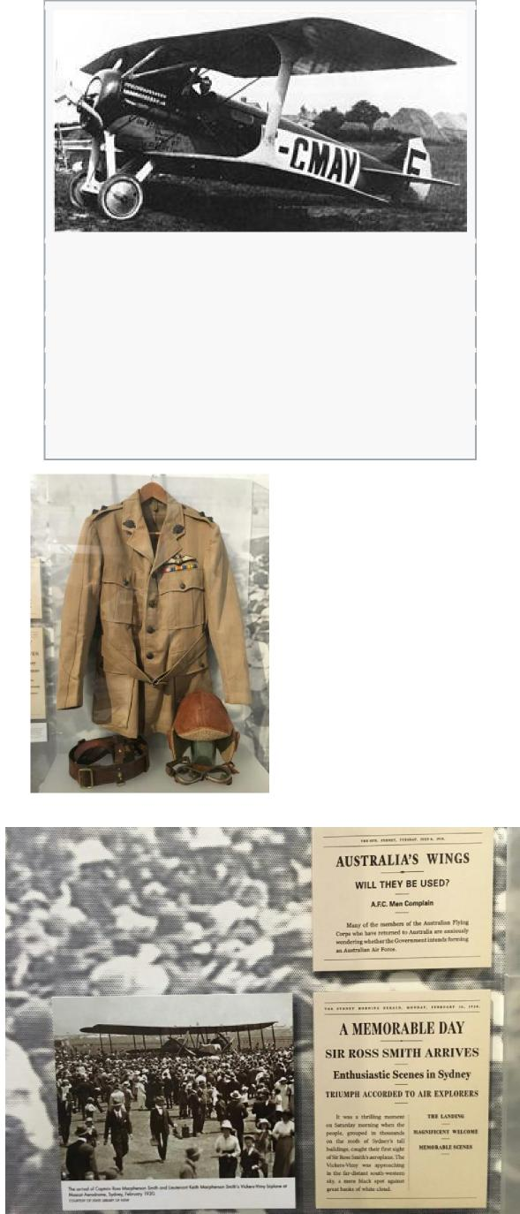
Role Airliner
Manufacturer Blériot
Designer André Herbemont
First flight November 10 1919
Primary user CMA/Air Union
Number built ca. 10
ROSS AND KEITH SMITH DISPLAY - SYDNEY WAR MEMORIAL, HYDE PARK October 2019
QANTAS MERCHANDISE /CASH ONLY as per list/prices: 'Qantas since 1920' bag tags ($10); (5) 'Return of the 707' DVDs ($13); (6) Super Constellation baseball caps ($30). All available online:https://qfom.com.au/shop/. Purchase on the night saves postage and convenience.
ONE HUNDRED YEARS AGO
NOVEMBER 1)1) - 201) Chronology JR
01 West Indies Airways begins service
between Key West, Florida, and Havana, Cuba.
10 The United States Army Air Service begins the first class at its new Air Service School of Application. The new school, located at McCook Field in Ohio, provides technical training in aeronautical engineering and is the predecessor of the Air Service′s first service school, which will be founded in 1920.
12 BROTHERS KEITH AND ROSS MACPHERSON SMITH SET OUT ON THE FIRST FLIGHT FROM ENGLAND TO AUSTRALIA, FLYING VICKERS VIMY G-EAOU. THEY WILL ARRIVE IN DARWIN, AUSTRALIA, ON DECEMBER 10 AFTER FLYING 18,175 KM (11,293 mI), WINNING A PRIZE OF £10,000 FROM THE GOVERNMENT OF AUSTRALIA.
14 The American Railway Express Company hires a Handley Page V/1500 to carry 1,000 pounds (450 kg) of parcels from New York to Chicago, but the attempt fails due to mechanical problems.
15 Alameda, California, officials announce that suspected criminals will be subjected to perilous flight to make them confess their crimes.
16 CAPTAIN HENRY WRIGLEY AND SERGEANT ARTHUR MURPHY SET OUT ON THE FIRST FLIGHT CROSSING AUSTRALIA FROM SOUTH TO NORTH (SEE 1920 IN AVIATION AND FRANK BRIGGS FOR THE FIRST EAST TO WEST FLIGHTS). WRIGLEY AND MURPHY FLY A ROYAL AIRCRAFT FACTORY B.E.2e FROM MELBOURNE TO DARWIN AND ARRIVE ON DECEMBER 12, HAVING SPENT A TOTAL OF 47 HOURS IN THE AIR.
NOVEMBER FIRST FLIGHTS
10 The Blériot-SPAD S.27 was a small French airliner developed soon after World War I. It was produced as a way for the Blériot company to find new markets for its wartime products in the postwar market, in this instance by adapting the design of the S.20 fighter into a small airliner. Accommodation for two passengers was provided in a small cabin within the fuselage, but in other respects the S.27 strongly resembled its predecessor.
Page 2
Three were operated by CMA on its Paris-London route, this total increasing to ten by the time that the company merged into Air Union.

Southern Skies November 2019
Page 3

VALE - TREVOR BOUGHTON
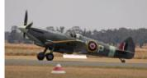
Trevor Boughton, a founding member of AHSA, died in Newcastle on 6th October 2019. Trevor Boughton and Jack Pryor were the leading forces behind the AHSA's formation. It was sad to learn of Trevor's passing.
THE AVIATION HISTORICAL SOCIETY OF AUSTRALIA started initially as the Aviation Historical Group of Australia in May 1959. The monthly notes of this Group continued until December 1959.
An introductory page was then issued with details of the formation of the AHSA and its leading initiators, named as Honorary Executive Committee at the base of Page 2.
The first page of the first Journal was issued on January 1960 with an introductory explanation, followed by the Monthly Notes on page 2.
Trevor lived in Melbourne at that time and later moved to Sydney. From memory he was a graduate electrical engineer who worked for the Commonwealth Department of Works in Australia Square in Sydney. I recall meeting him in his office. Trevor was a constant attendee at AHSA meetings and other functions. He later retired from his job and moved to the Hunter region.
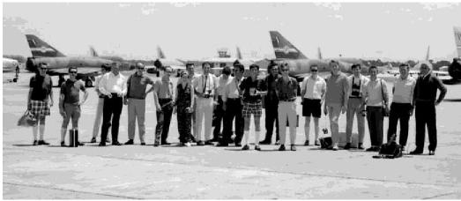
AHSA members taken at a visit to RAAF Williamtown on 14
November 1970.
Visits to military bases were arranged and proved very popular for keen AHSA photographers. Trevor is on the extreme right. Many AHSA members from that era are recognisable including me in the centre with the tartan shorts. Long socks were in vogue!
Per Eric Allen ee.allen@bigpond.net.au
Could members with knowledge of Trevor please let Dave Prossor have a short history of Trevor’s life and career?
Thank you, Gordon Lasslett, Paul & Christine Ewoldt, Tom Lockley, and aviation friends for submissions to this newsletter. Contributions should be sent to the Newsletter
Editor: judyrainsford@hotmail.com
JR 74 AHSA (NSW) Inc
Read more at https://www.australianflying.com.au/warbirds/temo ra-transfers-warbirds-to-the-raaf#lKEaDyAvQs3cPUdj.99
AHSA LIBRARY
The following books have been added to the library:

- Last Stand in Singapore - the Story of 488 Squadron RNZAF by Graham Clayton
- Australia’s Few and the Battle of Britain by Kristen Alexander
- Bill Lancaster - The Final Verdict by Ralph Barker
- ANZAC & Aviator - Biography of Sir Ross Smith by Michael Molkentin
A book launch of ANZAC & Aviator is being arranged at 1:30pm on Sunday 17 November. The venue is The Roseville Club, 64 Pacific Highway, Roseville. There is car parking and the club is about 50 metres south of Roseville Railway Station. The Bistro opens for lunch from 12 noon.
Copies of the book will be available at the launch for $30 for AHSA members (10% discount on the RRP) and Michael will be there to inscribe copies. I will bring some copies of the book along for sale at our November meeting or members can email me on glaslett@bigpond.net.au and reserve a copy that I will have Michael inscribe to them and I can either post it to them or bring it to our December Christmas meeting. Everyone is welcome at the launch. Profits on sale of the book to members will go to the AHSA (NSW) Inc.
The library has been given four cartons of books, records and photographs by Judy Eather, the widow of Charles (Chic) Eather who was one of Sid’s Pirates of Cathy Pacific fame. Paul will give a brief
report at the meeting. Gordon Lasslett - Librarian
TO RESERVE AND BORROW BOOKS EMAIL:
Christine: paul.ewoldt@hotmail.com or
Gordon: glaslett@ bigpond.net.au

Australian Flying 10 May 2019
TEMORA TRANSFERS WARBIRDS TO THE RAAF
Temora Aviation Museum (TAM) has transferred ownership of some of its most valuable warbirds to the
Royal Australian Air Force. Eleven historically-
significant aircraft have been donated to the RAAF as the air force prepares to celebrate its centenary in 2021. The aircraft, which TAM will still maintain and house under a five-year contract with the RAAF are: English Electric Canberra; De havilland Vampire;
Gloster Meteor; both Spitfires; Lockheed Hudson;
CAC Wirraway; CAC Boomerang; Cessna A-37B; Dragonfly; De havilland DH-82A Tiger Moth; Ryan STMS2. The CAC Avon Sabre operated by TAM was already owned by the RAAF.
According to Australian Flying's sister magazine, Flightpath,
the Vampire and Canberra will both be returned to
airworthy status before being transferred to the RAAF.
Flightpath has also reported a brief statement from the RAAF, which says "as we approach our centenary in 2021, this agreement will ensure that these historic aircraft can continue to be preserved, remembered and displayed."

Southern Skies November 2019 Page 4
A SIMPLE ENTRY FOR A SHATTERING EVENT IN WW2 : 14.5.1943
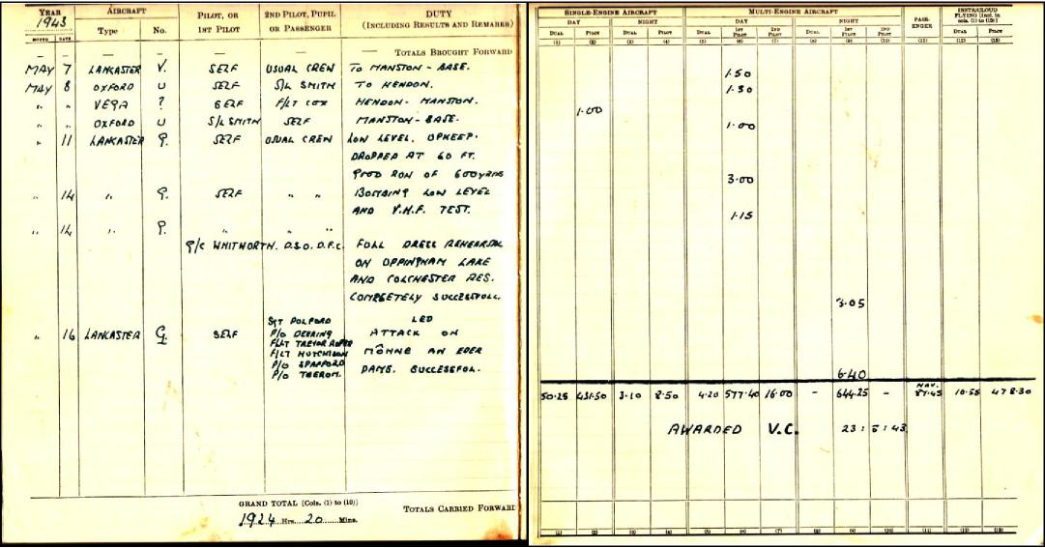
PILOT GUY GIBSON’S LOGBOOK - Lancaster bombing German dams 16 May 1943
Per Peter Marosszeky, AHSA Meeting October 2019
NSW XMAS DIARY: CHRISTMAS DINNER Wednesday 4th December at Sydney Rowing Club: 6-30pm for
7-00pm. No need for RSVP - all meals and drinks at members’ own expense. All welcome.

INTERSTATE NEWS
MELBOURNE MEETINGS are held on the fourth Wednesday of the month in the auditorium of the RAAF Association, 24 Camberwell Rd, Hawthorn East. Parking is available under the building - enter from the lane at the south end. The meetings start at 7.30pm - ring the bell if the front door is shut. A number of members meet casually for dinner from 6.00pm at the Tower Hotel opposite the RAAFA. Visitors are welcome.
Website http://www.ahsa.org.au/
Contact Dave Prossor, President,
president@ahsa.org.com
BRISBANE MEETINGS are held on the last Friday of each month in the Lounge Area, Terminal Building,
Archerfield Airport, Brisbane. Visitors are welcome.
Next Meeting: Friday 29th November 2019 - 7:00 for 7:30pm.
Peter Dunn, Secretary, advised that the AHSA Q’land
website can be found at - http://ahsaqld.org.au/
Contact: ahsaqld@gmail.com or
Warwick Henry at 0417 771 563
CALENDAR OF EVENTS : 2019
THE TEMORA AVIATION MUSEUM’S AIRCRAFT DISPLAYS
Email: info@aviationmuseum.com.au
Website:
http://www.aviationmuseum.com.au/event/aircraft-showcase
FACTS not FICTION
The first pilot’s licence did not belong to one of the Wright brothers!
Pilot Certificate number 1 was actually issued to William P. MacCracken, Jr, the Assistant Secretary of Commerce for Aeronautics, and not until 1927 (even though the Wright Brothers’ first flight was in 1903). The story goes that Mr. MacCracken offered the honour to Orville Wright, who declined since he was no longer flying.
The first aircraft to be intentionally shot down by another aircraft went down on October 5, 1914, when the observer in one plane shot the pilot in another plane with a hand gun.
Prior to this, military aviation was more a “gentleman’s game” – with pilots on opposing sides waving and saluting each other as they passed.

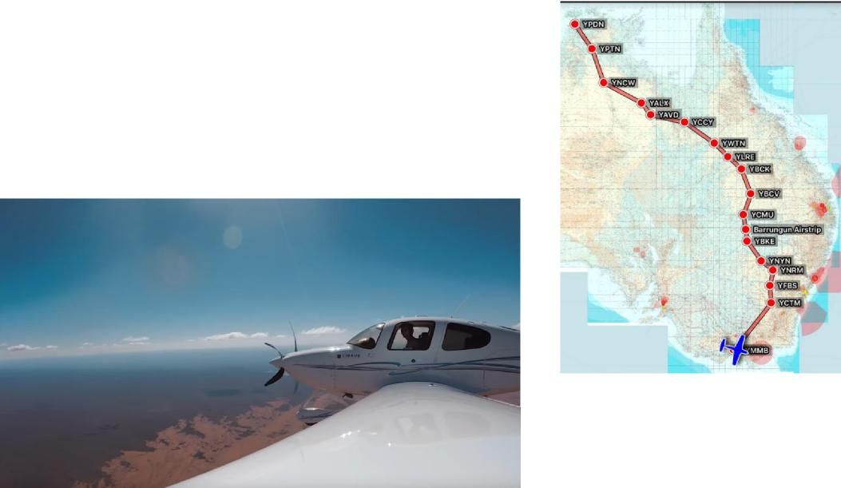
Southern Skies November 2019 Page 5
Countdown to 10 December 2019: Less than two months to go.
THIS MONTH WE HAVE NEWS OF A MAJOR ADDITION TO THE CELEBRATIONS - WRIGLEY AND MURPHY RECOGNISED AT LAST!
For the centenary of the flight, a new tribute flight will take place, following the route of Wrigley and Murphy in their 1919 survey flight.
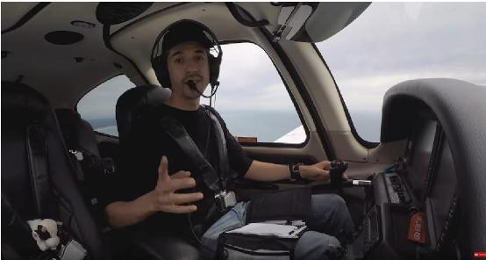
Aviator Stefan Drury (left) will fly his SR-22 Cirrus from Point Cook to Darwin. His tentative plan is:
- Friday 6th Dec: Point Cook - Cootamundra - Forbes - Narromine - Bourke
- Saturday 7th Dec: Bourke - Cunnamulla - Charleville - Blackall - Longreach
- Sunday 8th Dec: Longreach - Winton - Cloncurry
- Monday 9th Dec: Cloncurry - Avon Downs - Alexandria - Newcastle Waters - Tindal - Darwin
This gives him a contingency day. So barring major weather events etc he would stay overnight in Katherine and depart for Darwin on the 10th to join the Smith flight centenary celebrations.
Read about Stefan on his YouTube channel
https://www.youtube.com/stefandrury
Right: Stefan’s proposed flight will follow the route actually taken by Wrigley and Murphy. Below: Stefan’s Cirrus over Central Australia.
The background of the Wrigley / Murphy flight:
In the preparation of the Darwin- Adelaide
route followed by the Smiths, John Scott has particularly recognised the contribution of Reginald Lloyd’s motorcycle expedition to survey the route for his proposed airline Aerial Services Ltd with plans to commence an aerial service from Britain to Australia. John indicates that the route chosen was probably the suggestion of Dr Griffith Taylor, University of Melbourne meteorologist, who had lectured at Point Cook at the time that Jean Marduel (Guillaux’s associate) was there. Marduel took part in the expedition but had to withdraw at Camooweal, and the survey was complete by 8 August.
When faced with the necessity to provide supplies and airfields for the Smith crew flight from Darwin to Adelaide the Government sent out other expeditions. The most famous was the expedition of Hudson Fysh and his wartime friend P J McGinness across the northern coast from Normanton to Katherine. The expedition had been suggested by London members of the planning group and was only successful in that it proved that that route was quite unsuitable! Over ten major makeshift repairs were needed, and they averaged only 16 miles a day in the journey to Borroloola. From there they struggled on to the railway at Katherine.
In Darwin, Fysh was put in charge of preparing the Fannie Bay airstrip, while McGinness travelled back to Cloncurry, preparing landing sites that were actually used on the southern route, and finally welcoming the Smiths to Cloncurry. Fysh and McGinness were shortly afterwards involved in the establishment of QANTAS, originally Queensland and Northern Territory Aerial Services.

Southern Skies November 2019 Page 6
But the most spectacular reconnaissance of the Darwin to Adelaide route was carried out by Wrigley and Murphy, AFC airmen from Point Cook. Captain Henry Wrigley was an Australian pilot who served with 3 Squadron in 1917-18, being awarded a DFC. With Sergeant Arthur Murphy DFC he began a flight to Darwin as reconnaissance for the participants in the England / Australia air race. (For the pedants who ask why Arthur Murphy as a sergeant had been awarded a DFC rather than a DFM, he was awarded the medal when acting as an officer in the Middle East, but on his return to Australia had to drop rank to Sergeant to secure a position in the greatly reduced AFC).
Their aircraft was a BE2e of prewar design – indeed the first BE2s entered squadron service in 1912! The war had caused huge developments in aircraft, so the design and technology were obsolete. Their machine, serial number B6183, possibly known as CFS18, arrived from Britain in 1918 and was first flown in Australia in February 1919.
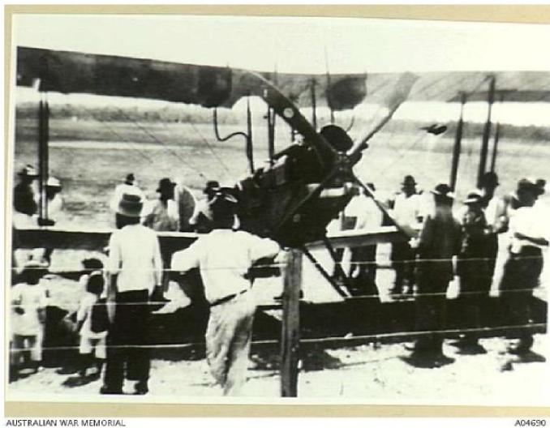
Picture: the BE2e at Avon Downs
It was planned to leave on 12 November but there were delays caused by engine unreliability. The final journey was as follows:
16 November: Melbourne to
Cootamundra; (at the time regarded as the longest single-hop flight in Australia);
17 November: Cootamundra to Forbes;
18 November: Forbes to Narromine, forced landing a t Wyanga Station 30 miles south of Narromine, en route;
19 November: Narromine to Bourke with a delay at Nyngan because of engine trouble – (details here are not clear);
22 November: Bourke to Barrungun (on the Queensland Border); 23 November: Barrungun to Cunnamulla; 24 November: Cunnamulla to Charleville (another day lost due to engine trouble);
26 November: Charleville to Blackall (with a stop at Tambo); 27 November: Blackall to Longreach ;
28 November: Longreach to Winton ; 29 November: Winton to Cloncurry.
At Cloncurry the engine suffered a major failure, and Murphy repaired it by visiting the railway workshop and using their metal lathe for turning a new valve from a car axle. On 6 December they left Cloncurry but after 30 miles returned owing to engine trouble. 7 December: Cloncurry to Avon Downs; 8 December: Avon Downs to Alexandria after failing to reach Anthony Lagoon owing to a faulty map. The tailskid shoe was damaged when it struck a rock on landing, the only accident. 9 December: Alexandria to Katherine. They had sent details of the length of runway required, and the people of Katherine had cleared an area of this length in the middle of a forest. Many trees had to be cut down to enable the aircraft to take off. This final delay meant that they arrived in Darwin on December 12, two days after the arrival of the Smiths and only one day before the Smiths set out on their journey south. Nevertheless, their information was greatly appreciated by the Smith crew.
The BE2 and its crew returned to Point Cook by ship. The aircraft was overhauled, and in February 1920 was given to the Australian War Museum. I believe it was accidentally destroyed a few years later.
Both men rose to the ranks of Air Commodore during long careers in the RAAF. Henry Wrigley was the senior RAAF officer in Britain during World War II and had a great reputation with the Australian airmen in Britain. He died in 1987, aged 94. He was also a world-recognised writer on military theory, particularly involving the use of air power. Arthur Murphy’s career was more involved with engineering – he was deeply involved in the early history of the Commonwealth Aircraft Corporation, notably the production of the Beaufort in Australia. He was very unhappy to be forced to leave the RAAF at the end of the war but remained active as an aeronautical engineer till his death in 1963.
Seventieth anniversary flight
There was another Wrigley / Murphy reenactment flight in 1989, when RAAF flight lieutenants Tim Shaw and Ben
Coy flew the route in a CT-4 trainer escorted by a RAAF DC-3. Tom Lockley

