Maurice Guillaux
Pioneer French aviator in Australia

Tom Lockley
April 2015

This version was published 2015 by AHSA (NSW) inc
as part of the commemoration of
the visit to Australia of Maurice Guillaux,
April-October 1914.
It includes some historical material that
emerged during the re-enactment process and not included in the version of June, 1914.

Comments, corrections and additions?
Please email Tom Lockley
guillauxcentenary@gmail.com
or mail PO Box 301
Pyrmont NSW Australia 2009

ISBN 978-0-9803693-8-0

Contents
Introduction 1
1. Guillaux before Australia 2
2. Australia before Guillaux 4
3. Guillaux’s arrival in Australia 6
4. Newcastle display, 25 April 1914 7
5. Back to Sydney: 2 and 9 May displays 8
6. Lebbeus Hordern and his seaplane 10
7: The journey south: Wagga Wagga and Albury 13
8. Melbourne performances, 28-30 May 1914 14
9. Guillaux in Bendigo and Ballarat (8 June – 14 June) 15
10. Adelaide Performance, 20 June. 18
11. The Geelong display, 4 July 1914 19
12: Prelude to the mail flight 20
13. The mail flight: 16 – 18 July 1914 22
14. After the mail flight 34
15. Guillaux after Australia 36
16. Australia after Guillaux 38
17. The final chapter. 39
The re-enactment flights 41
About this book 44

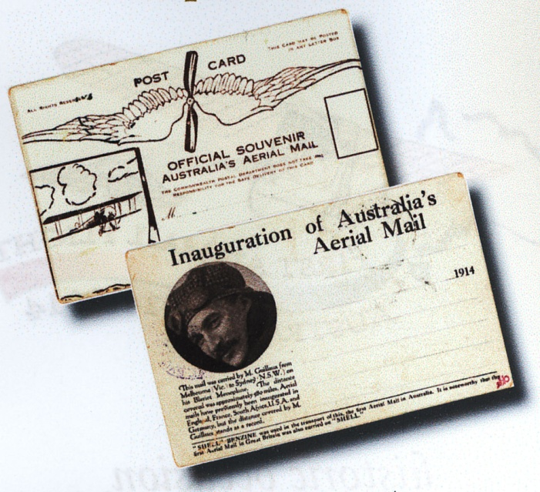
The first official air mail / air freight flight in Australia was performed by Maurice Guillaux on 16-18 July 1914 when he flew from Melbourne to Sydney. Some 2500 postcards, as illustrated above, were printed, but only 1785 were actually carried. A token cargo of tea and fruit juice was also carried.

To finance the 2014 re-enactment the original cards were modified and sold to philatelists and other interested people. The cards also recognised the support received from the French energy company Total. Another philatelic product was a series of special envelopes also carried on the flight (above).
A range of booklets philatelic material, including original postcards and envelopes, is still available: details on our website www.australiasfirstairmail.com or search ‘Guillaux’ in ebay. All money raised from this time onwards goes to historical recording of Guillaux’ time in Australia, particularly by placing commemorative plaques in significant buildings. Details of this can be found on the website as the project develops.
Tom Lockley

Introduction
In 1914, French airman Maurice Guillaux visited Australia, staying for less than 200 days. He conducted exhibition flights for huge crowds throughout south-eastern Australia. He also flew Australia’s first seaplane and made Australia’s first airmail / air freight flight when he carried 1785 specially printed numbered postcards and air freight some fruit juice and some Lipton Tea from Melbourne to Sydney, 16-18 July 1914. This is undoubtedly one of the most significant events in Australia’s early aviation history, but it has largely been lost to historical memory, mainly because it was overshadowed by the outbreak of war a few weeks later.
In June 2013 the Aviation Historical Society of Australia, (NSW) decided to commemorate the relevant events of his visit to Australia. Thanks to the Luskintyre Aviation Museum, a commemorative flight over Newcastle on 25 April 2014 marked the first performance in Australia 100 years previously. On 11 May 2014 the Seaplane Pilots Association of Australia conducted a fly-in of eighteen aircraft over Sydney Harbour to commemorate the first seaplane flight in Australia, flown by Guillaux on 8 May 1914.
The Melbourne-Sydney mail re-enactment flight itself, 12-14 July 2014, was a resounding success, thanks to the support of the philatelic community, the light and historical aircraft owners and organisations, the French community in Australia and the enthusiasm of the local centres through which the flight passed.
A considerable amount of historical material has come to light, and the purpose of this booklet is to summarise what we now know of this remarkable, but little known airman. It incorporates material that came to light as a result of the re-enactment. But gaps that still remain in our knowledge and the processes research continue.
I have mentioned (page40) many of those who are enthusiastically involved in the historical aspects of this project. To these, as well as the many other people whose efforts made the year’s activities such a success, goes our thanks.
Tom Lockley, secretary, Commemoration Group, AHSA NSW inc.

1. Guillaux before Australia
Ernest François, Guillaux, better known as Maurice Guillaux, was born in the small town of Montoire, Central France, in 1883. His father was a wheelwright, and he followed his father into this trade. He married at age 18, and a son, Bernard, was born in 1902. We know little about his life during the next ten years. He was involved in the automobile industry. He obtained his pilot licence, number 749, on February 19, 1912. A newspaper report states that he gave flying displays at that time, charging the spectators one sou. The aircraft used is not certainly identified.
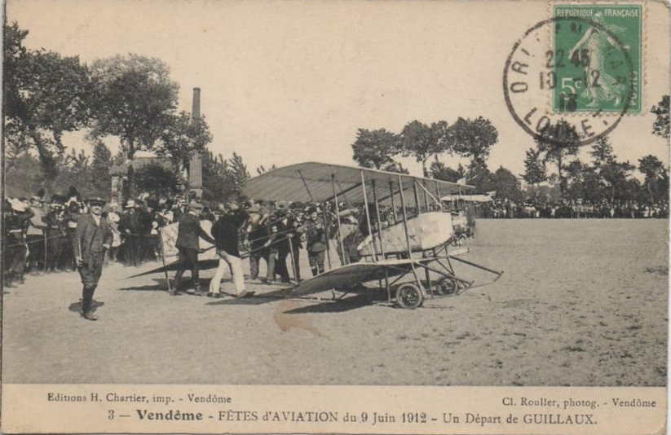
He soon became the chief pilot of the Caudron factory, based at Crotoy near the English Channel. He usually flew a two-seater Caudron B2, with a 50 horsepower Gnome engine (left). Beginning in early April, he took part in displays in France and England, gaining a reputation for his ability to handle bad weather. He flew across the Channel in both directions carrying a passenger – a rare feat at the time.
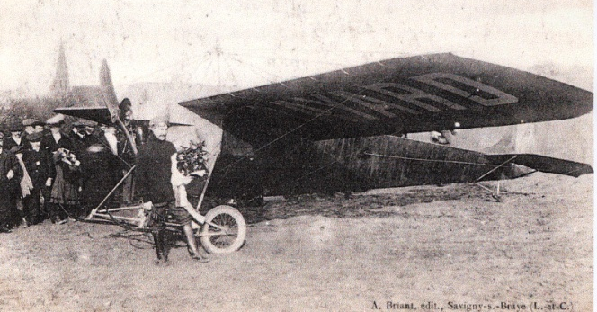
By August 1912, he was employed by the Clément-Bayard factory as display pilot for their ‘all-metal’ monoplane, (right) technical details for which are sparse. He also gained various qualifications as a military pilot. He set a new height record during November. On February 11, 1913, at Étampes, he established new records for speed and distance flown with a passenger, despite freezing conditions and heavy fog.
He also participated in the Pommery Cup competition, a prize awarded twice a year for long distance flying – the greatest distance, measured in a straight line, travelled between sunrise and sunset on one day. He won the first competition for 1913 with a flight from Biarritz to Kollum in Holland. On 23 August he made another flight from Biarritz, claiming to have reached the village of Brackel in Germany. His arch-rival, Brindejonc de Moulinais, had made a flight of similar distance. It was found that Maurice Guillaux had reached Brockel, a village some 60k closer to Biarritz, not Brackel. Guillaux claimed that this was a simple spelling error, but he was accused of cheating and disqualified from participating in the Pommery Cup for 10 years.
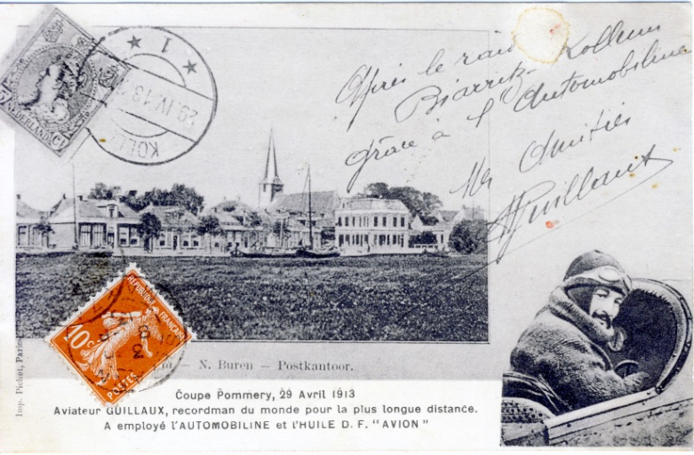
Incidentally, at the end of this flight he was arrested and imprisoned for two days by the Germans, who regarded him as a spy. In view of the scurrilous rumours that later swept Australia, (page36) this is a gentle irony!
Multiple copies were made of the postcard that Guillaux used to record his winning flight in April 1913.
However the popular appeal of the Pommery Cup competition was declining. The new celebrity airman was Adolphe Pégoud, whose aerobatic displays were hugely popular. Guillaux acquired a ‘looper’ (Boucle) Bleriot XI aircraft as used by Pégoud. It was a specially designed model with a 50 hp Gnome rotary engine. Carrying 55 litres of fuel, it could fly for two hours. It weighed only 300 kg. It is a strong aircraft, and for the time, very sophisticated in design and construction. The first Bleriot XI flew the English Channel on 25 July 1909 and over 500, in various configurations, were built. Guillaux’s machine is on display at the Powerhouse Museum, Sydney. In this aircraft he was the first pilot to ‘loop the loop’ over Paris.
At this stage Guillaux, with four companions, left France on what was intended as a world tour. He performed in Egypt and came to Australia; the plan was to move on to Japan and China.

2. Australia before Guillaux
There were some false starts to Australia’s aviation history. In 1851 ex-convict Dr William Bland designed an ‘Atmotic Ship’ designed to carry one and a half tons of passengers and cargo and be able to 'fly' from Sydney to London in under a week. It was never built. After a few failed attempts by others, William Dean became the first person to fly a hot air balloon in Australia in 1858. There were several other such flights in 1871. Henri l’Estrange, of French origin, flew a gas-filled balloon in 1879, but had to abandon his flight and descend by parachute.
Lawrence Hargrave’s aeronautical research in the late 1800s had a world-wide influence, involving such things as box kites and airfoil sections. George Augustine Taylor, influenced greatly by Hargrave, constructed and flew a glider on 5 December 1909. His wife Florence also flew and thus became the first woman to fly in Australia.
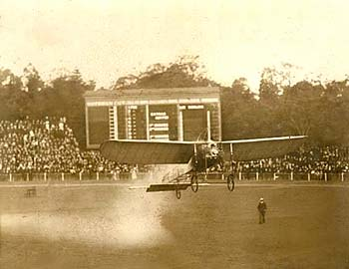
On December 9, 1909 Colin Defries made the first powered flight of a heavier-than-air machine in Australia, at Victoria Park Racecourse, in Sydney. He was followed by a more successful flyer, ‘Harry Houdini’, (Erik Weisz), the following year. A few other flyers got airborne, with varying success, including the Frenchman Gaston Cugnet who flew a Bleriot in 1910. After a take-off (left) at Melbourne Cricket Ground, December 1910, he crashed into the tennis courts shortly after. He was the first aviator with a recognised qualification to visit Australia.
In 1911, a New Zealander, Joseph Hammond, was more successful, giving public demonstrations of flying, including the first cross country flight, Altona to Geelong and return.
William Ewart Hart was also prominent. He was an Australian, recognised by the Aerial League of Australia as being the first pilot trained in Australia. He was the first airman to use Ham Common, (now part of Richmond RAAF base, near Sydney) and made headlines by flying from Penrith to Parramatta, (19 miles, 30 km) on 3 November 1911.
The star aviator of early 1914 was Harry Hawker. A talented mechanic, he left Australia in 1911 and became chief pilot for the Sopwith factory in England. In January 1914 he returned to Australia, with a speedy Sopwith Tabloid aircraft. His main aim was to encourage the development of the use of aircraft for defence purposes, and he motivated the government to actually unpack their purchased aircraft and to get the Point Cook air base into action.
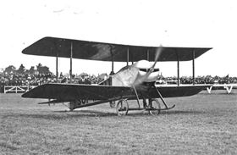
On 2 February 1914 he flew from New Street Elsternwick to Government House, meeting the Governor-General, Lord Denman. He gave public displays at Caulfield in Melbourne (picture on left) Randwick and Victoria Park (Sydney), Albury and Ballarat, where he crashed and damaged his aircraft beyond repair. An event at Bendigo was therefore cancelled. His displays were managed by Albert Sculthorpe, whom we will meet again (page 6).
He took a number of passengers for flights, including influential politicians and military officers, with a good proportion of young ladies. He was adored by the Australian public, but returned to England on 8 May 1914. He was disappointed that the government would not buy his aircraft; the authorities believed that the older, slower aircraft were all that were needed at the time and saw no value in purchasing the speedy Tabloid. They were also waiting for the British government to decide on their own policy, which would be adopted in Australia.

3. Guillaux’s arrival in Australia
Even before he announced his intention to tour Australia Guillaux had been mentioned at least 84 times in Australian newspapers.. These were usually brief mentions of his exploits, including the suspension scandal of 1913. Incidentally, the outstanding French airman to figure in Australian newspapers was Pégoud, the aerobatic specialist and early parachutist; first mentioned on August 20, 1913. There were over 500 articles referring to him during the remainder of the year. This type of flying had huge popular appeal.
Guillaux arrived in Fremantle on 4 April 1914 on the Oronsay. Reporters went on board to interview him. Their articles were widely reprinted and described, in positive terms, his exploits and the thrilling aerobatics to be performed. Guillaux and his associates, Messrs Repusseau, Maistre, Cominos, and du Coque, arrived in Sydney on 8 April 1914.
Lucien Maistre was the son of a former French vice-consul in Australia, and this may explain Guillaux’s team’s choice of Australia as the first major stop on the world tour. He is listed in early newspaper reports as a representative of the Gnome engine company. Repusseau is sometimes listed as ‘manager’. Even less is known of the other two. Albert Sculthorpe, a respected city councillor of St Kilda, Melbourne, had ‘managed’ Hawker’s air shows and from April 20 performed similar functions for Guillaux.
The assembly of the aircraft was a complex operation. We know that Guillaux was very knowledgeable about the aircraft and took a ‘hands-on’ role. He probably performed this task in premises owned by Jules Maillard, who had showrooms and a garage at 186a Phillip Street Sydney. The task was finished by Monday 20 April, when he gave an exhibition at Victoria Park Racecourse, Zetland. There was a small crowd of invited guests. ‘He looped the loop three times in succession, with the utmost ease, and as coolly as though he were lighting a cigarette’ (Sydney Morning Herald). In his next flight he went for a tour of Sydney Harbour, flying through the heads. Among those who congratulated him after the flights was W E Hart, pioneer Australian aviator (see page 5).

4. Newcastle display, 25 April 1914
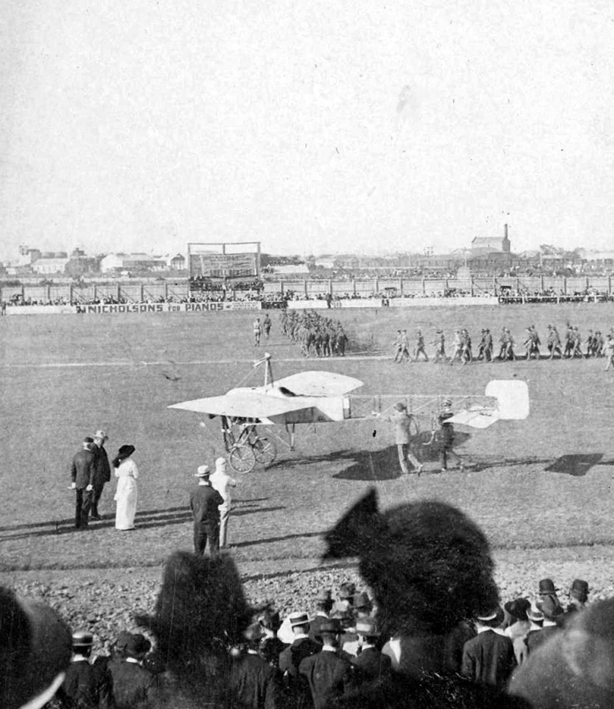
This photograph, reproduced by courtesy of the Newcastle Region Library, depicts the scene at Newcastle Showground on 25 April, 1914. Newcastle was the venue of Guillaux’s first public display in Australia, and we believe that his aircraft was the first to fly in Newcastle.
Groups of army cadets can be seen in the background, and the group near the aircraft probably includes the Mayor, Mr John Reid, and his wife. The fashionably dressed people in the foreground paid two shillings to sit in the grandstand for the display. Shell Benzine is advertised on a banner on the scoreboard.
Promptly at 3 pm, Guillaux appeared, moving to the aircraft as the band played the Marseillaise, the French national anthem. His display took a form that became fairly standard: a flight that was close to the venue, with many aerobatic evolutions, and a second flight in which he flew over the harbour; all the steamers tooted and the men on the vessels cheered loudly. The French frigate La Bruyere dipped its flag in salute. Guillaux then returned to give another aerobatic display before landing.
In 2014 this event was commemorated when, a hundred years later almost to the hour, a flight of three Tiger Moths from Luskintyre Aviation Museum flew over the Newcastle showground.

5. Back to Sydney: 2 and 9 May displays
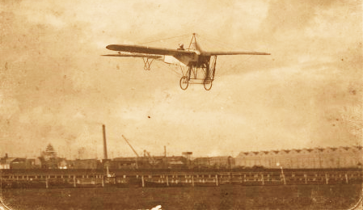
Guillaux flying over Victoria Park.
(MAAS collection)
Returning to Sydney by train, Guillaux flew over Sydney on Friday 1 May, attracting huge interest, and held a well-advertised public performance at Victoria Park on Saturday 2 May, as described by the Sydney Sunday Times with block capital subheadings:
Guillaux was fully 800 feet above the earth, and dipping the nose of the monoplane, he MADE A SENSATIONAL DESCENT straight at the Vice-President of the Executive Council (Mr Flowers), the Lord Mayor (Alderman Richards), and a group of pressmen. Mr Flowers looked up, and seeing the monoplane coming towards him at a terrific rate, caught hold of a little boy who accompanied him, and together with the Lord Mayor beat a hasty retreat. Guillaux, however, swerved upward when within 30 or40 feet off the ground, and relieved Mr Flowers' feelings. Climbing steadily, Guillaux circled the course several times. Once, when he was at the southern end, he tilted the machine and rushed downward in a bee-line for the hundreds of people who had congregated on the sandhill there. Most of them thought the airman was coming to grief there and then, also a number of themselves, for THEY FLED PRECIPITATELY.
Guillaux, however, righted the machine within what appeared to be a few feet of the side of the sandhill, and flew away. Setting the nose of the machine upward again, the Frenchman rose until there were fully 1500 feet between him and mother earth. He dipped the nose of the machine downward, and descended at a terrific rate of speed, giving one the impression that he was falling. He was too — for several hundred feet — but righted himself again gracefully, and soared aloft.
The Frenchman's next feat was what the crowd had been anxiously waiting for — the loop-the-loop, and he executed the dangerous manoeuvre at a height of about 2000 feet, where he was in full view of the spectators. Heading in the direction of the grandstand the little yellow machine suddenly turned a complete somersault. The roar of applause that broke from the crowd was deafening. A second or two later it broke out again as Guillaux looped the loop for the second time.. There were spiral descents, volplanes, banking and fish-like movements until he reached the straight, along which he flew at a RATE OF 71 MILES AN HOUR receiving the plaudits of the spectators. He was smiling when he started on the first aerial journey, and he was smiling when he landed, 25minutes later.
........ The second exhibition occupied 30 minutes.......... even more daring than the first, for, besides looping the loop so often that one lost count of the number of times he executed this movement, the Frenchman turned his machine over and flew for a considerable distance upside down — a feat that requires the greatest courage and technical skill.
Between flights Guillaux was presented to the Governor, Sir Gerald Strickland. An unnamed French lady presented Guillaux with a magnificent floral tribute.
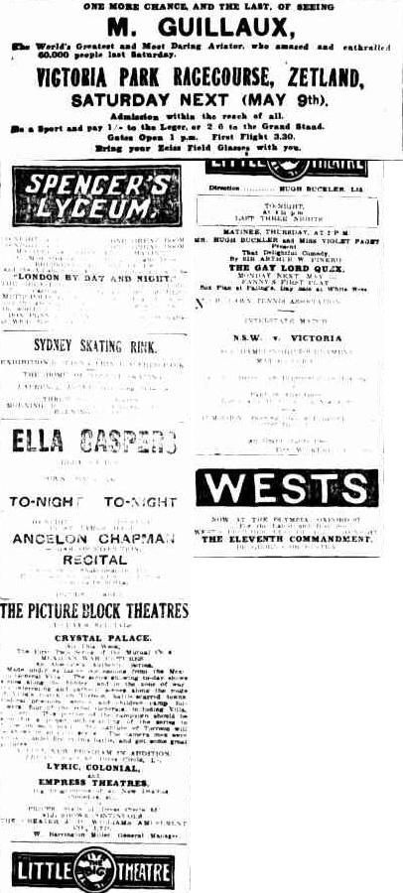
Guillaux and his team spent the next week assembling and flying Lebbeus Hordern’s Farman seaplane, as described below, but he returned to Victoria Park for another display on May 9. This repeated the previous program, with an unintended addition: the aircraft hit some phone wires stretched between two buildings, but he was able to carry on. This was one of Guillaux’s rare errors in his display flying.

6. Lebbeus Hordern and his seaplane
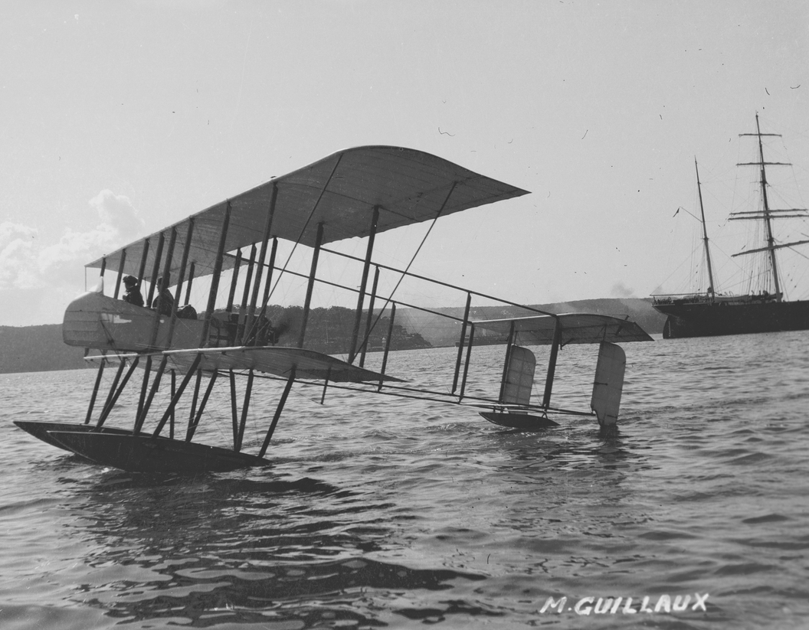Sam Hood photo, State Library of NSW, a128591
Anthony Hordern and Sons was the biggest department store in Australia and one of the biggest in the world. Early in 1914 Lebbeus Hordern of this family imported a Farman seaplane. In the week beginning 4 April, Guillaux and his team assembled the aircraft at in a specially built shed at the bottom of Bay Street on the foreshore of Double Bay. The Herald reporter noted that Guillaux was in charge of the operation and displayed considerable skill, knowledge, and meticulous attention to detail.
The Maurice Farman seaplane had entered service in several countries in 1913. A Greek Farman seaplane attacked Turkish warships with grenades during the Balkan War 1913-14. The Farman’s 70 horse-power Renault engine enabled a maximum speed of 60 miles-per-hour. Wingspan was 57 feet, 17.3 metres, length was 35 feet, 10.6 metres, and weight 1680 pounds, 760 kilograms. It could carry ‘two seventeen-stone passengers or three passengers of lesser weight!’ (17 stone=108 kg).
Maurice Guillaux flew the Farman for the first time on 8 May 1914, as described by the Sydney Morning Herald reporter:
Right to a millimetre’ was Guillaux’s comment after he had subjected all to a minute scrutiny……. nothing could be left to chance. Up into the pilot's seat he mounted, the hydro-aeroplane having been wheeled down to the water's edge by many willing hands. Petrol was poured into the tank, and a mechanic, who looked as if he came well up to the 17 stone standard, climbed into the passenger's seat behind Guillaux, a dapper figure in a tweed suit, who made no sartorial preparation for the flight beyond casting aside his Homburg hat.
The mechanic set the propeller whirring at top speed. So strong was the air-current which its revolutions set up, that a shower of sand and hats was blown into the shed behind, small children were thrown to the ground, and the crowd holding the ‘tail’ were almost forced to let go their hold.'
Guillaux sat himself firmly in his seat, gave the order for release, and immediately afterwards the 'plane was skimming along the waters of Double Bay at breathless speed. For a few hundred yards it rushed along, spurning the water, in a direct line for Clarke Island.
‘There she goes!’ shouted the spectators, as they saw the far-spreading wings lifted slowly into the air. By degrees it rose, like a great bird stretching its pinions for height, and up it soared, its white wings showing clearly against the dark green foliage which clothes the slopes of the opposite shore. Away over towards Mosman it glided, as easily as if it were a bird, and then, with a wide sweep towards the right, it sailed in the direction of Manly. It seemed to soar right over one of the Manly boats, which sounded its siren in salutation.
For a few minutes it was lost to view, and then it re- appeared over Point Piper. Right over the heads of the watchers at Double Bay it flew citywards, and after a circular movement, came back to the starting point. Landing on the water some distance out, it made its way to the point of departure, covering the intervening distance at the speed of an express train.
Guillaux then took Lebbeus Hordern for a flight. He came back enraptured. ‘Flying is the sport for me after this’ he said. The next passenger was the French Consul, M. Chayet.
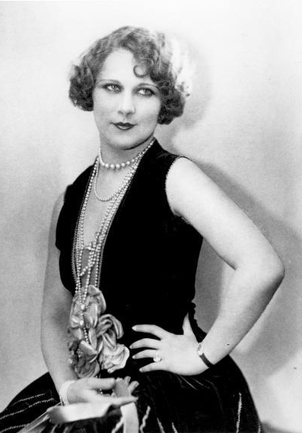
The following Monday Guillaux made twelve flights, On one of these the passenger was Miss Louise Carbasse, (left) then a 19 year-old Australian actress. After the war, she became a well-known Hollywood actress under the name of Louise Lovely. Three days later, in a flight above the harbour, he travelled at over 100 miles an hour, thanks to strong tailwinds.
Hordern and Guillaux announced plans to fly the seaplane from Sydney to Melbourne. The men remained on very good terms. Guillaux announced plans to remain in Australia to establish a flying business, his compatriot Jean Claude Marduel becoming involved (page 38).
Lebbeus donated the Farman to the defence forces at the outbreak of World War I. It became CFS 7, the seventh aircraft at Point Cook. It was sent on HMAS Una to take part in the capture of German possessions in New Guinea, and though it was not used, this was the first overseas military deployment of an Australian military aircraft.
After the war Lebbeus imported several other seaplanes, and they took part in many exciting flights. The decision to build the Australian seaplane carrier HMAS Albatross, announced in 1925, may well have been influenced by the publicity gained by Hordern’s seaplanes. Flying boats remained a major part of Australian aviation until the late 1960’s.
After two divorces, family squabbles and sundry mental problems, Lebbeus Hordern was found dead at his home on September 10, 1928 of ‘a self-inflicted dose of barbiturates’. It is not certain whether this was deliberate or accidental.
In 2014 a flight of 16 seaplanes flew over the harbour on 11 May to commemorate the centenary of Guillaux’s flight. A short ceremony was held at the Rose Bay RSL club, adjoining the flying boat base.

7: The journey south: Wagga Wagga and Albury
The following weeks Guillaux travelled to Melbourne, giving performances en route at Wagga Wagga and Albury, using the standard program: an aerobatic display close to the spectator venue, followed by a flight into the distance with another aerobatic display as he returned.
A certain Mr Kyrle was often present, notably at Albury and Wagga Wagga. He was sometimes listed as ‘manager’ but was not a usual member of the support group. He took ‘living pictures’ for a firm called ‘Panama Expositions’, and had been doing this since at least 1908. He showed 1000 feet of ‘living pictures’ of Sydney, and took other film of both cities and Guillaux’s displays. These were sent to Sydney for processing, and shown a few days later in both cities. Sadly the National Film and Sound Archive has none of these films; indeed, we have found less than two minutes of movie film depicting Guillaux in Australia.
The travelling party was welcomed at each city. At Wagga Wagga, when they attended the movies, they were presented with gifts provided by Huthwaite’s Department Store.
The Urana Independent and Clear Hills Standard gave a full report of Guillaux’s display at Wagga on May 16. Special trains had been run from Junee and Culcairn, and they were packed with passengers. The paper estimated that 8000 people paid for entry to the racecourse and another two to three thousand people gathered outside. They were thrilled by the daring aerobatics, one of the most spectacular being a vertical dive that pulled out only just above the watching crowd.
Australian aviator Harry Hawker had visited Wagga the previous March. This had been a sensation: special trains had been run to his performances, but Guillaux’s display was more spectacular. Despite a tendency to favour the Australian, the newspapers were again in raptures about Guillaux’s performance – ‘all other aviators pale before him’.
Alderman Frere was credited with arranging the display at Albury on 23 May. Alderman Frere was of French origin and Guillaux appreciated his support.

8. Melbourne performances, 28-30 May 1914
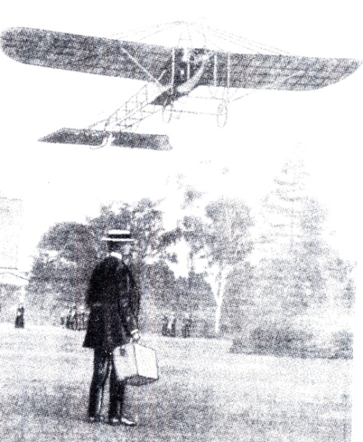
On 28 May Guillaux landed in the grounds of Government House, Melbourne. The Governor-General, Sir Ronald Munro Ferguson, his wife, the Governor of Victoria, Sir Arthur Stanley, and his wife were present. Lady Stanley conversed with Guillaux in French. The machine was carefully inspected. Lady Stanley called for a chair upon which she stood to get a better view of the controls. The picture on the left, taken from a movie, shows Guillaux taking off from Government House.
Guillaux performed an aerobatic show, and then returned to his base, the Flemington Showground, where he was congratulated by Lieutenant Harrison, of the Australian Flying Corps, who obviously invited Guillaux to visit Point Cook, where the first military flying school in Australia had commenced operations on 1 March 1914. The Argus reports that Guillaux had no problems in flying to Point Cook, but his mechanic, travelling by car, became bogged en route. Guillaux gave a flying display and also flew in one of the Point Cook aircraft over the Point Cook area. He congratulated the government on its establishment of the base and stated that Point Cook was an excellent site for the purpose.
The Governor-General was among the 25 000 to 30 000 spectators who attended his display at Flemington on Saturday 30 May. The standard program was performed, and was rapturously received. As the Herald reported ‘Melbourne people... had certainly seen nothing which even approached this in sensationalism. M Guillaux was to Mr Hawker as a Drury Lane melodrama is to a repertory play’.
There is no doubt that Guillaux spoke very little English, but the Herald printed a lengthy interview, which the sensationalist Truth made the target of considerable ridicule.

9. Guillaux in Bendigo and Ballarat (8 June – 14 June)
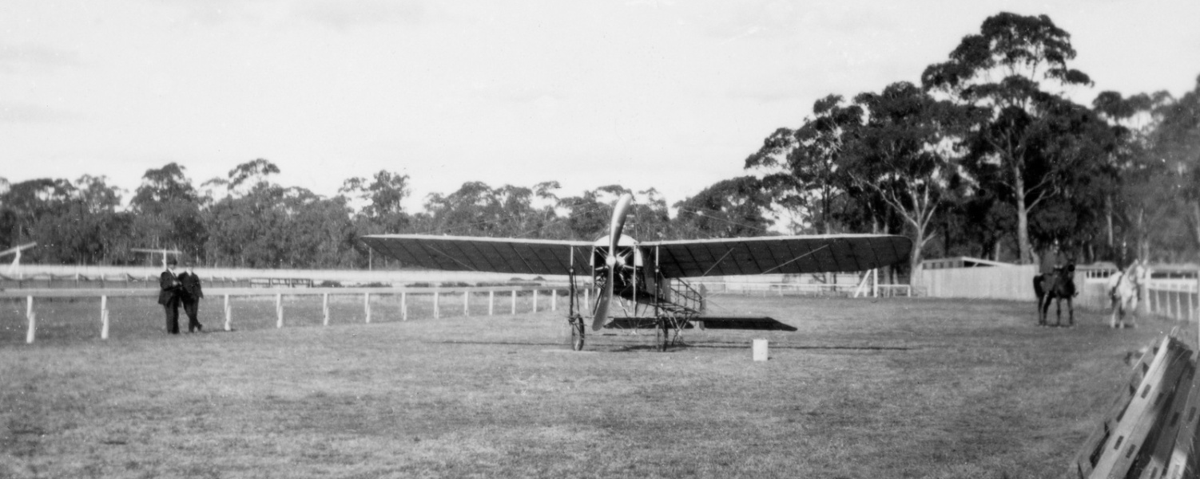
This wonderful picture, from the collection of Kevin O’Reilly, shows the Bleriot on the ground at Bendigo racecourse. It was taken on June 8, 1914, by local doctor Ken Skues.
The Australian ‘manager’, Albert Sculthorpe arrived in Bendigo on 4 June. He had to negotiate with the football club so that the performance did not clash with the game. There was considerable criticism of this in the local papers: people could see football every week, but had only one chance to see the flight.
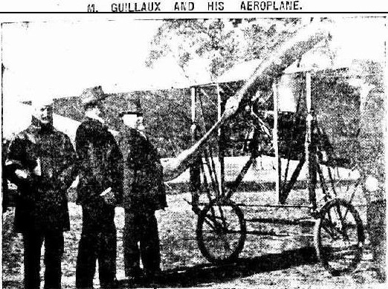
Guillaux with (L to R) Mr S Lazarus, president of Bendigo Jockey Club, Councillor R H S Abbott and Mr R Putnam secretary of the Jockey Club (barely visible on right).
Guillaux was in Sydney on Friday 5 June, flying Lebbeus Hordern’s ‘hydro-aeroplane’, but left that night for Bendigo.
His performance in Bendigo was on Monday 8 June, the King’s Birthday holiday. He stayed at the Shamrock Hotel, which is still standing. The performance followed the usual pattern, described as usual in glowing terms.

Bendigo to Ballarat
On Tuesday 9 June 1914, Guillaux flew from Bendigo to Ballarat. This in itself was a rare event: the aircraft was typically moved from town to town by train.
The newspapers publicised the route that would be followed and reported on it in detail. The Elphinstone News column in the Kyneton Guradian reported that the birds were terrified of the aircraft, ‘magpies by the score could be seen and heard flying away as fast as their wings could carry them’. They could clearly hear the aircraft as it passed over Castlemaine.
On arrival at Ballarat, he handed to the Mayor, Councillor Brokenshire, a letter from Councillor Andrew, the Mayor of Bendigo. Guillaux was also greeted by the City Clerk, Colonel R E Williams, Mr H Turnover, and Mr Gordon Chirmside, and he had a letter for Miss Bell, the daughter of Councillor Bell.
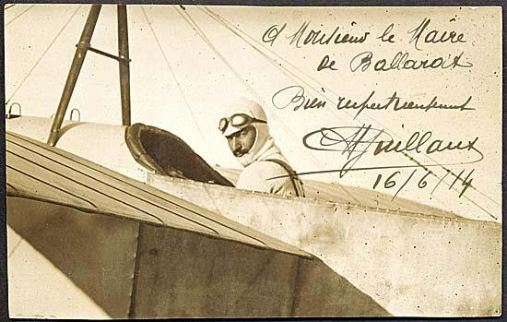
These articles constiuted a very early ‘unofficial’ air mail.
This postcard was also carried on the flight. In 2008 it was sold for $35,000.

The Ballarat Performance
The standard performance was again given at Ballarat on Saturday 13 June with special transport to the Epsom racetrack, where a band entertained the crowd until the flying display began at 3pm.
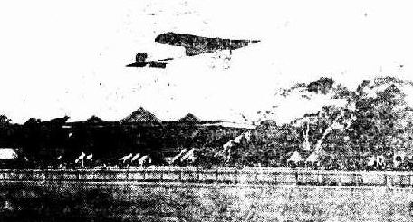
Guillaux made three flights, the second being cut short by failure of a spark plug. But in the third flight, ‘there was more sensation, head-diving, turning on the side, and upside-down flying, and this time a much higher altitude had been reached. Up and up the machine climbed, and suddenly it grew greyer and less distinct, and the onlookers realised that it had entered the clouds. Seven thousand five hundred feet, or so Guillaux estimated the height. It was getting late by the time the exhibition closed, but all waited to see the end of it, and went away more impressed than ever with the possibilities of aviation’. In Ballarat the football game occurred at the same time as the flight demonstration; crowds were small at the football, with many people distracted by the presence of the aircraft nearby.
The Ballarat Courier reporter said that thousands of people stood on the mullock heaps adjoining the racecourse, and during the performance Guillaux made another of his terrifying dives towards one mullock heap which was crowded with people. ‘When about 20 or 30 feet away, Guillaux deftly righted the machine and continued his flight. …….one portly individual who attempted to run down the heap fell down and rolled to the bottom. The mullock heap crowd will not quickly forget Guillaux’s visit to Ballarat’. (Dalesford Gazette).
While loading his aircraft on the train at Ballarat Guillaux and Repusseau lost £206 which was stolen from a coat left temporarily on a fence. This included a cheque written by Mr A Sculthorpe for £146, in favour of Mr Turnover, of Pathe’s Pictures.

10. Adelaide Performance, 20 June.
On 8 June 1914 the Adelaide Advertiser reported the imminent visit of Guillaux, but not very enthusiastically. They had already seen A W Jones fly in that city.
On Friday 19 June Guillaux flew over Adelaide, creating the usual high degree of interest, with a few aerobatics to whet the people’s appetite for the next day’s event at Cheltenham Racecourse. About 15,000 people attended, and as usual the newspaper reports were very positive. The spectators at the football at Jubilee Oval were delighted when Guillaux flew over the ground. The umpire was abused when, ‘with insistent whistle, he commanded players to resume while the airship was still in sight. The game was continued but for a space the crowd were quite unconscious of what was going on, on terra firma’ (Advertiser). Apparently the flight had been pre-arranged with Mr T Pope of Glen Ormond, who had persuaded Guillaux to fly over his home ‘Sunnyside’ where he was holding a party for 300 guests. Guillaux also flew over a parade of army cadets at Unley, and the boys greeted him with a huge cheer. The following Monday evening Guillaux’s party, and their aircraft, left for Melbourne by train.
There is an interesting postscript to this visit. The Bleriot aircraft in which Guillaux flew was purchased in January 1916 by Graham Carey, a remarkable Australian businessman. Aged 41 at the time, Carey had made a career in the transport business, and by 1912 was a prominent motor-car dealer in Ballarat. When he was rejected for active service, he acquired the Bleriot, which had been left behind by Guillaux. He learnt to fly the aircraft, and flew at various displays during the last months of the year 1916. He flew South Australia’s first airmail from Adelaide to Gawler on 23 November 1917, again in the Bleriot. After the war he bought a number of other aircraft. His story is told in A Message from the Clouds, by Des Martin and Bertha Carey.
The Bleriot was seldom used after 1917, but fortunately it has been preserved and remains on display at the Powerhouse Museum, Sydney – one of the world’s great aviation treasures.

11. The Geelong display, 4 July 1914
Guillaux flew from Melbourne to Geelong on Friday 3 July, and this was still an event newsworthy enough to be reported in the newspapers. He ensured that his aircraft was seen by as many people as possible and performed some aerobatics over the city.
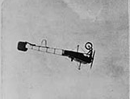
His performance at Geelong Racecourse on 4 July followed the standard program.
He also, for the first recorded occasion, took passengers for flights in the Bleriot, including a young lady Miss Jetta Tivey, daughter of the manager of the Colonial Bank, who ‘enjoyed every moment’ of her 20 minute flight. Mr R N Tournoeur, of Ballarat, was told to hold on to the pilot while he looped the loop.
He flew back to Melbourne the following day, and was caught in a crosswind that he estimated at 45 mph, which blew him southward. However when he descended to about 200 feet the wind was not as severe, and he could reach a ground speed of about 30 mph. The flight took about 70 minutes.
There was no major public performance between the Geelong event on 4 July and his departure for Sydney on 16 July. Guillaux made some minor flights, and on 14 July he made a flight over the city. The Argus described the effect of this – everyone was watching. Traffic came to a standstill.

12: Prelude to the mail flight
Arthur Rickard was a Sydney-based entrepreneur largely involved in real estate development. In 1908, for example, he organised a successful subdivision at Woy Woy, the first of many such deals. A great self-publicist, he approached the American aviator Arthur ‘Wizard’ Stone to fly the first Government official airmail from Melbourne to Sydney. On May 13 ‘Wizard’ Stone announced his plans, with a flight date proposed ‘on or about’ 23 May. This was delayed until 6 June, but on 1 June Stone crashed in Rockhampton, Queensland, while racing against an automobile. He was injured and his aircraft was badly damaged. The flight was cancelled.
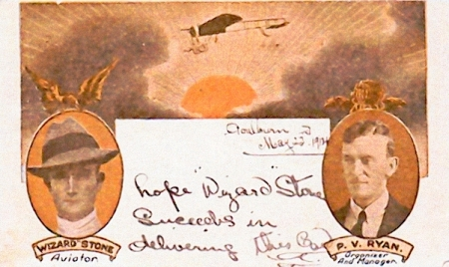
The cards designed for Stone’s flight were coloured. Some were actually sent from Melbourne to Sydney by train, and given special markings. They are quite valuable.
Rickard approached Guillaux to take over that project, but negotiations broke down.
Soon it was announced that Guillaux would make the flight, but exactly who was backing the flight it is a subject for further research. There is quite an amount of information on the subject, most of it contradictory!
The flight would not have been an appealing financial proposition without outside backing: Guillaux could draw crowds of thousands who would pay from one to four shillings each for a single performance, but the total proceeds of the long air mail flight would be much less than this.
On 9 July 1914 Messrs C H Powis and R Sissons of Melbourne wrote to the Postmaster General: With the authority of Mons. A Maistre, manager for Mons M Guillaux, we propose to place on sale post cards for conveyance by aeroplane from Melbourne to Sydney. We should be glad to learn whether your department would permit us to issue these cards and co-operate by placing the cards in a special bag..... and using a special cancelling stamp at this end.
Certainly, Mr Wilson of O.T. Cordials was involved: the aircraft wings were emblazoned with ‘ADD a little O.T.’ and within a few days of completing the flight O.T. had begun a huge advertising campaign. O.T. was the leading beverage manufacturer. As well as producing orange and lemon cordial, it produced an ‘adult soft drink’ simply known as O.T., a mixture of fruit juice and chilli. O.T. later became Kia-Ora, which was in turn taken over by Coca-Cola. The fruit juice for the re-enactment flight was chilli cordial, made to the O.T. recipe by Murray Breweries, of Beechworth, Victoria.
No advertising appears to have been needed to sell the postcards actually carried by Guillaux; there is evidence that over 2000 numbered cards were printed, and indeed that all were sold, but also that only 1785 cards were carried on the flight. The cards may have been quickly designed and printed: the aircraft shown is not a Bleriot.
Original cards sell for from $450. The re-enactment carried cards modelled on the originals with minimum change, eg ‘Re-enactment’ replaced ‘Inauguration’. 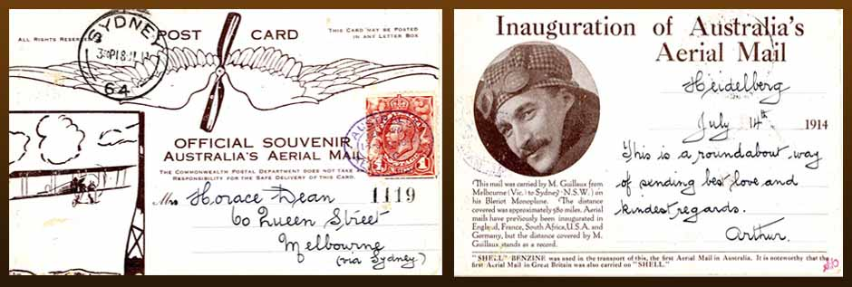
The whole organisation of the airmail flight took less than a month, much to the envy of those organising the re-enactment flight, which took over ten months to plan, even with the advantages of modern communications!

13. The mail flight: 16 – 18 July 1914
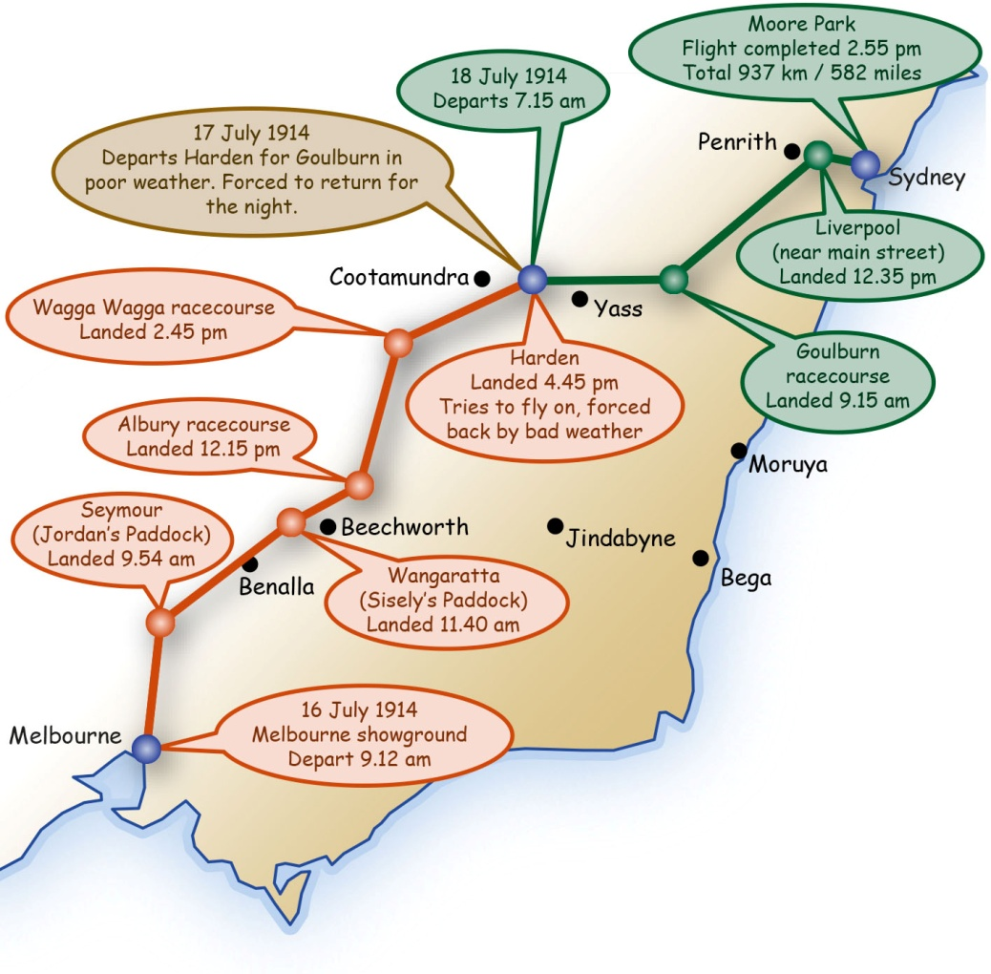
Guillaux began the morning of July 16 1914 at 6 am at the Cafe Denat (80 Bourke Street, Melbourne, now the Florentino Restaurant). After his morning cutlet, he went to the Melbourne Showgrounds and prepared his aircraft.
As well as the postcards he carried letters of greeting for various dignitaries. The O.T. lemon cordial and a quantity of Lipton Tea were loaded. He also had a thermos flask of tea, and his flight made these flasks very popular. He was conscientious in his promotion work for Lipton (see page 29). Fuel was provided by Shell, and this was noted on the postcards. Shell also supported the 1964 commemoration flight. Total Oil Australia, a French company, were the fuel sponsors for the 2014 flight.
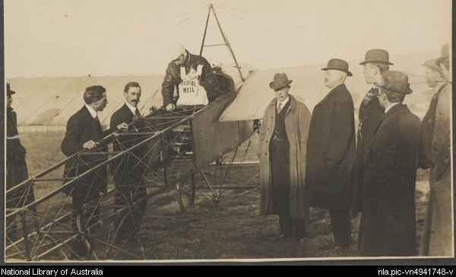
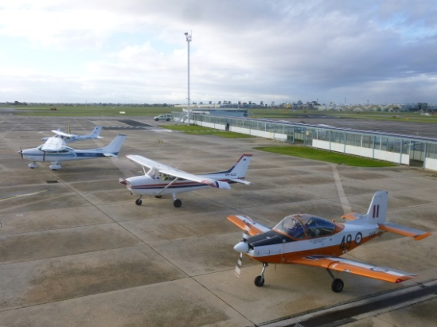
Departure from Melbourne, 1914. The Assistant Postmaster-General, Mr Crosbie, and other dignitaries, farewell Guillaux. Below: 2014: The aircraft leaving Essendon: CT-4 of Michele Schiffer, Jackie Milroy’s Cessna, Aminta Hennessy’s Cessna leading the way to check weather conditions, Owen Zupp in Jabiru at rear.

Seymour, 61 miles, 98 km from Melbourne, arrival 9 54 am
Practically all of Seymour seemed to be at Jordan’s Paddock on the Trawool road (now the Goulburn Valley Highway). According to the local paper, the road ‘presented the appearance of Flemington Road on Cup day. There were motors, waggons, carts, horsemen, paters and maters carrying children, footmen, etc, the whole forming a picturesque group.’ Guillaux’s representative, Monsieur J P Begin, looked after the aircraft, replenishing oil and eleven gallons of fuel. He may also have translated the welcome of the President of the Shire, Councillor George Howe. A bottle of ‘gold-top’ rum was passed around, the drinkers wishing good health to the aviator. Guillaux left at 10 25 a.m. and headed for the next stop, Wangaratta.

Seymour to Wangaratta 84 miles, 135 km, arrival 11 40 am
According to the Euroa Gazette, he was seen from the ground, first ‘by the eagle eye of Mr D Richards’ at Euroa at 10 45. He was at a considerable height and passed over the town half a mile north of the railway station, where many people were gathered. Children had been let out from school to watch the plane as it passed over on a steady direct course for Wangaratta, passing over Benalla at 11 20 am at an estimated speed of 70 mph. Glenrowan was passed at 11 35. ‘Guillaux passed between the school and Mount Glenrowan at a height of 2000 to 3000 feet’ according to the Glenrowan News in the Wangaratta Chronicle.

Wangaratta, 11 40 am to 12 15 pm (35 minutes)
Google Earth shows Sisley Avenue running into Racecourse Road, and the aircraft landed at ‘Mr J. Sisely's (sic) paddock on Racecourse Road’, probably the current racecourse. He landed very close to the beacon fire that had been lit to indicate the landing area and the wind direction. The crowd was, says Nelson Eustis, ‘larger than Seymour, but would have been much bigger had Guillaux not been running three-quarters of an hour early’. A member of Guillaux’s team was present, and they talked in French. Guillaux warned the onlookers in English, which he seldom spoke – ‘keep back, no smoking here’. Fuel and oil were supplied by Mr J Hickey. The mail train, which had left Melbourne three hours before Guillaux, arrived just as Guillaux was preparing to depart, and ‘had many wondering whether or not trains were becoming a trifle old-fashioned’. ‘If the landing was graceful, the soaring upward was superb. No tremor, no flutter of a wing as with a bird; but just as if some invisible power was lifting the machine it rose from the earth; then, sweeping around, the latest Australian Mailman came back over the town and sped off direct for Albury’ (Wangaratta Chronicle)
Guillaux’s aircraft was the first to land at Seymour and Wangaratta.
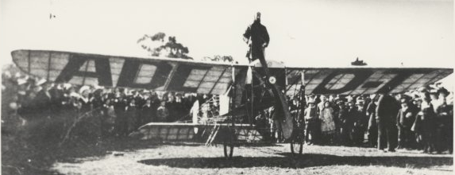 nla.pic-vn3723553 (E.A Crome collection)
One of the few good-quality photos of the airmail flight: Guillaux at Wangaratta.
Guillaux’s Bleriot was the first aircraft to visit Seymour and Wangaratta.

Wangaratta to Albury 45 miles, 75km, arrival 12:15 pm
There was no need to land at Albury. Guillaux could have flown on to other centres, possibly even to Wagga. But he wanted to meet his compatriot, Alderman Frere, again. He had performed in Albury on May 23, 1914.
After leaving Wangaratta, the airman is quoted as saying ‘I rose high and the cold was intense. Just as I was approaching Albury the machine rocked and fell into innumerable air pockets.’ But another report says that he passed over Beechworth at a height of 40 to 50 feet.
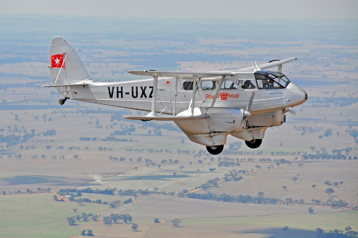
He flew over Chiltern, between Wangaratta and Albury, at 12.30 pm and as usual there was a huge crowd in the streets to see him pass over.
This DH-86 Dragon-Rapide of 1930s vintage participated in the 2014 re-enactment, flying from Benalla to Wagga Wagga.

Mangalore, Benalla and Temora in the 2014 re-enactment
The landing fields at Seymour and Wangaratta are now urban areas. The re-enactment first called at Mangalore airfield, north of Seymour, then at Benalla, where a flourishing aviation museum has been developed. Later in the journey, a detour was made to visit Temora, home of the world-class Temora Aviation Museum.

Albury, 12:50 pm to 1:35 pm
Guillaux’s aircraft could easily have flown further than Albury, only about 15 minutes’ flight from Wangaratta. However he landed at the racecourse, adjoining the present airport, at 12 50 pm, to see his friend Alderman Frere. The mounted police, under Senior Sergeant Blackburn formed a guard of honour. Among the notable people who were there to welcome him were the chairman of the racing club Mr E J Belbridge, the secretary of the Albury Racing Club Mr J Norman Hayn, Mr and Mrs F C Blacklock, Mr and Mrs H M Hassett, Mrs Kennedy and the Misses Kennedy, Mr and Mrs Gibson from Bulgandra station, Miss Thompson, Miss Cox, Miss Kenneally, Mr C J Williamson, Mr and Mrs G S Read, Mr and Mrs Phil Howard, Mr T H Butcher representing the Shell Oil Company of Australia, Mr F Read representing the Dunlop Rubber Company, Mr McLennan, Mr G A Gray JP, Mr J J Mangan, Miss Howe, Miss McLaurin and Ensign Setterfield. The Mayor, Alderman Waugh, welcomed him and called for three hearty cheers.
Alderman Frere provided a quick lunch before Guillaux took off again at 1 35 pm, with the help of the local Shell agent. This was the only stop at which Guillaux did not have one of his own staff to support him.
The Melbourne Truth, a newspaper completely devoted to sex and scandal, reported that Guillaux was having an affair with one Bessie Harrigan, who originally came from Albury. Guillaux, according to Truth, met her when she was working at the Paris Cafe, a ‘swell Phillip Street Cafe’ in Sydney. Though the 18 July edition of Truth says that she accompanied the group, she is not mentioned in the local newspaper report!

Albury to Wagga Wagga, 79 miles, 125 km arrival 2:45 pm
En route to Wagga Wagga he flew over the town of Culcairn, 32 miles out from Albury. A hoaxer had phoned the shire office and pretended to be one of Guillaux’s mechanics. He asked if Guillaux could land there, and frantic preparations were made for him to land on the Railway Parade. As he flew over, the local newspaper proprietor waved a piece of red cloth impaled on a pitchfork to attract his attention, but he flew on, much to the town’s disappointment. A similar thing happened at Henty, the next town on the route. A large crowd had gathered at Spencers Hotel, a special mail package had been prepared, and petrol was on hand.

Wagga Wagga, 2:45pm to 3:30 pm
As Guillaux approached Wagga Wagga, he saw a crowded racecourse, and landed in the main straight. However, it was the wrong racecourse, and he had landed shortly after a race had finished. He quickly flew off to the correct course, where the Mayor, Alderman McDonough and other councillors were waiting to greet him. One of Guillaux’s support team refuelled and serviced the aircraft. The Wagga Express recorded that ‘sitting in his airship, wearing a comfortable fur-lined leather coat, hooded with a red, white and blue scarf, Monsieur Guillaux wore an expression of excited pleasure and intense satisfaction of his so far successful flight’.
Before leaving Wagga Wagga, he was handed several additional letters to drop off at towns on the route. The weather was fine, and he left at 3 30, arriving at Harden at 4 06 pm.
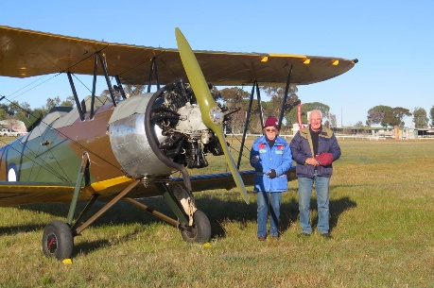
Guillaux had planned to give an exhibition at Harden, but with the weather still favourable and a good tail wind he decided to go on to Goulburn, 94 miles away, expecting to land before darkness. Three miles out of Harden, he encountered a strong head wind, and fearing that he would not reach Goulburn before dark he returned to Harden for the night.
This magnificent Avro Cadet joined the 2014 re-enactment for the flight into Harden.

Harden, 16-18 July
Guillaux spent the night at the Carrington Hotel. Local identity, Mr R J Simpson tells us that the plane appeared ‘to be a mass of wires,’ that townspeople flocked to the racecourse and a police guard was placed on the Bleriot overnight. However the Goulburn Post noted that when the aircraft arrived, there were lots of pencilled messages on it from the people of Harden, so the aircraft must have been accessible to them.
Friday dawned cold and wet in Harden, but nevertheless Guillaux gave an aerobatic display. He apologised for not looping the loop because he did not have the braces that held him in the machine, but somehow he made room for a passenger, and three Harden residents were taken for flights. Stan Brady, of Harden, won his flight in a raffle and was taken for a flight by Guillaux; fifty years later, aged 75, he was again a passenger in a Victa Airtourer of the re-enactment flight.
The following report comes from the Murrumburrah Signal - Monday July 20 1914, provided by the Murrumburrah Historical Society:
Visitors came from Young, Cootamundra, and all parts. Business in Murrumburrah and Harden was entirely suspended all employers giving their hands a couple of hours off. Steady rain commenced to fall shortly after 9am, but in spite of this about 1,000 people went to the racecourse, and stood in the rain for half an hour waiting for the aviator to complete his preparations. Meanwhile they had ample opportunity to examine the wonderful construction the Bleriot monoplane, which is capable of carrying a man through the air at the rate of 132 miles an hour.
About 10.30 the machine was wheeled out on to the course, and M. Guillaux, who had been standing by, smiled good-humouredly whilst the crowd examined his machine, stepped into the seat of the aeroplane. He was clad in a stout leather jacket, leather gloves, and white cap and muffler, while the French colours were attached to the car. The crowd were then made to stand clear, and after giving the engine a short run the aviator started the machine.
After running about 100 yards (95 metres) it rose gracefully and sailed away over Harden, wheeling round over the heads of the spectators and over the grandstand, ascending to the height of about 100 yards as gracefully and as majestically as an eagle. He then slowed his engine down and turned the machine on its side, the wings being perpendicular. After another circle he again ascended and swooped down with a beautiful curve right over the heads of the spectators, rising sharply. He next wheeled round and round, as does an eagle when ascending, turning the machine with wonderful dexterity. Wider and wider grew this circle till at a height of 3,000 feet he wheeled over Murrumburrah; and with a long sweeping curve landed as lightly as a bird on the spot from whence he started. He was greeted with enthusiastic cheers as he landed. M. Guillaux stated that when at a height of 3,000 feet he could not see the crowd on the racecourse, but could see the sun shining above the clouds. Everyone present was delighted with the exhibition, and considered it well worthwhile being wet through to see it. The local arrangements were carried out by Mr W Worner.
Another little sidelight from the Signal: When he landed at Harden on Friday morning, July 17 1914, he stepped from his plane with a carton of tea under one arm and a mail bag under the other. He held the carton up so that the crowd rushing to welcome him could clearly see the name ‘Lipton.’ Then he opened a flask and took a long swig of tea. -This is a good drink to have after a flight,' he said. Guillaux was not only Australia's first long distance flier—he was also one of the first ''flying salesmen’ seen in the country.
The symbolic cargo for the 2014 re-enactment was provided by the Australian company, Madura Tea. It is based in Murwillumbah, NSW.
Lucien Maistre, Guillaux’s representative at Goulburn, telegraphed continuously during the morning reporting extremely bad weather. Regardless, Guillaux took off at 2 pm. Over Galong, 20 miles from Harden, cold headwinds wind and heavy rain forced him to return and spend another night in Harden.
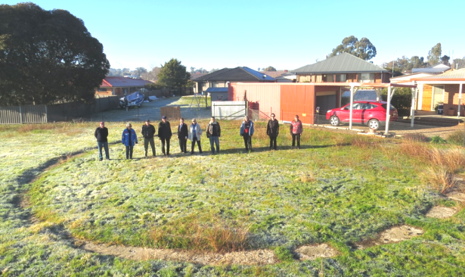
Harden again took a major part in the 2014 re-enactment. 13 aircraft flew into the showground, which doubles as a polo ground and airstrip, and about 20% of the shire’s population, over 1000 people, were present. The very active historical society has researched the original flight and some interesting material has been found.
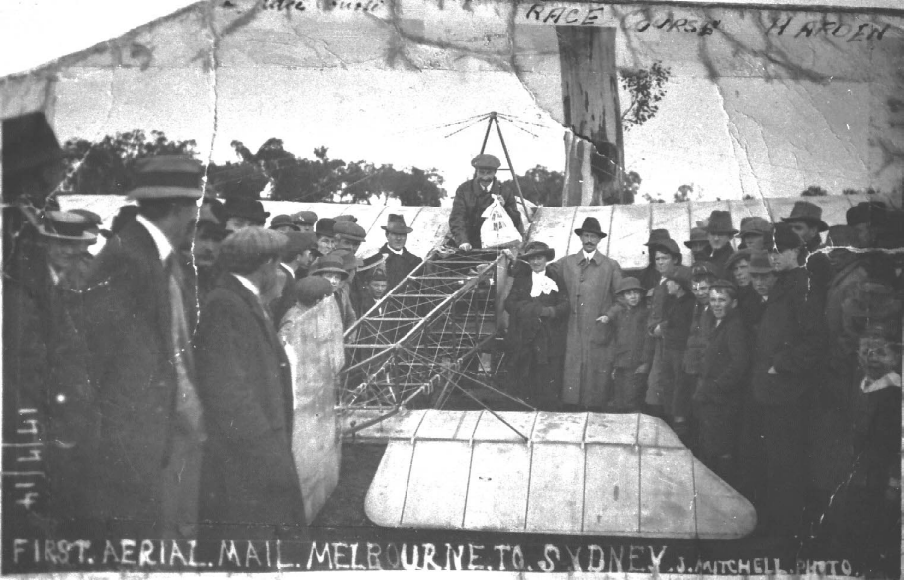
Above: on the ground at Harden, 1914. Previous page: The townspeople marked the landing ground with a circle of concrete markers, in which 2014 re-enactment participants are standing. It is in the agricultural plot of Harden-Murrumburrah High School, and is perhaps the only physical trace of the 1914 flight – or, indeed of Guillaux’s whole time in Australia..

To Goulburn, July 18, 84 miles 135 km, arrival 9 15 am
Next morning, the flight to Goulburn (94 miles) took two hours, indicating a strong headwind. Conditions were freezing. The land beneath the aircraft was rugged; it would have been far more heavily timbered than at present. Guillaux rated it among the worst flights he had ever undertaken. Eventually he was able to follow the railway line into Goulburn.
The previous day Goulburn people had heard that Guillaux left Harden at 2pm on the Friday; they rushed to the racecourse, the children from Bourke Street School being given a half-holiday for the purpose. However at 4pm it was announced that Guillaux had been forced to return to Harden because of adverse winds and freezing conditions.

Goulburn, 8:15 to 11:05 am
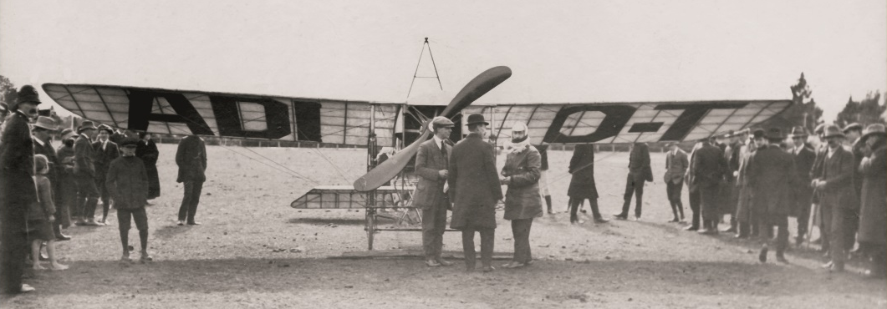
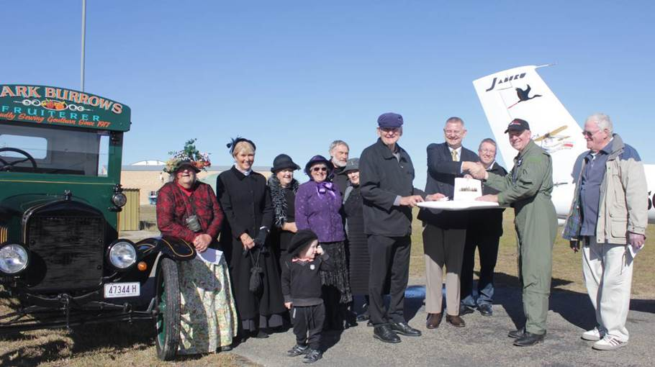
2014 the Mayor (Cr Geoff Kettle) and local historical group members greet the re-enactment group..
1914: the Mayor and Clyde Baxter (shoe factory owner) greet Guillaux.
photo from the Rocky Hill Museum, Goulburn.
The next day Guillaux left Harden at 7 15 am and exactly two hours later reached Goulburn. He battled adverse winds and freezing conditions; when he landed he rushed to get warm at the beacon fire that had been lit on the racecourse. Relatively few people were there to welcome him, but the Post description was ecstatic – ‘with the grace of a bird selecting a resting place M Guillaux issued from the clouds to the west of South Hill shortly before half-past nine this morning, and soaring gracefully over the eminence and descended with a swoop at the southern end of the racecourse and alighted almost in the centre of the ground’. At 9.15 am he landed and hurried to the signal fire to get warm. Those of us who have experienced the bitter cold of Goulburn winter mornings can sympathise with him. He stood by the fire, warming himself and drinking a cup of tea from the thermos he carried with him.
The Post article is a little disjointed: probably it was rather rushed so as to be included in that day’s edition. Through an interpreter, Guillaux described the freezing conditions and the difficulty of navigation; early in the trip he claimed to have climbed to 13000 feet and navigated by compass; he flew over snow-covered mountains. Near Goulburn he had descended below the cloud base, and had to pick his way around tall hills.
The Australia Post mail of 2914 was carried into Goulburn by the formation flight of the Canberra Aero Club.
Guillaux did not give an aerial display, and there is no mention of admission being charged. Many people crowded around the plane, examining it carefully. Guillaux himself supervised the refuelling and checked his machine very carefully, While it was being refuelled, two swans flew over; someone in the crowd compared them with the Bleriot, and Guillaux joined in the laughter.
He took off at 10 am, but was forced to return because of a faulty spark plug. Before his next take-off he ran the engine at high power, with the aircraft’s wheels chocked and three men holding down the tail. ‘The suction from the propeller blades was so strong that the men's clothing blew about as if in a gale of wind and their hats were carried away’...... ‘On his second ascent the airman rose to a height of 1100 feet. He circled the race course and then flew in the direction of Murray's Flat, where he altered his course slightly, evidently to give the people at Kenmore Hospital an opportunity of seeing him’.... ‘It was amusing to watch the horses stampede across the paddocks and a number of birds flying for safety. Guillaux makes the birds look trivial when he takes charge of the air.’

Goulburn to Liverpool 113 miles 180 km, arrival 12:35 pm
Guillaux was scheduled to land at Moss Vale, but because of weather, poor visibility or some other reason, flew on. He claimed to have climbed to 18,000 feet in an effort to find Moss Vale, one of several very suspect statements attributed to him at various times during his career.
In the 2014 re-enactment the flight landed at Berrima Aero Club to recognise the original plan and to allow two very significant aircraft to fly the Australia Post mail to Sydney. In 1914 Guillaux landed in a paddock just behind the main street of Liverpool. After lunch with Mr and Mrs Alfred Cloke, who lived nearby, he left at 2 05 pm; in2014 the best alternative was to land at Bankstown, where the Australian Aviation Museum hosted the arrival of the mail. It was conveyed by a 1904 Delage car and a fleet of other French vehicles to a reception at the Powerhouse Museum, where Guillaux’s original Bleriot XI aircraft is on proud display.

Liverpool to Moore Park 22 miles 35 km arrival 2:55 pm
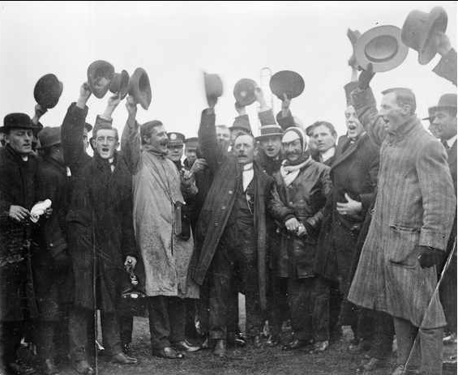
Aided by a good tail wind, Guillaux flew over several football grounds (it was a Saturday) and even over Manly before returning to Moore Park, where he landed at 2 55 pm, to a pre-arranged reception from a huge crowd and dignitaries including the Governor-General and the State Governor. The messages were handed over, and the official party adjourned to the area under the grandstand for drinks and toasts to the success of the flight.
Arrival at Moore Park. Picture: State Library of South Australia.
Guillaux made an appearance that night onstage at a matinee at the Tivoli, and though he only spoke a few words, the audience was wildly enthusiastic.

14. After the mail flight
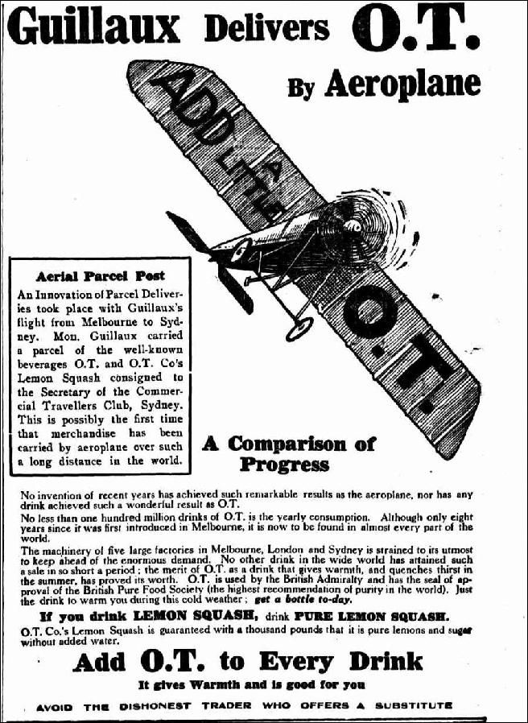
Guillaux had been a celebrity since his arrival in Australia. He often appeared in newspaper advertisements, including one for Hupmobile Cars. But after the mail flight, huge programs of advertising were begun for Lipton Tea and for O.T. Juice. At least 600 placements were made of the O.T. advertisement.
Many newspaper articles were published with accounts of the flight and indeed general comments on aviation. But the shadow of European war was beginning to dominate the news, as the implications of the assassination of Archduke Franz Ferdinand on 28 June began to make themselves felt. On 21 July Austria’s July Ultimatum brought the probability of war to the world’s attention. War ‘officially’ broke out on July 28, with Britain (and consequently Australia) becoming involved on August 4.
Guillaux did some more flying with the Farman ‘hydro-aeroplane’ and staged another flying display at Ascot Racecourse, now part of Kingsford-Smith airport, on 1 August. On this occasion his aircraft crashed after control was lost at a height of about 100 feet, and the aircraft was badly damaged. Guillaux was pulled from the wreckage with bad cuts to his head, but was able to walk to a car which rushed him to hospital after quick treatment from eminent doctors who were at the display.
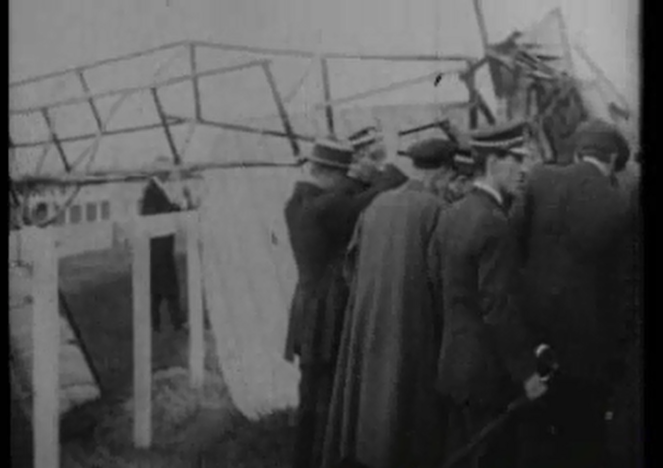
From the film footage: a ‘still’ of the crash at Ascot.
The aircraft was repaired (contrary to some reports) and Guillaux recovered enough to give a display at Bathurst on 12 September. There was a new feature – a demonstration of how aircraft could be used for bombing.
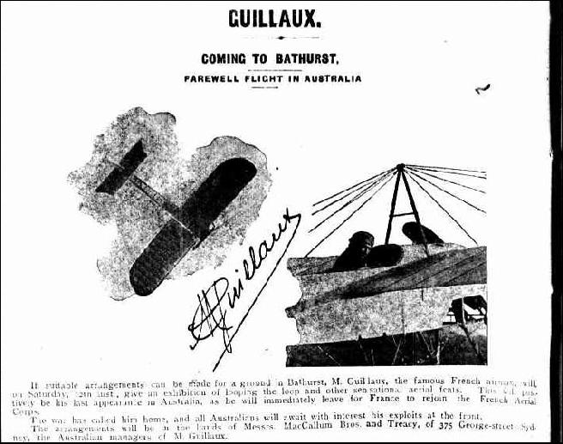But the time for displays was over. Lucien Maistre and Francois Repusseau quickly returned to France. Newspapers first reported Guillaux’s desire to return and then criticised him for not doing so. On 22 October he sailed with the headquarters group of 3 Australian Division, listed as ‘aviator’ on the embarkation list.

15. Guillaux after Australia
After Guillaux left Australia, there was little news of him. On 20 February 1915 the Moorabbin News reported that he had flown, in France, at 144 mph from Savigny-sur-Seine to Paris, thanks to a strong tail wind. The Geelong Advertiser, Saturday 27 February 1915, reported that local man Mr Tivey had received a postcard from him saying that he was off to the front to undertake reconnaissance missions. On 10 May 1915 the Sydney Morning Herald reported that he had begun work testing Bleriot aircraft.
Maurice’s grandson Michel retired in 1981 after a lifetime in the aviation industry and has sent us a photograph of Maurice and his son Bernard in a Morane Parasol P, late 1916 or 1917. There are records of him delivering Moranes to British squadrons between September 1915 and February 1916.
In his book Flying Matilda, (1957), Australian author Norman Ellison describes in detail a flight Guillaux is alleged to have made in 1917, taking five (named) Australians into the air on a Farman aircraft. The story is undated and is not supported by any official source found so far.
On 21 July 1917 the Mail published a rambling article by Private G. A. Oliver,’ Motoring Editor of the Mail’, then in London. In this he said ‘Guillaux is now rumoured to be taking an active part in the war on the German side’. Guillaux had already been dead for two months: he died in a plane crash on 21 May 1917. The ‘spy’ theme was developed by the Melbourne Punch on Thursday, 15 November, 1917 in the article reproduced on the next page. It is quite ridiculous. There is no evidence at all that anything like this event occurred and there is overwhelming evidence to the contrary. Canberra historian Bill Woerlee has forensically dissected the report, pointing out numerous discrepancies and impossibilities. The story itself need not be dignified with further comment, but the way it was spread is interesting – and very embarrassing to Australians.
Over the next six weeks the story was reprinted in at least 40 rural newspapers. The first rebuttal did not occur until 21 December, and an official statement was issued in mid-1918. On 23 May 1918 Punch retracted its story, buried in a page 8 article entitled ‘Views and News’.
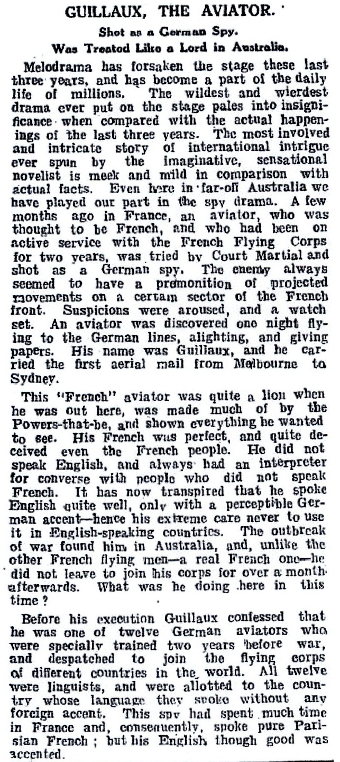
51 retractions or corrections were published in various newspapers before the end of the war, but even after 23 May 1918 the ‘shot as a spy’ story was also repeated at least 8 more times, the latest found so far being on page 1 of The Argus of Saturday 23 November 1940 (soon after the surrender of France). This is the only time it was published by a major metropolitan paper.
During 2014 some Australian aviation historians advanced a theory that the story arose from confusion of the surname Guilllaux with that of Joseph Caillaux. Caillaux was Prime Minister in 1911, but was forced to resign when it was found that he was secretly in contact with German authorities during a time of confrontation. During the war he was the leader of a parliamentary peace party. He was sentenced to imprisonment and exile for treason in 1917 but later returned to public life in France. However it seems difficult to believe that the two cases could be confused because of the relatively few common factors.

16. Australia after Guillaux
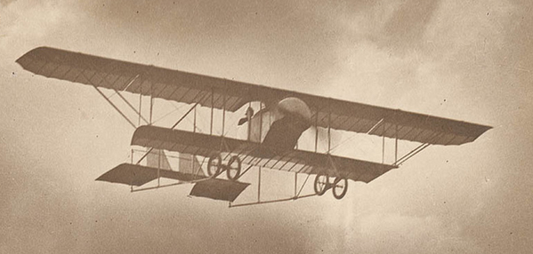
Jean-Claude Marduel, a French associate of Guillaux, briefly carried on Guillaux’s flying activities on Ham Common (now Richmond RAAF base) and later was attached to Australian units overseas. He worked in aviation until his death in 1939 and his story, like that of Guillaux, deserves to be more widely known.
Late in 1914, this Caudron G III arrived in Australia. Maurice Guillaux Guillaux had ordered it on June 10 in partnership with Walter Mc Conochie of Hurstville (see page 12). Marduel first flew it from Ham Common in September 1914 and later flew it from Richmond to Centennial Park. This aircraft later went to Point Cook as CFS 9.
The young Australians went to war, and the survivors became the leaders of a huge upsurge in Australian aviation, and Guillaux’s contribution was lost to public attention. Yet it is remarkable how many aviators and people connected to the aviation industry traced their interest to having seen Guillaux’s remarkable feats, including even Kingsford-Smith and Ross and Keith Smith. Many other Australians were excited and impressed by his activities – my father, who watched him land in Goulburn as a twelve-year old, described to me the excitement of seeing the Bleriot as a little dot in the sky, which became larger and finally landed on the racecourse, to the cheers of the crowd. He remembered the details, even in old age.

17. The final chapter.
Guillaux’s funeral was attended by many notable figures of the aviation world, including the brothers Morane, founders of Morane-Saulnier, M Caudron, M Marlin from the Gnome-Rhone organisation, and the famous pilots Edmond Audemars (another rival of Guillaux in the pre-war competitions) and Georges Guynemer, himself to die later that year.
Many French and British officers also attended. The mourners were led by Maurice’s father and his son Bernard. Maurice was buried in the cemetery of Neuilly-sur-Seine, Nanterre, with an elaborate monument and an inscription from his friends and his widow.
Most Australians know little of his exploits, and in France he is almost entirely unknown. His name is listed on an honour board in the Consulate-General offices in Sydney, as an Australian-French victim of the war. It is an interesting, if inaccurate, recognition of a man who made a great contribution to the development of Australian aviation.
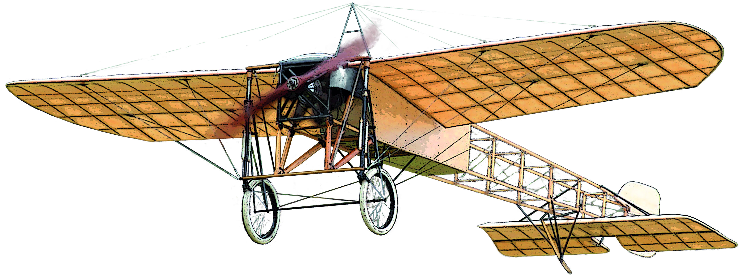
His aircraft hangs from the ceiling of the Transport Hall of the PowerHouse Museum in Sydney. Less than thirty original pre-World War I aircraft survive in the world, and of these undoubtedly the most significant is the Wright Flyer in the Smithsonian National Air and Space Museum, Washington DC; Louis Bleriot’s original aircraft, preserved in the Musée des Arts et Métiers in Paris would be next, and Guillaux’s Bleriot would have an excellent claim to be the third most significant aircraft in the world, because of the remarkable airmail flight and the influence it has had on Australian aviation history.
It is worthwhile making the effort, in this centenary year, to commemorate the epic achievement of the mail flight, and even more importantly, to collect the history of his 197 days in Australia before any more is lost.
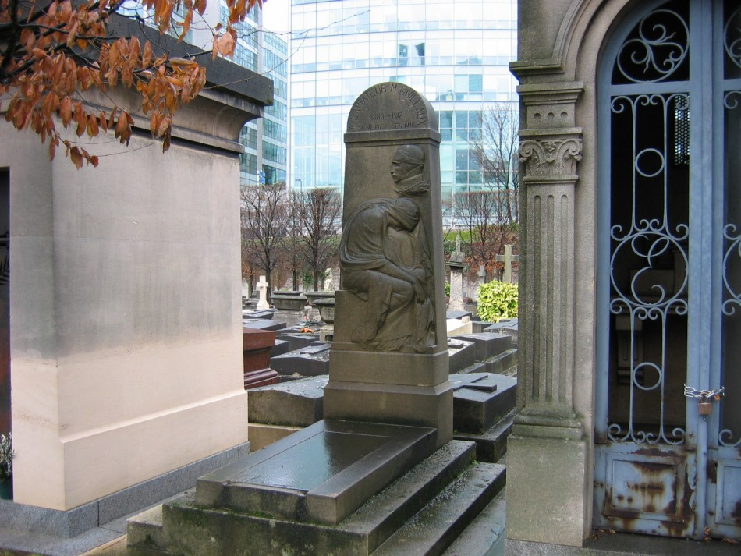
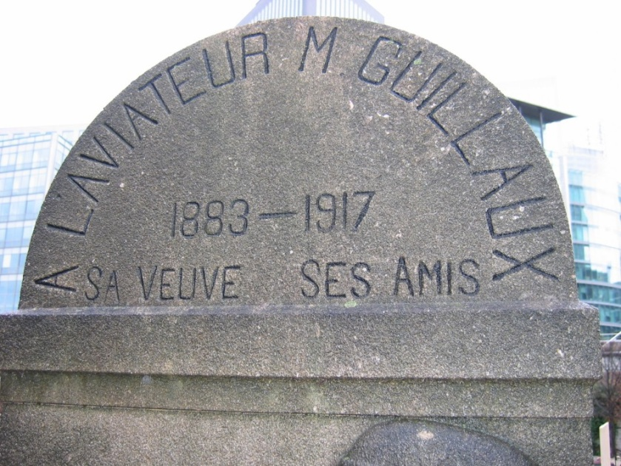
Maurice Guillaux’s grave in Neuilly-sur-Seine cemetery, Nanterre.
The inscription reads ‘To the aviator M Guillaux, 1883-1917, his widow, his friends’. He had married Heloise in 1901 at age 18; she was 17.

The re-enactment flights
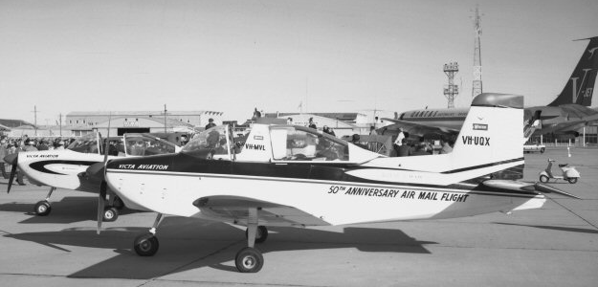In 1964 a major re-enactment of the airmail flight took place. Two Australian-made Victa Airtourers, VH-MVL (flown by Victa's chief test pilot, Vic Walton) and VH-UQX, (flown by Dick Sims) retraced Guillaux’s flight, adhering as closely as possible to the original timetable and carrying a large quantity of commemorative mail, departing Melbourne on 16 July 1964.
As the Victas completed their 3-day trip at Mascot on 18 July, Qantas Boeing 707-138B VH-EBC arrived overhead, setting a new record time of 38 minutes 25 seconds from Melbourne Tower to Sydney Tower.
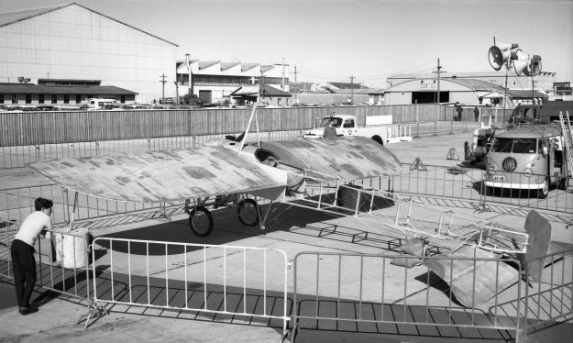
Guillaux’s original Bleriot XI, owned by the Museum of Applied Arts and Sciences at Ultimo, NSW, was displayed at Mascot for the arrival ceremonies.
Nelson Eustis, philatelist and historian of the time, was deeply involved in the orgnaisation of the 1964 stamp issues and the re-enactment flight.
Several varieites of special commemorative envelopes were carried on the 1964 flight and speical stamps were issued in denominations of five pence, the standard postage rate, and two shillings and threepence, the standard airmial rate.
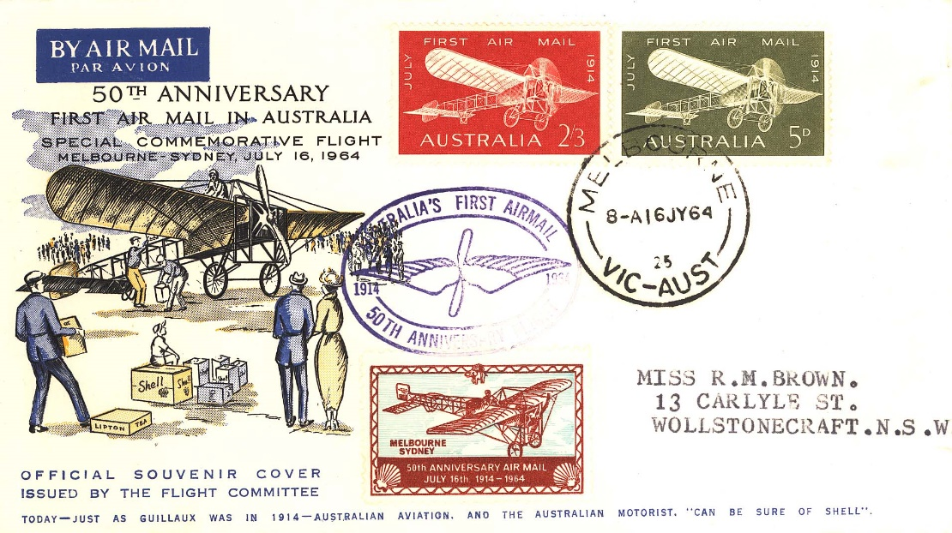
In 1989 a souvenir pre-stamped envelope was carried by Australia Airlines to mark the 75th anniversary of the airmail flight.
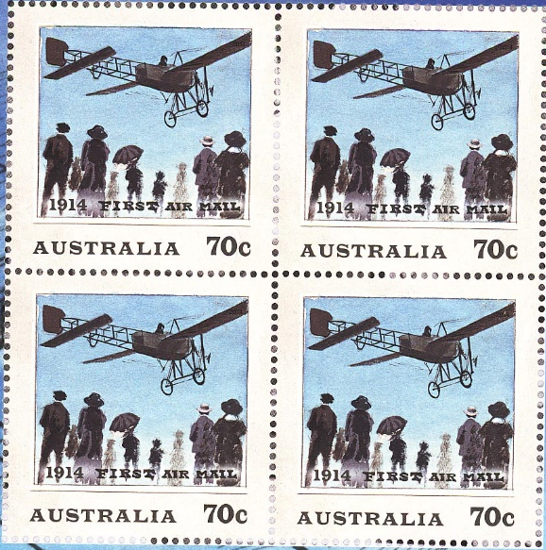
For the 2014 re-enactment, stamps were issued in the denominations of 70 cents, standard postage, and $2.60, the standard air mail psotage.
The designs were based on the original stamp drawing and a photograph by Harold Cazneaux from the collection of the NSW Art Gallery.
Australlia Post issued a number of other philatelic items that were carried in a relay of historic aircraft during the 2014 re-enactment.
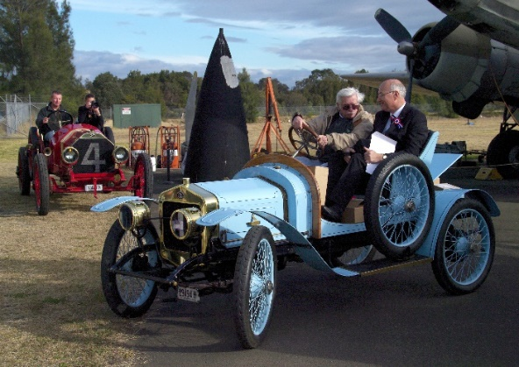
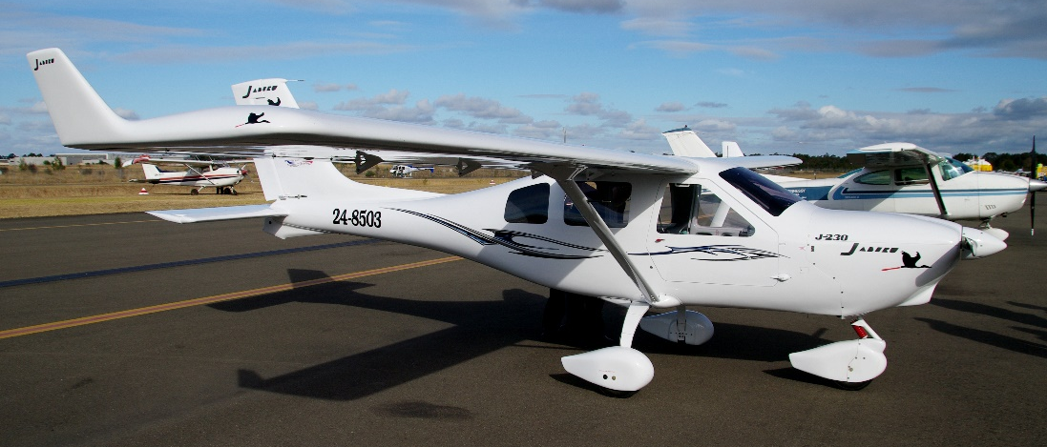
The 2014 commemorative postcards were carried in this Australian-made Jabiru light aircraft, seen arriving at Bankstown on Bastille Day. The mail was then taken to the Australian Aviation Museum, Bankstown in a 1904 Delage car, guarded by the Republican Guard of Sydney.
From there the mail was taken to the Powerhouse Museum in central Sydney where its arrival was the centrepiece of the Bastille Day commemoration.
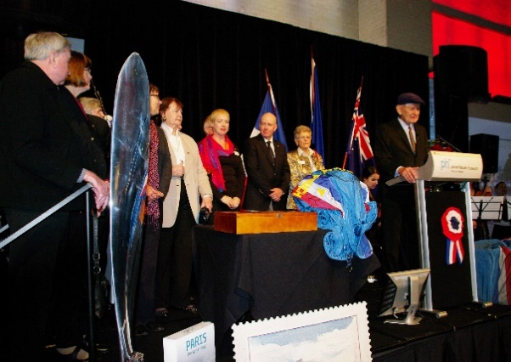
A relay of historic aircraft also carried Australia Post philatelic material and other mail, involving over 30 aircraft, some of which were over 70 years old.
This was certainly the most elaborate commemoration of this type that has been held in Australia, and the enthusiasm of aviators, philatelists and historians reflects a growing admiration of Guillaux’s skills

About this book
There has never been an attempt to cover the complete story of this remarkable man. This little booklet is a start, and eventually a comprehensive and authoritative record can be created from the material gathered. For reasons of space, sources are seldom recognised in this booklet, but the original material is being stored, largely on our website www.australiasfirstairmail.com .
Nelson Eustis’ little booklet 50 Years of Australian Air Mails, published 1964, has been the best single source of reliable information about the mail flight. AHSA recognises with gratitude the permission given to us by his family to reprint his booklet, which did much to kindle enthusiasm for the re-enactment project. Nelson Eustis, legendary philatelist and historian of the last century, was also largely responsible for the re-enactment flight of 1964 and associated philatelic events.
Researchers include (in random order) Ian Debenham, Antony Grage, John Scott, Chloe O’Reilly (Newcastle), Bill Woerlee, Kevin O’Reilly and his publication Flyers of Time, Keith White, Gary Sunderland, Paul and Christine Ewoldt, Bob Piper, Kate Ward and the Historical Society of Harden and David Kelly. From France we have been helped by French researcher André Michel of Montoire and various members of the Guillaux family, (notably his grandson Michel Guillaux) Eric Berti, French Consul-General to Australia and Professor Ivan Barko of IFARS.
Books consulted include the indispensable Flypast, (Neville Parnell and Trevor Boughton, AGPS, 1988), A Message from the Clouds (Biography of R G Carey, by Des Martin and Bertha Carey, privately published 2004), Military Aircraft of Australia 1909-1918 by Keith Isaacs, published by Australian War Memorial in 1971, and Flying Matilda, Norman Ellison, A&R 1957.Thanks to Chris Matts and Percy Lyell, AAMB Bankstown library for their search of magazines which has yielded much information.
Please send additional information, corrections and other comments to guillauxcentenary@gmail.com . Guillaux’s life is well worth recording for posterity.
Tom Lockley, April 2014

There is a record of A W Jones flying at West Maitland on July 12, 1913. However, when he took off to fly to Newcastle on July 15 he crashed; we cannot find records of either Jones or any other pilot flying at Newcastle before Guillaux’s flight.
‘Turnover’ was probably a wrong spelling of the name; a Mr Tournaeur (various spellings) is also mentioned. He appears again on page 19.

