History of Bankstown Airport 1940-2009
Historical notes for a heritage assessment
August 2009

This record was prepared as a briefing for a heritage assessment to be conducted by heritage architects Bruce Dawbin and associates.
It is sad to note that the Australian aviation Museum, Bankstown was closed in 2017. It was opened in 1994 by then Prime Minister Paul Keating, and was a purely voluntary effort. The arbitrary closure of the Museum by the office bearers of the relevant incorporated body was a tragedy. The extensive collection of aircraft was dispersed, but even more distressing has been the loss of the library collection. This incorporated the lifework of Bob Wills, who amassed over 40 m³ of irreplaceable material. It is believed that at least some of this material is in the care of the RAAF, so perhaps it may it be saved. For more information contact Tom Lockley at tomlockley@Gmail.com.
In the meantime we hope that this record is of use.
Chris Matts, librarian
Tom Lockley, archivist
Australian Aviation Museum, Bankstown

Table of Contents
List of illustrations iii
Background 2
Bankstown airport – a timeline 4
Early World War II: the Australian response. 8
The Empire Air Training Scheme 11
Activities in surrounding suburbs 12
The time of crisis: 1942-3 14
RAAF Squadrons of the early period 18
A United States base 20
The role of women 22
Fighter Control Unit and the ‘Bankstown Bunker’. 24
Other units 25
Camouflage 26
Auxiliary airfield at Hoxton Park 30
Other local airstrips 30
The Empire Strikes Back: return of the British 31
Background 33
MONAB II, HMS Nabberley 34
Other MONABs 37
Summary 39
Swords into Ploughshares: The early Post-War years 40
Hiring out the hangars 42
The Royal Aero Club (RAC) 43
The Migrant Camp 44
Bankstown and the Cold War 45
National Service 45
Preparation and Repair of Fireflies, Sea Furies and Gannets 45
Bristol Aeroplane Company 46
De Havilland 46
Air Agriculture at Bankstown 49
Smaller Aircraft Manufacturers 50
KS-3 / Yeoman Cropmaster agricultural aircraft 50
SA-29 Spraymaster 51
Victa airtourer 51
The Transavia Airtruk 53
The 1970s: a boom time for light aviation 55
The 1980s and beyond 58
Demise of the Royal Aero Club 63
Hawker de Havilland: the later years 64
The Australian Aviation Museum 65
Helicopters for bushfire fighting 67
Since 2004: Development Plans, 68
Modern Bankstown 68
The demise of Hoxton Park 68
Development Plans for Bankstown 68
Notes on individual Bankstown buildings 70
Introduction 70
The first building: Hangar 14 71
Hangar 131 73
Hangar 114 – the ‘American’ hangar, 114 Prentice Street 74
Bellman Hangars 75
Hangar 15 75
Hangars 16 and 17: General 76
Hangar 16 76
Hangar 17 76
Hangar 274 77
Hangar 135 77
Hangar 273 77
Hangar 299 79
Hangar 275 and 276: General 79
Hangar 275 79
Hangar 276 80
Singapore Hangars: 271 and 272. 82
Hangar 410 83
Miscellaneous buildings 89
Appendix 1: Notes for Comparative Analysis 91
Criterion A - Historic Value 91
Criterion B - Rarity 91
Criterion C – Scientific 91
Criterion D – Representative 91
Criterion E – Aesthetic 92
Criterion F - Creative/Technical 92
Criterion G – Social 93
Criterion H – Associative 93
Criterion I - Indigenous 93
Statement of Cultural Significance; Significance of the Setting 93
View Analysis, Significant Curtilage 93
From the writers: a final word. 94

List of illustrations
Figure 1: Plan of main historical airport area. 1
Figure 2: Bankstown airport site, 1938 3
Figure 3: Aerial view, 1942 8
Figure 4: Grading the cleared land, 1941 10
Figure 5: Empire Air Training Scheme Avro Anson 11
Figure 6: Brewster Buffalo fighters of 453 squadron, AWM collection 12
Figure 7: Aerial photo of airside area, July 1943 15
Figure 8: Bofors anti-aircraft gun which was sited off Milperra Road, World War II 17
Figure 9: Tiger Moth with bomb rack, 1942 17
Figure 10: Crash of a Kittyhawk at Bankstwon, February 22, 1942 18
Figure 11: 82 squadron Kittyhawks, Bankstown, 1943 19
Figure 12: Radio and electrical shack of 82 squadron 19
Figure 13: AWAS personnel at Bankstown searchlight station 22
Figure 14: the first WAAAF officers at Bankstown 23
Figure 15: WAAAFS, 1942 23
Figure 16: Interior of 'Bankstown Bunker' 24
Figure 17: William Dobell painting, Bankstown 1943 26
Figure 18 Camouflaged Magazine at Bankstown, 1941 27
Figure 19: Max Dupain photo of camouflage 27
Figure 20: Airfield in July 1943 28
Figure 21: Sketch of airfield camouflage, 1943 29
Figure 22: Cartoon – source unknown, but illustrating the unusual speed with which the MONABs were created. 32
Figure 23: October 1945: Aircraft to be dumped after the surrender of Japan 36
Figure 24: Aircraft being dumped from HMS Unicorn somewhere off the coast of NSW 36
Figure 25: Schofields at the end of the war 37
Figure 26: Jervis Bay MONAB 38
Figure 27: RAC fleet, about 1947, outside Hangar 14 43
Figure 28: Sea Fury fighters in Hangar 131, 1955 45
Figure 29: Bristol Sycamore helicopters, Hangar 275, 1955 46
Figure 30: De Havilland Drover at Australian Aviation Museum, Bankstown 47
Figure 31: Collision of Tiger Moth and Vampire, October 1960 48
Figure 32: Air Agriculture staff outside Hangar 17, 1970 49
Figure 33: Cropmaster KS-3 at Bankstown 50
Figure 34: YA-1 Cropmaster, Ashburton Museum, New Zealand 51
Figure 35: Victa Airtourer prototype VH-MVA at Bankstown, October 1962 51
Figure 36: Airtruk PL-12 exported to Sweden 53
Figure 37: Plan of airport, 1972 55
Figure 38: plan of airport, 3 February 1983 58
Figure 39: 1985 aerial photo 60
Figure 40: Aerial view, 24 April 1989 61
Figure 41: Bankstown Grammar School, Link Road, established 1986 62
Figure 42: Aerial View, 1997 62
Figure 43: Pilatus PC-9 under construction at de Havilland, Bankstown 64
Figure 44: Inauguration of Australian Aviation Museum, February 1994 65
Figure 45: interior of AAMB hangar 66
Figure 46: Current development plans for Bankstown Airport 69
Figure 47: Airport Drive, 'spine' of the older airport 'triangle' 70
Figure 48: Hangar 14, showing 'sawtooth roof' 71
Figure 49: Hangar 131, currently used by Ambulance Service. 73
Figure 50: The 'American' Hangar, Hangar 114 74
Figure 51: Bellman Hangar no 17 76
Figure 52: Hangar 275, currently Hawker Pacific (Boeing) 80
Figure 53: Hangar 276 - currently Illawarra Aviation and others 80
Figure 54: C-47 in hangar 271, featured in 1998 film ‘The Thin Red Line’ 82
Figure 55: Mascot 1929 83
Figure 56: Detail from previous picture: E indicates the hangar under construction 84
Figure 57: Mascot panorama, listed as c.1935 85
Figure 58: Detail from Mascot panorama, c 1935 85
Figure 59: Mascot 1940 86
Figure 60: Detail from Mascot 1940 panorama 86
Figure 61: Plan of Mascot airport, 1941 87
Figure 62: Hangar 410 being erected at its present site, 1962 88
Figure 63: RAC at Bankstown, ca 1965. 88
Figure 64: Workshop area, Klemm Street 89

Figure 1: Plan of main historical airport area.

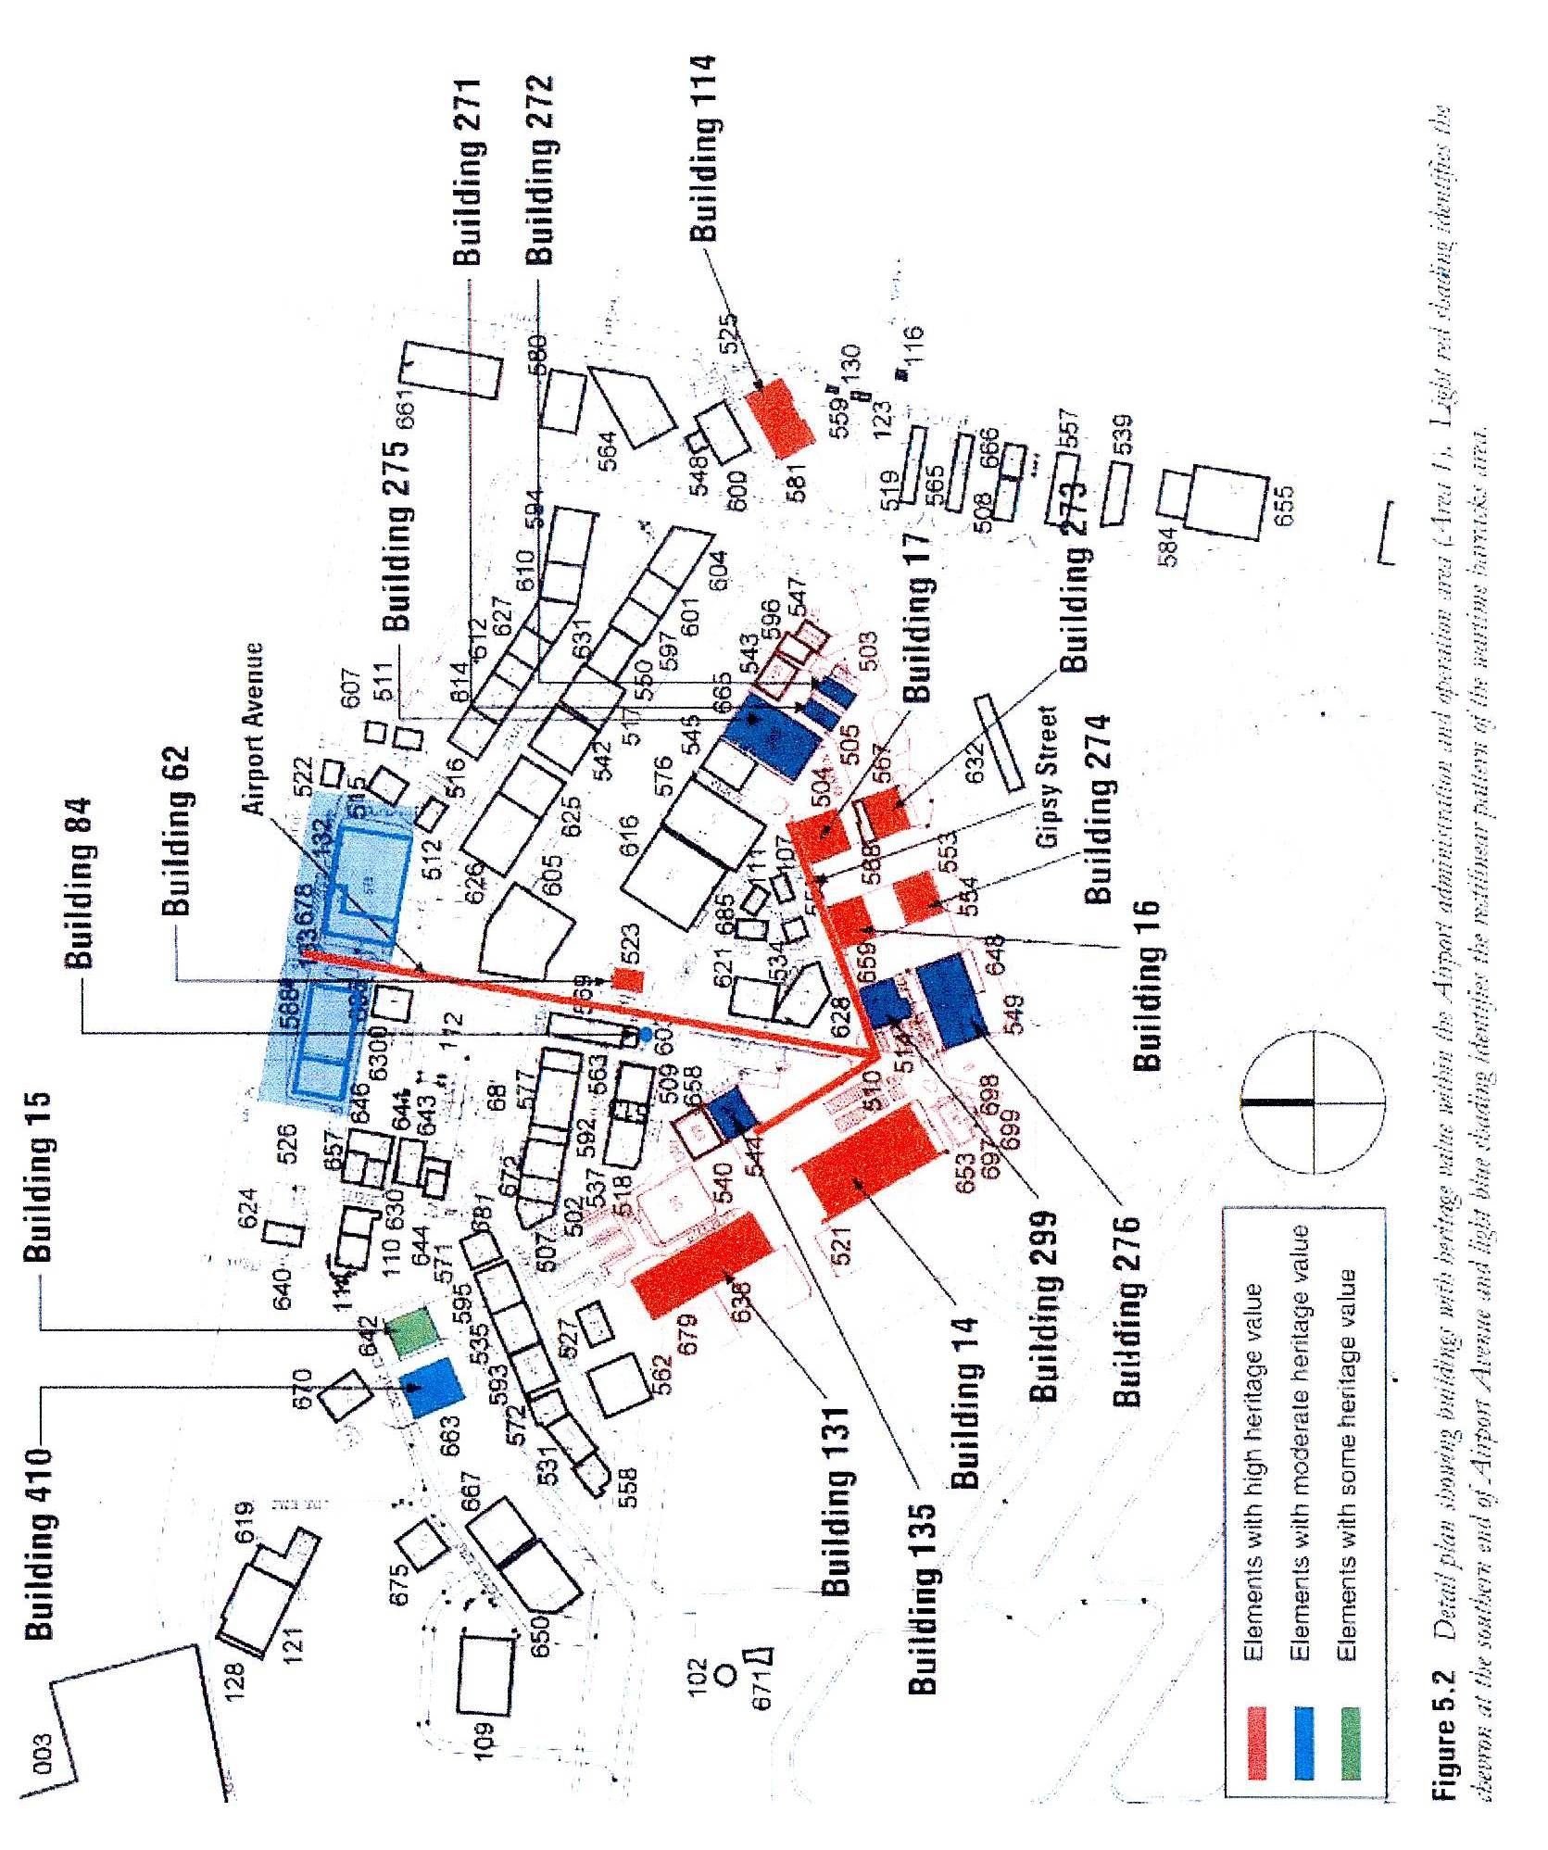
Background
…. a little boat of eight feet long, called Tom Thumb, with a crew composed of ourselves and a boy, was the best equipment to be procured for the first outset. …….We proceeded round in this boat, to Botany Bay; and ascending George’s River, one of two which falls into the bay, explored its winding course about twenty miles beyond where Governor Hunter’s survey had been carried.
The sketch made of this river and presented to the governor, with the favourable report of the land on its borders, induced His Excellency to examine them himself shortly afterward; and was followed by establishing there a new branch of the colony, under the name of Bank’s Town.
From Matthew Flinders, A Voyage to Terra Australis, published in 1815

The Georges River, in pre-European times, was an informal boundary between various sections of the Dharug language group and the Dharawal language group..
The Georges River catchment was home to a number of Aboriginal clans who belonged to Dharawal Nation: the ‘Saltwater People’ of the coastal and bay area, ‘Bitterwater People’ of the lower and middle reaches, and ‘Freshwater People’ of the upper and top reaches.
The first significant European visitors were Matthew Flinders and George Bass, whose record of their October 1795 exploration is featured above. Bank’s Town (sic) was thus one of the pioneer towns of Australia.
Early settlers had disputes with the Darul Aboriginal inhabitants, with attacks on the settlers at Bankstown and Liverpool. After an attack on Frederick Meredith and William Bond on their land grants near Punchbowl in 1809, there were reprisals, notably a massacre at Cataract Gorge in 1816, after which many of the remaining Aboriginals fled to the Burrogorang Valley.
The river provided access for small boats to the Liverpool area, but in general the development of Bankstown was quite slow: the area was not as fertile as for example Parramatta and Camden. The railway came to Bankstown in 1909, over fifty years after it reached Parramatta and Liverpool. The suburb developed after World War I, clustered around the railway station, but the area of the later aerodrome remained rural. Some areas were heavily timbered and there were a few market gardens, dairies and poultry farms.
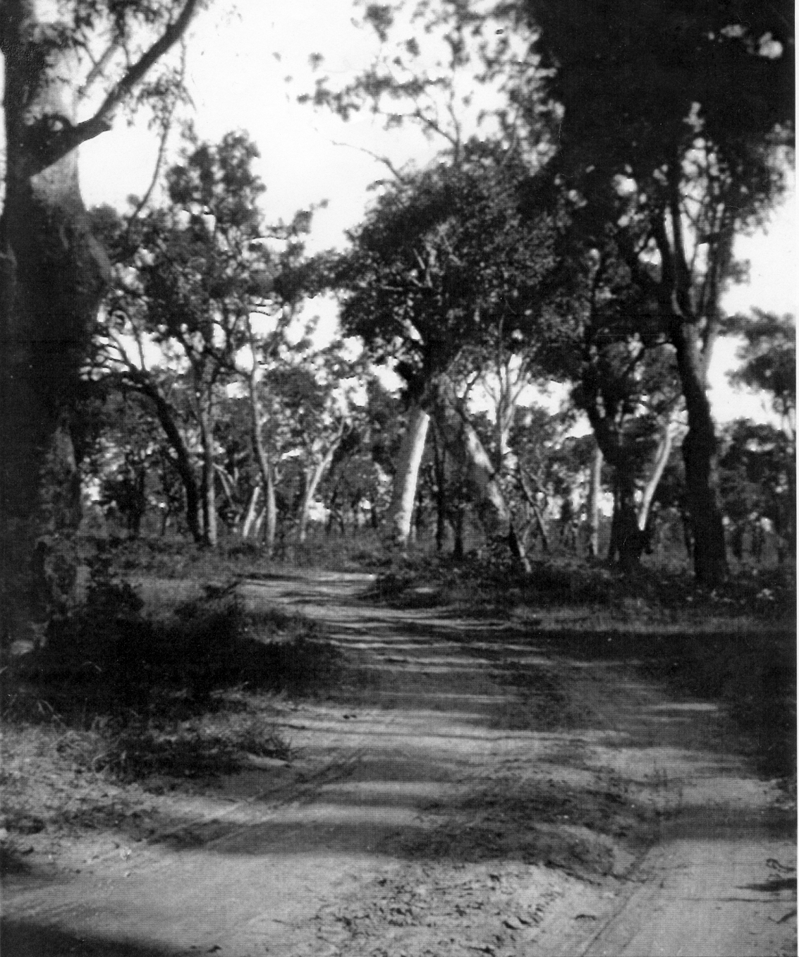
The development of an aerodrome at Bankstown was suggested as early as 1929. Mascot, at the time, was small, and surrounded by swamps, but the need became urgent at the outbreak of World War II.

Figure 2: Bankstown airport site, 1938

Bankstown airport – a timeline
1939-41: Early World War II .
3 September 1939: outbreak of European war
In Bankstown:
June 1940: Bankstown acquired as airfield site: work had already begun
2 December 1940: Formal establishment of Bankstown RAAF station
19 December 1940: No 2 Aircraft Park personnel reached Bankstown
12 January 1940: first aircraft arrived for assembly
3 March 1941: first aircraft assembled, first two hangars finished
9 April 1941: 451 squadron RAAF left for overseas service, finishing the war in Berlin as part of the occupation force
July 1941: 453 squadron left for Singapore, where it performed valiantly during early 1942
10 September 1941: the first WAAAF were trained at Bankstown
During the remainder of the year several batches of aircraft were erected and dispatched to other bases. Two more hangars, and many other facilities were erected. Camouflage of Bankstown airfield was carried out.
1942-3: The time of crisis:
7 December 1941: attack on Pearl Harbour begins Pacific War
Four months later, Hong Kong, Vietnam, Malaya, Thailand, Singapore, Burma, most of modern Indonesia, New Britain, the Solomon Islands, the Philippines, and much of New Guinea had been taken by the Japanese. When Singapore fell, 130,000 Allied troops, including 16.000 Australians, were captured. Darwin and Colombo had been bombed, and the Royal Navy had virtually retreated to Africa.
Significant events in Bankstown include:
Early 1942: arming of Tiger Moth trainers as emergency measure
16 February 1942: Arrival of Headquarters squadron and 7 Fighter Squadron of 49 Pursuit Group, USAAF, at Bankstown with Airacobra fighters
25 February 1942: establishment of Fighter Control Unit 101 to co-ordinate fighter defence of Sydney
7 April 1942: Arrival of 41 Fighter Squadron of 35 Pursuit Group, USAAF, with Airacobra fighters
30 May: Flight over Sydney by Japanese aircraft launched from a submarine preparatory to the midget submarine attack on Sydney Harbour that night
7 June: Shelling of Sydney and Newcastle from Japanese submarines offshore
July: Re-establishment of 24 Squadron RAAF to defend Sydney with a mixed group of aircraft
September 1942: Arrival of 452 squadron RAAF as part of a Spitfire wing to defend Darwin: moved to Northern Territory in January 1943
28 October: Completion of the ‘American’ Hangar no 114 on Birch Street
11 April 1943: 76 squadron RAAF re-equipped with Kittyhawk P40M aircraft and sent to New Guinea on 14 June 1943
18 June 1943: Formation of 82 squadron RAAF at Bankstown, equipped with P40M Kittyhawks, sent to New Guinea in May 1944
22 July 1943: First Australian-built Mosquito fighter-bomber flew at the new de Havilland factory at Bankstown: 212 were built
Throughout the period:
Building of de Havilland factory on southern side of aerodrome
Continuing erection of aircraft
Construction of Hangar 131, Hangars 271 and 272, and Bellman Hangars 16 and 17, continuing development of accommodation including a hospital
1944-45: The Empire Strikes Back: return of the British
By mid-1944, the German navy was practically defeated, and the Royal Navy returned to the Pacific with a large fleet, for which Bankstown became a major air base.
December, 1944: first Royal Navy workers reach Bankstown
January 18, 1945: The first assembled aircraft was test flown
January 29, 1945: Bankstown RAAF, handed over to the Royal Navy was commissioned as HMS Nabberley
January-August, 1945: Preparation of aircraft for use by the British Pacific Fleet; acting as host for aircraft from visiting aircraft carriers, acting as home base for three RAN Fleet Air Arm squadrons, supporting other British bases throughout Australia and northern countries.
15 August 1945: VP day, end of war against Japan; HMS Nabberley was involved in the return of prisoners of war from Japanese camps, and the disposal of aircraft
During the Nabberley period many new buildings were constructed, including accommodation huts, ancillary buildings and Hangars 275, 276, 299,
21 January 1945: The semi-underground ‘Bankstown Bunker’ was commissioned as headquarters for the Air Defence of Sydney
1945- 70
31 July 1946: HMS Nabberley was closed and Bankstown was handed back to the RAAF
Principal activities were:
Disposal of military aircraft by dumping, dismantling, or converting transports and training aircraft for civilian use
Hire of hangars and other buildings to various aviation enterprises, many of whom moved from Mascot because of its emphasis on the development of major airlines
Transfer of the Royal Aero Club from Mascot to Bankstown
27 January 1949: The ‘Bankstown Bunker’ ceased operation as ADHQ Sydney
23 January, 1948: first flight of the Australian-designed de Havilland Drover airliner at Bankstown
1 November 1948: Bankstown airport came under the control of the Department of Civil Aviation
29 June 1949: first flight of de Havilland Vampire, the first jet plane to be built in Australia
1949: Migrant Workers Camp set up in former barracks and some new buildings
1950: provision of street lighting, floodlighting for the control tower
1951 to 1967: Fairey Aviation maintained and modified Fairey Firefly, Hawker Sea Fury and Fairey Gannet aircraft for the Royal Australian Navy in Hangars 14 and 131
1952: the first paved runway
1954: Bristol Aeroplane Company began operations in Hangar 275, eg servicing helicopters
1956: Closure of Migrant Workers Camp
1960- to 1966: production of the Yeoman KS3 Cropmaster aircraft at Bankstown
12 December 1961: flight of the first Victa Airtourer, designed and built at Bankstown. Produced in various forms till 1974
1965:Runway lighting installed; Hawker de Havilland in partnership to produce Macchi MB326H jet trainer
April 15, 1965: first flight of the Transavia Airtruk at Bankstown: over 120 were manufactured until 1998.
10 September 1965: first flight at Bankstown of Aerostructures SA-29 Spraymaster
1970: Construction of the currently used control tower
The 1970s: the peak activity in light aviation
By 1970 Bankstown was the largest general aviation airport in the southern hemisphere, with over 250,000 aircraft movements per annum. This grew to a peak of approximately 400,000 movements per annum in 1980.
In 1970 it was proposed to expand operations using larger passenger and freight aircraft but this was opposed by local residents. So the main business of the airport until the mid-80s was sales, operation and service of light aircraft and pilot training. Helicopters became more common,
The complexity of military aircraft made it difficult to manufacture aircraft in Australia, and firms such as Hawker de Havilland were reduced to making components as part of offset schemes for the purchase of aircraft such as the F-18 introduced in 1984.
April 1987: Assembly of Black Hawk helicopters, from imported kits, for RAAF at Hawker de Havilland, Bankstown
14 November 1987: first flight of the Pilatus PC-9 trainer, 65 of which were built at Hawker de Havilland at Bankstown for the RAAF 1987-1992. This is the last mass-produced aircraft to be made in Australia.
The 1980s and beyond
The period from about 1985 is marked by development of the airport site for purposes other than aviation. Sites on Link Road and Birch Road, and the newly developed Miles Street area are good examples. Bankstown Grammar School was inaugurated in 1986 in Link Road.
Federal Airports Corporation took over the airport in 1988 and plans were made to privatise the airfield.
In 1991 the Royal Aero Club ceased operations at Bankstown.
In 1994 work commenced on the development of the Australian Aviation Museum, Bankstown, which opened in 1998. It now is in the middle of an area being developed for other purposes and will shortly be moved, possibly to Camden.
Bankstown Airport Limited, Camden Airport Limited and Hoxton Park Airport Limited, previously subsidiaries of SACL, were separated from SACL on 29 June 2001. All of the shares in BAL were sold to a private sector company in September 2001 to enable a new phase of development.

Early World War II: the Australian response.
Figure 3: Aerial view, 1942
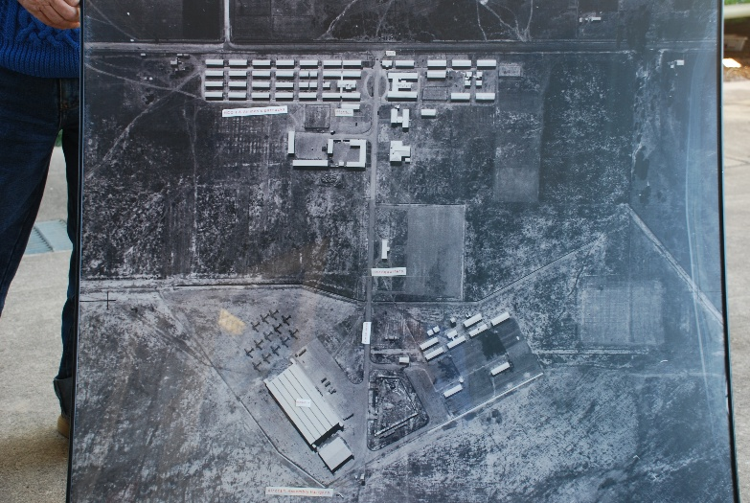
Hangar 14, in operation as erecting hangar, Wirraway aircraft alongside

RAAF Barracks

WAAAF barracks: first intake September 1941

RAAF Headquarters: first stage; parade ground to right

Bellman hangars 16 and 17 under construction

Though Australia entered World War II at its outset, 3 September 1939, until December 9, 1941, the only danger to Australia was from possible German surface raiders or submarines. In this period Australia was mainly occupied in sending forces to assist the European war and to strengthen Singapore and Malaya, our ‘forward defence’ against Japan.
However, a major part our activity involved the Empire Air Training Scheme, (EATS) under which various countries of the British Empire were trained as aircrew and sent to participate in the European war.
This involved the provision of a network of bases, which were mainly in the coastal area stretching from just north of Brisbane to Adelaide; a few were in south-west Western Australia.
The pace of the militarisation of Australia had been steadily increasing since 1934, but it was only with the realisation of the Japanese threat that a real sense of urgency developed. It was apparent that if a major Japanese attack developed while Britain was fully occupied in Europe there would be few British resources available to help Australia. Australia had inadequate infrastructure and relatively little industry, and enormous efforts were made to remedy these problems.
An unprecedented expansion of Australia’s air power was required. The formal proclamation of the Bankstown airfield project occurred under the National Security Act on 7 June 1940, The urgency was such work began immediately: the Act permitted construction to begin even before the land had been officially resumed by the government. The estimated cost of acquisition of the land was ₤60,000.
This speed of action was made possible by the enormous power granted to the director of munitions, Essington Lewis. He was exempt from the rules that regulated officers of the Crown, in particular the Public Service Act (1922). He was empowered to acquire compulsorily any materials or building which he needed; he could issue contracts with private firms without calling tenders; he could spend up to £250,000 on any project without prior approval and he could delegate and revoke responsibilities at will.
The Allied Works Council and the Civil Construction Corps were the bodies that actually did the work. They had sweeping powers to commander any equipment needed, hence the grader seen below was actually ‘borrowed’ from Bankstown council.
The station itself was formed as a separate entity on 2 December 1940 when RAAF Headquarters was established at Bankstown in order to control operations at the new air base and to `take charge of works and facilities’. This was quartered in the first section of the Airport Avenue building depicted on page 89.
The most important early unit at Bankstown was No 2 Aircraft Park, established for the assembly of aircraft. The nucleus of this was formed from No 1 Aircraft Park at Laverton on 1 May 1940. It moved to Bankstown on 19 December 1940 and remained in use until 28 March 1945, when taken over by the Royal Navy Fleet Air Arm. Aircraft Parks were establishments where aircraft, having been assembled, were stored pending dispatch to squadrons or training units.
The first dismantled aircraft – 13 Avro Ansons – arrived on 12 January 1940, and were erected in the erection hangar. This was done even before the hangar was itself completed (on 3 March 1940), when the first Bellman Hangar (Hangar 15) was also completed. The Bellman Hangar was erected in 20 days.
In February the first Airspeed Oxford trainers were received for assembly. The first three complete Oxfords were supplied to the Central Flying School at Camden on March 14 1940. Avro Ansons were supplied to Geraldton in Western Australia during May, June and July.
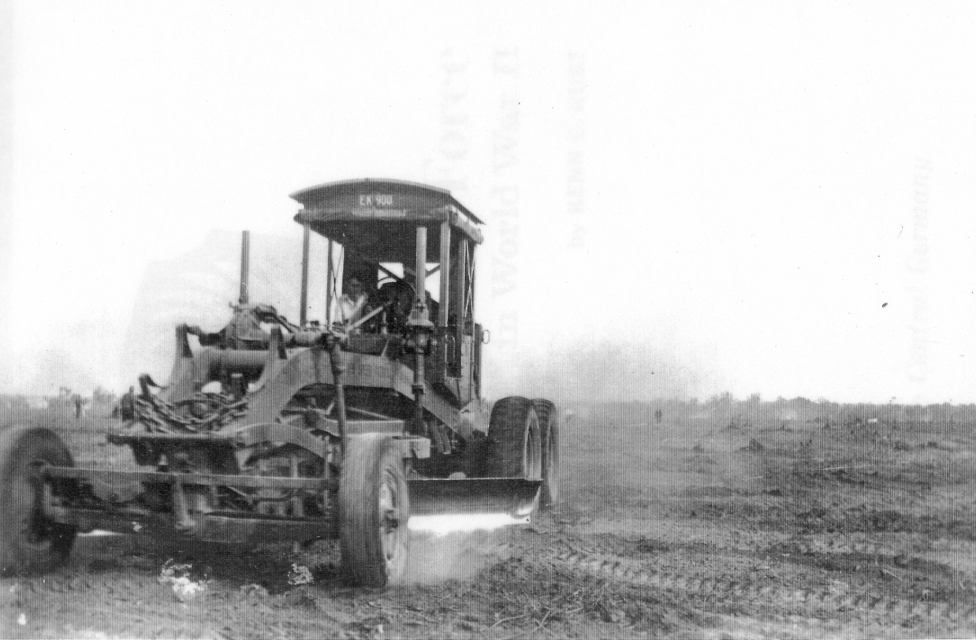
It is clear that much of the general financing for airfield development came from US sources as part of the lend-lease scheme, and that this funding continued at least throughout most of 1943. The Aircraft Park continued to develop during 1944 until being handed over to the Royal Navy as MONAB II.
Figure 4: Grading the cleared land, 1941
Aircraft were supplied from here to at least the following wartime facilities:
Operational airfields at Albion Park and Bulga (Singleton)
Operational Training Units at Williamtown, Tocumwal and Wagga Wagga
Bombing and Gunnery School at Evans Head
Permanent RAAF stations at Fleurs (Kemps Creek, Penrith- also used by US navy), Nowra,
Elementary Flying Training Schools at Temora, Narrandera, Narromine and Tamworth
Service Flying Training Schools at Deniliquin and Uranquinty
Aircraft Depots at Richmond, Forest Hill (Wagga Wagga) and Tocumwal
Air Observers School at Cootamundra
Wireless Operator and Air Gunners School at Parkes
Central Flying School at Camden
Aircraft were also based at Menangle Park, supported by Bankstown.

The Empire Air Training Scheme
At the outset of World War II, Australia joined New Zealand and Canada to establish the Empire Air Training Scheme, to provide aircrew, at that time, for the war against Germany. Avro Anson aircraft were needed as crew trainers, and the idea of manufacturing them in Australia was given much consideration. These plans involved the Clyde Engineering Works at Granville.
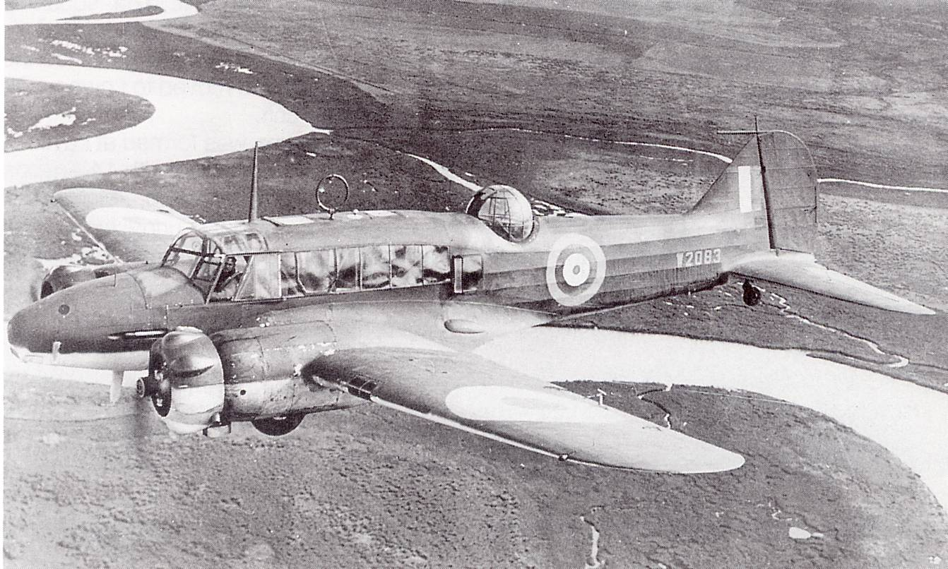
No Avro Ansons were built in Australia, but the RAAF and the Civil Construction Corps set up an erecting hangar, the first building on the Bankstown Aerodrome site, to assemble imported Avro Anson aircraft, the Airspeed Oxford trainer of similar specifications, and Fairey Battle aircraft, obsolete single-engined light bombers also used as crew trainers.
Figure 5: Empire Air Training Scheme Avro Anson

451 squadron
451 squadron was formed at Bankstown on 12 February 1941, one of the first of the squadrons in which many aircrew were products of the Empire Air Training Scheme. It left Sydney on 9 April 1941 and fought in the African campaigns, in the invasion of Italy, and the final attack on It was part of the occupation forces in Germany after the war.
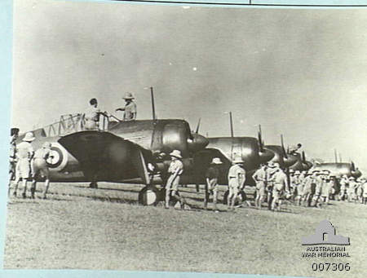

Figure 6: Brewster Buffalo fighters of 453 squadron, AWM collection

453 Squadron
453 Squadron was formed at Bankstown in May 1941 and departed in July 1941 for Singapore. After the outbreak of the war, the squadron fought the Japanese for nearly two months, despite being equipped with obsolete Brewster Buffalo fighters which were completely outclassed by the Japanese.

Activities in surrounding suburbs
‘An aircraft-manufacturing network evolved across western Sydney. Unwin Street, Granville was the home of the Australian Aluminium Company’s works which started production in 1940 and supplied the cast, sheet and bar aluminium needed for the aircraft.’
The production of the Beaufort bomber was carried out with the assistance of no less than 600 smaller firms, many of these being in the Bankstown area. The front fuselage, stern frame, undercarriage and engine nacelles were made at the Railway workshops at Chullora. The first Australian-made Beaufort made its first flight in August 1941.
As British engines were not available, Australia had to establish an aero-engine from scratch, manufacturing American-designed twin-row Pratt and Whitney Wasp radial engines. These were produced at a newly built factory by the Commonwealth Aircraft Corporation factory in Birnie Avenue, Lidcombe. At that plant forgings of high quality steel made by Australian Forge and Engineering Pty Ltd of Auburn were then further machined and incorporated into the Wasp engines. The body panels and engines were assembled at Bankstown either at the RAAF base or at the Chullora railway workshops where a special aircraft-manufacturing annex had been erected.
The Australian-built engines were more powerful (1200 hp) than the British Beaufort’s Bristol Taurus engines of 1000 hp. This necessitated considerable redesign. The Australian aircraft had a new undercarriage, made by National Motor Springs Ltd at Alexandria, and all electrical accessory equipment was made at Marrickville by Technico, formerly manufacturers of vacuum cleaners. This was typical of the way that previously minor enterprises of Australia rose to the occasion to meet the demands of the new industry.
The fully assembled Beauforts were test-flown either at Fishermens Bend, Melbourne, or at Mascot, Sydney. They were faster and better armoured than the original British aircraft, and the establishment of this industry, over a period of less than five years, was a remarkable feat.
******************
John Curtin became Prime Minister on 7 October 1941. A month later the Pearl Harbour attack brought Australia under direct threat of attack.
Bankstown airfield assumed a major role in the direct defence of Australia, and later, in the attack on Japan.

The time of crisis: 1942-3

Without any inhibitions of any kind, I make it clear that Australia looks to America, free of any pangs as to our traditional links or kinship with the United Kingdom.
John Curtin, Prime Minister of Australia, New Years Message, 1942

Australia is a nation stripped for war. Our minds are set of attack rather than defence. We believe in fact that attack is the best defence; here in the Pacific it is the only defence. We know it means risks, but 'safety first' is the devil's catchword today. Business interests in Australia are submitting with good grace to iron control to drastic elimination of profits. Our great labour unions are accepting the suspension of rights and privileges which have been sacred for two generations, and are submitting to an equally iron control of the activities of their members. It is now 'work or fight' for every one in Australia. The Australian Government has so shaped its policy that there will be a place for every citizen in the country. There are three means of service - in the fighting forces; in the labour forces; in the essential industries. For the first time in the history of this country a complete call-up, or draft, as you refer to it in America, has been made.
John Curtin, Broadcast to the people of America, 14 March 1942

Figure 7: Aerial photo of airside area, July 1943
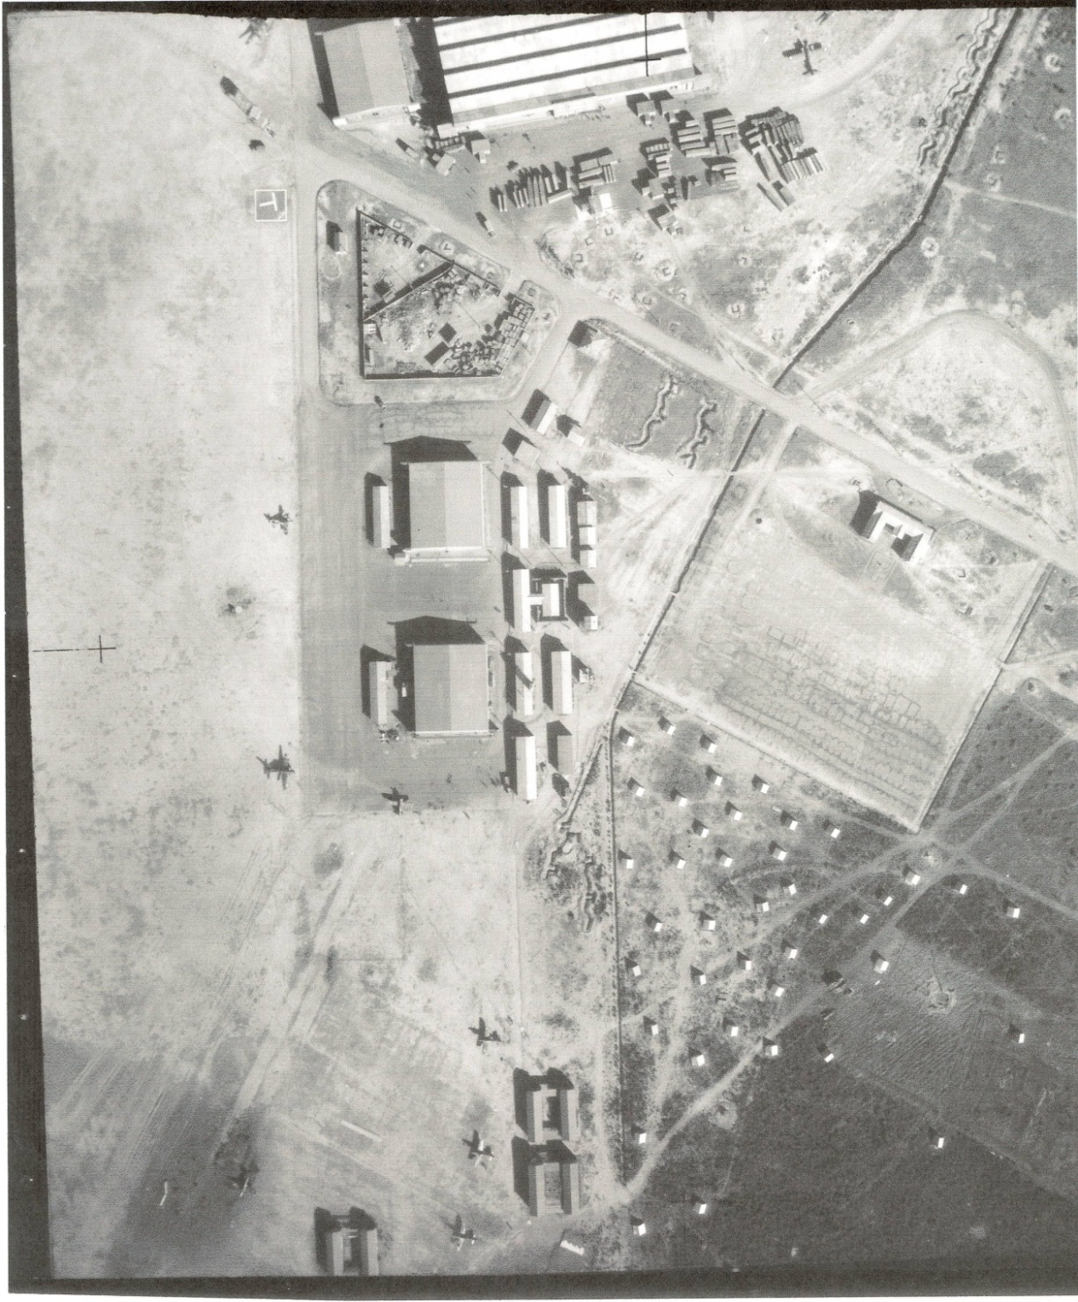
Hangar 14 and Hangar 15 (in its original position) can be seen at the top of the picture. The packing cases from the aircraft are below it. The pentagonal compound is for the storage of timber. Nearby, to the left, is a T-shaped wind direction indicator, moved manually. At this stage, aircraft did not land and take off on set runways, but simply pointed into the wind. A drainage canal runs almost diagonally. To the right of the timber yard, and along the canal, can be seen dug slit trenches, which are curved so as to reduce blast damage. Below the timber yard are the two Bellman Hangars 16 and 17. The U-shaped headquarters building has now been completed, backing on to the parade ground. The white dots are claimed to be dummy chook yards, put there as a camouflage exercise (see page 29).Airacobra, P-40 and Anson aircraft can be seen.
The attack on Pearl Harbor was followed by six months of amazing success for the Japanese.
They already dominated China and held Manchuria.
The Royal Navy fled the Pacific following the sinking of HMS Repulse and Prince of Wales. Hong Kong, fell. Thailand became an ally of Japan, Vietnam came under full Japanese control, and the Japanese moved through Burma to threaten India.
The Malayan Peninsula was quickly taken and the mighty fortress of Singapore, which was intended as the keystone of Australia’s forward defence, was captured, taking 130,000 prisoners including 16,000 Australians.
The Netherlands East Indies, modern Indonesia, was captured. The Philippines fell, last resistance by US troops being on 6 May.
The Solomon Islands and all of the Island of New Guinea except the south-west corner was taken over.
The Japanese held island bases including the Caroline Islands, Marshall Islands Gilbert Islands, the Marianas, Tarawa, and even had a foothold in the Kurile Islands off Alaska.
The Japanese navy had rampaged through the Pacific, bombing Darwin very severely, and reaching Colombo, where they sank Royal Naval ships including the aircraft carrier HMS Hermes.
On the night of 31 May–1 June 1942 three Japanese midget submarines entered Sydney Harbour and attacked the shipping there.
Eight days later, Sydney and Newcastle were shelled by artillery shots fired from submarines offshore.
So it was not surprising that Australians feared imminent invasion and were taking every possible step to mount a defence.
It has been claimed that plans existed to defend mainly the area south of a line drawn between Brisbane and Adelaide, the so-called Brisbane Line. Whether this is true or not, it is clear that the majority of Australia’s defence industry, and of facilities such as airfields, lay within this area. Sydney, and Bankstown itself, was centrally placed as a hub, and indeed was a probable major strategic target for the Japanese.
In Bankstown efforts were made to put the station on a war footing. Airmen and Home Guard militia were armed and conducted guard duties. AWAS and VAD detachments were formed.
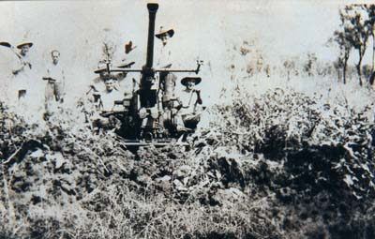
At least six anti-aircraft guns were stationed around the perimeter to protect it from air attack. At various times, these were located in different positions, such as near the hospital, at the corner of Henry Lawson Drive and Milperra Road and others near the present Bankstown Grammar School. One of these guns is preserved by the Australian Aviation Museum, Bankstown.
Figure 8: Bofors anti-aircraft gun which was sited off Milperra Road, World War II
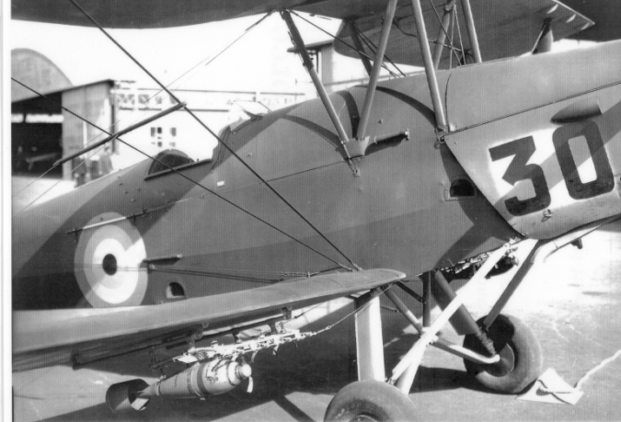
Another battery was situated on the corner of Bexley Road and Homer Street, Kingsgrove to help protect the approaches to the airport. These guns missed their only chance to fire in anger when a Yokosuka E14Y1 seaplane was launched from Japanese submarine I-25 off Sydney on 30 May, 1942. It flew over the harbour and over Bankstown preparatory to the midget submarine attack in the early hours of 31 May. It is clear that the Japanese had knowledge of the RAAF base at Bankstown as a major military asset of the time.
A radar station was established at Revesby, and there was major concern that the station could be threatened by bushfires, which were common in the area, at that time quite undeveloped.
Figure 9: Tiger Moth with bomb rack, 1942
Some really desperate measures were undertaken at Bankstown during the crisis period of early 1942. Wirraway trainers were modified for use as dive-bombers in September 1942 by Clyde Engineering, but even more desperate was the arming of Tiger Moth biplane trainers with small bombs, undertaken early in 1942.

RAAF Squadrons of the early period

24 Squadron RAAF
The first RAAF squadron tasked with the direct defence for Sydney was 24 Squadron RAAF, who were based at Bankstown from July. The squadron had been at Rabaul, New Guinea, in January 1942 and their improvised Wirraway fighters had been overcome by vastly superior Japanese aircraft. To defend Sydney they had a mixture of aircraft, Wirraways, Bell Airacobras, Brewster Buffalos, and Vultee Vengeance dive bombers. They left Bankstown in August 1943 to return to New Guinea, flying Vultee Vengeance aircraft.
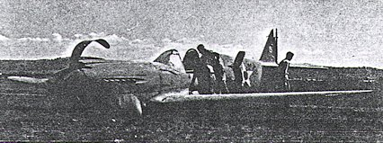
Figure 10: Crash of a Kittyhawk at Bankstown, February 22, 1942

Other RAAF squadrons at Bankstown
Altogether some 22 RAAF squadrons utilised Bankstown at some stage during the war. However, its importance as a potential combat base declined, partly due to the development of new bases along the coastline, but mainly because the threat to Australia was diminished.
Among the more significant were the following:
457 Squadron. Due to the perilous condition of Darwin’s air defences, a Spitfire wing was sent from Britain, arriving in Australia in September 1942. There were delays in obtaining aircraft, and the three squadrons were accommodated at Richmond (54 squadron RAF), Camden, (457 squadron RAAF) and Bankstown (452 squadron, RAAF) until their aircraft arrived and they moved to the Darwin area in January 1943..
76 Squadron. This squadron was re-equipped with 24 new P-40M Kittyhawks during its time at Bankstown, 11 April 1943 to 14 June 1943 before being sent to Milne Bay, New Guinea
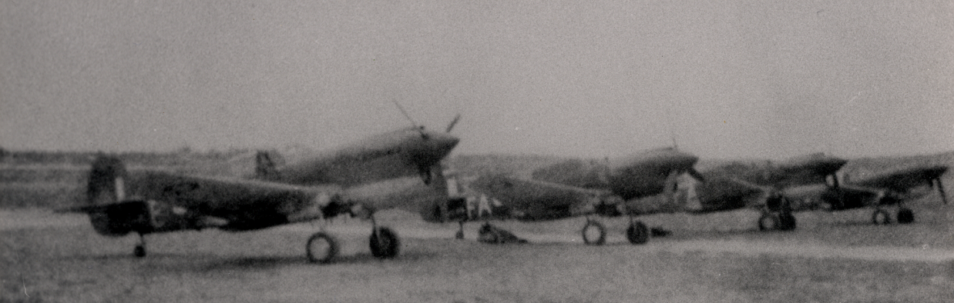
82 Squadron was formed at Bankstown on 18 June 1943, and equipped with P40M Kittyhawks and a flight of P39D Airacobras. The squadron remained resident at Bankstown until May 1944, when it moved to New Guinea, and after the New Guinea campaigns finished the war at Morotai.
Figure 11: 82 squadron Kittyhawks, Bankstown, 1943

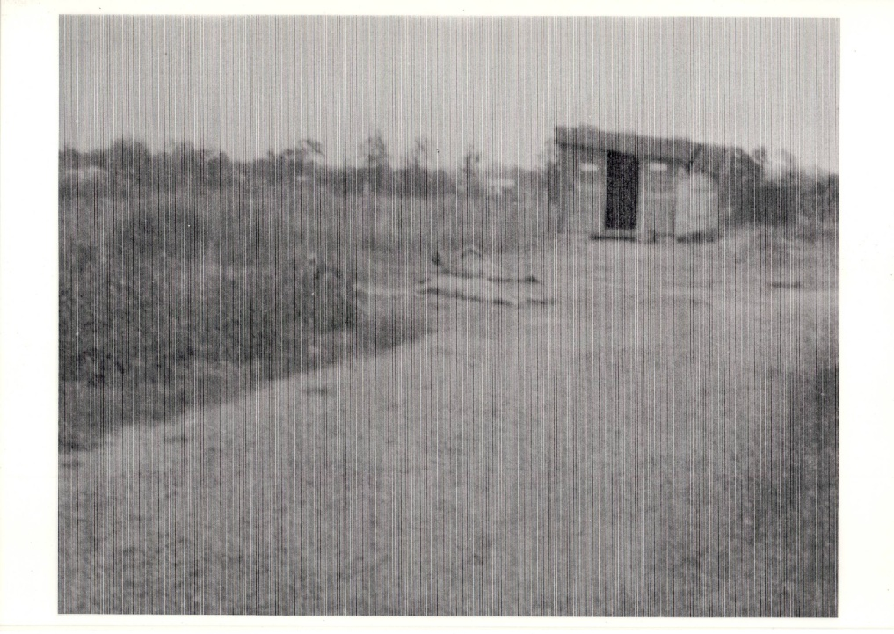

Figure 12: Radio and electrical shack of 82 squadron

A United States base
Though the US underestimated the Japanese threat, it had been anticipated that the Philippines could be cut off, in the early part of any war with Japan, because of local Japanese Navy supremacy. Accordingly, Major General Brereton, the Commanding Officer of the US Far East Air Force (USFEAF, later the Fifth Air Force) had visited Australia in November 1941to plan an alternative route, via Australia (the Brereton Route). Aircraft would be delivered via Brisbane / Charleville / Cloncurry / Daly Waters / Darwin, then on to the Philippines. Aircraft being flown from Sydney went through a specially-built base at Bourke.
When war broke out, the situation became much worse than had been anticipated. It was soon apparent that the Philippines could not be reinforced, and the aircraft in transit to the Philippines fell were deployed from Australia and within Australia. The development of US bases was accelerated, but ‘not having on location the equipment, forces and supplies necessary to carry out and expedite construction, the [US] government worked out arrangements with the Government of Australia to have the work performed using local resources’.
Because they were en route to the Philippines, the Headquarters squadron and also 7 Fighter Squadron of 49 Pursuit Group arrived at Bankstown on 16 February 1942, only 75 days after the war began. They set up their headquarters in the golf clubhouse on the other side of Milperra Road, and the majority of personnel lived in tents. The squadron left Bankstown in April 1942. A detachment had already gone to Horn Island in Torres Strait, and the remainder went to Batchelor Airfield, just south of Darwin
They were equipped with P-40 Kittyhawk aircraft, the only modern fighter aircraft in Australia at the time which were capable of engaging the Japanese with any hope of success.
41 Fighter Squadron of 35 Pursuit Group, USAAF, arrived at Bankstown on 7 April 1942, and was prepared for combat and sent to Port Moresby, New Guinea, arriving in August 1942; Lieutenant Cantello was the first commander of this group until his death (see next page). ‘Upon arrival in Australia this organisation had 14 officers and 75 enlisted men, and of this personnel approximately 85% were fully trained’.
These were the only USAAF units formally based at Bankstown, but it remained important as an aircraft erection and repair facility. Construction of a large hangar was under way in August, and completed on 28 October, undertaken by American servicemen. Bankstown had facilities for 700 officers and enlisted men, held 22,000 gallons of fuel, was capable of handling heavy bombers, and had repair facilities.
Prior to the erection of the ‘American Hangar’ in September 1942, US Kittyhawk fighter aircraft were erected at Archerfield, Brisbane. They were delivered to US pursuit squadrons at Bankstown, Fairbairn (Canberra), and Williamtown (Newcastle) by ferry pilots, each base receiving 25, with an additional 10 being sent to the RAAF headquarters squadron at Bankstown and ten more to Laverton, near Melbourne. Within two weeks more than 30 planes had been wrecked during training.
By March 1942, about 330 Kittyhawks had been delivered to various units of the USAAF in Australia. 140 of these were lost during training accidents in Australia. Following the first bombing raid on Darwin, 19 February 1942, many were sent north, using the ‘Brereton Route’ (see page 20).
After the departure of the Kittyhawk squadrons, Bankstown it remained important as an aircraft erection and repair facility. Construction of a large hangar was under way in August 1942, and completed on 28 October, undertaken by American servicemen. According to US data, Bankstown as a US base had facilities for 700 officers and enlisted men, held 22,000 gallons of fuel, was capable of handling heavy bombers, and had repair facilities.
Oral history collected by Chris Matts indicates that it was used in 1943 for the collection of US aircraft from various sources for repair. Some Brewster Buffalos were brought to the hangar, and a few were given to 24 squadron. The rest were being refurbished in mid-1943, but orders came that they should be destroyed as they were obsolete and more modern aircraft were available.
US servicemen were billeted at Bankstown and at a specially made camp at Hearne Bay. It is clear that repairs were carried out and some erection work was also performed, both at Bankstown and at Mascot, However, as the action moved further north, the Bankstown facility was used less and less by the US.
It is difficult to give an exact date for the departure of USAAF personnel, but certainly by the last quarter of 1944 they had completely gone.
Thus ended a very exciting time in the history of Bankstown, during which Bankstown was popularly known as Yankstown because of this friendly invasion. ¹²

Lieutenant Leo Cantello
The commander of 41 squadron was Lieutenant Leo Cantello.
Just after midnight on 8 June 1942 the Japanese Navy submarine I-24 fired several shells into the Eastern Suburbs of Sydney. Lieutenant Cantello was at Bankstown and took off in his Aerocobra single-seater fighter to try to attack the submarine. The aircraft was not equipped as a night fighter, and it stalled and crashed over what was then the small farming community of Hammondville, about five kilometres from Bankstown. Lieutenant Cantello was killed in the crash. The crash site was marked by the creation of a reserve adjoining the Georges River, named in his honour, with a monument recording his brave action.

The role of women

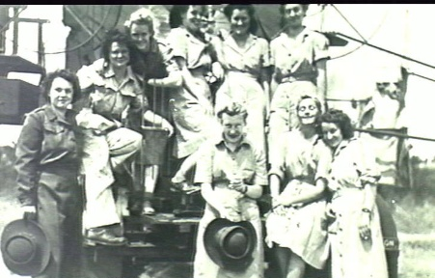
Figure 13: AWAS personnel at Bankstown searchlight station
The women of Bankstown rose to the challenges of the time in various ways. A strong Voluntary Aid Detachment was formed and Red Cross and other organisations took part in war efforts of many kinds. But the RAAF base is especially important in the history of women’s involvement.
The first WAAAF unit to be stationed at a RAAF base occurred with the establishment of a temporary Training Section for the Women’s Australian Auxiliary Air Force (WAAAF) at Bankstown RAAF base. Its first course of recruits passed out on 10 September 1941.. It `aroused curiosity and gossip in the city of Sydney, and attracted a great deal of press publicity’ and of particular note was that the WAAAF were sharing quarters with the RAAF and had their meals in the male mess, albeit at different times (although it seems that WAAAF and RAAF officers ate together). Facilities provided for the WAAAF Training Section at Bankstown included `its own administration hut, drill square and sleeping quarters’. The WAAAF officers and trainees left Bankstown in early 1942, shortly before the USA Army Air Force moved in.
The WAAAF barracks was erected to the north of the main gate area. Mrs June Stone has described her activities during the war, as clerk at the RAAF headquarters at Bankstown and in the Fighter Control Operations room, located for a time in a tunnel under the Mitchell Library, Sydney. She described her clerical role in coastal defence missions that were undertaken from Bankstown.
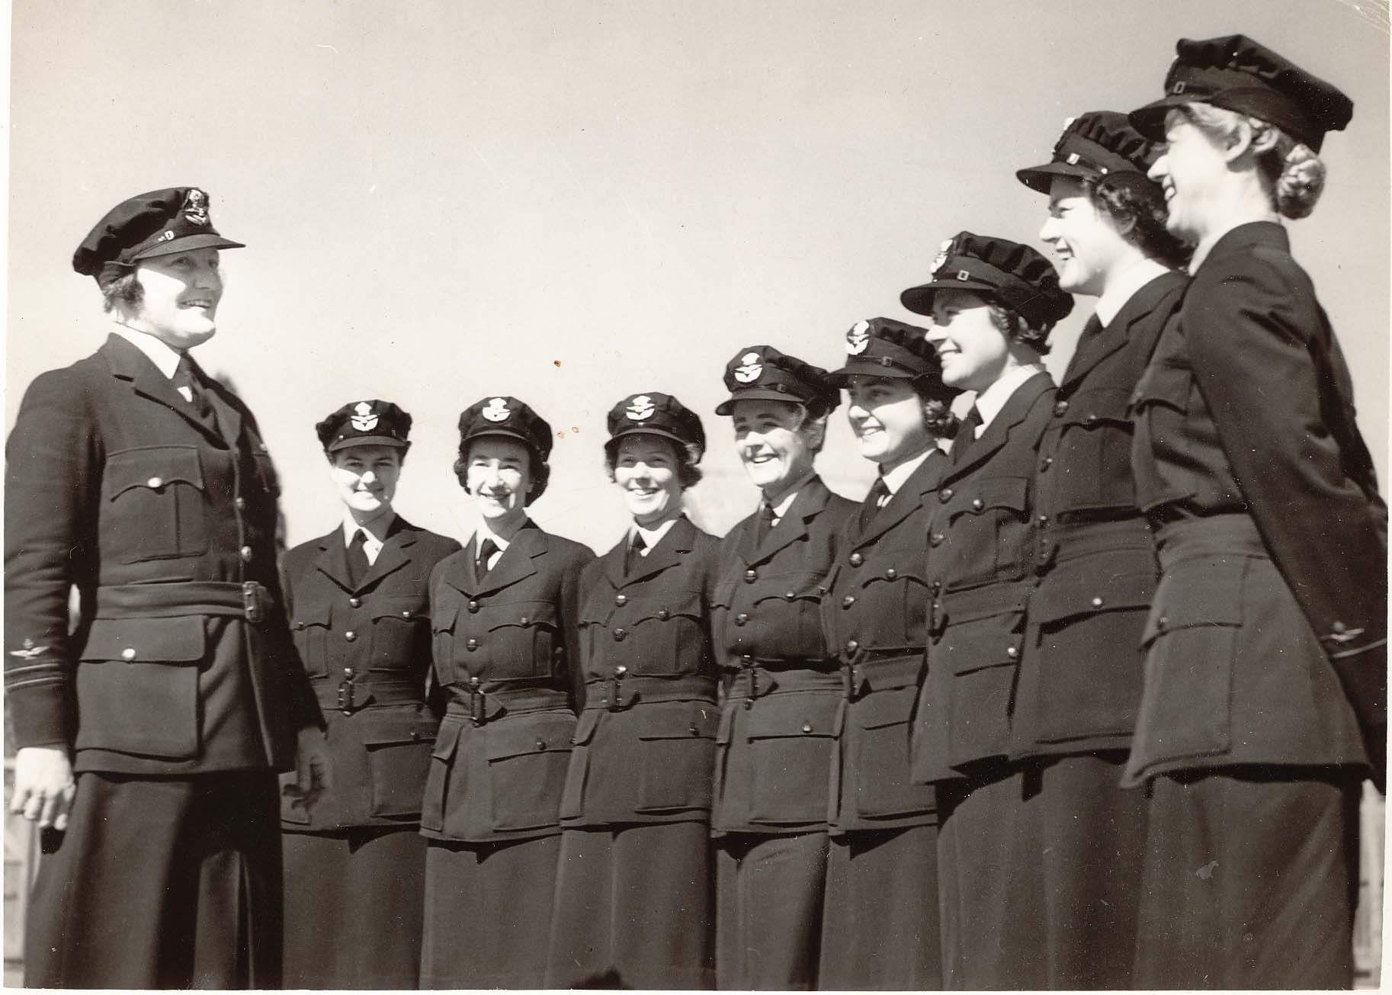
Figure 14: the first WAAAF officers at Bankstown
Left to right: Officer in Charge, Flight Officer D Hawthorn; Assistant Section Officers J Opie (training officer), Isaac (accounting officer), M Russell (equipment officer), A Herring (training officer), Mrosk, (barracks officer), and training officers M Seavers, P Burnard, E Green
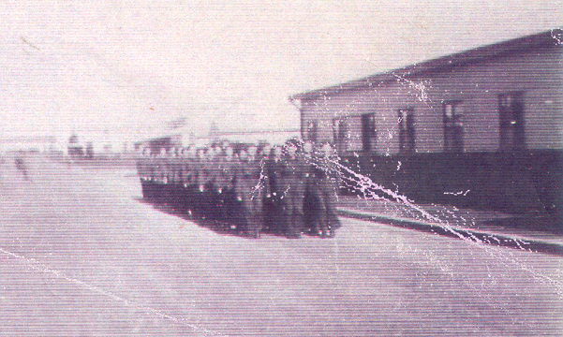

Figure 15: WAAAFS, 1942

Fighter Control Unit and the ‘Bankstown Bunker’.
Bankstown was also the home of Fighter Control Unit 101, originally unit 1. It was formed at Bankstown on 25 February 1942, and after various name changes – and a brief suspension during 1942 – was supplanted by Air Defence HQ Sydney on 21 January 1945 (see below).
It was first established in the Capitol Theatre, in Bankstown. Plans were then made to erect an semi-underground control room which would have expanded communication facilities and these were finalized in January 1943..
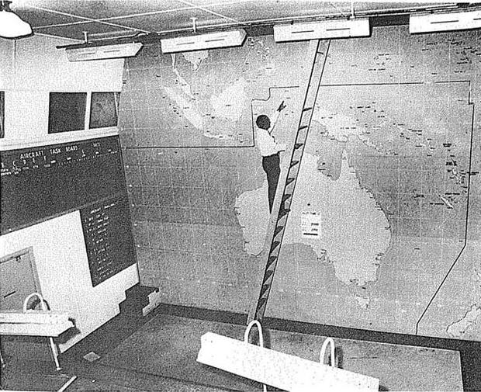
Figure 16: Interior of 'Bankstown Bunker'
This facility is the source of many urban myths, one being that it was General Macarthur’s secret headquarters. The truth is less exciting.
Work commenced in late 1942 and the facility cost £30,579 to build. Its official commissioning was on 21 January 1945 as the headquarters of Air Defence, Sydney (ADHQ). By this time the facility had not much chance of being involved in any action, but it was operated until 27 January 1949, with, apparently, representatives from the RAAF, the USAAF and the Observer Corps and also some WAAAFs.
The bunker area is now in the midst of Wattawa Heights housing estate, on what used to be known as Black Charlie’s Hill. It was still intact in 1971 but shortly after was seriously vandalised and has interior fire damage. Local homeowners do not encourage visitors!

Other units
Many non-flying units also had association with Bankstown of which these are only a few representative examples:
164 Radar Station was formed at Richmond on 22 July, 1944, then moved to Bankstown on 22 August. It was then moved to Bargo, eventually being disbanded at Richmond in January 1946.A similar process applied to 354 Radar Station, formed at Richmond on 15 September 1944, and was stationed at Bankstown from 13 October 1944 until early 1945, when it was moved to Tarakan, Borneo, beginning operations in association with the landing there, on 2 May 1945. 163 Radar Station was disbanded at Bankstown on 9 September 1946, having been withdrawn from Labuan, Borneo, and 323 Radar Station was disbanded at Bankstown on the same day, having been withdrawn from Tarakan, Borneo.
Airfield Construction squadrons began to be formed in 1942. They were vital to the construction of new airfields, often in remote sites that were threatened or under attack by the enemy. During World War II Bankstown’s main role was in the preparation of 7 Airfield Construction Squadron early in 1942, before being sent to Milne Bay where it performed a vital role in the crucial operations there.
After the war, 5 Airfield Construction Squadron was reformed at Bankstown on 8 August 1951. and a detachment of 6 Airfield Construction Squadron was based at Bankstown from 3 June 1055 to 36 May 1955. Such units as these were responsible for the development of bases in Northern Australia and elsewhere; a modern network of RAAF bases now exists along our northern shore, thanks to their work..
No. 10 Works Supply Unit was based at Bankstown for a week in January 1943 before it was transferred to Milne Bay.
Bankstown itself was a major stores and supply unit, staffed by a variety of specialist units. After the war, the Regents Park No 2 Stores Depot continued to function until 1959, with accommodation and other facilities at Bankstown. This site was re-developed for housing and other purposes in 2000

Camouflage
Camouflage in Australia has an interesting story.
In 1939, a group of Sydney civilians formed the Sydney Camouflage Group. Its members included artists, photographers, architects, scientists, engineers and civil servants.
The chairman was Professor William Dakin, a zoologist from Sydney University. By 26 April 1940 the group included publisher and artist Sydney Ure Smith, watercolourist John D. Moore, abstract artist Frank Hinder, graphic designer Douglas Annand, and photographer, Max Dupain.
A considerable amount of work was done, from the earliest stages, to camouflage Bankstown Airport, and also other Sydney sites such as Garden Island Dockyard and Richmond Aerodrome. At Bankstown, several ‘dummy houses’ were built to make Bankstown RAAF base and its surrounds appear as a farm, hangers were disguised as houses with fake roads to further confuse the enemy. These projects protected these important sites but also provided examples to be copied elsewhere. In 1941 their findings were published in a book entitled The art of camouflage which became an important manual for efforts elsewhere..
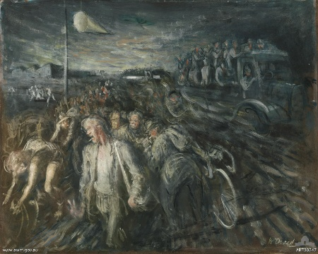
The famous artist William Dobell, later Sir William Dobell, was a consultant on this development. During his time at Bankstown he painted Knocking off time at an aerodrome, Bankstown (1943), showing ‘A group of men from the Civil Construction Corps leaving the airfield in Bankstown. Some of them are travelling in a truck, others are on foot or are riding bicycles. Dobell has captured the mass movement of the workers at the end of a working day and the various transportations available to civilians in war time.’

Figure 17: William Dobell painting, Bankstown 1943

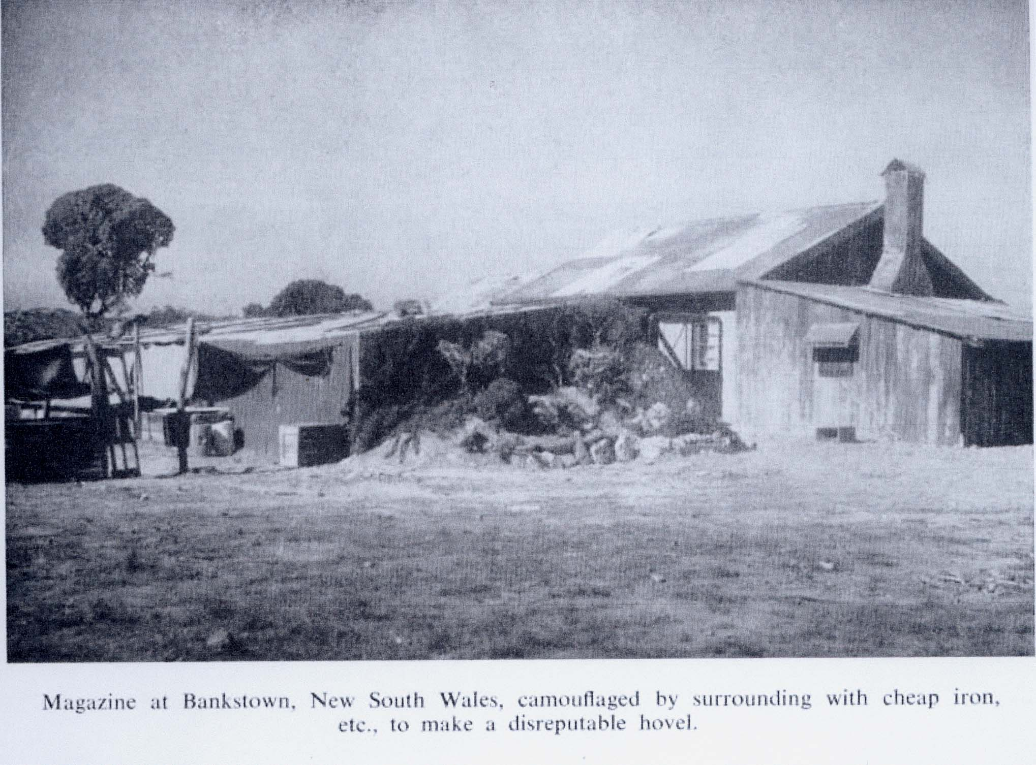
Figure 18 Camouflaged Magazine at Bankstown, 1941
The magazine was surrounded by cheap iron etc to make a it look like a disreputable hovel.
Figure 19: Max Dupain photo of camouflage
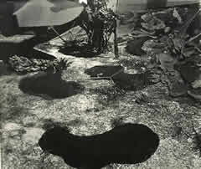
This photo, dated February 1943 shows areas surrounding the aircraft disrupted by large patches of dark earth hessian.

Figure 20: Airfield in July 1943
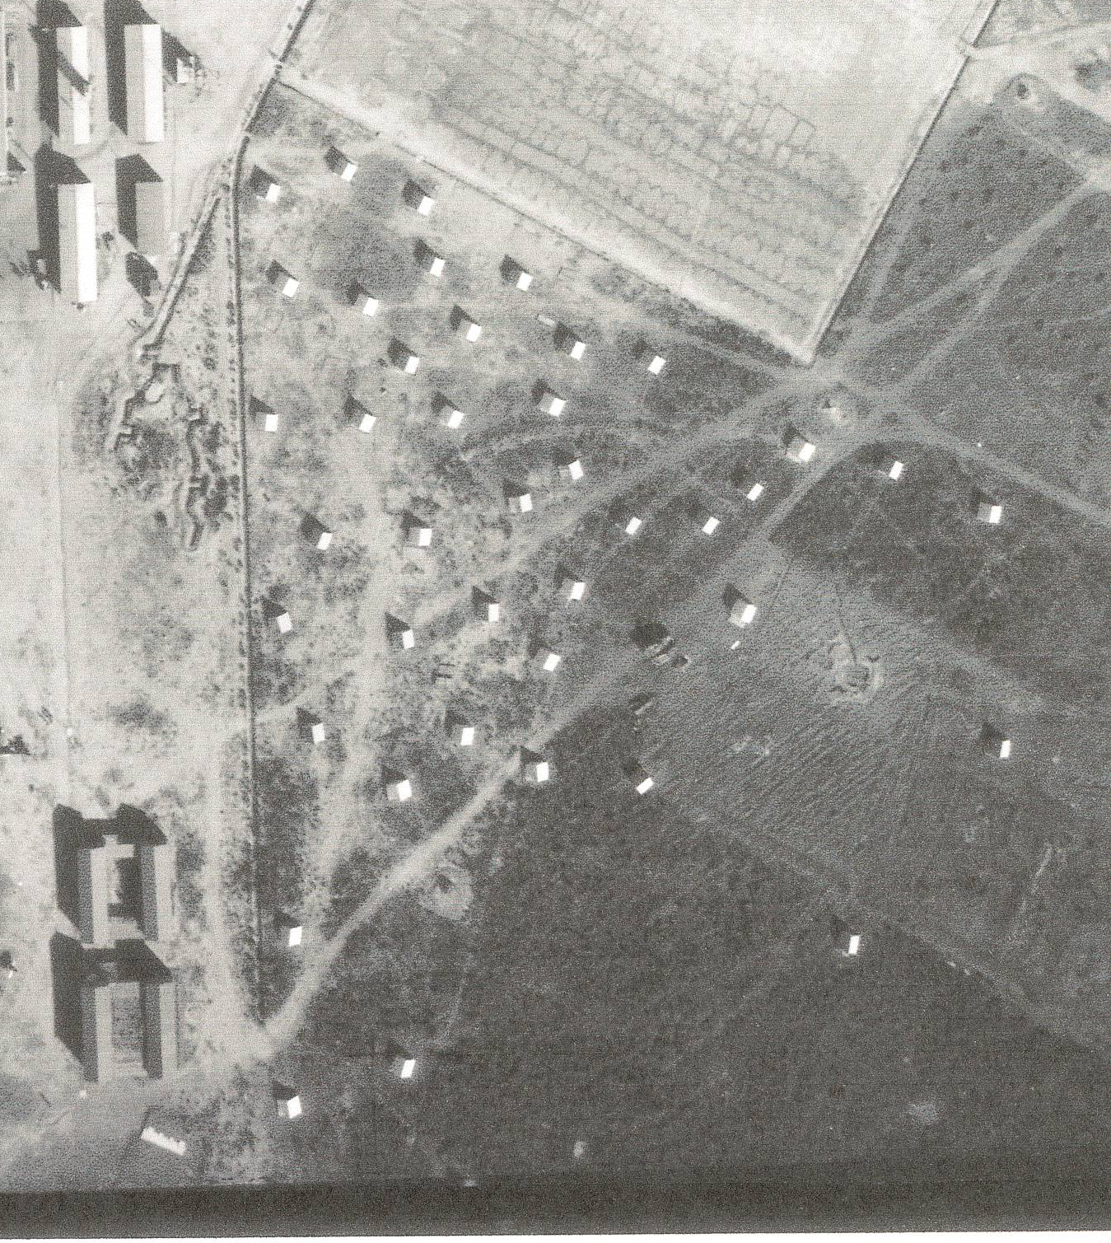
The white dots in this enlargement of Figure 7: Aerial photo of airside area, July 1943, page 15, are dummy chook yards! They included dummy hens – ‘white leghorns, in fact’ – made by a Sydney woman!

Figure 21: Sketch of airfield camouflage, 1943
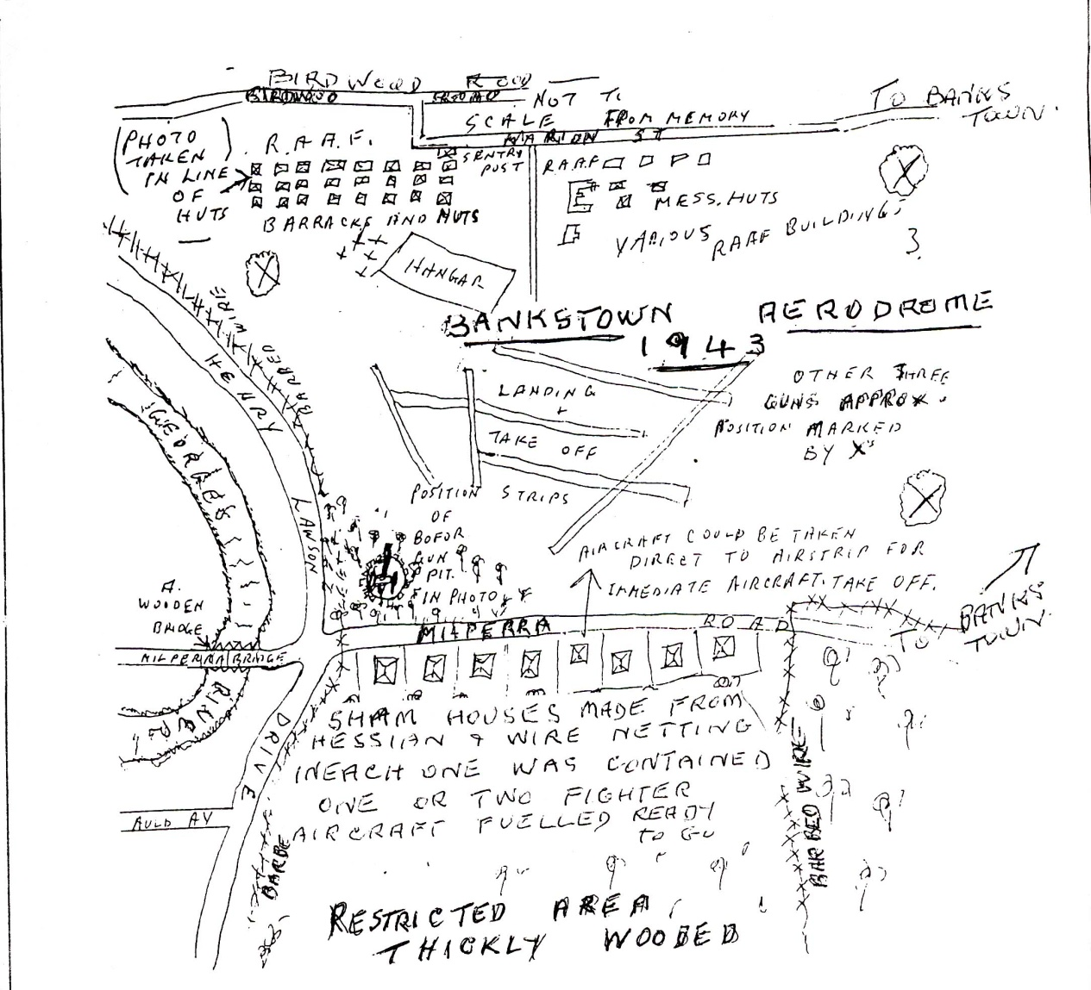

Auxiliary airfield at Hoxton Park
Many major airfields (and some quite minor airfields) had satellite airfields, to which, for example, aircraft could be dispersed in case of attack. They could also be used by individual aircraft in case of emergency. The bombing of Darwin in February 1942 had underlined the need for this. Interestingly, though Bankstown is a major base, with links to other RAAF stations as indicated above, it had only one formal satellite, at Hoxton Park.
Hoxton Park was established as satellite airfield for Bankstown in 1942-3. It was14 km west of Bankstown, and thus it was also available for use by aircraft from for airfields such as Schofields and Camden. Some fighters were based there when the threat of air attack to Sydney was quite real. Its runway was about 1.1 km long, and ran almost north-south; this is very unusual in the Sydney basin and therefore pilots valued this runway as a possibility for landing in certain extreme weather conditions.
At the end of the war it was ‘acquired but not maintained’ by the RAAF, and then passed to DCA control. Its later history is mentioned on page 68.

Other local airstrips
A World War II airfield was situated at Menangle Park, south of Campbelltown; in mid-1942 32 squadron RAAF was based here, commanded by Wing Commander David Campbell. a distinguished poet. Aircraft flew coastal patrols from this base.
The Civil Construction Corps had built a single sealed runway through the middle of the Menangle Park racetrack. The broadcast tower was used as an aircraft control tower and the saddling paddocks were covered with camouflage netting between the trees, where the aircraft were parked.
Camden airfield was also used for training and coastal patrol operations. There is a War Cemetery at Camden, predominately occupied by the remains of airmen killed in the many crashes that occurred in the district during World War II.
There had also been an airstrip at Warwick Farm, known as Hargreave Park, which was not been used during World War II. It was officially opened on 20 September 1930 and was described by the magazine Flying as a ‘Flying Country Club’. One idea was to include a golf course in the grand plan. Kingsford-Smith and Ulm flew from there on many occasions. After December 11 1932 was ‘not maintained as an aerodrome’ and the licence was ‘allowed to lapse’. The Warwick Farm was used during the war to accommodate servicemen, often only in tents.
As well as the older RAAF base at Richmond, there was a major base at Fleurs, Kemps Creek, near Penrith. It was used by the RAAF and also by the US Navy in 1943.
There were also airstrips at Bargo, the Oaks, Wallgrove, St Marys, Castlereagh, Pitt Town and Ettalong during the war, but no trace remains of any of these.

The Empire Strikes Back: return of the British

At this stage it may be helpful to mention the situation of the war in the Pacific, particularly that of the British Pacific Fleet. The war in Europe was coming to a close and Churchill and Roosevelt decided that Britain should take a more active part in the Pacific War. Churchill had, it is believed, two reasons for this. One was to show Australia that they had not been forgotten and the other to wean them away from American dominance (not that they needed any weaning as they had outstayed their welcome; I saw the US Officers mess in flames in Brisbane with the fire brigade delayed). The other was to avenge Singapore……… So the BPF was decreed with Admiral Bruce Fraser in command. It was to be based in Australia and work as part of the American fifth Fleet (Admi Nimitz). It was very much the junior partner (we had about ten carriers and the Fifth Fleet had over forty), but never-the-less it was the largest Fleet the UK had ever formed, " The forgotten fleet ". It was also dependent on the US for many supplies particularly aircraft. The British FAA aircraft were unsuitable for the prevailing conditions and were now flying almost entirely US machines.

The reminiscences of Lieutenant Gordon Pursall, RN, who served with the Salvage section of MONAB II at Bankstown.
s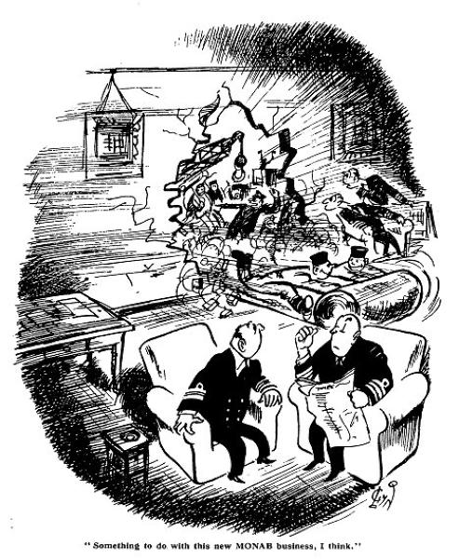

Figure 22: Cartoon – source unknown, but illustrating the unusual speed with which the MONABs were created.

Background
After the fall of Singapore, the British Royal Navy concentrated on the war against Germany.
However, by mid-1944, the German surface navy and U-boat threat had declined.
A large fleet was formed to wage war against Japan. There were 24 aircraft carriers, four battleships, and about 450 other vessels. It was the largest overseas deployment ever undertaken by the Royal Navy.
The United States Navy was not keen to have the British taking part in their operations against Japan. Particularly Admiral King, the Chief of Staff, remained angry that the Royal Navy had deserted the Pacific early in 1943, leaving the US to fight alone the desperate battles of the Coral Sea and Midway,
Nevertheless, at the Quebec Conference, on September 12, 1944, a final agreement was reached to enable full participation by the British Navy in the subjugation of Japan.
This needed logistical support, and within a fortnight Australian Prime Minister John Curtin agreed to assist. Payment details were worked out later, and in the event the British government contributed £5,400,000 of the total cost of supply facilities in Australia, and Australia contributed the remaining £1,150,000 in recognition of the residual value of the buildings left in Australia. The US were happy to let Britain use any abandoned US facilities in rear areas, but would give no other logistic help.
Some 19 shore establishments were set up in Australia. The most important of these were Mobile Naval Air Bases, MONABs. The majority were within 160 km of Sydney, but three were near Brisbane.
It is interesting to note that some participants from the UK were told of the need for Britain to re-establish its presence in Australia, and they were conscious of the need to ‘show the flag’ to supplant the US influence of the past few years. Though the British participants were at first subject to some ‘culture shock’ it is notable that many of them remained in Australia or emigrated later.

MONAB II, HMS Nabberley
Bankstown was the main base for the assembly and preparation of aircraft, which came from the US or UK.
RN personnel were using the base even before the formal takeover on 25 January 1945 . The first aircraft assembled, a Corsair II fighter, was test flown on January 18th 1945.
Because of a shortage of technical staff, teams specialised in different aspects of aircraft preparation and a kind of production line developed, ‘enabling an aircraft to come out of a crate into one hangar and leave that hangar complete in all respects and ready for butt testing, compass swinging and test flight’. This was almost certainly done in Hangar 131, because the other large Hangar 14 had other uses, and the American Hangar 114 seems to have not been widely used by HMS Nabberley.

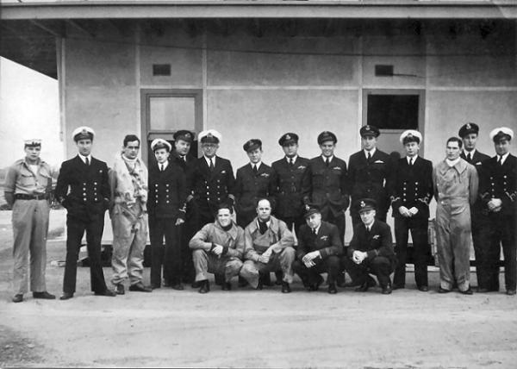

When all aircraft had been disposed of, MONAB II and HMS Nabberley paid off at Bankstown on March 31st 1946, and Bankstown returned to RAAF control.
Buildings erected for HMS Nabberley included Bellman Hangars 273 and 274, 131, 135, 271 and 275. The building alongside Hangar 131 shown as being erected in some photos of the time was never completed, being removed to Yagoona where it was a showroom for Hastings Deering..
There was accommodation for 84 officers and 1644 other ranks. Some of the hangars and a few barrack buildings remain. Additional hard-standing taxiways were laid but it is interesting to note that the airfield was not paved during the war, the aircraft landing and taking off on dirt airstrips.
Aircraft from Bankstown were flown to other MONABs, or loaded on the smaller carriers HMS Unicorn, Stalker and Speaker, which took them to the battle areas or to larger aircraft carriers in the north.
Many of the aircraft carriers of the British Pacific Fleet called at Sydney during 1944-45. In a typical visit, the aircraft from the carriers were flown ashore, to enable them to receive major repairs and servicing, and also enabling the work areas of the carriers to be refurbished and restocked with spare parts and ordinance. The hangar space within the carriers was very crowded when the aircraft were on board!
Among the units who were prepared at Bankstown were:
- 723 squadron (28 February – 8 Martinet Target Tugs and 8 Corsair IIs.)
- 724 squadron (10 April – communications: 2 Beechcraft Expeditors and 2 Avro Ansons)
- 723 Fleet Requirements Unit (1 May)
- 1833 squadron (Corsair IIs, 14 May, from Illustrious)
- 1830 squadron (Corsair IIs, 24 May, from Illustrious)
- 1701 squadron Air-Sea Rescue (Sea Otter amphibians))
After the Japanese surrender several ships were rushed from Sydney to Singapore and Hong Kong filled with medical supplies, ambulances and medical staff for the rescue of prisoners of war that had been held by the Japanese. HMS Nabberley staff assisted with this and with the reception of the ex-prisoners on their return. Some were in very poor condition.
Apart from a few Seafires and the durable Fairey Fireflies, all the aircraft assembled were American, supplied under the ‘Lend-Lease’ program that had begun in 1941. Basically, the US provided the British and other countries fighting against Germany with equipment that was supposed to be only lent for the duration of the war. President Roosevelt had used this method of supplying anti-German forces to placate those in the USA who were reluctant to participate in what they saw as a purely European matter. In the event, the US did not want the equipment back at the end of the war, but insisted that it be destroyed. Thus, after the cessation of hostilities in 1945, all the US aircraft at Bankstown and elsewhere were destroyed, typically by being dumped into the sea.
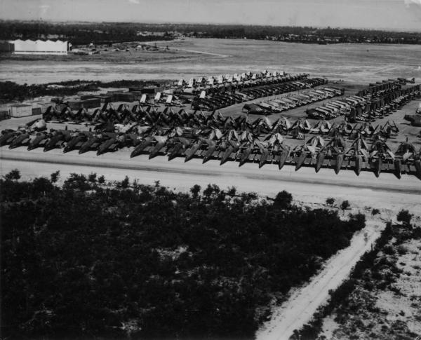
When a carrier arrived by the dock the aircraft, possibly up to seventy, were taken to Bankstown, serviced and returned to the carrier for transfer to the Island aircraft parks north of Australia. It usually meant working night and day for about three days as when the last load was delivered the first load was ready for return to the carrier. The ships arrived about every ten days.
One major change was the alteration of the British roundel markings, The red centre circle was painted out with white paint, because the British markings could be mistaken for the red Japanese markings. When all aircraft had been disposed of, MONAB II and HMS Nabberley paid off at Bankstown on March 31st 1946, and Bankstown returned to RAAF control.
Figure 23: October 1945: Aircraft to be dumped after the surrender of Japan
Figure 24: Aircraft being dumped from HMS Unicorn somewhere off the coast of NSW

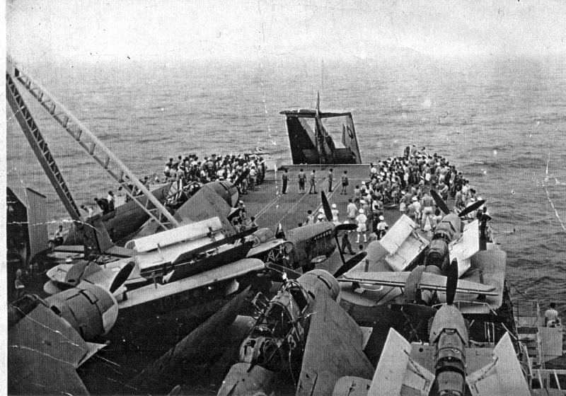

Other MONABs
Fourteen MONABs were planned, and ten were actually commissioned, though some did not leave Britain.
MONAB 1 was HMS Nabbington. It was based at Nowra from 1 January 1945. HMS Nabswick, MONAB V, was based at nearby Jervis Bay from April 1945. The main function of these bases was to receive aircraft from visiting Royal Navy aircraft carriers that were visiting Australia. This enabled minor work to be done on the aircraft and gave the carriers the opportunity to re-organise and re-equip their hangars. Both were closed by 18 March 1946. The airstrip at Jervis Bay was abandoned and responsibility for the station at Nowra reverted to the RAAF. It was then decided that Australia should have its own Fleet Air Arm, with two aircraft carriers, and the Nowra base was taken over by the Royal Australian Navy and commissioned as a RAN shore establishment on 11 August 1948.
MONAB III HMS Nabthorpe was temporarily lodged in tents at HMS Golden Hind, the Warwick Farm accommodation unit in January 1945, then in mid-February was set up at Schofields, about 50 km west of Sydney. This station also housed aircraft from visiting carriers. In March, 706 squadron, with Avenger, Barracuda, Corsair, Firefly, Hellcat and Seafire aircraft, was established as a Crew Pool and Refresher Flying School. Another squadron, 899, mainly trained Australian pilots in naval flying techniques, notably deck landings. These men became the nucleus of the Australian Fleet Air Arm.
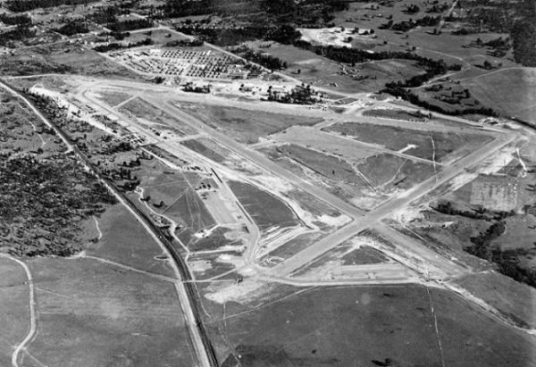
Figure 25: Schofields at the end of the war
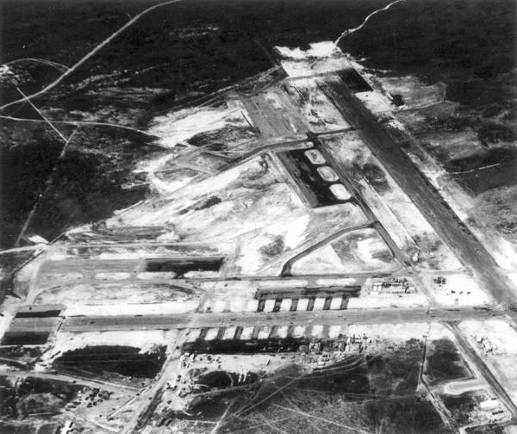
Figure 26: Jervis Bay MONAB
At the end of the war, operations soon ceased, and Nabthorpe ‘paid off’ in November 1945. Some tidying-up work was done by MONAB VI, HMS Nabstock, transferred from Maryborough (see below), but by June 1946 all operations had ceased and Schofields was returned to the RAAF. With the establishment of the RAN Fleet Air Arm, Schofields was recommissioned as HMAS Nirimba in November 1950, being used largely for training purposes until finally being decommissioned on 25 February 1994.
There were considerable MONAB operations in Queensland, mainly around Brisbane. MONAB VI, HMS Nabstock, arrived in Maryborough in late May 1945. It acted mainly as temporary host to squadrons from visiting aircraft carriers, with considerable interchange of aircraft to and from Bankstown. Aircraft were also received from TAMY I, see below. Nabstock ceased operations at Maryborough on November 14, 1945, and was relocated to Schofields, Sydney, relieving MONAB III..
MONAB VII, HMS Nabreekie was commissioned in August 1945 at Archerfield airfield, Brisbane, but performed very little work at that site, and was ‘paid off’ on November 5th 1945.
Transportable Aircraft Maintenance Yard No. 1 (TAMY 1) arrived in at Archerfield early in February 1945. Its task. Their task was to assemble aircraft, mainly Corsair fighters, but there were many problems. By August, monthly aircraft erections were only about 32 aircraft, despite the opening of another facility at Oakey airfield, 200 km west of Brisbane. TAMY I was the last Royal Naval aircraft facility in Queensland to be paid off, on 31 May 1946.
There were three MONABs not based in Australia:
MONAB IV, HMS Narbaron, Poonam Island, off Manus Island, which functioned briefly from April 1945.
MONAB VIII, HMS Nabcatcher, was established after the war at Kai Tack airfield, Hong Kong, and functioned until December 1947.
MONAB IX – HMS Nabrock, actually left Britain after the end of the war, and after a brief sojourn at Warwick Farm, moved to Sembawang, on the north of Singapore Island, on 1 October 1945. Its main task was clearing the airfield of debris and dumping at sea US Wildcats under the terms of the Lend-Lease agreement. The unit ceased operations on 15 December 1945.

Summary
The British Pacific Fleet was the largest deployment ever undertaken by the Royal Navy. The most important units of the fleet were the aircraft carriers, and to supply the aircraft the network of MONABs as described above was established,
Of the nine functioning MONABS, the most important aircraft erection centre was Bankstown, and its work was essential to the success of the deployment. Almost all MONABs had some association with Bankstown or Warwick Farm. As outlined on page ## several buildings erected for MONAB II HMS Nabberley are still in use. Three ‘Igloo’ hangars (no longer standing), 2 Bellman hangars and 2 Singapore Hangars were erected, as well as accommodation for accommodation for 84 officers and 1644 other ranks and engineering services. Some of the hangars and a few barrack buildings remain. Additional hard-standing taxiways were laid but it is interesting to note that the airfield was not paved during the war, the aircraft landing and taking off on dirt airstrips.

Swords into Ploughshares: The early Post-War years
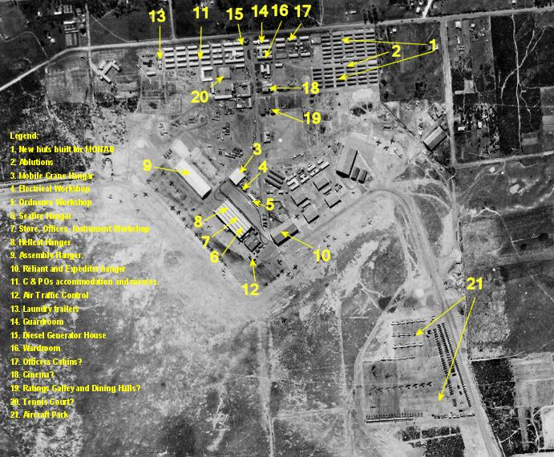
The main activity of the early post-war years was the disposal of military aircraft. This occurred in several ways:
- Lend-lease military equipment from the US were, under the terms of the agreement, were to be retained by the recipient countries only until the end of hostilities. The US required that these aircraft should be completely destroyed, hence most were dumped at sea.
- Military aircraft from the UK and those surplus to Australian needs could be scrapped or melted down.
- Where possible, transport aircraft such as the C-47 (‘Dakota’) were refurbished to airline or civilian transport standards, and these were the workhorses of the airlines during the 1950s and 1960s. Avro Ansons, and the various versions of the Lockheed Hudson, were also used for this purpose, particularly by the smaller operators such as Fawcett and Marshall (see pages 81and 78).
- Elementary trainer aircraft, such as Tiger Moths and CAC Wacketts were either dumped or sold to individuals, flying clubs and training schools.
All these activities were seen at Bankstown.
In 1948 RAAF strength hit a low of just 8025 service personnel, but already the ‘cold war’ was creating tensions. The US and UK were rearming to meet the perceived threat from the USSR and communist China. The RAAF became involved in the Malayan ‘emergency’, combating communist rebels, and in the Korean War.
The post-war plan was for a permanent force of 16 squadrons, and so Bankstown had a minor resurgence as a RAAF base. Initially it was planned that Bankstown was to be the base of 22 Squadron, a fighter squadron of the Citizen Air Force, ie staffed by part-time servicemen.
However the developing major airline traffic at Mascot led to pressure to remove the smaller aircraft. The decision was made to move the smaller civilian aircraft to Bankstown and to move 22 squadron to Schofields. The aerodrome was handed over to the Department of Civil Aviation on 1 November 1948. No 2 Stores Depot remained at Bankstown, and also the remaining barracks and some other facilities were used for the National Service program (see page 45) until 1959.
Apart from the government activity, there was room for new enterprises at Bankstown. The Royal Aero Club moved from Mascot, and a whole new group of entrepreneurs took over some existing buildings. Among others, The Kingsford-Smith Aviation company moved into hangars 16 and 274. This company had no relationship with Sir Charles Kingsford-Smith, but had taken over the name following the collapse of Kingsford-Smith’s company in 1933. Doug Fawcett moved into hangar 276. Sid Marshall moved into hangar 273 and also had an enormous dump of old aircraft in bushland east of Birch Street. Hangar 17 has been consistently used by various light aircraft maintenance firms, and is now used by AirAg, specialising in maintenance and modifications. A current project is a beautifully presented de Havilland Chipmunk with a Lycoming engine.
The changes made by the war were enormous. As an example: at the outbreak of World War II the RAAF had 244 aircraft and a total strength of 3489 men When the armistice with Japan was signed on 15 August 1945, the RAAF had a total of 173 622 men and women and 5620 flying aircraft..
Another factor that influenced developments at Bankstown was the restriction placed on imports involving payment in US dollars, during the period from December 1947 to February 1960. There was a shortage of new aircraft even in the United States and Europe, so this gave great encouragement to local manufacture, and particularly to modification and adaption of military trainers and transport aircraft.
After the Department of Civil Aviation took control on 1 November 1948, many improvements occurred. Street lighting and floodlighting for the control tower were installed in 1950 and in 1952, a paved runway was constructed. This was necessary because of the introduction of the Vampire jet fighter, built by de Havilland at Bankstown. The growth of light aviation led to the paving of three 11/29 runways and one of the two cross-runways by the mid 1970s. The idea of an ‘airfield’ where aircraft simply took off from a large paddock directly into the wind was long gone. Runway lights were installed in 1965 and the extant air traffic control tower complex was erected in 1970.
Apart from this, a large number of aircraft sales, service and repair firms, as well as training schools, charter operators and even small airlines made their base at Bankstown, which was cheaper and less crowded than Mascot.
This was a time of excitement, enterprise, and optimism in the light aircraft industry, particularly manifested at Bankstown. This is reflected by the fact that of the 17 Australian-designed aircraft that flew between the end of the war and 1966, no fewer than ten were first flown at Bankstown.

Hiring out the hangars
Even before the aerodrome was handed over by the RAAF to the Department of Civil Aviation on 1 November 1948, 18 hangars and 16 huts had been hired out to a wide range of enterprises.
Among others, the Kingsford-Smith Aviation company moved into Hangars 16 and 274. This company had no relationship with Sir Charles Kingsford-Smith, but had taken over the name following the collapse of Kingsford-Smith’s company in 1933. Doug Fawcett (see page 81) moved into Hangar 276. Sid Marshall (see page 78) moved into Hangar 273 and also had an enormous dump of old aircraft in bushland east of Birch Street.
Huts cost from ₤3 to ₤34 a year, depending on size, position and condition. Among the tenants were Technico, a firm which before the war made vacuum cleaners, but now manufactured a wide range of aircraft instruments.
Bellman Hangars usually cost ₤316.16s per year, ie about 7d per square foot per year. Larger hangars cost about 1s.4d per square foot per year.
The Royal Aero Club had a special arrangement, paying only a ‘peppercorn rent’ if required. There were three reasons for this:
- The club had remarkable political connections. Its officebearers and patrons were leaders in political, government, legal and business circles
- The club claimed that it had been forced out of Mascot
- The club pointed to its importance as a training institution for pilots; their instructors and graduates had contributed a lot to the wartime effort, and had been especially significant in providing personnel for the Empire Air Training Scheme.

The Royal Aero Club (RAC)
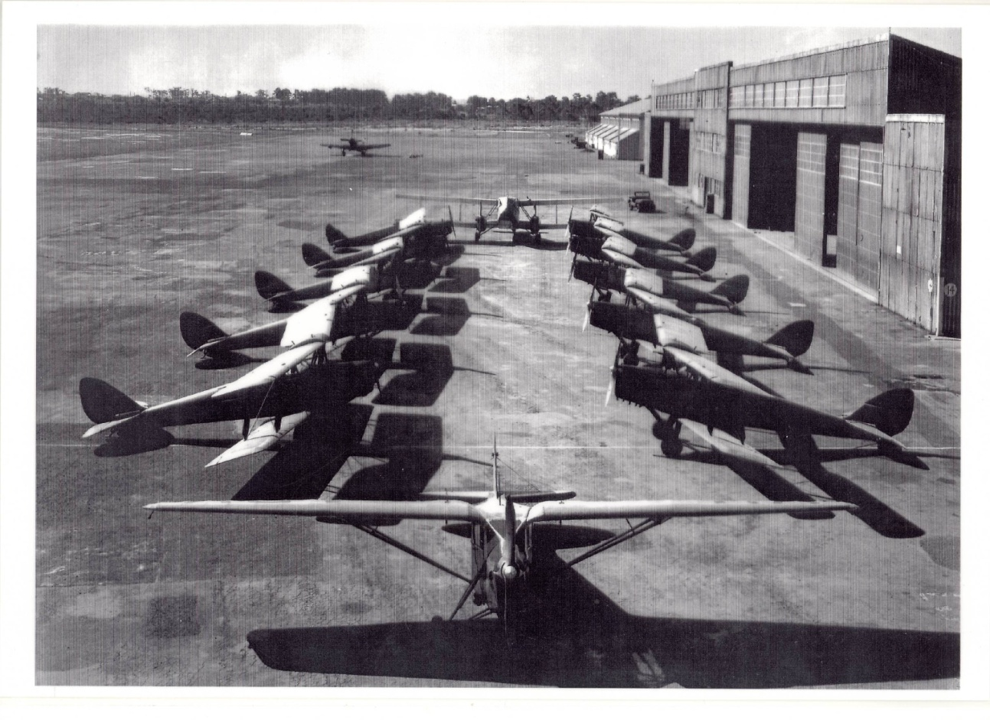
Figure 27: RAC fleet, about 1947, outside Hangar 14
The Royal Aero Club of New South Wales was formed in 1926, and operated mainly from Mascot. In 1946, the Royal Aero Club had made a request to the Department of Air for Bankstown to be used for `private flying and aircraft manufacture to take some of the pressure of the increased traffic in light aircraft’ off Mascot Airport’. This also suited the Department of Civil Aviation, as they wanted fewer small aircraft using Mascot airport, which catered to an expanding airline market.
The need to establish Bankstown as a second major Sydney airport, catering mainly for light aircraft was a strong factor in the decision to move 22 squadron RAAF to Richmond, and to scale down the RAAF presence.
During the pre-war and early post-war period, the RAC and other flying clubs were supported by the Federal Government. Flying training was subsidised, the clubs received a special payment when a member acquired a formal qualification, and the purchase of ex-military training aircraft often occurred on very favourable terms.
Of all the flying clubs, the Royal Aero Club was the most prestigious. It was given use of hangars at Bankstown at a ‘peppercorn’ rental. It was intended that they would be given some huts as clubhouse, but by 1948 the hospital was vacant and they were allowed to use this facility.
Vestiges of class distinctions remained for a long time: in the early days, instructors were regarded as of lower status than the members, and not permitted in parts of the extensive clubhouse area. There were tennis courts and a gun club, with properly constructed clay pigeon shooting facilities.
The 1947 fleet consisted of 18 Moths, and a de Havilland Dragon. The club continued to grow for nearly twenty years. In 1961 it claimed ownership of 14 aircraft at Bankstown.
The RAC held spectacular aviation pageants at Bankstown in the early post-war years. On October 11, 1947, a display included Mustangs, Lincolns, Wirraways and Beaufighters, a Slingsby Sailplane and an autogyro. A special feature was the last flight of Kingsford-Smith’s Southern Cross before it became a museum display. 50,000 people viewed the 1949 display, including service displays such as formation aerobatics by RAAF Vampires. The RAN had 14 aircraft conducting dummy deck landings and also demonstrated JATO takeoffs.
Hangar 410 was relocated to Bankstown in 1962 for use by the RAC. It was placed near the clubhouse, and at the same time Bellman Hangar 15 was moved closer to the clubhouse.
In 1965 the RAC had 1163 flying members, with a fleet of 16 aircraft. Its clubhouse (the former hospital) included a fine dining room and accommodation for visitors. A project was under way to train Malaysian pilots under the Colombo plan by which the Federal Government provided education for citizens of countries to our near north.
The RAC had believed that, having transferred to Bankstown, they would continue to be supported financially and also would receive favourable terms for rental of facilities. This situation, by and large, persisted until 1990, when the club was evicted. (see page 63).

The Migrant Camp
A migrant camp was established, using existing barracks and other facilities plus a few new buildings, in 1949 and ceased operation in 1956. This was a Migrant Workers camp, for individuals rather than for families: the nearby, much larger, Villawood camp catered for families. The relationship of the camp with the airfield and the community was not always happy. The Migrant Camp area was fenced off in 1952,

Bankstown and the Cold War

National Service
The outbreak of the Korean War in 1950, coupled with the Malayan Emergency and the Viet Minh uprising against the French in Vietnam, appeared to threaten Australia directly. Recruiting for the regular Armed Services proving insufficient, in 1951 the Menzies Government re-introduced conscription which had ended in 1945.
Conscripts were required to do six months’ training and then to be part of the reserve forces. Bankstown was a centre for RAAF national service while it operated (1951-59). The and the servicemen were accommodated in the wartime RAAF and WAAAF barracks, and used former wartime facilities such as the cinema. The option to do RAAF national service at Bankstown was attractive to local youth, many of whom had been members of the local Air Training Corps.

Preparation and Repair of Fireflies, Sea Furies and Gannets
The Fairey Aviation Company established a major facility in Hangar 14 and Hangar 131 in 1947, Their main task was preparing Sea Fury and Firefly aircraft for the RAN, whose first aircraft carrier HMAS Sydney was commissioned into the RAN on 16 December 1948. Many modifications were made to suit Australian needs.
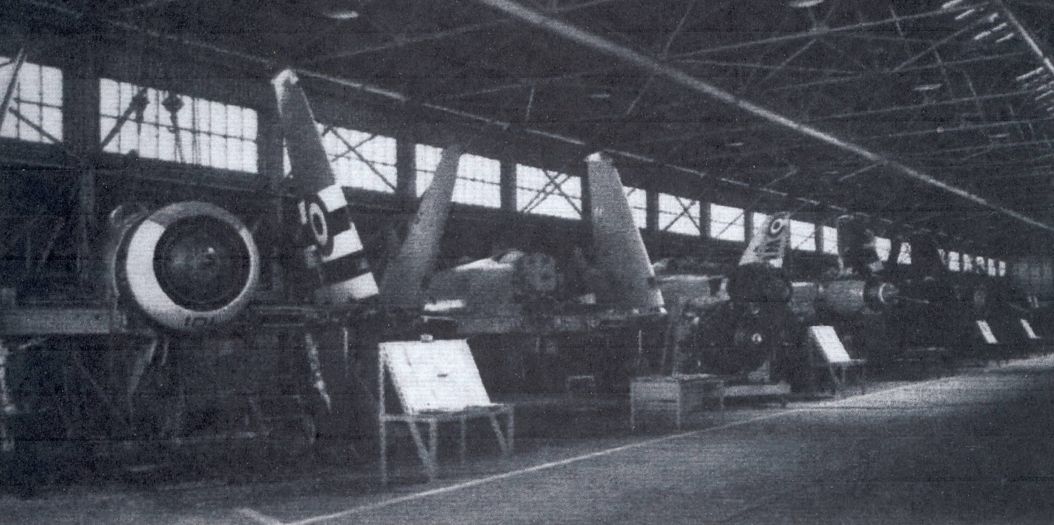
Figure 28: Sea Fury fighters in Hangar 131, 1955
The last such aircraft prepared at Fairey’s Bankstown operation were the Fairey Gannets, which replaced the Fireflies towards the end of the 1950s. The Gannets were star performers at the Bankstown Air Show of 1960.
In association with the Salisbury factory in South Australia, Fairey and other firms in Bankstown worked, during the 1950s and 1960s to produce rocketry, telemetry and other items for use at Woomera Rocket Range. Hangar 14 was closely guarded, 24 hours a day, by armed guards and guard dogs, during this time. These operations died out by about 1970.

Bristol Aeroplane Company
In 1954 the Bristol Aeroplane Company (Australia) began operations at Bankstown in Hangar 275, preparing material for use at Woomera range and also servicing aero engines and helicopters, notably RAAF Bristol Beaufighters, which remained in service until 1956 and the Bristol Sycamore helicopters in service with the RAN.
During the late 1950s Bristol was involved in the supply of the Bristol Bloodhound ground-to-air guided missile, first by assisting with the test models that were used at Woomera, then with the erection of the missiles supplied to the RAAF. They came into service in 1961 but were phased out by 1968. A few were stationed at Allambie Heights, Sydney, to defend the city from any attack.
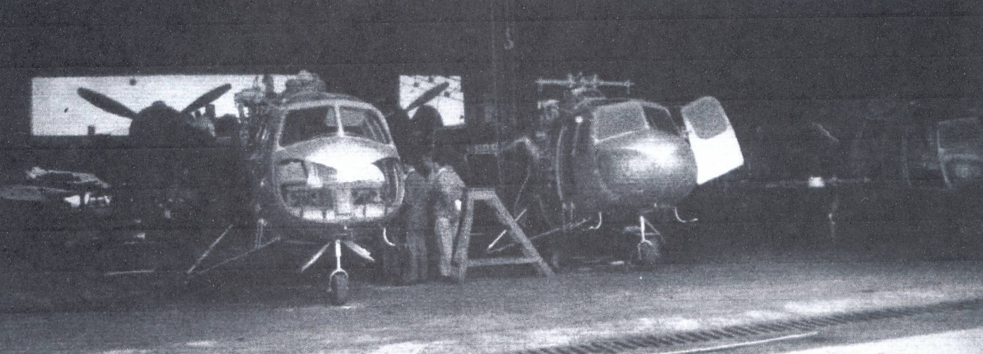
Figure 29: Bristol Sycamore helicopters, Hangar 275, 1955

De Havilland
From 1927, de Havilland Australia was the first overseas subsidiary of the de Havilland Aircraft Company. From its base at Mascot, it sold, assembled and repaired the range of de Havilland aircraft, moving into the production of the DH-82 Tiger Moth primary trainer including the construction of engines. De Havilland also provided significant parts of the Beaufort project, including propellers and wind structures.
Another project was a troop-carrying glider, of which 8 examples were made, and delivered to Bankstown, by mid-1943.
Their buildings at Bankstown, on the opposite side of the aerodrome from the main building, front onto Milperra Road. Construction began in 1942 and the main project was the production of the Mosquito fighter-bomber. The first Australian Mosquito was delivered to the RAAF on 5 March 1944 and 212 were built They served in the RAAF till 1953.
After the war, the three-engined Drover light transport was designed and built at Bankstown, its first flight being on 23 January 1948. 20 of these were built. They were used for remote area transport and by the Royal Flying Doctor Service.
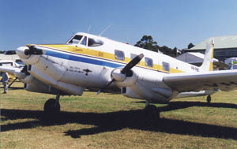
Figure 30: De Havilland Drover at Australian Aviation Museum, Bankstown
190 Vampire jet fighter and trainer aircraft were built at Bankstown, the first flying on 29 June, 1949. These required considerable modification from the original British design.
De Havilland played a major support role in the field of guided weapons design and production during the 1950s.
From 1965, Hawker de Havilland, (successor to de Havilland Australia) collaborated with the Commonwealth Aircraft Factory to produce the Italian Macchi MB326H jet trainer. 97 Macchis served with the RAAF between 1967 and 2001, when the type was replaced by the BAE Systems Hawk 127.
The later history of de Havilland can be seen on page 64.
Test pilot Brian Walker needs to be remembered for his part in the development of de Havilland aircraft.

Group Captain Brian Walker, DSO
Brian Walker (1913-2008) was born in Lyndoch, in South Australia’s Barossa Valley, in 1913, son of an Anglican clergyman. Like many of his generation, he was inspired to become an aviator as a result the example of Charles Kingsford-Smith, whose Lockheed Altair he saw at Adelaide in 1932.
He joined the RAAF in 1935, training at Point Cook and being appointed to 1 Squadron at Laverton, flying Bristol Bulldog and Westland Wapiti biplanes. He became an instructor and a skilled pilot of many kinds of aircraft. At the outbreak of the war he was commanding officer of the newly formed 25 squadron in Western Australia. In early 1942 he was involved in defending Darwin as Commanding Officer of 12 Squadron, flying Wirraways. He led 30 Squadron, flying Beaufighters, in New Guinea, taking a prominent part in the crucial Battle of the Bismarck Sea, and later became commander of 1 Fighter Wing (Spitfires) defending Darwin in 1944-5.
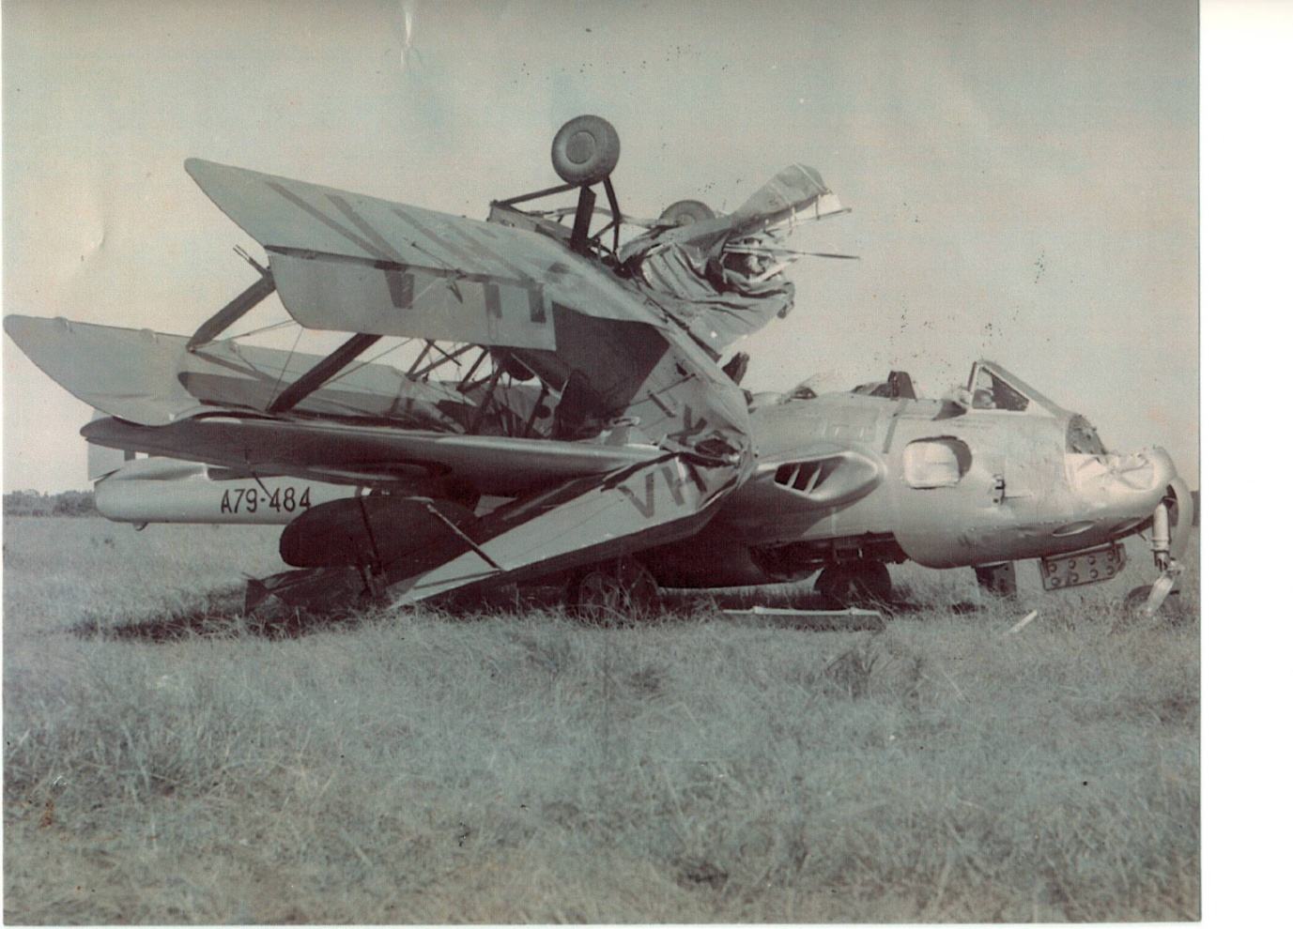
He had also in 1943 been a test pilot for the early Mosquitoes built at Bankstown and after the war became a test pilot for de Havilland. After gaining some more experience in England, he returned to Bankstown, test flying Mosquitoes and imported de Havilland Doves.
In 1948 he flew the de Havilland Drover, Australia’s only locally produced airliner. He then flew the Australian-modified Vampire fighter.
Figure 31: Collision of Tiger Moth and Vampire, October 1960
One of Brian Walker’s less successful moments!
He later flew in New Guinea, then returned to Bankstown. His flying career came to an end in 1985, after a period of 50 years, having flown over 60 different types of aircraft.
Walker was a brilliant pilot. He claimed to have solved many problems, such as a fault in Beaufort bombers that was causing many crashes in 1943. His aircraft had jammed trim tabs in a nose-down position, and could barely remain airborne. He flew it for fifty minutes before safely landing at Bankstown, ‘wheels up’.
He also had some spectacular mishaps, such as that shown on the previous page. He was also well-known for examples of rowdy behaviour on the ground, one of which had led to a court-martial, and for various other escapades such as flying in a USAAF B-25 bomber under the Sydney Harbour Bridge and ‘borrowing’ various service aircraft to impress his current girlfriends.
As well as being an important player in Bankstown’s aviation history Walker is an example of Australian war heroism and individuality.

Air Agriculture at Bankstown
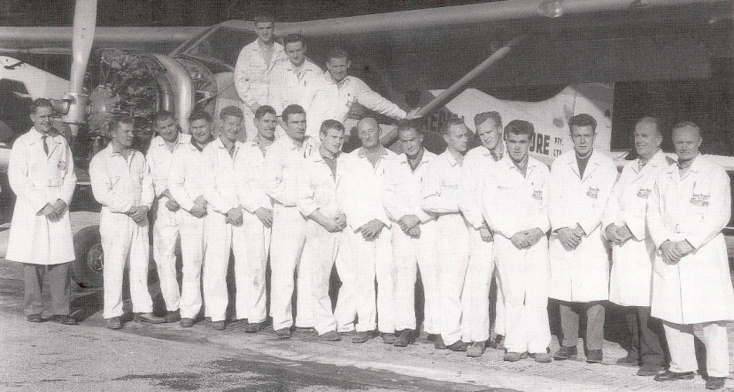
Air agriculture began in July 1947 when East- West Airlines began a crop-dusting operation with a single Tiger Moth. From this operation, a separate organisation, Air-Griculture was formed in 1949, and this became Air Agriculture in mid-1952. Based in Bankstown, this was the first really well-organised operation in this field. By 1953, they were operating 10 Tiger Moths, and by 1957 the de Havilland Beaver was being used. In 1959 the company even used a specially modified Bristol Freighter. By 1970 this was quite a major operation.
Figure 32: Air Agriculture staff outside Hangar 17, 1970
The firm has always used Hangar 17 but during the 1960s and 1970s used 131 and 114 for various purposes.

Smaller Aircraft Manufacturers

KS-3 / Yeoman Cropmaster agricultural aircraft
The Wackett intermediate trainer was designed by the brilliant Australian designer L J Wackett, and built at Fishermans Bend, Melbourne. It first flew in October 1939, and about 200 were built between May 1941 and April 1942. At the end of the war, many surplus aircraft were sold off, including many Wackett trainers. Prices were from ₤73 to £205. 98 of the 134 Wacketts sold in 1945 were purchased by John T Brown, manager of Kingsford-Smith Aviation Service, and many were stored in Hangar 16. Those that could be made airworthy were sold, often to flying schools, and many were used by Kingsford-Smith Aviation Service themselves over the next few years. They were gradually replaced as more modern aircraft became available. .
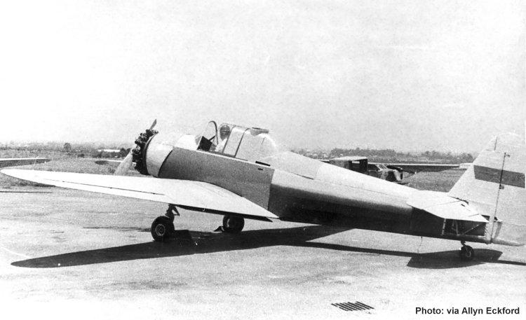
Figure 33: Cropmaster KS-3 at Bankstown
This relatively early modified Wackett has the original radial engine.
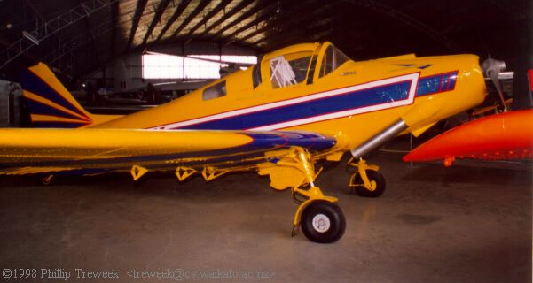
Figure 34: YA-1 Cropmaster, Ashburton Museum, New Zealand
The Cropmaster utilised a new metal wing, a new tailfin and tailplane, with a fertiliser hopper in the rear seat position. This example has a 250 hp Continental engine.
Over the period 1960 to 1966, 21 Wacketts were modified as agricultural aircraft, again in Hangar 16, with storage in Hangars 131 and 14. They were produced by the Yeoman Aircraft subsidiary of Kingsford-Smith Aviation Service. Modifications included the installation of more powerful engines. The aircraft performed valuable service until superseded by more modern aircraft late in the 1960s, as US aircraft became more readily available.

SA-29 Spraymaster
The Spraymaster was another agricultural aircraft, this time based on the DHC-1 Chipmunk, which was made by Aerostructures at Bankstown. Three aircraft only were produced. The first flew in September 1965.

Victa Airtourer
Figure 35: Victa Airtourer prototype VH-MVA at Bankstown, October 1962
The Victa lawnmower was manufactured in Milperra. In the late 1950s, after discussion with the Kingsford-Smith Flying School, work began on designing a light aircraft. On 12 December 1961 the first all-metal Victa Airtourer 100 (VH-MVA) was flown at Bankstown. The first Aircruiser, a four-seater version, first flew on July 17, 1966.
The basic fabrication was performed at the Victa factory, then the disassembled aircraft were brought to Hangar 114, the ‘American’ hangar, where they were assembled. This included installing the wiring harness, instrumentation, and control mechanisms, which were, for the time, very advanced. The aircraft were then extensively tested, both on the ground and in test flights, for this purpose being based in Hangar 276 and 131.
168 aircraft were manufactured by this process at Milperra and 80 more were manufactured in New Zealand. It was used by the RAAF as the CT4 Airtrainer, Series A-19. 37 such aircraft were used between 1972 and 1992, and about 70 Airtourers are still flying.
The contribution of Mervyn Richardson and Henry Millicer to this project needs to be acknowledged:

Mervyn Victor Richardson and the Airtourer
Mervyn Richardson (1893-1972) was not formally educated beyond primary school but was a remarkably talented mechanic and inventor.
His early career was not always successful but in 1952 he invented the famous Victa Rotary Mower, which was an enormous success.
He began production, and his mowers were an enormous success. By 1958 Victa Mowers had moved to a new factory at Milperra and its 3000 employees were building 143,000 mowers a year for export to 28 countries.
In the 1960s Victa diversified: in addition to lawnmowers, the firm manufactured the ‘red phone’ (a private payphone system installed in shops and clubs), the Victa Airtourer (a light aircraft) and, for a short time, Victa project homes. The construction of the airtourer is described on page 51.
Richardson was very wealthy, and enjoyed spending his money. He flew an amphibian from his luxurious home at Pittwater to Bankstown to work, but always took a cut lunch in a paper bag to work each day.
He died in 1972 at the age of 79.

Henry Millicer
Henry Millicer (1915-1996) was born in Poland and fled to Britain at the start of World War II. He was a brilliant engineer, and during the war he had a distinguished record as a bomber pilot. After the war he continued his studies and emigrated to Australia in 1950. He worked with the Government Aircraft Factory and was involved in the development of the Jindivik pilotless aircraft and the Malkara missile. His main connection with Bankstown was as designer of the various Victa light aircraft.
Millicer later became the principal lecturer in Aeronautics at the Royal Melbourne Institute of Technology. In 1992 he was made a Member of the Order of Australia. He planned to recommence production of the Aircruiser, a version of the Airtourer. He died in 1996 aged 81..
He was a strong supporter of Australian aviation, and a very clever and resourceful engineer who should also be remembered as a successful immigrant of the early post-war period.

The Transavia Airtruk
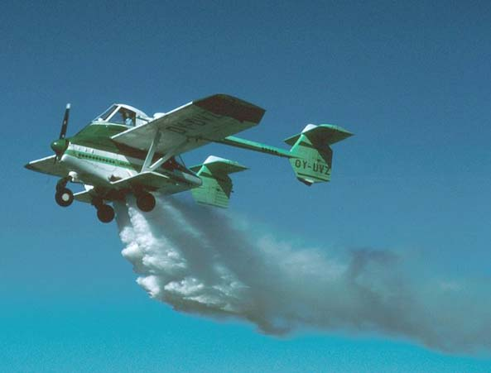
Figure 36: Airtruk PL-12 exported to Sweden
The Airtruk PL-12 first flew at Bankstown on April 15, 1965. This innovative aircraft was designed by Luigi Pellarini, and was ideal for aerial agricultural work. With a relatively small 224 kW (300 hp) engine, it could carry a load of a tonne of fertiliser. The unusual twin tail-boom configuration enabled fast loading.
Over 120 of these aircraft, in various models, were built, mainly at the Transavia factory at Seven Hills, and most were test-flown at Bankstown. The last was built in 1998. One version, known as the PL-12U was constructed as a multi-purpose aircraft for passenger, cargo and ambulance roles; several of this type were purchased by the Thai Government for use in counter-insurgency operations.
An ambulance version is preserved at the Australian Aviation Museum, Bankstown.
Two significant people need to be mentioned in regard to this aircraft;

Franco Belgiorno-Nettis
Franco Belgiorno-Nettis came to Australia in 1951 and, with a partner, built Transfield, the largest engineering and construction company in the Southern Hemisphere. Within five years, he became one of the country’s most successful industrialists.
Transfield Corporation is mainly remembered for the hundreds of kilometres of high-tension electrical lines erected throughout Australia. In the mid-1950s the company diversified into aviation.
Belgiorno-Nettis needs to be remembered as an example of the self-made migrant success story, and the aircraft remains an outstanding example of Australian initiative, design and manufacturing skill.

Luigi Pellarini
The Transavia Airtruk and the Fawcett 120 (see page 81) were designed by the Italian emigrant aircraft designer Luigi Pellarini. He needs to be remembered as an example of a person with drive, talent and initiative. Most of his activity was centred around Bankstown airport.

The 1970s: a boom time for light aviation
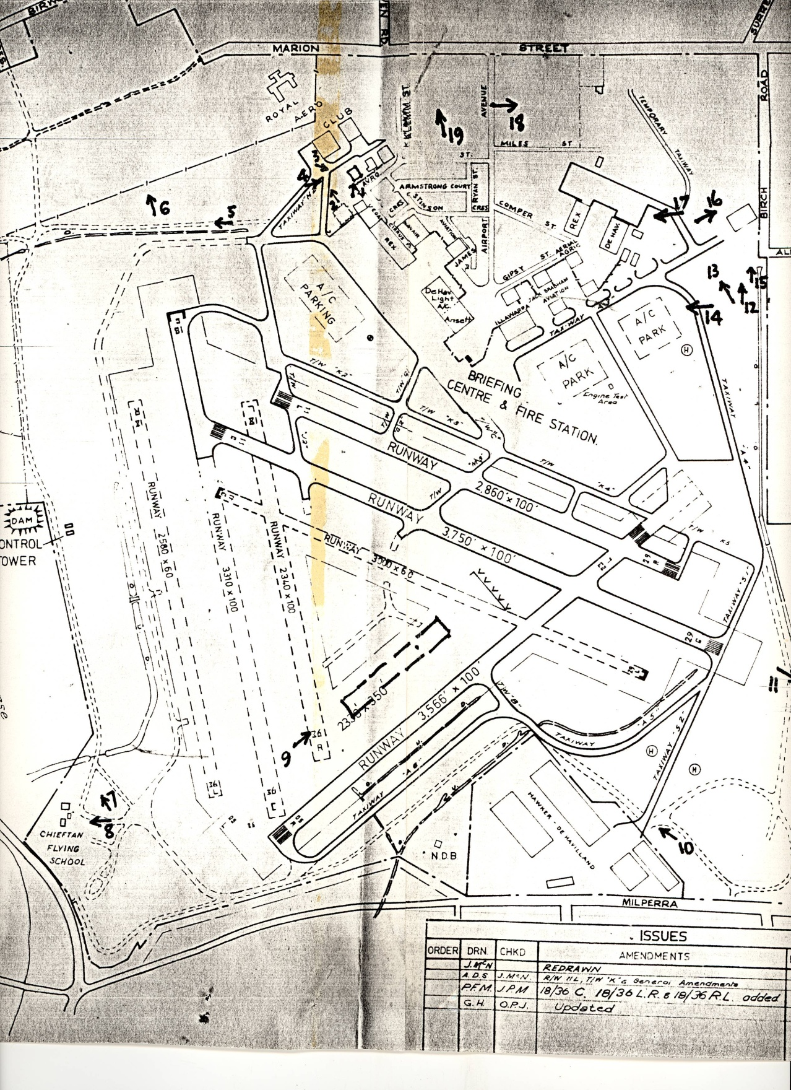
Figure 37: Plan of airport, 1972
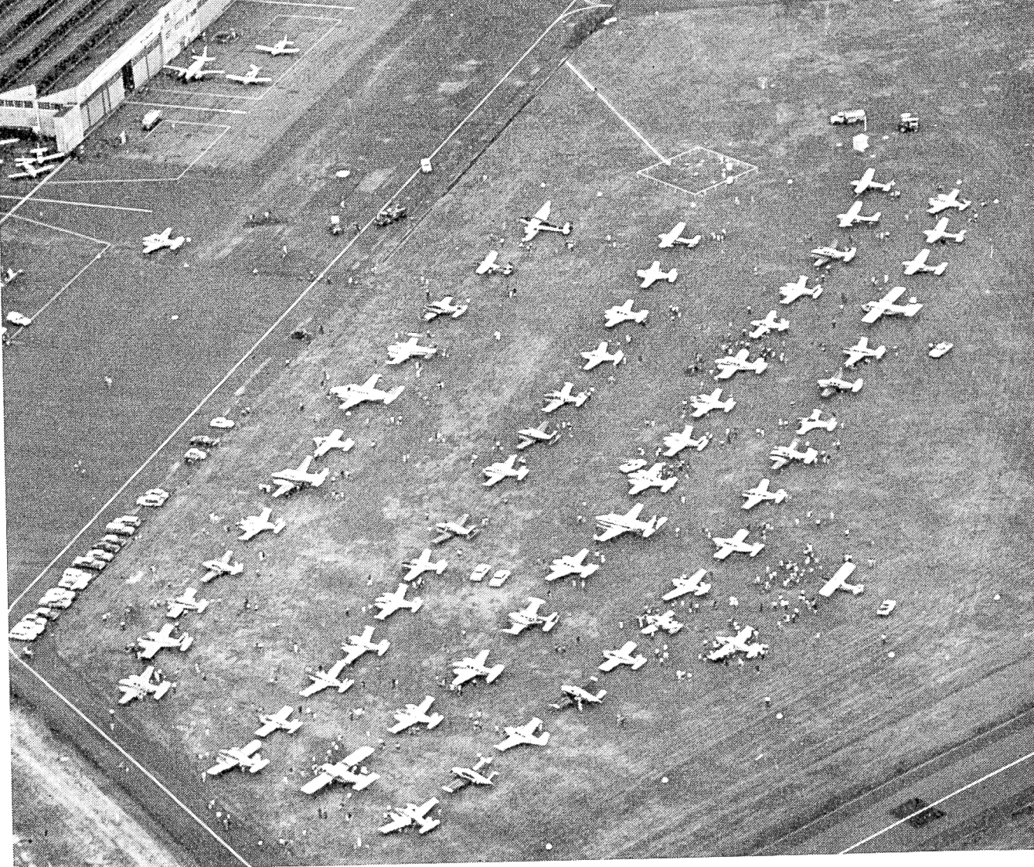
Bankstown’s status as a centre of light aircraft was demonstrated in 1969, when it was the finish point for the Captain Cook Bicentenary England-Australia Air Race held in that year. Of the 70 starters, 59 completed the course within the set time.
By 1970, ‘Bankstown Airport was the largest general aviation airport in the southern hemisphere, with more than 250,000 aircraft movements annually’. The airport expanded its operations at this time, despite opposition from local residents and the state government, who had announced that they would not approve further development of the airport facilities.
Another event of importance in that year was a major air display on September. The Aircraft magazine report details a wide program of activities, including a large number of ultralight aircraft, air races including even privately-owned Mustangs, aerobatic displays from the latest Cessnas, and transport aircraft such as the Short Skylan and HS-748. A Boeing 707 flew over and gave a display, but did not land.
The RAAF was notable by its absence: the Vietnam War was in full swing and this was given as an excuse. The RAN had also re-equipped with more complex aircraft. However it is notable that at this time Bankstown had very little defence importance apart from the work being done at de Havilland.
Development of the airport suffered another blow when in 1970 the government put forth a proposal to expand the airport’s operations but this was vigorously opposed by the local community. Operations on the 05-23 runway were curtailed during 1974: the aviation community blamed the local MHR, one Paul Keating, for what it regarded as this ‘short-sighted’ action. It was claimed that housing land under the approaches to this airstrip had been purchased cheaply, because of the proximity of the airport, so it was unreasonable for the owners now to complain about noise problems.
The principal commercial operations at Bankstown in the 1970s were in the field of light aircraft.
Firms such as Rex Aviation prospered from the sales and service of aircraft that predominately came from the US, such as Cessnas. Rex Aviation (which has no connection with the current feeder airline) had the franchise for the sale of Cessnas since the end of World War II, and had no problem in selling all that they could obtain during the early post-war years, when there were restrictions on purchases involving payment with US dollars. For much of the period to 1960, Rex could only obtain one or two aircraft a month. Its office was in Hangar 276.
As a symptom of the times, it is interesting to note that in 1972 preliminary plans were made for the construction of Cessna parts, and possibly a complete Cessna aircraft, by the end of the decade. Rex Aviation was actually now owned by the Commonwealth Aircraft Corporation of Australia. However, growing internationalisation and changes in government policy meant that this idea did not eventuate and the enterprise was privatised in 1985.

The 1980s and beyond
Figure 38: plan of airport, 3 February 1983
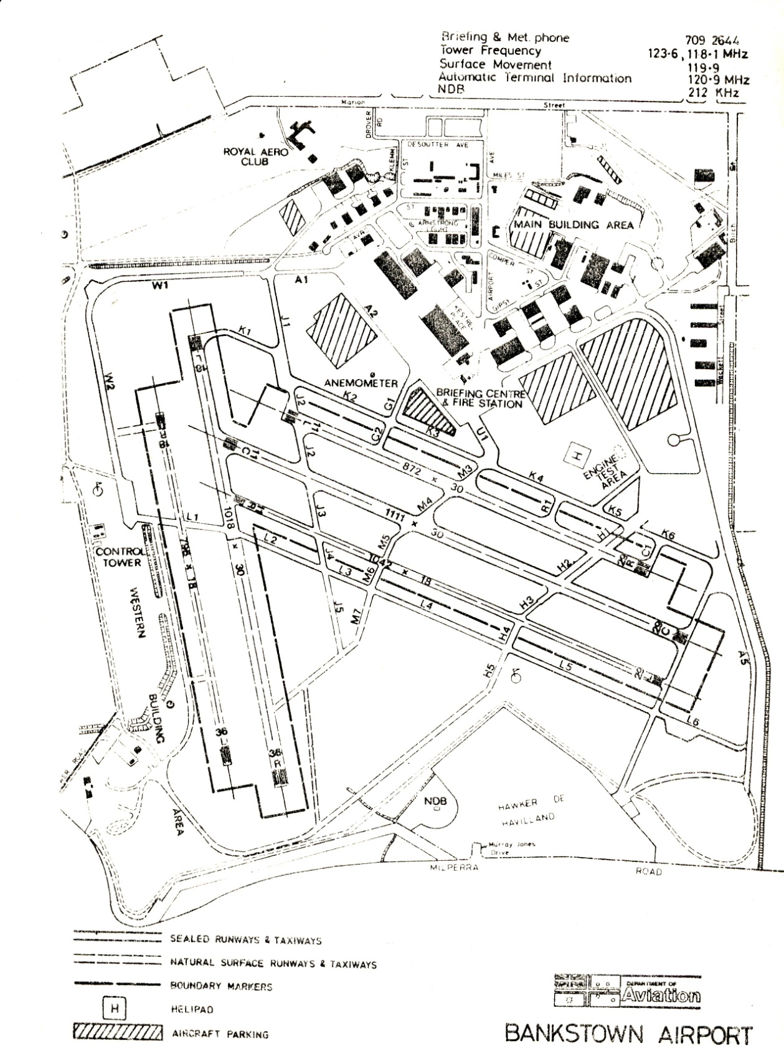
In the early 1980s, Bankstown Airport housed 460 aircraft:
.. and it was responsible for the servicing and maintenance of 35 percent of all aircraft in New South Wales and provided employment for 2370 people. It was a substantial facility with twenty nine aircraft maintenance organisations, nineteen aircraft sales companies, ten assembly companies, fourteen training schools, fourteen charter companies and twelve aerial mapping and crop dusting companies located there
1980 aircraft movements were approximately 400 000. This was the peak of light aircraft activity at Bankstown.
As can be seen by reference to the following aerial pictures, the period between 1985 and 1990 was a period of great development for the area. Several new areas were opened up, and it is notable that many developments were not related to the aviation industry.
Figure 39: 1985 aerial photo
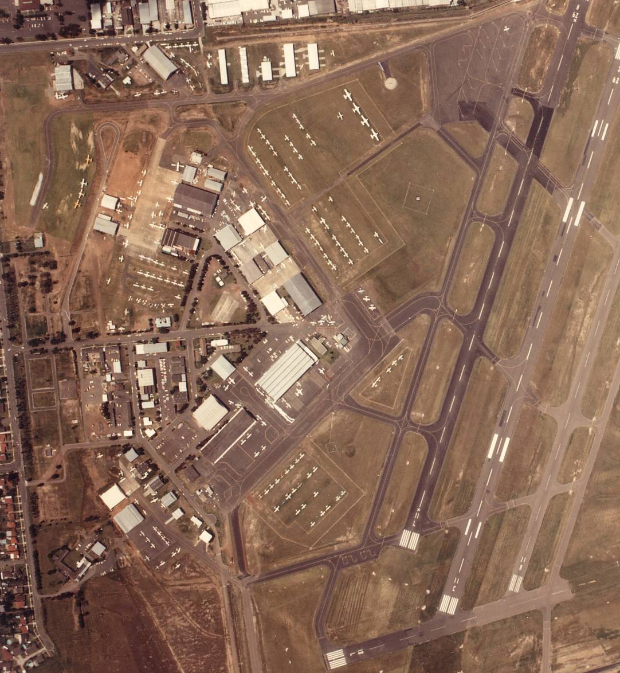
Note the relatively clear area in the top left corner which is developed in the following picture, only four years later. By this time, many non-aviation businesses were setting up operations in the airport area.
Figure 40: Aerial view, 24 April 1989
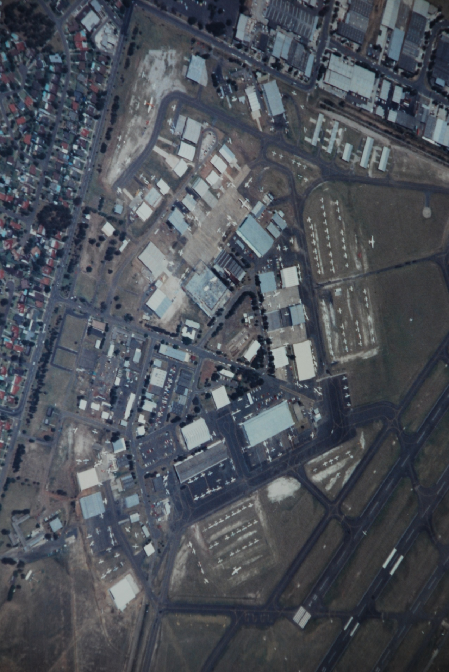
Between 1985 and 1989 the area in the top right-hand corner (Miles Street) is well developed, a majority of these buildings being for non-aviation business. Exceptions include several helicopter firms such as Heli-Muster. Also, along Link Road, to the south of this picture, new aviation enterprises such as Clamback and Hennessy, and helicopter sales company Heliflight had also recently appeared.
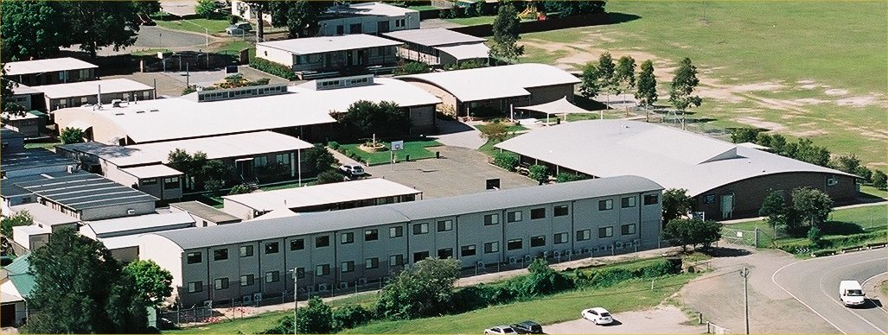
Figure 41: Bankstown Grammar School, Link Road, established 1986
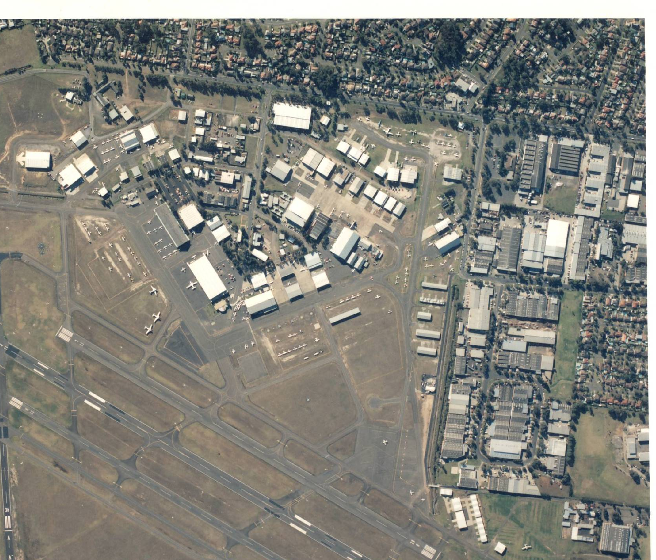
Figure 42: Aerial View, 1997

Demise of the Royal Aero Club
The Aero Club suffered during the 1970s and 1980s from a decline in government subsidies for training. Also, there had been an attempt in 1979 to get the Aero Club to pay market rentals for their hangars and clubhouse. A concentrated political campaign caused this move to be postponed. In 1989 it was again proposed to charge market rates for these facilities, and this time the club was unable to have the decision reversed, despite another strong campaign. Federal Aircraft Corporation, which then controlled the airport, terminated the special arrangements for the Aero Club in 1990, and shortly after the annual meeting for that year, the club ceased operations. The clubhouse, the old hospital, remained standing until 1998, but was demolished shortly thereafter. The hangars (14 and 410) were leased to commercial operations.

Hawker de Havilland: the later years
Hawker de Havilland (HdH) again became involved with the RAAF with the adoption of the F-18a Hornet after 1985. This required the development of a whole new set of skills, and it was no longer possible to build the front-line fighter aircraft in Australia.
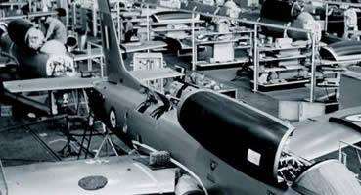
Figure 43: Pilatus PC-9 under construction at de Havilland, Bankstown
The last military aircraft to be built in Australia under licence was the Pilatus PC-9 trainer ordered for the RAAF, and HdH, who by this time had taken over the Commonwealth Aircraft Corporation (CAC), built 65 of the 67 PC-9s ordered by the RAAF, from 1987 to 1992,. Even though it is used for ‘basic’ training it is a far cry from the Tiger Moth: it is a turboprop aircraft with retractable undercarriage, variable pitch airscrew, and a top speed of over 550 km/hr.
Since then all aircraft have at best been assembled in Australia. 38 Sikorsky 39 S-70A-9s ‘Black Hawk’ helicopters were assembled by Hawker de Havilland at Bankstown by HdH during the 1990s, from imported components.
To an extent, this was replaced by offset schemes in which Australian factories produced components for a variety of international civil and military component programs. The former de Havilland factory now produces structures and systems for Boeing, Airbus and other major manufacturers.
In February 2009, Hawker de Havilland was renamed Boeing Aerostructures Australia, and continues this type of operation. In the process, incidentally, Boeing acquired the heritage of CAC, which had itself became a fully owned subsidiary of Hawker de Havilland in 1985.

The Australian Aviation Museum
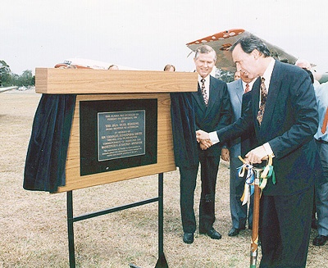
Figure 44: Inauguration of Australian Aviation Museum, February 1994
Prime Minister Keating unveiling a plaque on the museum site.
The Australian Aviation Museum operates in the south-east corner of the airport. The project was inaugurated in 1994 by the then Prime Minister, Paul Keating. A Bellman Hangar was erected as the main building: this came from storage at Hoxton Park, and was one of a number that had been erected on various country bases. By 1998 the museum was in full operation, including an office block, which now includes a library, administration area and specialist rooms.
Until recent years, the museum has housed an excellent collection of aircraft. These included the first production Avon Sabre fighter, two de Havilland Drovers, a Scottish Aviation Twin Pioneer, and a collection of seven DC-3 aircraft. The museum was the Sydney base of the Erickson Skycrane firefighting helicopter and the home base of Dakota Air Transport, which then had a fleet of three flying DC-3s. A worthwhile collection of aircraft remains including the only Fawcett 120, a Transavia Airtruk and a Dassault Mirage. There is an excellent collection of historical aircraft engines and propellors.
A plan was in hand to have the museum approached along a memorial driveway, off Link Road, that paralleled the existing cross runway, and would be lined with commemorative markers recording all the units that had left from Bankstown to participate in World War II.
However, over the last two years, the museum has been fenced off from the main airport to enable general development works to proceed, and so many of the more significant exhibits have been withdrawn. It is no longer possible for aircraft to be taxied to the museum.
The museum has therefore had to put many exhibits into storage. These include a Junkers G-90 replica and film sets for the interior of a Boeing 747 and a space shuttle.
The library houses what is probably the largest collection of aviation literature in Australia. There is a major book collection, including periodicals from many sources. The library is custodian of major archives such as those relating to pioneer aviator Nancy Bird, the Butler Air Transport, the Royal Aero Club, the Royal Aeronautical Society (Australia), and CASA. It has absorbed the library of the Aviation Historical Society and the Bob Wills Collection, among many other significant documents. A particular effort has been made to collect and maintain records of the development of Bankstown airport.
The development of the museum has been made as the result of an all-voluntary effort by some hundreds of workers over the years. Several major restoration projects are in train, including the re-conversion of a DC-3 to RAAF C-47 specifications.
Because the site is needed by developers, and because of high costs associated with relocation of the museum to another site within the airport area, it does not possible for the museum to continue at Bankstown. Plans are being prepared for a move to Camden.
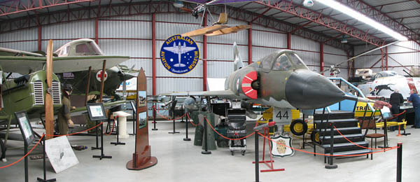
Figure 45: interior of AAMB hangar

Helicopters for bushfire fighting
Bankstown airport has taken a leading role in the use of helicopters for bushfire fighting.
Since 2001, the mighty Erickson Skycrane helicopters have been part of the Australian summer bushfighting season, and usually the Sydney-based helicopters have been based at Bankstown, until 2008 at the Australian Aviation Museum, Bankstown.
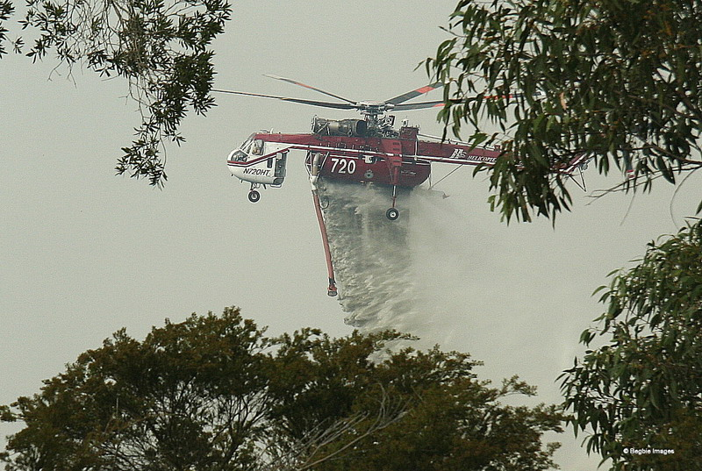
Other firms that have been involved include
- Heli-Flite helicopters, (Hangar 450, Miles Street) who have 19 helicopters available for this work
- Wieland Helicopters, (Hangar 610, Miles Street)

Since 2004: Development Plans,

Modern Bankstown
Now Bankstown Airport claims 362,206 aircraft movements in 2008, making it the 26th busiest airport in the world. A very large proportion of these are training exercises, a ‘touch and go’ landing / takeoff counting as two movements. Hoxton Park airfield had previously been used for many such activities, but much of the training activity now takes place at Bankstown.
The overwhelming majority of movements (91%) involve fixed-wing aircraft under 7 tons weight, and another 8% are helicopter movements, often including training operations.
There has been interest in developing Bankstown as a second airport for low-cost airlines, using quite large aircraft, but these have met considerable local opposition.
‘Bankstown is increasingly becoming an industrial park with the closure of the old 18/36 runway, although the three parallel 11/29 runways will remaining operating for the foreseeable future, although at nothing like their old operational tempo.’

The demise of Hoxton Park
According to local state MP Mr Paul Lynch, ‘At its peak [Hoxton Park] handled more than 100,000 movements a year, making it the busiest uncontrolled (non-towered) airport in Australia for much of its history. It hosted many airshows raising money for charity. Fire surveillance, shark patrol and aircraft inspecting power lines were based there at various times and it was used for security operations during the Olympics. In its entire history there were only two serious accidents, a much better record than most airports and indeed far better than the accident rate for what was (for most decades) the quiet country road running past its entrance’.
Hoxton Park Airport ceased all operations as of 1700, 15 December, 2008
Many operations moved to Camden, which remains a centre for general aviation, gliding and aerial firefighting operations. ‘Touch and go’ training landings that were formerly practiced at Hoxton Park are now largely transferred to Bankstown.

Development Plans for Bankstown
On 21 January 2004 James Fielding Group and Leighton Holdings Limited publicised their plans for Bankstown, Camden and Hoxton Park airfields.
In another publication, Leighton Holdings set out the plans for Bankstown Airport.
These involved the development of approximately 105 hectares of under-utilised land surrounding the main airport.
There was potential for growth in revenues from the airport resulting from the growth of general aviation, the possible introduction of limited regional passenger services, advancement of airport as a major Sydney logistics/distribution hub and the expansion of bulky goods and service facilities
It was planned to create an integrated employment, business and retail hub. Toll Freight opened a new 7,500 m² warehouse and office building, as well as an associated aircraft apron area in 2007
Hoxton Park was closed in 2008, when the leasehold expired. About 50 hectares is being developed, including a highway / retail service centre for the M7 freeway adjoining the site, with storage facilities for bulky goods, distribution outlets and light industry.
Figure 46: Current development plans for Bankstown Airport

The orange area is currently being developed for non-aviation purposes by DevCo, a private enterprise company.

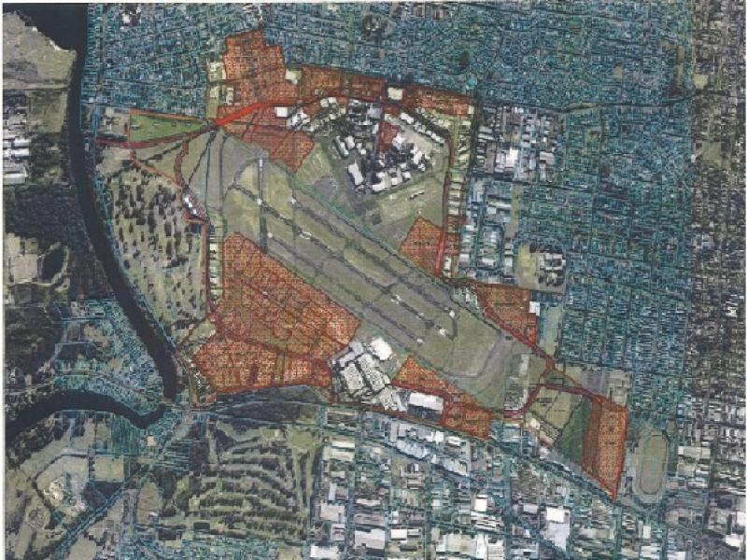
Notes on individual Bankstown buildings

Introduction
This section concentrates on the historical buildings of the v-shaped area of which Airport Drive is the central axis.
The whole precinct under discussion has considerable historic, aesthetic and associative values. This section indicates the manner in which the historic hangars of the World War II period and shortly after have been constantly used for aviation enterprises, often embodying considerable skill and initiative.
It should be noted that street names (eg Drover Road, Desoutter Avenue, Avro Street, Gipsy Street, Stinson Crescent, Cirrus Place etc) are related to the history of early aviation in Australia, and that the significance of these should be promulgated.
The basic structure of the precinct is still apparent, and it gives a good impression of the atmosphere of the time.

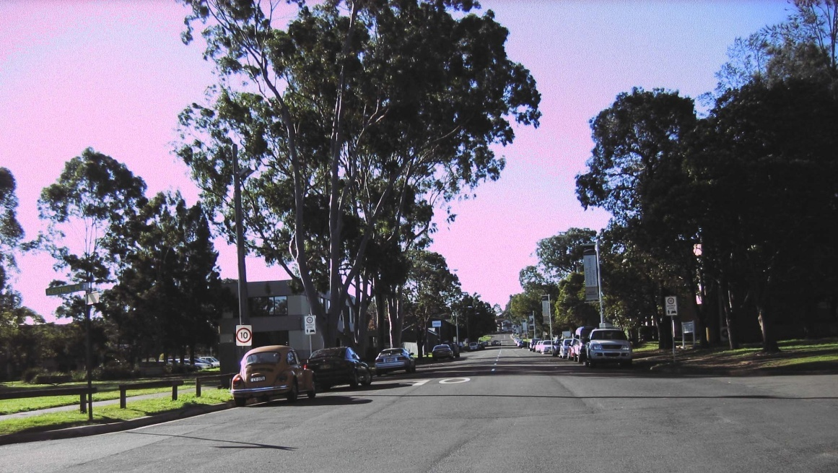
Figure 47: Airport Drive, 'spine' of the older airport 'triangle'

The first building: Hangar 14
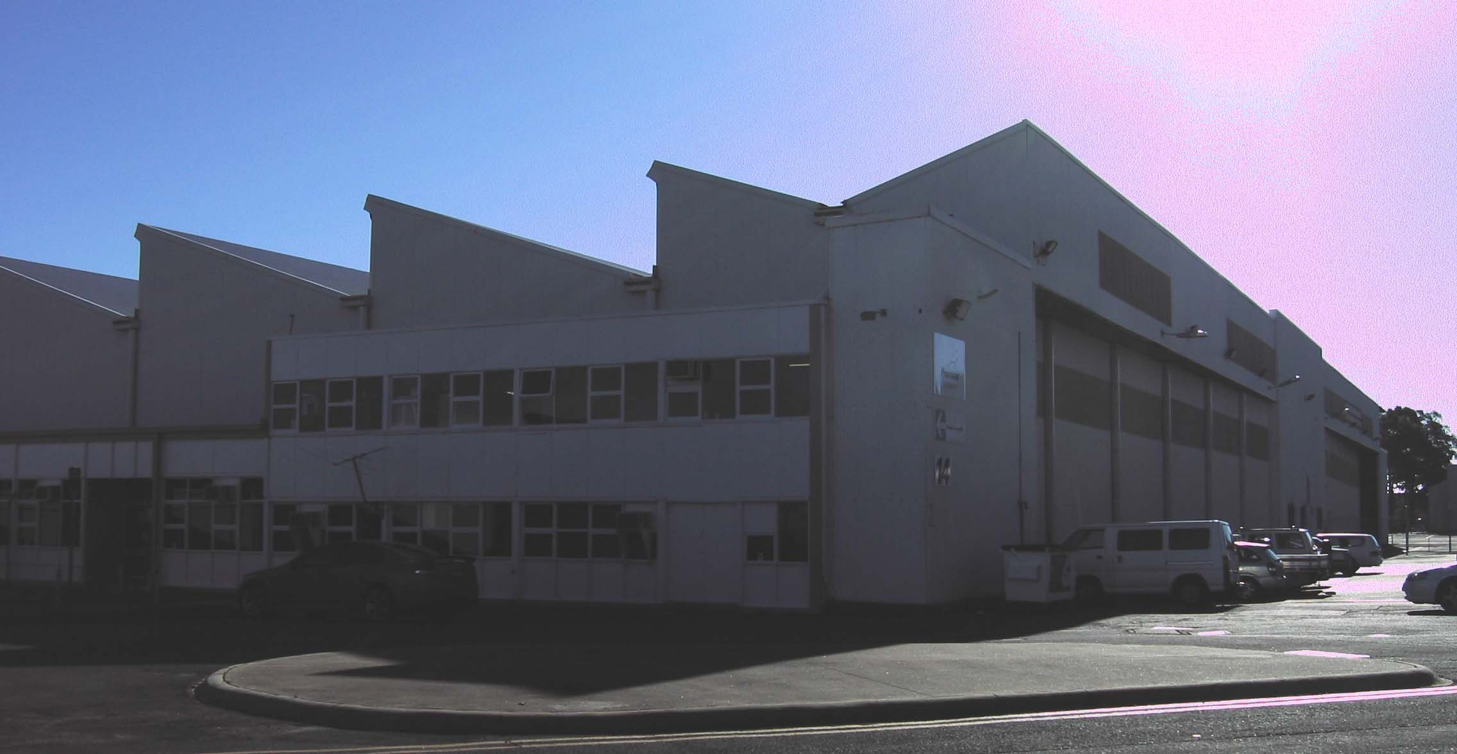
Figure 48: Hangar 14, showing 'sawtooth roof'
This was the first hangar construction on the site, by the Department of Public Works, as a wartime emergency job, intended as an erecting hangar for aircraft imported mainly from Britain.
It is constructed with BHP steel and clad in fibro.
The building has a sawtooth roof structure and four sets of six sliding doors. There is a central office section, which enabled it to be divided into two sections. Each end section was 21038 square feet, about 1954 square metres, and the office area was 8880 square feet, about 825 square metres.
It was used for various RAAF assembly projects the war, notably Avro Anson and Airspeed Oxford advanced trainers and Fairey Battle light bombers. These were converted for use as aircrew trainers for the Empire Air Training Scheme. Many of the 940 Ansons and 366 Battles received after mid-1940 were assembled at Bankstown.
It was taken over by HMS Nabberley in 1945, and the ends of the hangar were used as storage areas for Hellcats and Seafires.
On the departure of HMS Nabberley it was rented out from June 1947. Annual rent for half the hangar was ₤1690. The most significant tenants were Aircraft Disposals Coy, and one V J Madson./
The north-western section was used, from 1948, by the Fairey Aviation Co Pty. Ltd, but the name changed to Fairey Aviation Company of Australasia in 1951. This factory prepared and overhauled aircraft for the Royal Australian Air Force and Royal Australian Navy, and converted RAN Firefly AS.5 antisubmarine aircraft to become advanced T5 trainers.
The south-eastern section was occupied by the Royal Aero Club from 20 December 1949 to 31 October 1962. The RAC was allowed tenancy on a monthly basis at a peppercorn rent, though the RAC later asserted that this was a perpetual occupancy at no cost.
Hangar 410 was moved from Mascot by Commerce Associates for the RAC and Commerce Associates moved into the southern half of Hangar 14 after 31 October 1962.
An additional building (Building 123), containing offices, was added to the southeast wall in the 1950s.
Special Projects of the 1950s included various projects for the Woomera Rocket Range, in association with Fairey’s Salisbury (South Australia) establishment. At this time of the ‘cold war’ security around the Fairey factory was very strong. A compound was formed which included the southern part of Hangar 14, Hangar 131, Hangar 544 and Hangar 540.
In this building the Fairey Firefly aircraft, and also the Hawker Sea Fury fighters, both used by the Royal Australian Navy in the Korean War (1950-53) were erected and maintained. Sea Furies and Fireflies were used in HMAS Sydney, which was in service from 1948 to 1958, serving in the Korean War during 1951-2, and also in HMAS Vengeance, which was in service from 1952 to 1955.
Fairey Gannet anti-submarine aircraft were erected and maintained during the period 1956-67 and were used in the aircraft carrier HMAS Melbourne during this period, while Melbourne’s Sea Venom fighters were prepared and maintained by de Havilland at Bankstown.
Also, Fairey was involved in work on various kinds of rocket missiles being tested at Woomera during the 1950s and 1960s and the fenced-off area was constantly patrolled by security guards and guard dogs.
On the departure of Fairey in about 1969 it was used by Piper Aviation as a sales and service depot. This was a subsidiary of Ansett Transport. It was then used by Toll and Ipec as a freight depot, and currently by Pionair. Pionair currently conducts a freight and charter service, including the use of Convair CV580 aircraft designed and built in the 1950s and 1960s, re-engined with turboprop engines.
The hangar also houses a Boeing 747 film set, used in films such as Mission Impossible, which is being preserved and restored by the Australian Aviation Museum, Bankstown.

Hangar 131
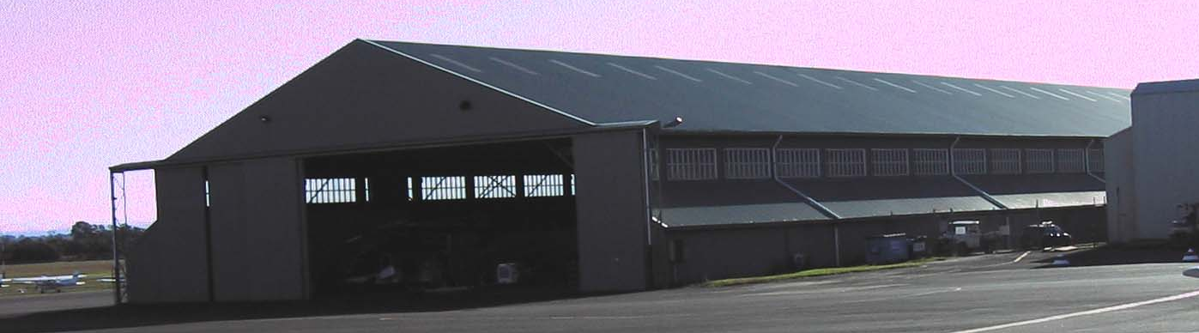
Figure 49: Hangar 131, currently used by Ambulance Service.
The building was constructed after July 1943, and the circumstantial and oral evidence indicates that it is a RAAF construction predating the takeover of the station by the Royal Navy.
They used it as a general assembly shed, with an efficient production line sequence as described on page 34.
The building is a long rectangular gable roofed structure with skillion wings on a steel frame clad with profiled steel sheeting.
In June 1947 it was rented by New England Airways, at a rent of ₤2,860 per year but operations at Bankstown largely ceased when New England Airways was absorbed into Butler Air Transport on 17 May 1948. Hangar 131 was handed over to the Department of Civil Aviation in the first transfer of buildings from the RAAF, 1 October 1948. Shortly after, it began to be used by private firms, then from 1951 was used by Fairey Aviation. It was fenced off in the high-security compound that is described on page 49.
It has been used for general aviation purposes and its role in the construction of the Victa series of aircraft has been noted elsewhere.
Of more recent years it was used as a freight terminal prior to the erection of specialist facilities on the northern side of the airport.
At the moment it is being used by the NSW Ambulance Service, who conduct an emergency response operation using state-of-the-art Augusta helicopters. The crews on duty are quartered near the site of the World War II hospital.

Hangar 114 – the ‘American’ hangar, 114 Prentice Street
Figure 50: The 'American' Hangar, Hangar 114
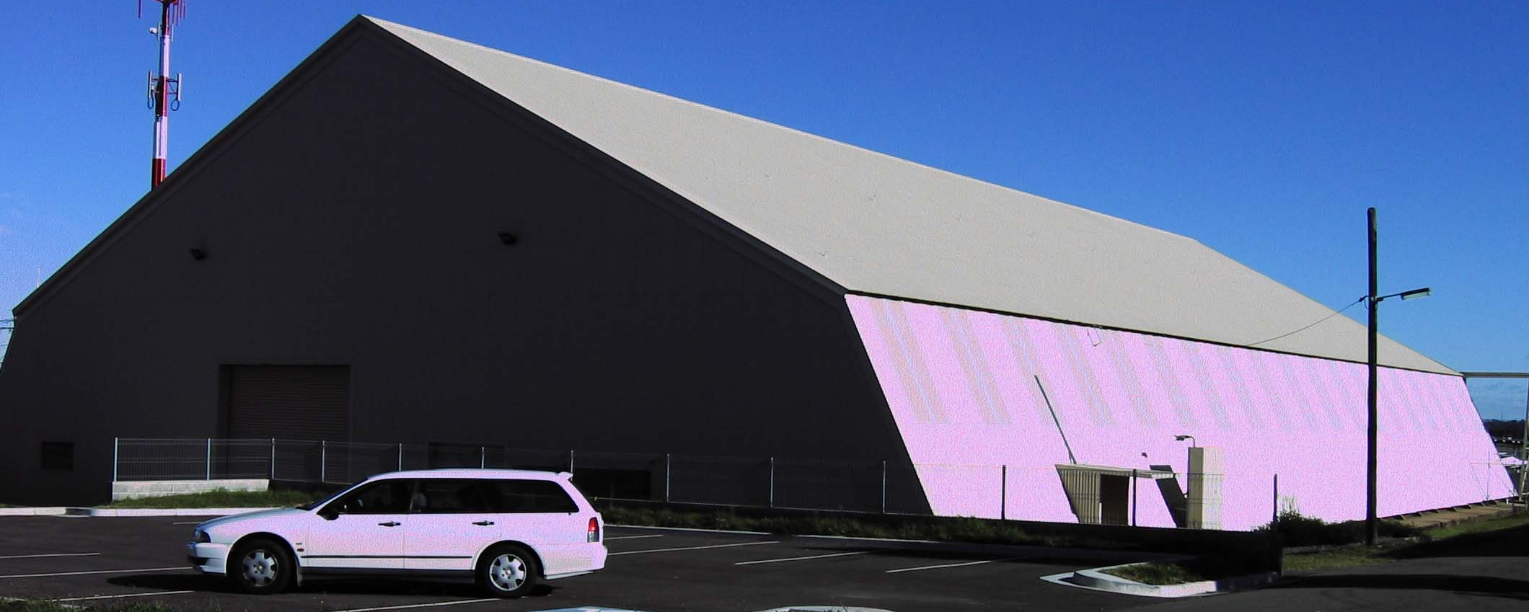
This hangar was built in 1942 by US engineers, and was thus popularly known as the ‘American Hangar’ to house aircraft assembly and maintenance during World War II.
This hangar was used for the assembly and maintenance of RAAF Aircraft by Clyde Engineering during and after World War II.
The only USAAF units formally based at Bankstown had moved on by the time the erection of this hangar was completed, 28 October, 1942..
It remained in use as a maintenance and staging facility by the USAAF and RAAF at least during 1943 (see page 21).
The exact nature of the use is not clear, and it appears that a rather informal arrangement was in place by which the hangar was used by Clyde Engineering, the USAAF, and the RAAF. Clyde Engineering formed a subsidiary company, Clyde Aviation Engineering, for their work in maintenance of aircraft.
A USAAF document states that Bankstown had facilities for 700 officers and enlisted .men, held 22,000 gallons of fuel, was capable of handling heavy bombers, and had repair facilities. This document also indicates that the USAAF had formally abandoned the base by the last quarter of 1944.
At the end of the war when the other hangars were rented out, there was some uncertainty about whether the building did belong to the RAAF, but it was certainly used by Clyde Engineering. This was solved by 1950, when the hangar was rented out to various operators as hangarage.
Its use as an assembly shed for the Victa aircraft has already been noted on page 51. It also has been used of recent years by the Australian Flying Training School, and as a studio for the TV production Australian Top Gear.
A typical use was for the sale and service of the US Mooney aircraft by a local subsidiary of the home company in 1981. In 1985, it was used for crash investigation purposes.
The building is rectangular with a gable roof and steel frame and is clad with corrugated iron. The hangar is unique in that it has a large sliding door on one side and another at the southwest end.

Bellman Hangars
The Bellman Hangar is a British design of 1936, designed to accommodate the expansion of the RAF that was occurring to meet the threat being posed by events in Germany. To house the new aircraft, new hangars were required. The hangars, typically of approximately 53.3m wide by 30m long, have sliding doors on each end and a single gable roof. Bellman hangars are significant because they exemplify the earliest prefabrication techniques. A minimum number of construction elements could be easily mass-produced by relatively unsophisticated techniques.
They could be erected in about 500 man-hours.
About 280 were manufactured and erected in Australia between about 1939 and 1945 and less than 60 survive.
The early set of Bellman hangars (16,17, 273 and 274), as well as the two added at the end of the war (135 and 299), are virtually identical in structure, with some additions and a variety of more modern cladding. They are all 96 feet by 114 feet (approximately 29 x34 metres).
These six hangars are of a type that was produced in large numbers for the RAAF during World War II and examples can be seen at several airports in New South Wales such as Williamtown, Fairbairn and Amberley.
The importance of retaining the Bellman Hangars is emphasized by the State Heritage Office as ‘an important reminder of the technical skills rapidly acquired in the early years of the war. The Bellman hangar was a British design for a demountable hangar which was manufactured by Lysaghts at Newcastle for use in Australia and the Pacific’..

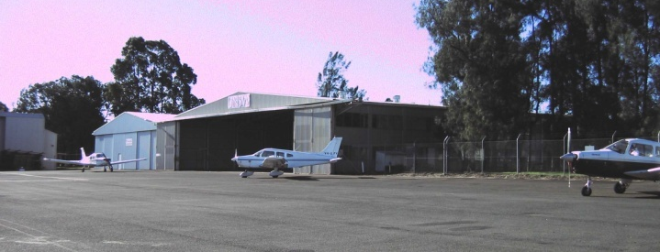
Hangar 15
Hangar 15 in Drover Road, currently used by Aquila Aviation, was actually the first Bellman on site. Its original location was just to the south of Hangar 14. It was completed on 3 March 1941, taking only 20 days for its erection. It was immediately used for the erection of aircraft.
It was then used by the small firm Brown and Dureau from May 1947. at an annual rent of ₤316.14s.0d.
It was handed over to the Department of Civil Aviation in the first transfer of buildings from the RAAF, 1 October 1948. It was moved to its present site, near what was then the RAC clubhouse, in 1962. The arrangement was that it would be used by the RAC, and that hangar 410 would be moved from Mascot and located alongside. The RAC would then vacate Hangar 14.

Hangars 16 and 17: General
Hangars 16 and 17 are two of the original four Bellmans erected for the RAAF in 1942.

Hangar 16
After World War II the hangar was used by Kingsford-Smith Aviation Services, notably for the storage of Wackett trainers and their conversion to KS-3 Cropmaster aircraft (see page 46). The 1947 rental was ₤316.14s.0d. per year. . It has continued to be used for light aircraft maintenance since that time.

Hangar 17
Figure 51: Bellman Hangar no 17
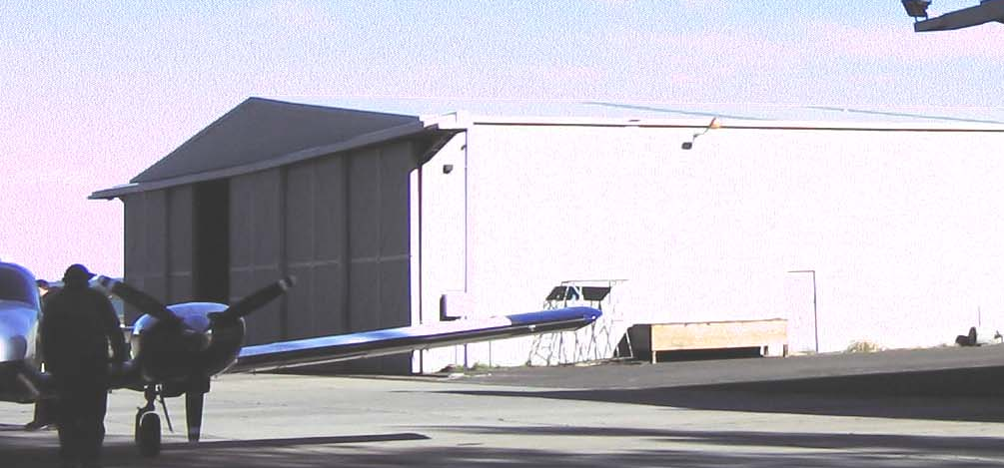This is currently being used by AirAg, which, despite their name, is more involved in repairs and maintenance than with aerial agriculture. They are particularly interested in the restoration of historical aircraft, including the Scottish Aviation Twin Pioneer, of which two are housed at the Australian Aviation Museum, Bankstown.
Directly after the war, it was hired briefly by New England Airways, until February 1947, at a rent of ₤316.16s.
It has been used for similar purposes since World War II.

Hangar 274
The hangar is one of four Bellman hangars that housed the RAAF station aircraft during World War II. It was built before the establishment of HMS Nabberley.
From 15 September 1946 it was used by Kingsford-Smith Air Service, whose major operations were still at Mascot. Rent was ₤316.16s per year.
Along with Hangar 17 it is used by AirAg Pty Ltd, an aircraft service firm which has a particular interest in the restoration of historical aircraft.

Hangar 135
The Bellman Hangar at 135 Aviation Place was one of the wartime pre-fabricated hangars erected at Bankstown in 1945 for the Royal Navy’s Air Base. An early post-war tenant was Intercontinental Air Tours, who paid ₤316.16s per year, taking possession on 1 July 1947. They also rented Hut 130, nearby, for ₤25 per year.
Hangar 135 later became part of the high-security compound of the Cold-War era referred to earlier.
It is currently used by the University of New South Wales (UNSW) flying operations. They are one of the few tertiary institutions which currently offer practical aviation as part of their engineering teaching.

Hangar 273
Hangar 273, off Comper Street, has some modern alterations.
It was originally reserved for the use of the Royal Aero Club, but was let to Syd Marshall who occupied the hangar from 16 December 1946, relocating from Mascot. Rent was ₤316.14s per year.

Sid Marshall, BEM (1902-1975)
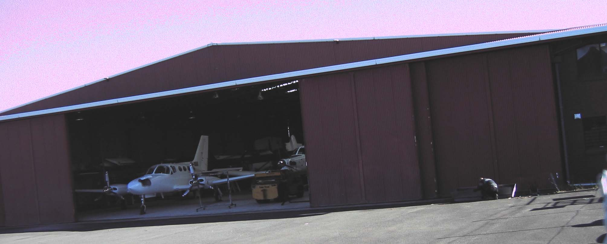
Sydney David Marshall began his career as an aircraft engineer with Kingsford Smith and Anderson in interstate Flying Services (1927). After the loss of the aircraft Southern Cloud, March 21, 1931, he moved to New Guinea, where he worked as an aircraft engineer and pilot with Guinea Airways. They flew Junkers W-34 transport aircraft and de Havilland Moths to support mining operations at Bulolo. Guinea Airways also had a Westland Widgeon light aircraft which had crashed, and Sid purchased it and repaired it, then made the first flight across the Coral Sea from Port Moresby to Cooktown and on to Mascot between 12 and 14 April, 1934.. His later career was varied: he established an aerial ambulance service, flew widely in New Guinea (including a flight in a Tugan Gannet to Rabaul at the time of the volcano eruption 29 May 1937, this being the first time an Australian-designed and built aircraft had been flown outside the country and the first to be used for an overseas charter).
He took the only film of the last take-off of Amelia Earhart, when she took off from Lae on 2 July 1937 prior to her disappearance.
During the war he was involved in maintenance of front-line aircraft throughout the Pacific, and after the war he moved to Bankstown where he set up business in hangar 273.
He sold, maintained and operated a wide range of aircraft.
He collected many aircraft, thereby preserving them for posterity. Notable among these is Spitfire A58-758, now preserved at Temora Aviation Museum and a Messerschmitt Bf 109-G, preserved by the RAF in Britain.. Another aircraft preserved by him was Avro Cadet VH-AGH, now privately owned.
An attempt to establish Marshall Airways as a commuter airline was unsuccessful, partly due to the governmental two-airline policy of the time. His Avro Anson MK.1 W2068/VH-ASM was acquired for his airline fleet on 22 June 56, and is now in the collection of the RAF museum at Hendon.
He and Doug Fawcett were strong supporters of the Ultra Light aircraft category, which was promulgated in December 1955. p261 and when the ULAAA was registered under the companies act in Nov 1959 Marshall was the first president,

Hangar 299
Hangar 299 is a Bellman hangar reclad in modern corrugated iron. The hangar was erected in 1945 for the Royal Navy but saw little use during the war.
After the war, and till the present time, it has been used by the engineering firm of Ray and Larkin. H J Larkin DFC. was a World War I pilot who established Larkin-Sopwith Aircraft Supply Co after the war, then in the 1930s established the Larkin Aircraft Supply Company, when he manufactured various types of light aircraft at Mascot. The firm moved to Bankstown after the war. An attempt to convert Boeing trainer aircraft for agricultural use in the 1950s was a failure. The firm continued trading under the name of Ray and Larkin, even after being bought out by the famous racing driver Jack Brabham in 1969. Hangar 299 is also used by Allan Bligh Aviation Pty Ltd undertaking maintenance and repair tasks for private owners and restoration, especially of older aircraft.
It is presently occupied by Bankstown Flight Facilities Pty Ltd, an air training school, and Sydney Air Scenics, an associated tourism company.

Hangar 275 and 276: General
Hangar 275 and 276 are Royal Navy type B1s Hangars (Butler Hangars) manufactured by Dorman Long and Co. Ltd (who built the Sydney Harbour Bridge). They were erected for use by the Mobile Naval Air Base in 1945. Both are 275 feet by 123 feet, about 69 metres by 37 metres.

Hangar 275
Hangar 275 was erected to the west of Bellman hangars 16 and 17.
After the war the hangar its first tenant was Airflite Training Ltd, who paid ₤1,644 per year, from 11 December 1946. Airflite was bought out by Bristol Aircraft of the UK over the period 1952-3. trading as Bristol Aviation Services Limited. Its first task was the servicing of RAAF Bristol Beaufighters. An early task was the introduction of the Bristol Sycamore helicopter, the second helicopter type used in Australia.

Figure 52: Hangar 275, currently Hawker Pacific (Boeing)
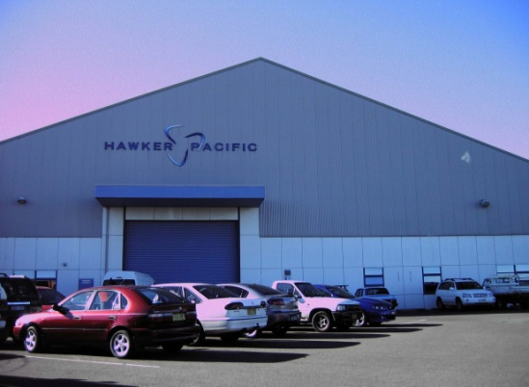
In 1956 Bristol was overhauling large aircraft such as the Bristol Freighter and the DC-3. In 1961 Bristol was selling the Italian Piaggio STOL transport, widely used in New Guinea. An example is preserved by the Australian Aviation Museum, Bankstown.
Bristol Aviation Services were subsequently taken over by Hawker de Havilland and then that firm merged to form Hawker Pacific. Hawker Pacific itself became part of Boeing Australia which continues to utilise the hangar and the office areas that have been added on. The original structure is visible, but major modifications have been made, notably with more modern cladding.
At the same time two smaller buildings were erected nearby (505 and 503). Hangar 505 is used by Australian Aviation Facilities Pty Ltd and 506 is used by Australian National Aviation Pty Ltd, both of which are aircraft service firms.

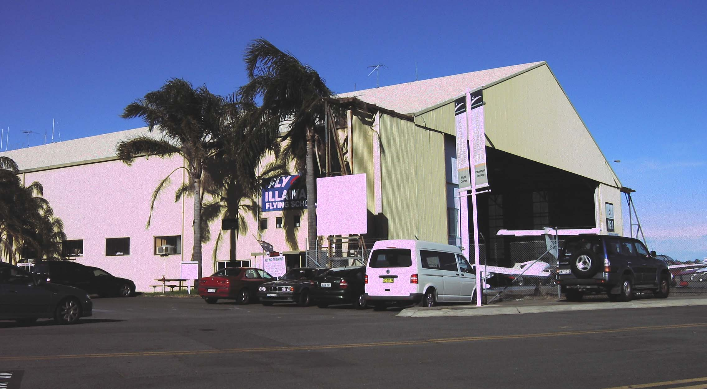
Hangar 276
Figure 53: Hangar 276 - currently Illawarra Aviation and others
Hangar 276 was erected near hangar 14 and 15.
Initially, after the war, it was rented to the Royal Aero Club on 25 April 1947, at ‘a peppercorn rental, if demanded’. The RAC moved into hangar 14, so 276 was used for general aviation purposes, its first user after the RAC Commerce International Pty Ltd.
It is presently occupied by Illawarra Aviation and by other small operations such as ‘The Red Baron’ scenic tours and aerobatics operation.
Illawarra Aviation, and this hangar, are associated with Doug Fawcett, whose contribution to Australian Aviation needs to be recorded.

Doug Fawcett: engineer
Doug Fawcett, (1922-2005), spent his childhood living alongside Mascot aerodrome, then barely more than an open field in an outer Sydney suburb, with a few aircraft and some sheds. His father was an aircraft mechanic.
He left school at age 14 to work in the aircraft industry and by the time World War II began he was highly qualified in fields of aircraft maintenance and worked in many areas of Australia and New Guinea. Immediately after the war he first became chief engineer of Butler Air Transport, including converting C-47 military aircraft to DC-3 airliner standard. In 1947 he opened his own engineering firm, moving its main operations to Bankstown in 1950. Among other projects, he modified Lockheed Lodestar military aircraft for civilian use and refurbished various aircraft for use by Israeli forces. He also modified Mustang fighters for non-military use, including Arnold Glass’ aircraft and other aircraft used for target-towing contracts with the RAAF.
In 1950 he acquired the Illawarra Flying School and set up operations at Bankstown. Its fleet grew from two Tiger Moths to over 12 more modern aircraft of various kinds.
The Tiger Moths were gradually replaced with various more modern Piper and Cessna aircraft, and many Tiger Moths were adapted for aerial agriculture for use by Fawcett’s Farm Air Pty Ltd . Other aircraft were used for aerial advertising, towing banners. In 1954 Frank Sinatra visited Australia for a concert tour, but had a quarrel with the local press and threatened to leave immediately. Fawcett was a fan of Sinatra’s and organised for an aircraft to fly over Sydney with a banner reading ‘Frankie, don’t go home!’ and the tour was saved.
In the early 1950s there was an embargo on the importation of American aircraft because of currency problems, and Fawcett sponsored the development of a substitute light aircraft. This locally designed aircraft, the Fawcett 120 was constructed at Bankstown, and first flew on 11 November 1954. It was planned to sell the production aircraft for about ₤2800. However a relaxation of the import restrictions meant that US aircraft could be brought in at lesser cost, and though the Fawcett 120 was an excellent design, it did not go into production. The sole Fawcett 120 is preserved at the Australian Aviation Museum, Bankstown.
He purchased two Lockheed Lodestars which he refurbished and used for transport and passenger services throughout the late 1950s and early 1960s, but was handicapped by the current ‘two airline’ policy. In the summer of 1963-4 he established a regular Sydney-Dubbo service, flying via Canberra, thus making an interstate flight, interstate trade being protected by the Australian Constitution.
During his life he was also involved in many other non-aviation projects, including the provision of mobile lunch vans selling direct to factory workers, the fabrication of portaloos, and construction of mobile homes.
Fawcett deserves a place in the human heritage of Bankstown as an example of a self-made Australian with great initiative.

Singapore Hangars: 271 and 272.
Some oral histories suggest that the two hangars known as ‘Singapore’ hangars are so-called because they were destined for Singapore, then diverted to Australia after the fall of Singapore. However it is clear that Hangar 271 and 272, off Rearwin Place, Airside, were built prior to the take-over of Bankstown by the Mobile Operating Naval Air Base in 1945.
They are 96 feet by 47 feet, about 29 metres by 14 metres, smaller than the Bellmans. Their rental cost in early 1947 was ₤ 234 per year.

Hangar 271
Figure 54: C-47 in hangar 271, featured in 1998 film ‘The Thin Red Line’
In early stages, this hangar was reserved for use by the Royal Aero Club, but was released for use by other tenants. In 1947 the tenant was Charter Flights, owned by one Howard Norris. Oral history indicates that he used Percival Proctor aircraft, and later used Hangar 114 as well.
It has been used by a variety of aviation firms ever since.
Bankstown Avionics Pty Ltd is the present tenant, and they also use hangar 109.

Hangar 272
In 1947 the tenant was the Truscott Club for Aeronauts, whose office was in Manly. This group had no association with the famous wartime RAAF pilot Keith (‘Bluey’) Truscott. It has been constantly used by a variety of general aviation firms since that time.
Presently it is used by Cirrus Aircraft NSW Pty Ltd, who import and service the US-designed Cirrus light aircraft.

Hangar 410
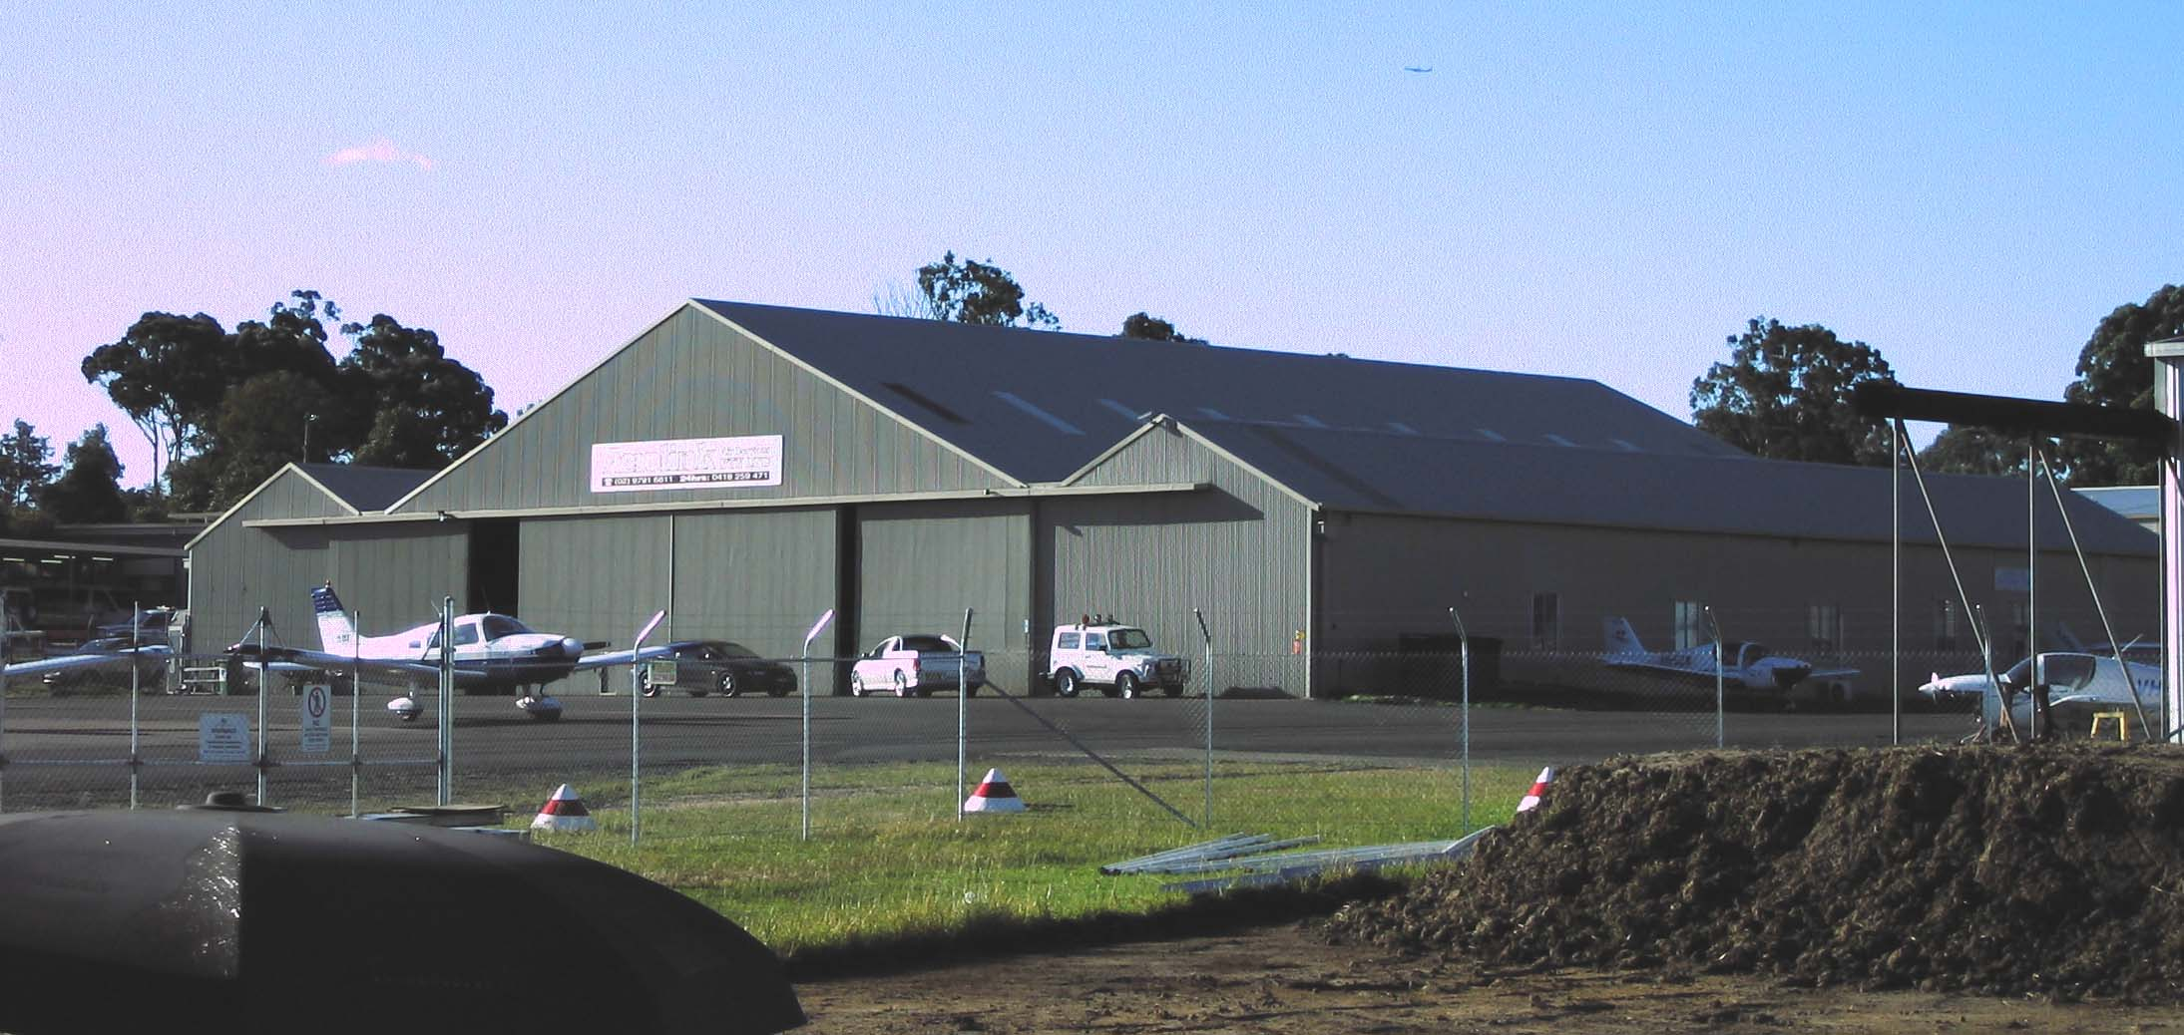
Hangar 410 is a triple gable roofed building facing relocated from Kingsford Smith Airport.
This building has a very interesting history. A 1929 photo (Figure 58) shows it under construction for the original Australian National Airways, formed by Charles Kingsford-Smith and Charles Ulm. This airline ceased operations as a result of the Southern Cloud crash of 1931.
Figure 55: Mascot 1929
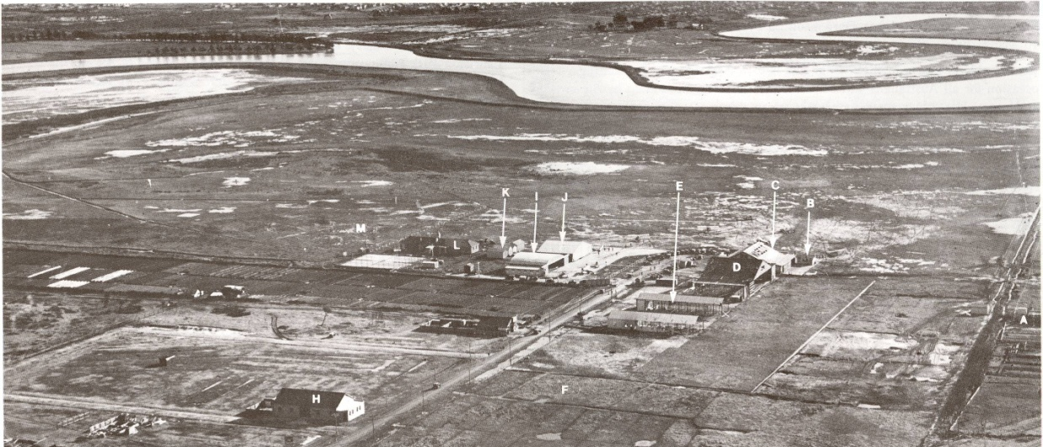

Figure 56: Detail from previous picture: E indicates the hangar under construction
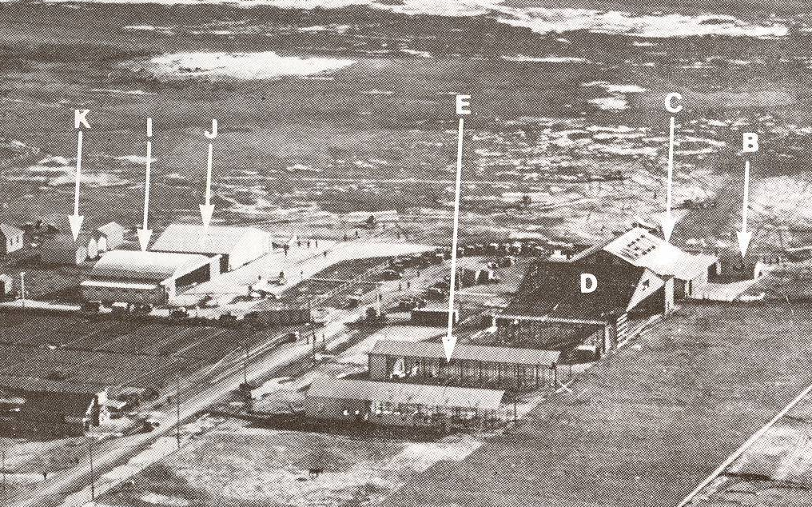
It was then used by New England Airways, who became part of Airlines of Australia on 4 October 1935. They renamed the hangar, but by 1940 it was being used by de Havilland (See Figure 60, page 86).
Airlines of Australia was absorbed by the new Australian National Airways in 1942.
The hangar was demolished in 1962. It was on the site presently occupied by the QANTAS domestic operation in terminal 2.

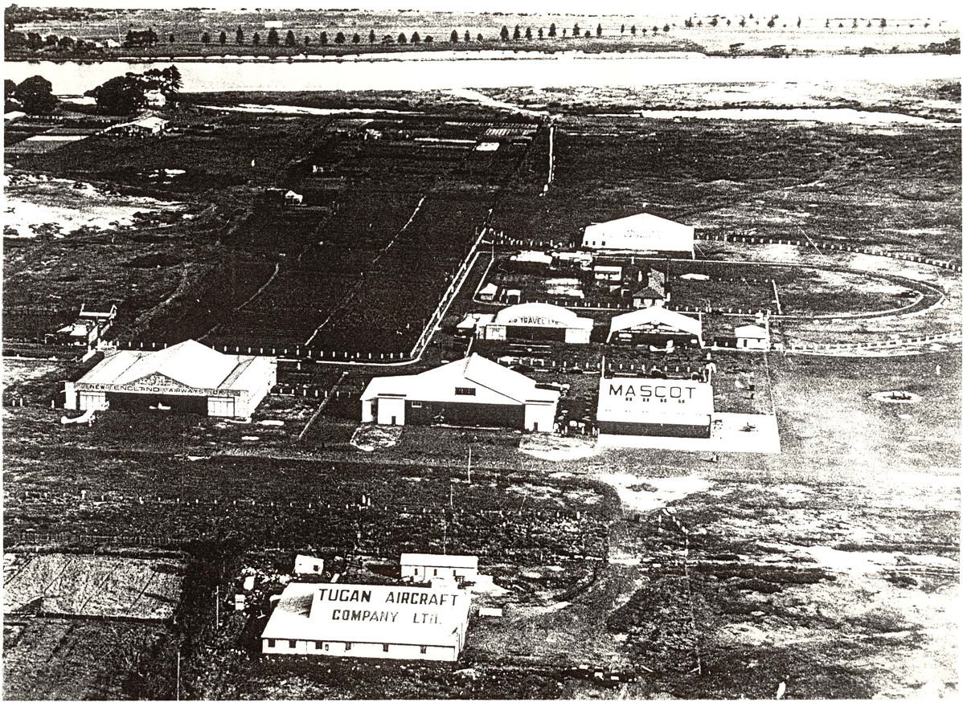
Figure 57: Mascot panorama, listed as c.1935
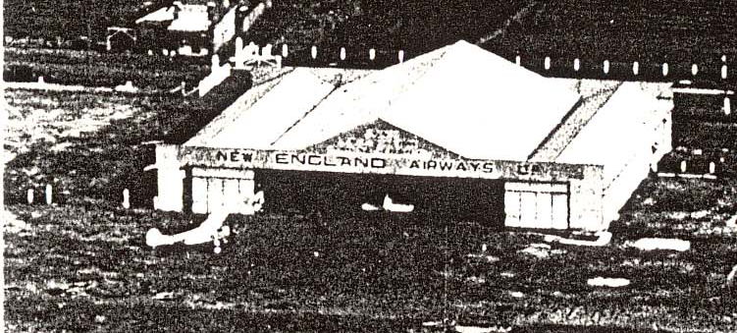
Figure 58: Detail from Mascot panorama, c 1935
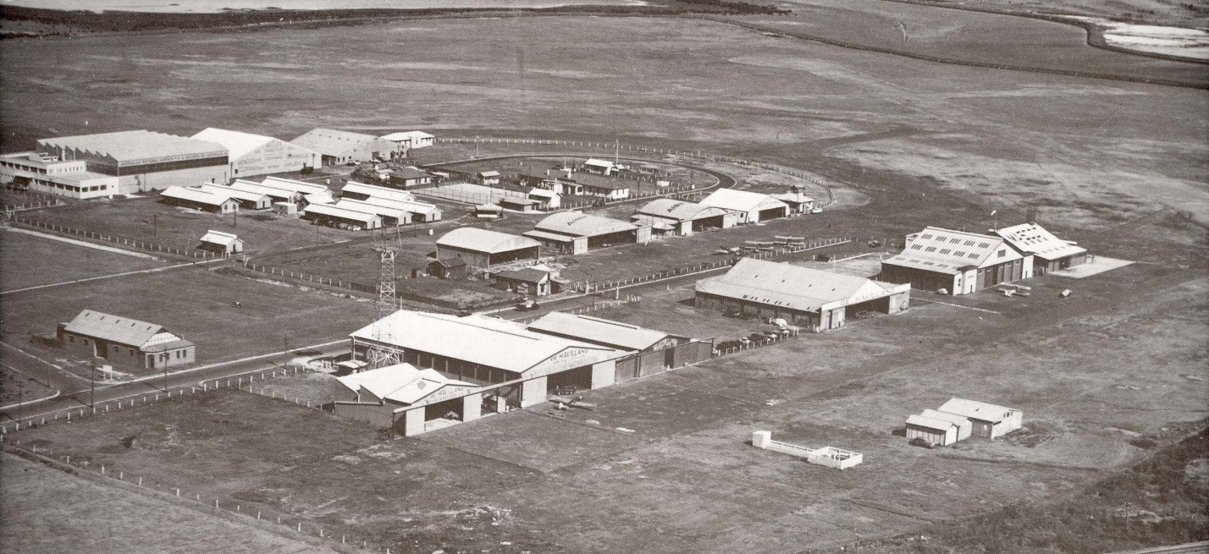
Figure 59: Mascot 1940
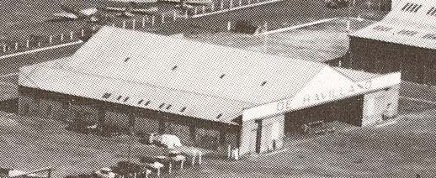
Figure 60: Detail from Mascot 1940 panorama
The hangar is at this time labelled ‘de Havilland’. During the war some hundreds of DH Tiger Moth trainers were built by de Havilland and tested at Mascot.
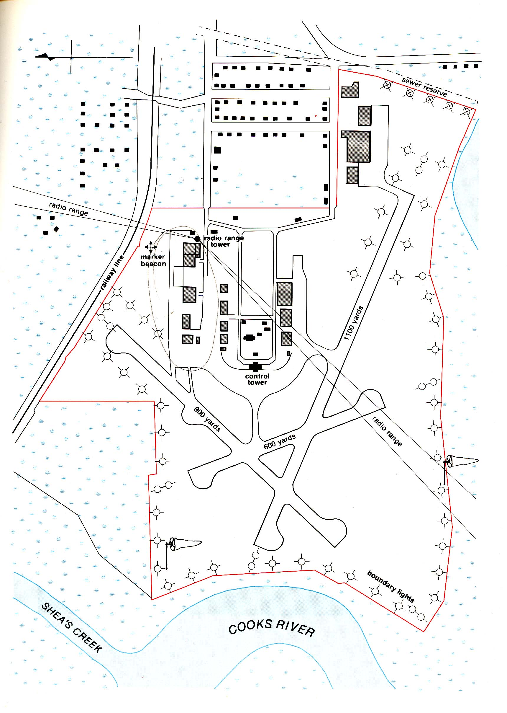
Original position of hangar 410 at Mascot

Figure 61: Plan of Mascot airport, 1941
The hangar was demolished and moved to Bankstown, where it was occupied by the Royal Aero Club on 1 November 1962. The move was part of a complex arrangement that freed Hangar 14 for use by Commerce Associates. Commerce Associates paid for the move, and also moved Hangar 15 to its present site. The Commonwealth prepared the site, provided galvanised iron cladding, and connected electrical power.
The RAC ceased operations at Bankstown in 1991, and since then it has been used by a variety of aviation enterprises. Since 1998 it has been used by Aerolink Australia, a charter operation.
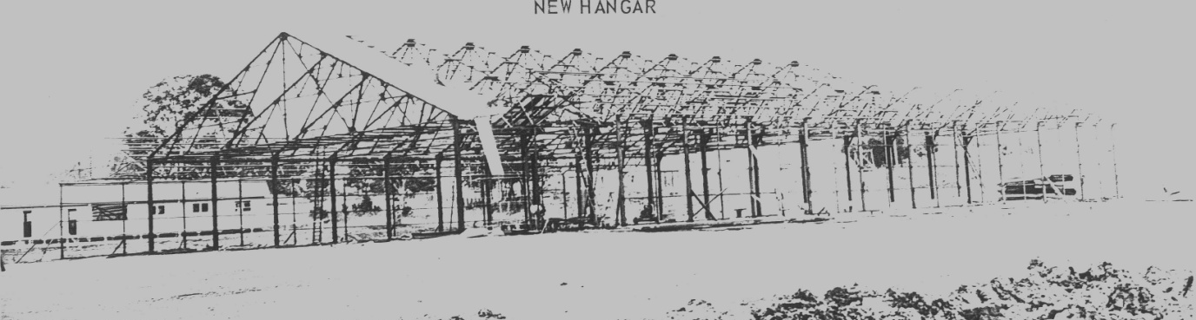
Figure 62: Hangar 410 being erected at its present site, 1962
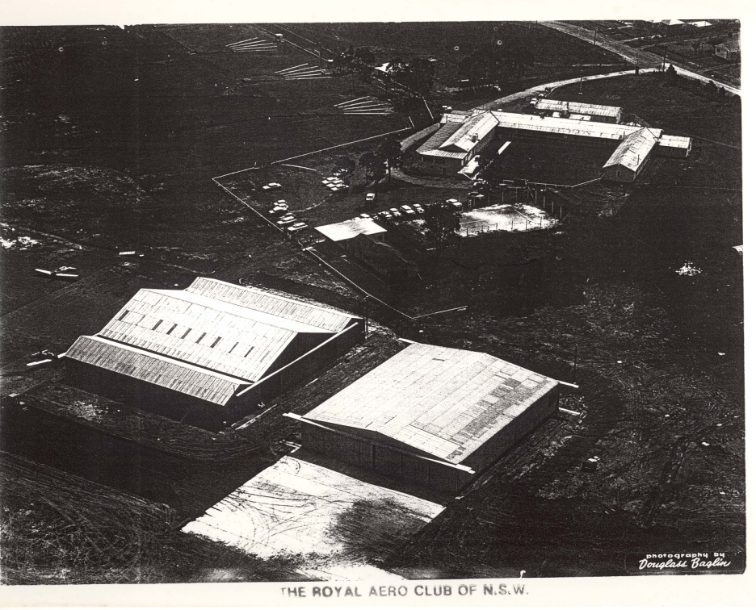
Figure 63: RAC at Bankstown, ca 1965.
Hangars 17 and 410 in foreground; U-shaped clubhouse (former hospital); clay pigeon shooting range in background.

Miscellaneous buildings

RAAF Headquarters Airport Avenue at Comper Street
The first module of this building was erected very early – it is depicted in the 1941 aerial photo. Two other modules were included by 1943, making a u-shape of three standard ‘barrack’ buildings with a portico at the rear. The rear area was a parade ground. in use throughout the war and during the national service period referred to on page 45
This was a major administrative centre, and within its walls operations were planned which were integral to Australia’s coastal defences.
It is timber framed and clad in weatherboard with a corrugated iron roof. It is the only building of its type to survive at Bankstown relatively intact and has aesthetic and representative qualities in addition to its historic significance.
The building remained RAAF Headquarters until circa 1980, although it was briefly leased to Fairey Aviation as office space in the 1950s.

Toilets and believed Canteen Building Gipsy Place
This remaining standard barrack building and was formerly a canteen building for the RAAF. It adjoins toilet and ablution blocks, of similar structure.

Workshop area, Klemm Street
Figure 64: Workshop area, Klemm Street
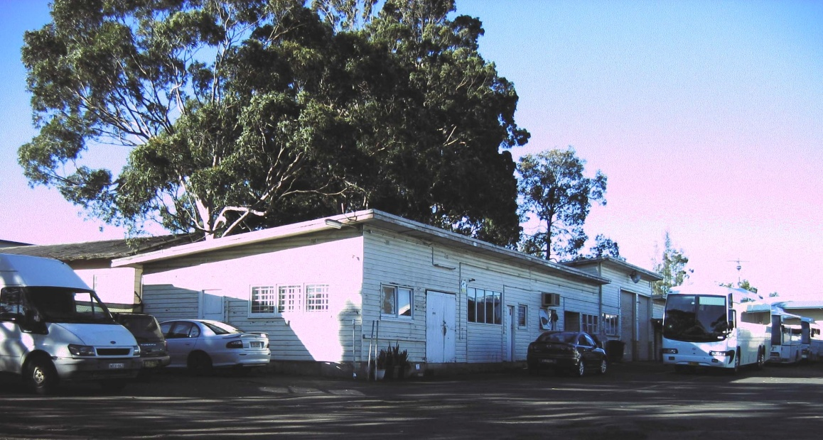
Some remaining World War II buildings can be seen at the bus depot which was, after the war a maintenance depot for the Department of Civil Aviation. The writers of this study believe that at least part of the buildings may date from the time of HMS Nabberley.

Electrical Substation Airport Avenue at Stinson Crescent
Electricity for the original station was supplied from a substation at the entrance gate, but this was replaced by a rather handsome small building, before 1944. The electrical substation is a small brick gable roof building facing onto Airport Avenue. It features decorative brickwork to lintels and is a rare example of a brick building from the 1940s at Bankstown. It remains functional.
The electric transformers are fenced off behind the building .

The Hospital
The hospital was a U-shaped building set back from the airfield. The only remaining trace is a faint outline of foundations.
Local oral tradition is that many WAAAF members who were, or became nurses, worked at the hospital which opened at the aerodrome late in 1942 or early 1943, (certainly before 1945) for which senior staff was provided by Concord hospital. The main purpose of the hospital was alleged to be the treatment of venereal diseases. Certainly it was known officially as The Isolation Hospital, building 74.
Interestingly, though it is commonly referred to as an RAAF hospital, it is not listed in either of the full lists of RAAF institutions that are kept in the library of the Australian Aviation Museum, Bankstown. It is also not mentioned in any of the war history books published by the published by the Australian War Memorial including the four volumes of medical history.
Oral history collected by Chris Matts suggests that it was for US servicemen and specialised in the treatment of venereal disease. Another suggestion is that it was for any servicemen who had contagious diseases.
The building was no longer in use as a hospital in 1948, and at some time shortly thereafter it was handed over to the Royal Aero Club to be used as a clubhouse. The club ceased operations in 1990. The hospital /clubhouse was still standing in 1998 but was demolished shortly thereafter. It was, by then, in very poor condition.
The site is now cleared, but some foundation traces appear to be present. Other buildings in the centre of the U, of more modern origin, presently include the airport base for the Aerial Ambulance helicopters based in Hangar 131.

Appendix 1: Notes for Comparative Analysis

Criterion A - Historic Value
Bankstown airfield was constructed with surprising speed and efficiency at a time of great crisis. The military facility was transformed into a peacetime airfield that not only handles a thousand aircraft movements a day but also has an advanced and innovative aircraft industrial area.
Aspects of the site give a clear reminder of the only time when Australia was in great danger of attack in wartime and even of invasion. See page 17.
Bankstown was an integral part of the overall war effort, and its contribution was both important and atypical. Aircraft Park No 2 was the only aircraft park in New South Wales, and as such, was essential to the supply of aircraft to the many bases springing up around the state. It equipped and/or trained many military units from Australia, the United States and the United Kingdom which played significant roles in important military actions throughout the whole wartime period. It was also an important operational base.
Bankstown was also an emblem of the development of the whole region which occurred during the war years and after, as noted on page 12.

Criterion B - Rarity
This is probably the largest collection of wartime hangars still existing on one site in Australia.

Criterion C – Scientific
The mass-produced Australian-designed aircraft since World War II are
- The de Havilland Drover
- The GAF Nomad
- The Victa Airtourer
- The Transavia Airtruk.
All of the above, except the GAF Nomad, had their first flights and/or their production centre at Bankstown.
Of the 15 aircraft produced in Australia between the end of the war and 1966, no less than 10 were built at, or first flew from, Bankstown.
As noted on page 46, Bankstown firms had a considerable part to play in the scientific activities of Woomera Rocket Range in the 1950s and 1960s.

Criterion D – Representative
Many of the bases which were developed as a response to the challenges posed by the war have disappeared without trace. In New South Wales, the only remaining airfields with significant remains of wartime activities are Bankstown, HMAS Albatross, Williamtown, Temora, Schofields and possibly Tamworth. Of these the only one within the Sydney basin is Bankstown, and it has certainly the best collection of buildings of this time.

Criterion E – Aesthetic
The main aesthetic aspect is the ‘look and feel’ of a traditional airfield, which is hard to obtain from airports that deal with major airlines and larger aircraft. It would be desirable to maintain a good proportion of open space so as to retain this impression.
The association with famous artist Sir William Dobell needs to be publicised, as does the work of photographers Max Dupain and others in developing camouflage techniques.

Criterion F - Creative/Technical
The early hangars, and in particular, the Bellman hangars, are examples of early prefabrication and mass production techniques of large industrial buildings. Though erected for a particular short-term purpose, they are still efficient and usable over half a century later.
There is an impressive amount of local initiative being displayed at Bankstown, and this is ongoing, yet continually developing and changing.
At various times the airfield has led in the development of new skills for Australia, (eg World War II) and in the production of aerospace material The Hawker / de Havilland factory has had over half a century producing the latest in aviation technology.
At the moment Bankstown airfield tenants have in train many exciting projects. To mention just a few:
- major restoration works on an iconic Consolidated PBY Catalina amphibian
- preparation and maintenance of ‘state of the art’ aerial ambulance helicopters
- filming of the popular TV program Top Gear Australia in an aircraft hangar
- establishment of a film set depicting the interior of a Boeing 747, being undertaken by the Australian Aviation Museum
- new and innovative air and land freight facilities
- A thriving general aviation industry, involving both fixed wing aircraft and helicopters, including pilot training and recreational flying
- the innovative University of New South Wales tertiary program in aviation education
- numerous minor projects of aircraft construction and maintenance..
- The Australian Aviation Museum, the only aviation museum in the Sydney Basin, formed entirely with voluntary workers.

Criterion G – Social
The Bankstown area is not one of high socio-economic status.
Thus it is important that the population in general, and the younger population in particular is aware of the initiative and enterprise that has characterised the development of aviation in the area, so that they can appreciate the possibilities that they themselves have.
The WAAAF camp was significant as an example of the development of new roles for women which appeared as part of the war effort (page 22).

Criterion H – Associative
The airfield has been associated with defence personnel during World War II, and after the war was a major area for innovation and enterprise. As such it attracted several significant figures in Australian aviation history:
Specifically, the following persons might be relevant:
Sid Marshall (page 78)
Doug Fawcett (page 81)
Franco Belgiorno-Nettis (page 54)
Luigi Pellarini (page 54)
Henry Millicer (page 53)
Brian Walker (page 47)
June Stone (page 22)

Criterion I - Indigenous
There is little Aboriginal material on the site, but along the Georges River there are several areas of some significance. This can be acknowledged and publicised within the proposed development.

Statement of Cultural Significance; Significance of the Setting
The ‘airside’ area within the airfield perimeter fencing is dominated by the hangars, many of which have outstanding significance. It provides a unique identity to the Bankstown region, and a source for tradition and civic pride in an area that otherwise has considerable disadvantage.

View Analysis, Significant Curtilage
The open view of the airport is essential to preserving its atmosphere. The area around the headquarters building is especially significant open space, being the original parade ground.

From the writers: a final word.
The writers are:
Chris Matts. Chris grew up in the Bankstown district, and served in the RAAF shortly after the war, based in Bankstown. After a career as electrical engineer, for the last ten years in retirement he has been the voluntary librarian at the Australian Aviation Museum, Bankstown. This is now probably the best collection of aviation-related material in New South Wales. For some decades he has been collecting material on the history of Bankstown airport. He has published A Brief History of Bankstown Airport, for the Australian Aviation Museum, Bankstown and has collected material for a full history, and this material has become the basis for this work.
Tom Lockley. Tom is a retired teacher, who has taught senior history. He holds a BA degree in history and an MEd degree, concentrating on the impact of technology on society, from New England University. He has had two books on local history (of Coleambally and Gulargambone) published and has been archivist at the Australian Aviation Museum since 2002.
The Australian Aviation Museum, Bankstown has operated for more than ten years. There have been no paid employees. Up to 100 voluntary workers have attended on a weekly roster, and at its peak is held a significant collection of Australian aircraft, and still has a remarkable library collection. Much of the material for this study has come from its archives.
It could well have been expected that a high priority for the development of the airport area would have been to preserve the museum on site, on financial terms befitting its status as a nonprofit organization which was the principal guardian of the heritage of Bankstown airfield.
The writers of this report note with considerable concern that the Australian Aviation Museum, Bankstown is not mentioned in the development plan for Bankstown Airport nor was it mentioned in the Heritage Study commissioned by BAL for this development plan.
The financial terms offered for the relocation of the museum were such that it could not continue to function at Bankstown. At present it appears that if the museum is to survive, it will have to move to Camden Airport. However, no final deal has been arranged with the new airport owners. Further, particularly in view of the current financial climate, it will be extremely difficult to obtain the large amounts of money for transport of aircraft, exhibits and library, and the erection of new buildings.
At the moment the museum remains at Bankstown, surrounded by earthmoving activity. Because the museum is no longer accessible by aircraft from the airport, many exhibits have been removed, including Sabre and Drover . Visitor numbers are down, therefore income is approaching a dangerously low level. Volunteers are finding it difficult to continue with projects, and many will find it difficult to travel to the proposed new venue at Camden.
In short, the future of the museum is precarious. It appears that the museum has the alternatives of either moving to Camden or closing down. It is the writers’ strong feeling that this museum should be maintained at Bankstown, so as to reflect its importance in Australian history.
Failing this, the writers submit that as a bare minimum,
- Attractive and durable signs should be installed, describing the history of various parts of the area. This could include an explanation of the reasons for the street names, and possibly a walking tour of historical aspects of the precinct.
- There should be some thematic displays in the proposed new buildings such as the shopping mall. This could include aircraft or at least 25% scale models of aircraft that have featured prominently in the story of Bankstown. Bowermans Office Furniture, 308-310 Canterbury Road, Canterbury, is an example of a shop that has integrated aviation materials with its décor.
- There should be a full and complete archival collection, properly maintained, detailing the history of the airport.
- In the development, particularly of the main area, attention must be given to maintaining the overall ‘look and feel’ of the precinct. The owners have emphasised that the prime function of the site remains the airport, so matters such as the maintenance of open space and the preservation of the curtilage of the buildings are important.
The headquarters building on Airport Drive could well become a heritage display centre.
The above is in addition to preservation of existing significant buildings and their curtilage that may be recommended in other parts of the full report by Dawbin Architects.

Chris Matts
Tom Lockley
July, 2009

Plan from study by Godden Mackay Logan, Bankstown Airport, - Heritage Management Study, April 2005, page 60. The colour coding is from the GML study and is not necessarily reflect judgments made by the current process.
Kohen, J and Lampert, R ‘Hunters and Fishers in the Sydney Region’, in D J Mulvaney and J Peter White: Australians to 1788. Sydney, Fairfax, Syme & Weldon, 1987, p.351
http://kaimiaway.org.au/feasibility/ch_1/index.htm, website of The Sutherland Shire Environment Centre, a non-government organisation devoted to preserving the environment of the Georges River
Cass, T: Western Sydney Thematic History, State Heritage Register Project, 2005
http://www.westernsydneylibraries.nsw.gov.au/westernsydney/river.html quoting Appleton, Richard. The Cambridge dictionary of Australian places. Cambridge, UK: Cambridge University Press, 1992. Keating, Christopher. On the frontier: a social history of Liverpool. Sydney: Hale & Iremonger, 1995.
Heritage NSW, newsletter of the NSW Heritage Office, Spring 2003, page 9
Brew, A: Thematic Study: World War II Aerodromes and associated structures in New South Wales, Deakin University and the NSW Heritage Office, November 2001, appendix G, page 59
Sun Newspaper, 4 September 1929, page 14 – ‘‘Knock Out’ Bankstown Drome Plan, Mascot Preferred, (From Our Special Representative)’, Canberra.
Picture from Bankstown Historical Society collection stored at Bankstown Library.
summarised from McCarthy, J M, Australia and Imperial Defence, 1918-39, University of Queensland Press, 1976, chapters 4-6.
Mellor, D P, Australia in the War of 1939–1945. Series 4 – Civil - Volume V – The Role of Science and Industry, Australian War Museum, 1958, page 37ff
White, K, Brief history of RAAF Station, Bankstown NSW. Australian Aviation Museum, Bankstown, 2001
Hasluck, P: Australia in the War of 1939–1945. Series 4 – Civil - Volume II – The Government and the People, 1942–1945, Australian War Memorial, 1979, pages 117-118
ibid, page 291 ff.
National Archives of Australia, DWB [Director of Works and Buildings] - RAAF Number 2 Aircraft Park - Bankstown NSW - Buildings and services, Series accession number A705/1eg pages 275 and 300.
ibid, page 25ff.
Brew, A, op cit, this material extracted from Appendix G http://www.heritage.nsw.gov.au/docs/aerodromes_appendices.pdf
Wilson, S: Anson, Hudson and Sunderland in Australian Service, Aerospace Publications, Canberra, 1992, page 33-34. Fairey Battles assembled at Bankstown (2 Aircraft Park) are listed at http://www.adf-serials.com/2a22.shtml
Barton, L: Bankstown to Berlin with 451 (RAAF.) Squadron, 1941-1946, 451 (RAAF) Squadron Association, Sydney, 1996
AWM Collection Record: 007306, copyright expired, public domain. The label clearly states that the picture was taken at Bankstown but this is not so: the squadron travelled to Singapore and was equipped with aircraft there.
Hall, E R: Glory in Chaos – the RAAF in the Far East 1940-2, Sembawang Assoc iates, West Coburg, Victoria, Part 2, chapter 4, page 265ff
Kass, T: Western Sydney Thematic History, State Heritage Register Project, 2005, page 44
Role of Science and Industry 390-92
Re the ‘Brisbane Line’ see Hasluck, P, The Government and the People, Australia in the war of 1939-1945, vol.II (Canberra: Australian War Memorial, 1970): pp. 711-717 and Cottle, C. The Brisbane Line: A Reappraisal. Leicestershire; Upfront Books 2002. Whether the concept was indeed official policy or not, Andrea Brew, op cit, appendices H, J and K shows the Brisbane Line on her maps and the basic point made above is still relevant.
Picture from the collection at the Australian Aviation Museum, Bankstown, which also houses the gun itself.
Gill, G: Royal Australian Navy, 1942–1945, Australian War Memorial, Canberra, 1968, pages. 64–72
Letter from Headquarters, Eastern Area, RAAF to Divisional Works Office, 2 Nov 1944, copy from collection of Australian Aviation Museum, Bankstown
Gillson, D: Australia in the War of 1939–1945. Series 3 – Air - Volume I, Australian War Memorial, Canbetta, 1962, page 528
Grant, G, Spitfires over Darwin, 1943, R J Moore, Melbourne, 1995, page 11
AAF Airfields in Foreign Countries, AAF Installations Directory Part 1, page 37, document in the collection of Chris Matts
http://www.afhra.af.mil/factsheets/factsheet.asp?id=10238
Letter from Forty First Fighter Squadron, Thirty Fifth Fighter Groul to Headquarters, Fifth Air Force, of 8 November 1942, document in the collection of Chris Matts
Construction record document of USAAF, from the collection of Chris Matts
Construction record document of USAAF, from the collection of Chris Matts
AAF Airfields in Foreign Countries,, as above
AWM Collection Record: P05600.002, http://cas.awm.gov.au/photograph/P05600.002
AWM Collection Record: P05600.002, copyright expired, (public domain).
http://www.womenaustralia.info/biogs/AWE0423b.htm ; the exact date comes from Operations Record Book Station Headquarters Bankstown page 6
AWM Collection Record: F04045, interview 19 February 1991
Picture from AAMB collection, names and spellings not guaranteed!
National Archives of Australia file DWB [Director of Works and Buildings] - RAAF installation - Bankstown - Buildings and services, A705/1
Baker, B, RAAF WWII list of Formations, document in the collection of the Australian Aviation Museum, Bankstown
Fuller records are held at AAMB.
http://www.auburn.nsw.gov.au/uploadedFiles/AuburnWeb/Development/DCP-%20RAAF%20Site.pdf gives details of the conversion of the site at Regents Park.
Frank Hinder, personal records, Australian War Memorial, series 895/4/182, item 7 of 12, page 7, referred to in http://www.awm.gov.au/journal/j38/camouflage.asp
Mellor, D P: The Role of Science and Industry, Australian War Memorial, page 538.,
AWM Collection Record: ART30247
Mellor, DP et al, The Role Of Science And Industry, Australian War Memorial, 1958, page 533 and page 538
NAA (NSW), C1905 T1, item 3 [3][2], copyright expired
Sun-Herald, 8 October 1989
Bryce, N: ‘Bankstown Aerodrome 1943’, in Bankstown Historical Society Journal, October 1995, page 16. Mr Bryce served at Bankstown as a soldier at the time, manning anti-aircraft guns.. The ‘dummy ‘houses had ‘real’ poultry yards and the guards thus had a good supply of eggs!
Fawcett, D: Pilots and Propellers¸ self-published in 1988, page 115-6
on the corner of Burragorang and Cawdor Roads, three kilometres south of Camden Post Office
Document in the collection of AAMB historian Keith White
This work was originally written for the Fleet Air Arm Officer’s Association entitled ‘Three Years of Interest 1943 – 1946’, published at http://www.royalnavyresearcharchive.org.uk/MONABS/REM_Pursall.html , There are some factual errors here, but the passage is interesting as an expression of a participant’s perceptions.
Dates from Davidson, E et al, Chronology of World War II, Cassell, London, 1999.
The naval ships are listed on http://www.royalnavyresearcharchive.org.uk/BPF-EIF/BPF_Ships.htm. Some of the ships were from Canadian, New Zealand and Australian navies, and others were crewed by seamen from these countries.
United States Department of State. Foreign relations of the United States: Conference at Quebec, 1944, page 314-315
Hasluck, P: The Government And The People 1942-1945, Australian War Memorial, 1979, page 554ff.
The established bases are listed on http://www.royalnavyresearcharchive.org.uk/BPF-EIF/BPF_Ships.htm and the planned units are listed on http://www.btinternet.com/~faahistoryweb/index.htm
Pursall, Lt P, Three Years of Interest, 1943-46, a publication of the Fleet Air Arm Officer’s Association, 1947, reprinted at http://www.btinternet.com/~faahistoryweb/REM_Pursall.html
Oral history collected by Chris Matts, 1998. The building no longer exists at that site.
Three Years of Interest 1943 – 1946, Fleet Air Arm Officers Association of UK, reprinted at http://www.btinternet.com/~faahistoryweb/REM_Pursall.html
US Congress, Lend-Lease Act, 11 March 1941
Lehan, M: HMAS Albatross, Australian Naval Aviation Museum, 2000, pages 15-29.
This facility mainly dealt with the reception of Royal Naval ships visiting Brisbane; a similar establishment in Melbourne being known as HMS Beaconsfield.
Odgers, G, The Royal Australian Air Force, Child and Henry, Brookfale, 1984
http://www.airforce.gov.au/history/ww2.aspx
Age newspaper, December 2 1947
discussed in Sydney Morning Herald, March 6, 1961
Rosen, Sue`What’s Under the Hill’ in Bankstown Historical Society Journal, Vol 21 No. 3, July 1987, p 3. and 21, 88, 143-145. Eather, S Flying Squadrons in the Australian Defence, Aerospace publications, Canberra, 1995 page 56-57. Rosen, Sue, Bankstown, A Sense of Identity, Hale and Ironmonger, Sydney, 1996.
Beudeker, B 2003, op cit, p 15; AHC, Register of the National Estate Database, ‘Bankstown Airport, Bankstown NSW’ File No. 1/16/003/0009
Rosen, S, 1996, op cit, pp 119-120; Peters, Merle 1991, op cit, p 22.
See, for example, letter from A Hepburn, Director-General of Civil Aviation, to District Superintendent, Mascot, 5 July 1946, copy of document in archives of Australian Aviation Museum, Bankstown
Ministerial memo from A S Drakeford, Minister for Air and Civil Aviation, 25 August 1948, copy of document held at Australian Aviation Museum, Bankstown
Interview with former members C Matts and B Wallace
Flight magazine, 6 November 1947, page 163
Flight magazine, 14 December 1949, page 163
National Archives file, Migrant workers hostel, Bankstown number 1, New South Wales, Series number A445, Control symbol, 221/1/8, 1949 - 1956
letter to Maintenance Group of RAAF Melbourne, from Air Member for Supply and Development, 31 May 1952, copy in the collection of the Australian Aviation Museum, Bankstown.
http://www.diggerhistory.info/pages-conflicts-periods/other/ntl-service.htm
Recollections of Chris Matts, who was one of these servicemen.
Jones, C, Wings and the Navy 1947-53 Kangaroo Press, Sydney, 1997, page 42,
Picture from Flight magazine, 26 August 1955, page 326
Aircraft magazine, July 1960
Flight magazine, 7 May 1954, page 3
http://www.airforce.gov.au/raafmuseum/exhibitions/external/bloodhound.htm
Mellor, DL The Role of Science And Industry, Canberra, Australian War Memorial, 1958 p 391
The Beginning Australian Aircraft Industry, paper issued by the Department of Aircraft Production, February 1946, page 4
Flight magazine, July 28 1949
Rolland, D, Aerial Agriculture in Australia, Aerial Agricultural Association of Australia, 1996, pages 13-20
ibid, page 20
Australian Archives. Department of Supply MP891, Series B, History Sheets of Government Munitions Factories and Establishments
http://www.adf-serials.com/2a3.shtml
Photograph of aircraft now in Queensland Air Museum www.qam.com.au
Robey, K, ‘The Cropmaster Makes History’, Aircraft magazine, July 1962, pages 62ff, also Eyre, D,. ‘Kingsford-Smith KS-3’, The Illustrated Encyclopedia of Aircraft in Australia and New Zealand,. Sunshine Books, Hornsby NSW, 1983 page 143
www.aerospace.co.nz/B5D670E4-F8BD-11DD-B067000C2918740E -
Richard V. Wood, ‘Richardson, Mervyn Victor (1893 - 1972)’, Australian Dictionary of Biography, Volume 16, Melbourne University Press, 2002, pp 84-85.
Aircraft magazine, September 1961, page 42
Aircraft magazine, August 1961, page 20-21
http://www.airforce.gov.au/RAAFMuseum/research/aircraft/series3/A19.htm
Basic information from Wood, R V, ‘Richardson, Mervyn Victor (1893 - 1972)’, Australian Dictionary of Biography, Volume 16, Melbourne University Press, 2002, pp 84-85.
Aircraft magazine, October 1966, pages 23ff.
Aircraft magazine, May 1965, pages 29ff
http://www.transfield.com.au/thefirst50years/
http://www.abc.net.au/dynasties/txt/s982538.htm
Aircraft magazine, February 1970, page 14
Aircraft magazine October 1970, page 37 ff.
Maltby, K et al Bankstown: Sense of Identity. From Settlement to City. Bankstown City Council. p. 13
Aircraft magazine, October 1974, page 32
Aircraft magazine, June 1973, page 27
Flight International magazine, 28 September 1971, page 23
Rosen, Sue 1996, op cit, p 162.
Briefing notes prepared by Federal airports Corporation for Hon R Willis, Federal Minister for Communications and Transport, November 21, 1988
The RAC archives for the period are held at the Australian Aviation Museum, Bankstown.
http://www.boeing.com.au/ViewContent.do?id=39467&aContent=History
http://www.bankstownairport.com.au/corporate/CIN060.asp, press release from Bankstown Airport Limited, 12 June 2009, also Air Services Australia figures given on http://www.airservicesaustralia.com/projectsservices/reports/movements/calytd2008.pdf
http://www.abc.net.au/news/stories/2008/03/07/2182892.htm, Sydney Morning Herald March 7, 2008, page 3 Bankstown won’t fly, says minister
http://www.railpage.com.au/modules.php?&name=Forums&file=viewtopic&t=11346021
NSW Legislative Assembly Hansard, 26 June, 2003
http://www.leighton.com.au/verve/_resources/R_Infrastructurepres.pdf
http://ext.mirvac.com/jfg/pdf/20031217_dec03%20airports%20presentation1.pdf
Wilson, S, Anson, Hudson and Sunderland in Australian Service, Aerospace Publications 1992, page 17
Bartion,B, op cit. page 2
Letter from Director, Department of Transport, to manager, RAC Bankstown, 29 March 1979, copy in the collection of Australian Aviation Museum, Bankstown.
Parnell, N, Flypast, page 428
National Archives of Australia: Series no A705, Control symbol171/26/77 PART 1, Barcode 3284715, DWB [Director of Works and Buildings] - RAAF Bankstown NSW - Post war airfield - Buildings and services, 1946 – 1960, Minute from Chief of the Air Staff, 1 October 1948
Construction record document of USAAF, from the collection of Chris Matts
Memorandum from 2 Stores Depot, Regents Park, to Headquarters, No 4 Maintenance Group,, 14 May 1947. Document in the collection of Australian Aviation Museum, Bankstown
Flight International, 9 May 1981, page 1287
Sydney Morning Herald, August 2, 1985, page 11
Brew, A, Thematic Study: WWII aerodromes and associated structures in New Sough Wales, ##, page 44
Royal Air Force maintenance manual for Bellman hangars <http://www.defence-estates.mod.uk/publications/functional_standards/01_bellman_hangars.pdf>
Heritage NSW, Autumn 2005, page 9
RAAF Unit History sheets (Form A50) [Operations Record Book - Forms A50 and A51] Station Headquarters Bankstown Dec 40 - May 42. Series number A9186
Barton, B, op cit. page 1
National Archives of Australia: Series no A705, Control symbol171/26/77 PART 1, Barcode 3284715, DWB [Director of Works and Buildings] - RAAF Bankstown NSW - Post war airfield - Buildings and services, 1946 – 1960, Minute from Chief of the Air Staff, 1 October 1948
ibid
Civil Aviation Act 1988, Certificate of Approval no C518185
Barton, B, op cit. page 2
Memorandum from District Superintendant, Department of Civil Aviation, to the Director-General, 26 March 1947, from the collection of Australian Aviation Museum, Bankstown.
Flypast, p 470
http://www.tighar.org/amelia_3.rm
http://www.aviationmuseum.com.au/aircraft/spitfire.cfm
AWM Collection Record: P04068.001, http://cas.awm.gov.au/photograph/P04068.001
http://www.rafmuseum.org.uk/london/collections/aircraft/aircraft_histories/1996-0066-A%20Avro%20Anson%201%20W2068.pdf
Flypast, p 260-261
Flight International magazine, 24 July 1989, page 129
Flight International Magazine, 27 August 1954, page 302
Flight International Magazine, 24 August 1956, page 181
http://www.qam.com.au/aircraft/piaggio/VH-BHK.htm
Copy documents obtained by the RAC and in the archives of the Australian Aviation Museum, Bankstown
Much of the material for this section comes from Fawcett’s privately published book Pilots and Propellers, 1988, but has been checked from other sources.
Memorandum from District Superintendant, Department of Civil Aviation, to the Director-General, 26 March 1947, copy in the collection of Australian Aviation Museum, Bankstown.
Gall, J, From Bullocks to Boeings, AGPS, Canberra 1986, page 23
Gall, J, as above.
The Australian Aviation Museum, Bankstown has a poor-quality picture of about 1938 which shows the signage for Airlines of Australia.
Parnell, N et al: Flypast, a record of aviation in Australia, AGPS, Canberra, 1988, pages 424-425
Gall, op cit, page 38
Gall, op cit, page 38
Gall, J, op cit page 51
Letter from Director, Department of Transport, to manager, RAC Bankstown, 29 March 1979, copy in the collection of the Australian Aviation Museum, Bankstown
Picture from RAC archives held by Australian Aviation Museum, Bankstown
Picture from RAC archives held by Australian Aviation Museum, Bankstown
Godden Mackay Logan, Bankstown Airport Heritage Assessment, 2003, p.10
National Archives of Australia: Series no A705, Control symbol171/26/77 PART 1, Barcode 3284715, DWB [Director of Works and Buildings] - RAAF Bankstown NSW - Post war airfield - Buildings and services, 1946 – 1960, Minute from Chief of the Air Staff, 1 October 1948
Interview with Sam Dodds, who served at Bankstown 1942-45
Aircraft magazine, May 1965, pages 29ff
cf Bureau of Statistics Publication A Social Atlas of New South Wales.
cf Bankstown Airport - Heritage Management Strategy, April 2005, page 86

